Penguin Press Vol.2_Issue 10 Distribution Copy.pdf

PENGUIN PRESS


“A Culture of Caring”
Vol.4, Issue 17


Annabel C. Perry PreK-8

“B” Ready for 2022-2023!


We Did It!
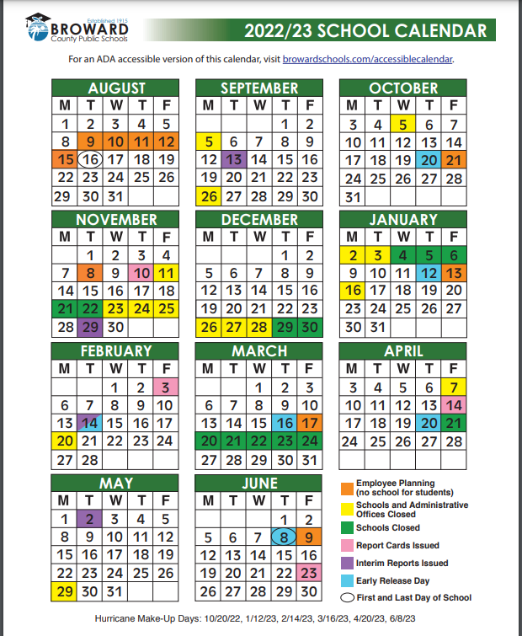
PRINCIPAL’S NOTE

Penguin Family,

Happy New Year Penguins! It is with great pride that I would like to announce that Annabel C. Perry PreK-8 will be kicking off the upcoming school year with the distinction of being identified as a "B” rated school. The hard work and commitment from the students, staff, and community does not go unnoticed as we have worked collectively toward a common goal.

It has been a long summer here on campus and I am looking forward to welcoming back all of our returning Penguins, as well as those who are new. As a school, it is our goal to continuously introduce new initiatives and programs to support all students. In addition to our implementation of IB, we are excited to welcome our new partners from Verizon Innovation and The Food Forrest. Both new programs will make learning relevant and hands-on to keep students engaged and active in their growth.
Aside from academics, it is more important than ever that we keep the safety of our students as our top priority. With this in mind, we need everyone’s support, and if YOU SEE SOMETHING, SAY SOMETHING. You can find several easy-to-use reporting methods on our website at www.browardschools.com/perryelem.

As always, I encourage you to reach out if you have any questions, concerns, or ideas. I can be reached at 754-323-7050.

Thomas J. Correll, Principal

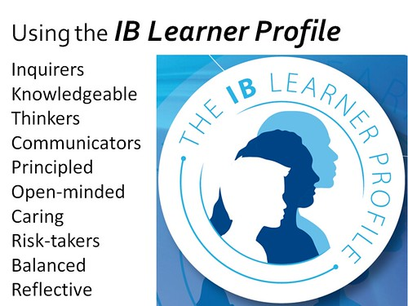
August/September: IB LEARNER PROFILE: CARING
Caring//cuidando/kappranswen: displaying kindness and concern for others.

At Annabel C. Perry PreK-8, we show empathy, compassion, and respect. We have commitment to service, and we act to make a positive difference in the lives of others and in the world around us.

MISSION STATEMENT
The mission of Annabel C. Perry PreK-8 is to create “A Culture of Caring” in a safe and nurturing environment by being open-minded about other cultures, showing compassion toward others, and reflecting on individual behaviors to promote internationally-minded people.

VISION STATEMENT
The vision of Annabel C. Perry PreK-8 is to develop internationally minded students, through inquiry-based learning and a curriculum that fosters cultural awareness.

ANNABEL C. PERRY PREK-8
IB World School for the Primary Years Program (PYP)
Candidate School for the International Baccalaureate (IB)
- Middle Years Program (MYP)

International Baccalaureate (IB)Candidate school for: Primary Years Program (PYP) and the

FREE & REDUCED LUNCH APPLICATIONS

Power Up! With nutritious meals from your local school cafeteria.

The Broward County Public Schools, Food and Nutrition Services Department encourages households to complete a Free or Reduced-Price meal application along with the Meal Benefits Disclosure form. To apply please go towww.myschoolapps.com and complete the forms.



Breakfast is served from
7:30 am – 7:55 am

SAFETY & SECURITY
The safety and security of our students, staff, and families is our top priority. With this in mind, we need everyone’s support; if YOU SEE SOMETHING, SAY SOMETHING. Everyone is encouraged to report suspicious or dangerous behavior, as well as any threats to our school and in an emergency, call 911 immediately. Reports can be made to any staff member on campus, however, preferably should be reported to one of the school’s administrators or security staff members.

Now, any student, educator, parent, or member of the public can also report school safety concerns directly to law enforcement and school administrators easily and anonymously through one of the tip reporting methods below:

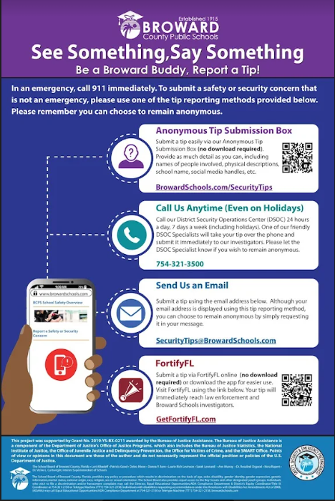

As a part of our safety procedures for the 2022-2023 school year, we will be conducting monthly emergency and evacuation drills as well as active assailant drills, in coordination with local police and fire rescue to better prepare in the event of a true emergency.

In addition, all students are required to wear their 2022- 2023 IDs at all times while on school campus. At the beginning of the year students will be required to use IDs from the previous school year until new ones are issued. Annabel C. Perry PreK-8 thanks you for helping keep our school community safe!

Policies regarding school IDs will be further explained to students during our grade level assemblies and communicated via Parent Link.

Important Information

Every student is required to always wear a student ID. There are no exceptions. Student IDs will be provided by the school. Please note, when the fifth request for a badge is received, the student must purchase a new, permanent identification badge not to exceed $5.00.
Supervision is provided on campus from 7:30 am until 2:30 pm. There is NO supervision prior to 7:30 am. Please DO NOT drop students off prior to 7:30 am.

:

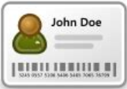

Dismissal Definitions
Car Riders: Leave the car line in a car. No child will be permitted to walk off the car line and cross traffic.
Walker/Bike Riders:
- West Gate – Walk off campus from the WEST exit and walk west from the school.
- East Gate – Walk off campus from the EAST exit and walk north/east from school.

Late Arrival & Early Dismissal
Students who arrive to school after 8:00 am MUST sign in. Security will be at the gate until 8:20 am. After 8:20 am student must be escorted into the school and signed in by a parent.
A parent must sign out their student who required an early dismissal BEFORE 1:30 pm (11:30 am on Early Release Days).
Please remember to bring a valid ID EVERYTIME you pick up your child. Under no circumstances will ANYONE be allowed to pick up a child without proper ID.

Arrival information

Please drop off and pick up students at designated drop off locations. The East Car Loop or the West Car Loop. DO NOT drop students off at the front of the school. The front of the school is NOT a drop off or pick up location.
Breakfast is served between 7:30 am and 7:55 am. This allows time for your child to eat breakfast and get to class on time at 8:00 am.
Dismissal Information
Car riders are dismissed as follows:
- Primary (VPK – 2nd grade) – West Car loop
- Intermediate (3rd – 8th) – East Car Loop
- PreK – West Car loop
Please have older siblings meet the youngest sibling at the designated location.
- Any student who is a walker must be dismissed at the East or West Walkers gate.
- Bus Riders will be escorted from their classrooms to the bus area.
- YMCA students will be escorted from their classrooms to their YMCA counselor.
- Memorial students meet in the back of the cafeteria. Memorial students are NOT permitted to leave campus and then return to Memorial.

Back to School Forms
Attention Parents:
There are a number of important forms that need to be completed at the start of the school year. This information is key for ensuring your child is safe while on campus, and that families are informed about all rules and expectations for the school year. Key forms that need to be completed online include:
- Emergency Contact and Release forms·
- BCPS Code of Coduct
- Photo Release
- Updated Contact Information
- Medical Notifications and Medications
- School Parent Compact Form

- Leave the car line in a car.
- No child will be permitted to walk off the car line and cross traffic.

iCenter News!

Exciting things are happening in the iCenter!

We will continue our Design Studio (Maker Space) and K-5 classes are learning about the Design Cycle. Design thinking can be applied across the curriculum and used to solve real-world concerns.

Students in grades 3-8 are learning how to use Follett Destiny on their Clever page to sign into many digital resources, including Axis 360. Axis 360 is also available as a smartphone app and has a vast variety of eBooks and Audiobooks that can be played online or downloaded to your device... all for FREE!

Uniform Policy

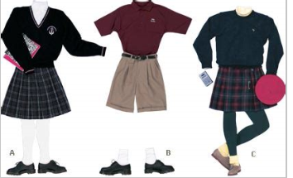

We are a uniform school. Every student is expected to be in uniform every day.
Students’ adherence to our uniform policy is important in helping us identify students on campus. For more information on approved colors and types of clothing, please refer to your child’s first day packet.
Students not adhering to the school’s uniform policy will receive consequences per the Broward County Discipline Matrix.

Annabel C. Perry PreK-8
Dates to Remember

- Picture Day: September 2, 2022
- Labor Day: September 5, 2022
- Book Fair: September 5-9, 2022
- Open House: September 7, 2022
- Interim Reports: September 13, 2022
- School Advisory Committee (SAC)/Food Forest September 28, 2022
- September 26, 2022: School and Administration Offices Closed

Website: https://www.browardschools.com/perryelem Follow us on Twitter@Annabel _C_ Perry

