Penguin Press Vol.2_Issue 10 Distribution Copy.pdf

PENGUIN PRESS


“A Culture of Caring”
Vol.4, Issue 17


Annabel C. Perry PreK-8

Excited to “B” Back


We Did It!
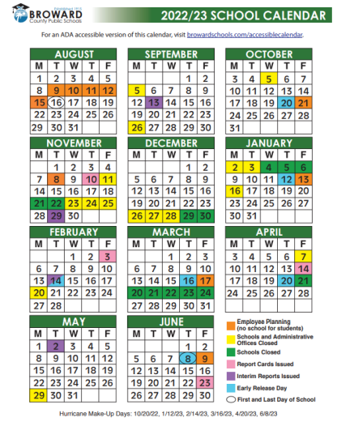
PRINCIPAL’S NOTE

Penguin Family,

This month, Annabel C. Perry PreK-8 took time to pause and reflect as we remembered and commemorated the 17 lives lost, those injured, and all others impacted by the tragedy that took place at Majory Stoneman Douglas High School on February 14, 2018. As a school, Monday, February 14th was dedicated to a Day of Service and Love. Collectively, our teachers worked with students on projects that made an impact on our school and community. We ask that you continue to take the time to talk with your child(ren) about compassion, care, and selflessness.
In addition to our remembrance, we will be celebrating Black History Month throughout February with a variety of project-based lessons that connect students to their IB Learner Profile. These projects are currently displayed in our front office to highlight the students’ outstanding work. We also look forward to our annual Black History Showcase to cap off the month.
Along with the project-basd lessons for February, our students are continuing to shine both in the classroom and during our after school learning opportunities. Our most recent data show a great increase in student learning. As we close the achievement gap created over the past two years, we ask for your support to continue to provide assistance and encouragement at home.
As always, I encourage you to reach out if you have any questions, concerns, or ideas. I can be reached at 754-323-7050.

Thomas J. Correll, Principal

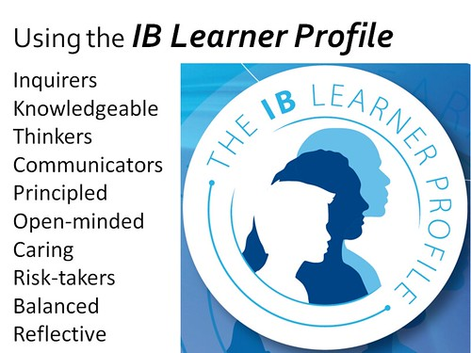
January: IB LEARNER PROFILE

Risk-Taker/Tomador de riesgos/moun kap pran risk: those willing to be wrong in order to learn something new. They aren't afraid of mistakes.

MISSION STATEMENT
The mission of Annabel C. Perry PreK-8 is to create “A Culture of Caring” in a safe and nurturing environment by being open-minded about other cultures, showing compassion toward others, and reflecting on individual behaviors to promote internationally-minded people.

VISION STATEMENT
The vision of Annabel C. Perry PreK-8 is to develop internationally minded students, through inquiry-based learning and a curriculum that fosters cultural awareness.

ANNABEL C. PERRY PREK-8
IB World School for the Primary Years Program (PYP)
Candidate School for the International Baccalaureate (IB)
- Middle Years Program (MYP)

International Baccalaureate (IB)Candidate school for: Primary Years Program (PYP) and the

Free and Reduced Lunch Applications

FREE & REDUCED LUNCH APPLICATIONS
Power Up! With nutritious meals from your local school cafeteria. The Broward County Public Schools, Food and Nutrition Services Department encourages households to complete a Free or Reduced-Price meal application along with the Meal Benefits Disclosure form. To apply please go towww.myschoolapps.com and complete the forms.



Breakfast is served from 7:30 am – 7:55 am

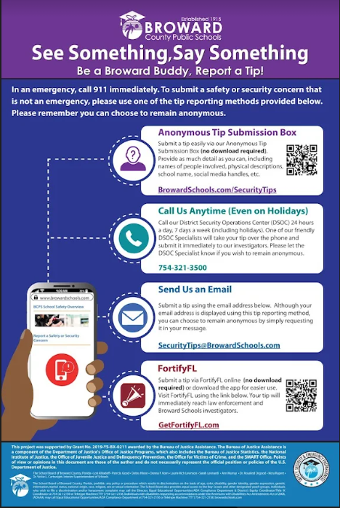

SAFETY & SECURITY
The safety and security of our students, staff and families is our top priority. With this in mind, we need everyone’s support; if YOU SEE SOMETHING, SAY SOMETHING. Everyone is encouraged to report suspicious or dangerous behavior, as well as any threats to our school and in an emergency, call 911 immediately. Reports can be made to any staff member on campus, however, preferably should be reported to one of the school’s administrators or security staff members.
Now, any student, educator, parent, or member of the public can also report school safety concerns directly to law enforcement and school administrators anonymously and easily through one of the tip reporting methods below:

As a part of our safety procedures for the 2022-2023 school year, we will be conducting monthly emergency and evacuation drills as well as active assailant drills, in coordination with local police and fire rescue to better prepare in the event of a true emergency.
In addition, all students are required to wear their 2022- 2023 IDs at all times while on school campus. At the beginning of the year students will be required to use IDs from the previous school year until new ones are issued. Annabel C. Perry PreK-8 thanks you for helping keep our school community safe!
Policies regarding school IDs will be further explained to students during our grade level assemblies and communicated via Parent Link.

- Arrival information:
- Please drop off and pick up students at designated drop off locations. The East Car Loop or the West Car Loop. DO NOT drop students off at the front of the school. The front of the school is NOT a drop off or pick up location.
- Breakfast is served between 7:30 am and 7:55 am. This allows time for your child to eat breakfast and get to class on time at 8:00 am.
- Dismissal Information:
- Car riders are dismissed as follows:
- Primary (VPK – 2nd grade) – West Car loop
- Intermediate (3rd – 8th) – East Car Loop
- PreK – East Car loop
Please have older siblings meet the youngest sibling at the designated location.
- Any student who is a walker must be dismissed at the East or West Walkers gate.
- Bus Riders will be escorted from their classrooms to the bus area.
- YMCA students will be escorted to from their classrooms to their YMCA counselor.
- Memorial students meet in the back of the cafeteria. Memorial students are NOT permitted to leave campus and then return to Memorial.

- Dismissal Definitions:
- Car Riders:
- Leave the car line in a car.
- No child will be permitted to walk off the car line and cross traffic.
- Walker/Bike Riders:
- West Gate – Walk off campus from the WEST exit and walk west from the school.
- East Gate – Walk off campus from the EAST exit and walk north/east from school.
- Late Arrival and Early Dismissal:
- Students who arrive to school after 8:00 am MUST be escorted into the school and signed in by parent.
- A parent must sign out their student who required an early dismissal BEFORE 1:30 pm (11:30 am on Early Release Days).
- Please remember to bring a valid ID EVERYTIME you pick up your child. Under no circumstances will ANYONE be allowed to pick up a child without proper ID.

- Any student who is a walker must be dismissed at the East or West Walkers gate.
- Bus Riders will be escorted from their classrooms to the bus area.
- YMCA students will be escorted to from their classrooms to their YMCA counselor.
- Memorial students meet in the back of the cafeteria. Memorial students are NOT permitted to leave campus and then return to Memorial.

- Dismissal Definitions:
- Car Riders:
- Leave the car line in a car.
- No child will be permitted to walk off the car line and cross traffic.
- Walker/Bike Riders:
- West Gate – Walk off campus from the WEST exit and walk west from the school.
- East Gate – Walk off campus from the EAST exit and walk north/east from school.
- Late Arrival and Early Dismissal:
- Students who arrive to school after 8:00 am MUST be escorted into the school and signed in by parent.
- A parent must sign out their student who required an early dismissal BEFORE 1:30 pm (11:30 am on Early Release Days).
- Please remember to bring a valid ID EVERYTIME you pick up your child. Under no circumstances will ANYONE be allowed to pick up a child without proper ID.

Late Arrival & Early Dismissal

Students who arrive to school after 8:00 am MUST sign in. Security will be at the gate until 8:20 am. After 8:20 am student must be escorted into the school and signed in by a parent.
A parent must sign out their student who required an early dismissal BEFORE 1:30 pm (11:30 am on Early Release Days).
Please remember to bring a valid ID EVERYTIME you pick up your child. Under no circumstances will ANYONE be allowed to pick up a child without proper ID.

Uniform Policy

We are a uniform school. Every student is expected to be in uniform every day.
Students’ adherence to our uniform policy is important in helping us identify students on campus. For more information on approved colors and types of clothing, please refer to your child’s first day packet.
Students not adhering to the school’s uniform policy will receive consequences per the Broward County Discipline Matrix.

Important Information
Every student is required to always wear a student ID. There are no exceptions. Student IDs will be provided by the school. Please note, when the fifth request for a badge is received, the student must purchase a new, permanent identification badge not to exceed $5.00.
Supervision is provided on campus from 7:30 am until 2:30 pm. There is NO supervision prior to 7:30 am. Please DO NOT drop students off prior to 7:30 am.

Dismissal Definitions:
Car Riders:
Leave the car line in a car.
No child will be premitted to walk off the car line and cross traffic.
Walker/Bike Riders:
West Gate- Walk off campus from the WEST exit and walk west from the school
East Gate: Walk off campus from the EAST side walk north/east from school.

- Leave the car line in a car.
- No child will be permitted to walk off the car line and cross traffic.

Website: https://www.browardschools.com/perryelem Follow us on Twitter @Annabel_C_Perry

