William Dandy Middle School Dress Code Policy

Our School Dress Code

This dress code is designed to reduce distractions, improve safety, and create a more positive educational climate for the students and the staff at William Dandy Middle School. School uniforms are mandatory. The William Dandy Middle School uniform dress code will consist of the following clothing items:

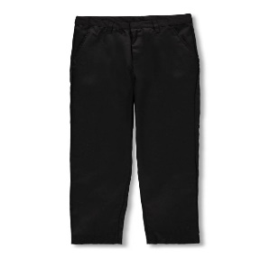
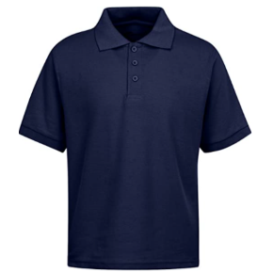
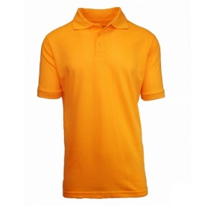
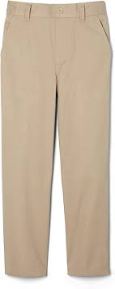
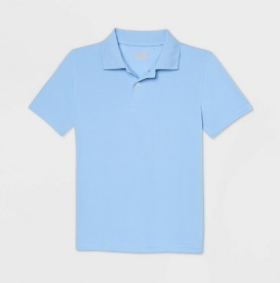
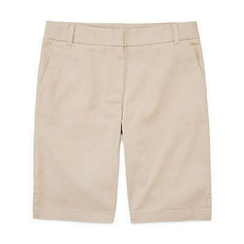

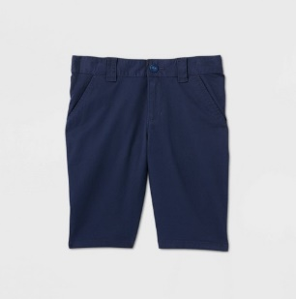
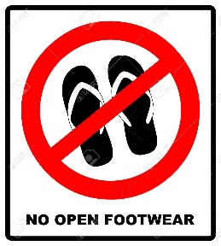
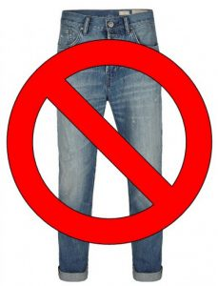

Girls
- Golf polo style shirts must be worn in the following colors: Yellow/Gold, White, Navy, Light Blue or Royal Blue
- Cotton blend pants in the following colors: Navy Blue, Khaki, or Black.
- Shorts must not be shorter than mid-thigh. Color choices: Navy Blue, Black and Khaki
- Solid colored hooded jackets may be worn, but hoods may not be worn during the school day. Color choices: Yellow/Gold, White, Navy, Light Blue or Royal Blue
- No denim, Lycra, Spandex, or Nylon jeans! No Jeggings! No white jeans! (No Jeans AT ANY Time!)
- No dresses
- No button-down shirts
- No stretch pants, Tights or Brazilian pants. No form fitting pants or gym shorts.
- Athletic shoes are recommended; however, students must follow School Board Policy regarding footwear. William Dandy Middle School Policy prohibits sandals, flip-flops, athletic slide sandals and crocs.

Boys

- Golf polo style shirts must be worn in the following colors: Yellow/Gold, White, Navy, Light Blue or Royal Blue.
- Cotton blend pants/shorts/joggers in the following colors: Navy Blue, Khaki, or Black.
- Hooded jackets may be worn, but hoods may not be worn during the school day. Color choices: Yellow/Gold, White, Navy, Light Blue or Royal Blue
- No denim, Lycra, Spandex, or Nylon jeans! No white jeans! (No Jeans AT ANY Time!)
- No gym shorts
- No hats
- No button-down shirts
- Athletic shoes are recommended; however, students must follow School Board Policy regarding footwear. William Dandy Middle School Policy prohibits sandals, flip-flops, athletic slide sandals and crocs.

**** WDMS Spirit Tee Shirts can be worn on Fridays with uniform bottoms.


**** If the weather is 55 degrees or lower students may wear Black or Navy sweatpants (no stripes or designs). Parents will receive a Parent Link phone call indicating cold weather days and how students may dress.

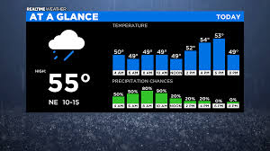

*William Dandy Middle School has an ID Badge Security System. Students are required to wear their ID badge on a lanyard AT ALL TIMES. The school provides the first ID badge and lanyard at no cost. Lost IDs must be replaced at a cost of $5.00. Replacements may be requested from the Book Keeper.

