Penguin Press Vol.2_Issue 10 Distribution Copy.pdf

PENGUIN PRESS


“A Culture of Caring”
Vol.3, Issue 15

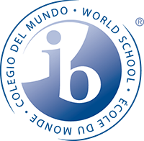
Annabel C. Perry PreK-8

Keeping the Past Present

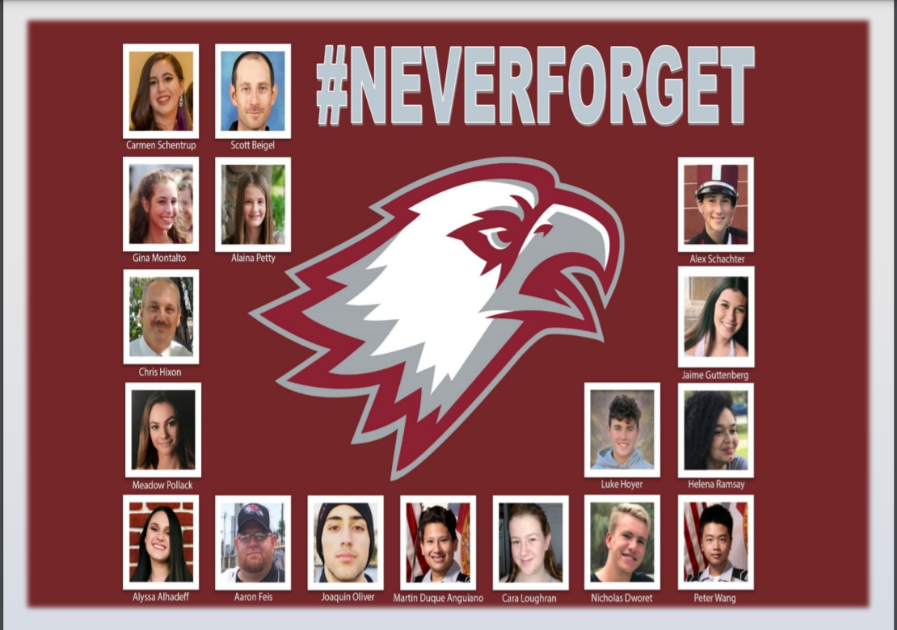
Marjory Stoneman Douglas (MSD)
DAY OF SERVICE AND LOVE

Remembering the seventeen lives that were tragically taken away February 14, 2018

From Broward County Public Schools (BCPS): We are committed to continuing to provide support to our students, staff, families, and communities. Following the lead of Marjory Stoneman Douglas High School, BCPS has adopted the idea of engaging in A Day of Service and Love.
Annabel C. Perry PreK-8 will engage in schoolwide service activities that:
- Builds awareness, engagement, and connections during difficult times
- Cultivates Social and Emotional Learning
- Creates significant reflection and service opportunities
- Raises visibility of needs within our community
- Grows network and support of community partners
- Connects communities with information, resources, and opportunities to get involved in ongoing service
- Encourages stronger civic engagement and bringing us all closer

PRINCIPAL’S NOTE

Penguin Family,

This month, Annabel C. Perry PreK-8 took time to pause and reflect as we remembered and commemorated the 17 lives lost, those injured, and all others impacted by the tragedy that took place at Majory Stoneman Douglas High School on February 14, 2018. As a school, Monday, February 14th was dedicated to a Day of Service and Love. Collectively, our teachers worked with students on projects that made an impact on our school and community. We ask that you continue to take the time to talk with your child(ren) about compassion, care, and selflessness.
In addition to our remembrance, we will be celebrating Black History Month throughout February with a variety of project-based lessons that connect students to their IB Learner Profile. These projects are currently displayed in our front office to highlight the students’ outstanding work. We also look forward to our annual Black History Showcase to cap off the month.
Along with the project-basd lessons for February, our students are continuing to shine both in the classroom and during our after school learning opportunities. Our most recent data show a great increase in student learning. As we close the achievement gap created over the past two years, we ask for your support to continue to provide assistance and encouragement at home.
As always, I encourage you to reach out if you have any questions, concerns, or ideas. I can be reached at 754-323-7050.

Thomas J. Correll, Principal

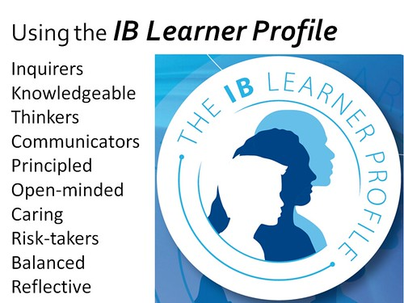
January: IB LEARNER PROFILE

Risk-Taker/Tomador de riesgos/moun kap pran risk: those willing to be wrong in order to learn something new. They aren't afraid of mistakes.

MISSION STATEMENT
The mission of Annabel C. Perry PreK-8 is to create “A Culture of Caring” in a safe and nurturing environment by being open-minded about other cultures, showing compassion toward others, and reflecting on individual behaviors to promote internationally-minded people.

VISION STATEMENT
The vision of Annabel C. Perry PreK-8 is to develop internationally minded students, through inquiry-based learning and a curriculum that fosters cultural awareness.

ANNABEL C. PERRY PREK-8
IB World School for the Primary Years Program (PYP)
Candidate School for the International Baccalaureate (IB)
- Middle Years Program (MYP)

International Baccalaureate (IB)Candidate school for: Primary Years Program (PYP) and the

BLACK HISTORY MONTH

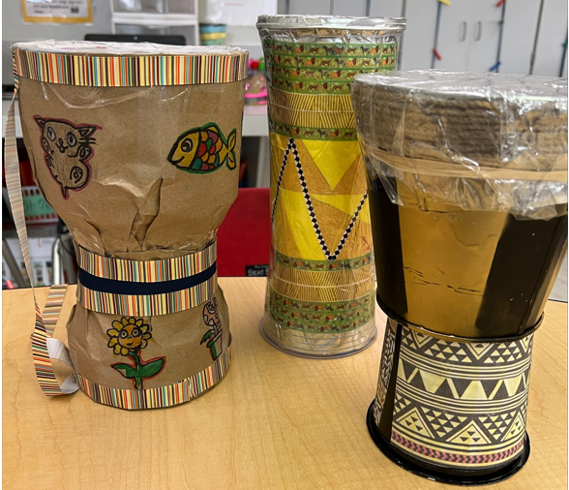
February is a time to reflect on the legacies and achievements of Black Americans

February marks Black History Month, an annual observance in the United States since 1976. The origins date back to 1926, when Dr. Carter G. Woodson established a week to raise awareness of Black history.

Editorial: Black History Month 2022, February 4, 2022, p1, WYFF4

2022 Spring Cognitive Abilities Test Administration (CogAT)
Parents:

Please be advised that we will be administering the Cognitive Abilities Test (CogAT) assessment to all current 2nd grade students during the week of March 7th to March 17th with the week of March 28th to April 1st as a make-up week. The assessment is given over three days with a 45 minute a day testing window. The assessment will be computer based.

The purpose of the CogAT is to assess the level and pattern of cognitive development of students and to screen all children for possible eligibility for gifted services. This assessment provides valuable information regarding your child’s learning strengths and styles that will allow teachers to improve differentiated instruction and student achievement in the classroom.

If you do not want your child to participate in the CogAT assessment, please complete and return the opt-out form on or before Monday, February 28th.

Sincerely,
Thomas Correll, Principal

IB Corner

IB Learner Profile:
Risk-Taker

Students are not afraid to take risks
as they build new knowledge in a variety of sports and academic activities. They try their best to overcome adversities.

How have you been a Risk-Taker today?

February Music Genre:
“Jazz”

Jazz is a genre of American music that originated in the late nineteenth and early twentieth century and focuses on rhythm and improvisation.

Examples of Jazz
"It Don't Mean A Thing (Without That Swing)" "Fly Me to the Moon”
"Summertime"
"All of Me"

Counselor’s Corner
February
HONESTY: Being Truthful, Trustworthy and Sincere

Honesty, is being truthful, trustworthy and sincere. It is also taking responsibility for one’s conduct and obligations and being loyal so people can trust you. People who are honest have integrity and the moral courage to do the right thing, and to stand up for their beliefs even when it is difficult or not popular to do so. We ask that you continue to encourage honesty with your child.
Character Check
Ensure that your child is reflecting on the following questions to keep themself in check:
• If I want to borrow something, do I ask the person who owns the property?
• Do I always do my own work and not cheat myself out of learning?
• Am I striving to earn my parent’s and friend’s trust?
• Is lying comfortable for me?
• Does my current social circle consist of people that I can be honest and true to myself with, that I can rely on, and I feel can rely on me?
Thank you,

Juliet-Ann Olagbemi MA, NBCC
Certified School Counselor

Teachers Out-Of-Field…

…are currently teaching the subject or previously taught the subject. The teacher needs to either pass the appropriate subject area exam or complete 6 semester hours of college coursework in the area.

Burt, R: Gifted
Curry, T: ESOL Category (cat.) 1
Mauricin, R: ESOL Category 2
Mitchele-Calixte, S: ESOL Cat. 1, Gifted
Molina. J: Elementary Ed
Robles, J: Gifted
Said, S: Gifted
Sharperson, S: ESOL Category 1
Smith, A: Gifted
Teague, N: Elem. Ed, ESOL Cat. 1
Tirado, M: PreK/Primary Ed.
Trail, F: Gifted
Velasco, L: Gifted
Walker. D: Gifted, ESOL Cat. 1
Walker, A: Gifted
Whitehead, N: Elem. Ed, ESOL Cat. 1, Gifted

Parent and Family Engagement

Documentaton of the Parent and Family Engagement was posted in the School Improvement Plan (SIP). This document is available to the community in our SIP. If you would like to review the SIP on your own, go to https://www.browardschools.com/perryelem. Next, on the right hand side, under SCHOOL QUICK LINK, click on SCHOOL IMPROVEMENT PLAN (SIP). Once there, you will then be able to see the School plan for this year.

ASSESSMENT NOTIFICATION

Notification on your child(ren)’s level of achievement on each of the state’s academic assessments was sent home in September 2021. This hard copy score report included translation in English, Spanish, and Creole. The report included students’ quantitative and qualitative analyses.

BCPS 2021/2022
Spirit Week

Feb. 22, 2022 – Feb. 28, 2022

Tues. 2/22: Black Excellence Day
Wear Black History Month or HBCU
T-Shirts
Wed. 2/23: We Love Our Roots Day
Wear your favorite black, green, or
red clothing
Thurs. 2/24: President Barack Obama
VP Kamala Harris Day
Gentlemen: Wear your favorite Barack Obama
T-Shirt or formal black shirt and tie
Ladies: wear your favorite Kamala
Harris T-Shirt or pearls with pink and
green clothing
Fri. 2/25: Freedom Friday- Wear all
black to represent UNITY
Mon. 2/28: Fun Cornelius Day – Dashiki and Afro hair style day!

After School Concession Stand!

Who:
A. C. P. Penguins
What:
Snacks and More from $0.50 - $2.00 per item
Snowcone $3 (presale)
When:
Daily during dismissal
Where:
Cafeteria Courtyard
Why:
To support student activities

Bring your money and shop!

Website: https://www.browardschools.com/perryelem

