Penguin Press Vol.2_Issue 10 Distribution Copy.pdf

PENGUIN PRESS


“A Culture of Caring”
Vol.3, Issue 14

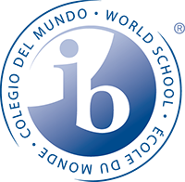
Annabel C. Perry PreK-8

Happy New Year 2022!

COUNSELOR’S CORNER
January
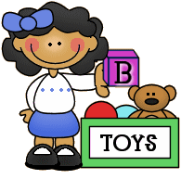
Respect
Respect is a critical element in all healthy relationships. When children respect others they treat people with consideration and courtesy and do not violate them physically or verbally. Respect for others should be woven into the fabric of each student’s life and characterize all their relationships. It is a fundamental character quality that prepares children to live productive lives as they relate to and work with others. The three areas of Respect listed below are very important:
Respect for Authority
Respect for Others
Self-Respect or Respect for Oneself
Respect for Authority is being respectful of people in authority like teachers, coaches, administration, and other adults on campus. Respect for others is treating others the way we would like to be treated. Self-respect means believing in and loving yourself. Respecting yourself not only means valuing yourself, but also making the right decisions and taking the right steps when it comes to your life. Self-respect in children comes from being treated with respect by their parents and other adult role models. Teaching children self-respect does not mean complimenting everything they do. They also need honest criticism. However, when we do criticize, we should focus on things they have done, the behavior, not on them personally.
What You Can Do:
• Teach your child how to be respectful and how to choose good values.
• Encourage your child to build a positive identity that focuses on his/her integrity.
• Emphasize that character is built upon the decisions and actions a person takes.
• Help your child reach his/her full potential by encouraging him/her to develop their talents, set reachable goals and honor themselves as a unique person.
Thank you,
Juliet-Ann Olagbemi MA, NBCC
Certified School Counselor

PRINCIPAL’S NOTE

Penguin Family,

This year is going by so fast, and it is hard to believe we are already in the 3rd marking period. As we turn the corner for the second half of the year it is imperative that we keep our focus and make sure that we put forward every effort to close any and all achievement gaps. Reflecting on the first half of the year, I can say with confidence that we have met or exceeded just about all of our goals.
Academically, our students have been working harder then ever to reach their individual goals. We have seen a great increase school-wide based on our diagnostic testing. To ensure we continue this upward trend, we have implemented the Penguin After School and Saturday Camp. During this time our students can get small group and individualized instruction tailored to their needs. The turnout has been tremendous and I encourage all parents/guardians to reach out for more information about how to get involved.
Aside from academics, we remain committed to the social and emotional well being of our students. This month our teachers will be highlighted for their efforts by Broward County Public Schools and BEACON Communications. We look forward to sharing their success stories both with the community as well as the District.
As we finish the year strong, I encourage you to reach out if you have any questions, concerns, or ideas. I can be reached at 754-323-7050.

Thomas J. Correll, Principal

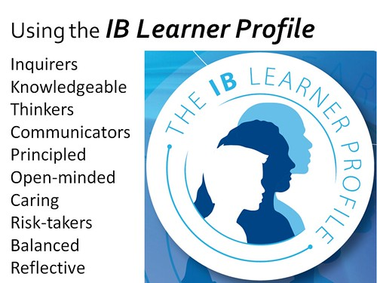
January: IB LEARNER PROFILE

Knowledgeable/informados/konesans: Intelligent and well informed

MISSION STATEMENT
The mission of Annabel C. Perry PreK-8 is to create “A Culture of Caring” in a safe and nurturing environment by being open-minded about other cultures, showing compassion toward others, and reflecting on individual behaviors to promote internationally-minded people.

VISION STATEMENT
The vision of Annabel C. Perry PreK-8 is to develop internationally minded students, through inquiry-based learning and a curriculum that fosters cultural awareness.

ANNABEL C. PERRY PREK-8
IB World School for the Primary Years Program (PYP)
Candidate School for the International Baccalaureate (IB)
- Middle Years Program (MYP)

International Baccalaureate (IB)Candidate school for: Primary Years Program (PYP) and the

Assistant Principal
Updates/Reminders

Happy New Year!

We are excited to be kicking off the second half of the 2021-2022 school year. Our students are busy working on mastering standards and preparing for the spring administration of the Florida Standards Assessment.

According to our most recent iReady Diagnostic, students are making tremendous growth. We are so proud of how far they have come but know our work is not done yet!

We encourage all parents to continue to be active participants in their child's education! Please check those iReady minutes for reading and math daily to ensure your child is getting at least 45 min weekly in both subject areas. With your continued help, we can be the most successful. Let’s have a great start to the second semester!

All My Best,
Dr. Leydig

Penguin Stores
Now Open!
Elementary- Penguin Store
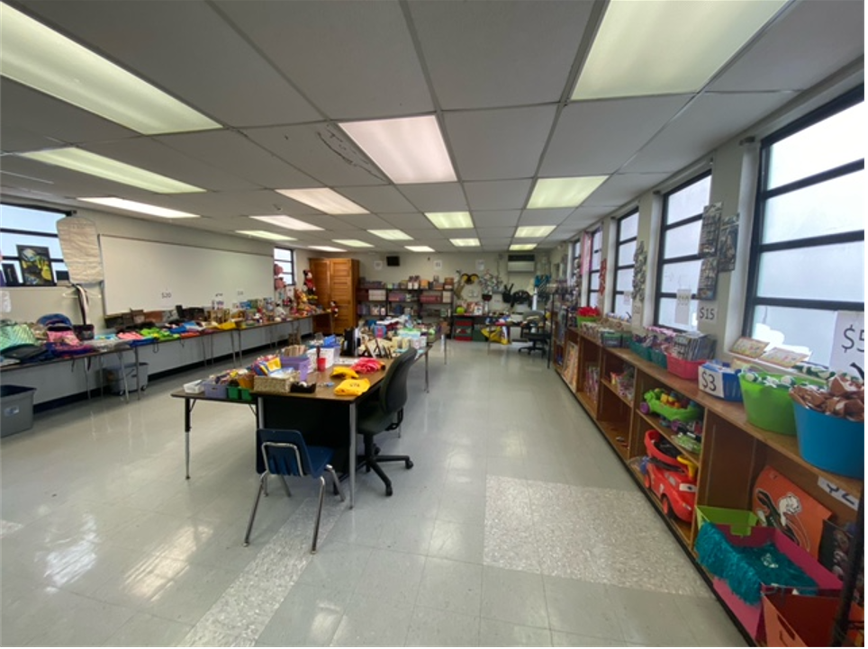

Middle- Emperor Penguin Store
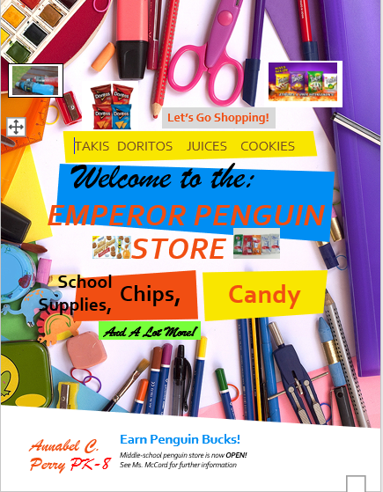

IB Corner
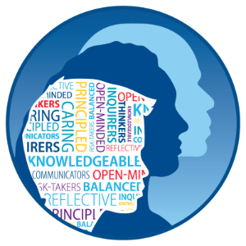
IB Learner Profile:
Knowledgeable

Students at Annabel C. Perry PreK-8 demonstrated their knowledge of music during our December Holiday show. Students exemplified their musical talents of reading musical notes and playing them on their instrument.

Introducing
Annabel C. Perry PreK-8’s
“Spelling B”

Begins in February!
- Each grade will receive a list of words for students to practice (K-8).
- Each class will compete against their classmates. The top 3, 4, or 6 spellers, depending on grade level, will compete against students within that grade level.
- Twelve students from each grade level will go to finals to compete.
- The top speller from each grade will be crowned the “Spelling B” champion.
- “Spelling B” Competitions will begin in April

Upcoming Assessments

- Primary Mid-Year Assessment
Grades 1 & 2

- Civics Diagnostics
Grade 7
- Science Mock Assessment
Grades 5 & 8
- Writing Diagnostics
Grade 6

January’s Music Genre:
“Disney”

Music featured in Disney movie soundtracks and film scores

Examples of “Disney” Music

"A Whole New World"
"I Just Can't Wait To Be King"
"When You Wish Upon A Star"

Curriculum Corner: Standards Being Addressed

(ELA) Elementary School: Grades K-2 are focusing on the new BEST Standards using the Benchmark Advance curriculum. Grades 3-5 are focusing on standards LAFS RL. 2.4, RL.2.5; RL.2.6.
(ELA) Middle School: Students are working on Informational Writing to prepare for FSA writing. ELA teachers are focusing on RI 2.4. Analyzing word meanings, RI 2.5 Analyzing text structure and the structure of paragraphs, and RI 2.6 Determining Point of View.
(MATH) Elementary: 3-5th are getting ready for fractions
(MATH) Middle School: 6th grade students are practicing ratio and proportions, 7th grade - expressions and equations, and geometry. Students in 8th grade are wrapping-up equations. Algebra students are working on Systems of equations.
Elementary School Science: Grades 3-5 are working on Electric Charges & Transformation of Electric Energy SC.5.P.10.3, SC.5.P.10.4
Middle School Science: SC.6.P.11.1, (NOS) Conservation of Energy, Kinetic and Potential Energy

Curriculum Corner PreK-8
i-Ready

Students are encouraged to use their personalized learning pathways in
i-Ready. These interactive lessons are challenging and engaging. Continuing the use of i-Ready will support teaching and allow students to retain important skills and concepts. The lessons help students grow academically.

Where Can I go to See How my Child is Performing?
View your child’s “My Progress” box by clicking on “Detail” to see your child’s progress by each skill domain and standard.

Should Students use
i-Ready Daily?
Students are encouraged to use
i-Ready each day. Students can complete short lessons or 15-20 minutes of a longer lesson.

BCPS 2021/2022 Calendar and Events

January 11 - Human trafficking Awareness Day

January 17-21: ”No Name Calling
Week”
January 21: International
Holocaust Rememberance Day

Florida Jewish History

National Mentoring

Character Trait ”Respect”

iCenter News!

Exciting things are happening in the iCenter!

We have started our Design Studio (Maker Space) and K-5 classes are learning about the Design Cycle. Design thinking can be applied across the curriculum and used to solve real-world concerns.

Students in grades 3-8 are learning how to use Follett Destiny on their Clever page to sign into many digital resources, including Axis 360. Axis 360 is also available as a smartphone app and has a vast variety of eBooks and Audiobooks that can be played online or downloaded to your device... all for FREE!

To Our New Penguin Family Members

Welcome!

Ms. Tirado – Grade 3

Ms. Johnson – Teacher’s Assistant
Ms. Roberts – Gaeneral Clerk 2
Ms. Pabilando –Resource Teacher, 2nd grade
Ms. Isakh – Teacher Assistant PreK
Ms. Simpson –Autism Teacher
Mr. Mourad – Computer Technician

Website: https://www.browardschools.com/perryelem

