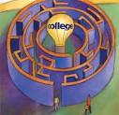
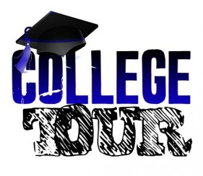
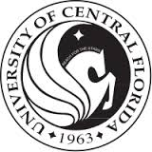


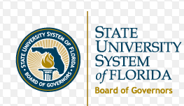
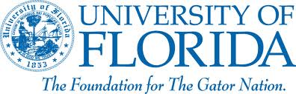
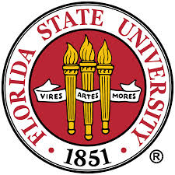

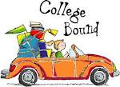

TOTAL COST: $460.00

PRINT ONLINE RECEIPTS AND TURN INTO MS. ANCONA (GIRLS PE TEACHER)
crystallake.browardschools.com

Payment Dates

and Amounts
NON-REFUNDABLE  1 ST. PAYMENT  ONLINE ONLY | $150.00 | BY  TUESDAY  NOVEMBER  19TH
NON-REFUNDABLE  2nd PAYMENT  ONLINE ONLY | $152.00 | BY  TUESDAY  DECEMBER  17TH
NON-REFUNDABLE  3rd PAYMENT  ONLINE ONLY | $158.00 | BY  TUESDAY  JANUARY  14TH

3551 NE 3rd Avenue
Pompano Beach, FL 33064
Principal: Earnest Toliver
crystallake.browardschools.com
Trip Coordinator Cindi Ancona
Cindi.ancona@browardschools.com

Crystal Lake Middle School

Crystal Lake Middle School

8th Grade College Tour
2020

Projected Itinerary
Wednesday - March 11, 2020
5:00AM - passenger motor coach arrives at Crystal Lake Middle School – 3551 NE 3rd Avenue, Pompano Beach, FL 33064 – School number: 754-322-3100
5:30AM - Depart from the school for Daytona
7:00AM – Brief stop at St. Lucie county rest area for restroom break
10:00AM - Self-Guided Tour of Bethune-Cookman University – 640 Dr. Mary McLeod Bethune Blvd. Daytona, Beach FL 32114 school is on SPRING BREAK
11:15AM – Depart Bethune Cookman college for lunch at Volusia Mall Food Court1700 W International speedway Daytona Beach (At Students’ expense)
12:30 PM Depart for Gainesville
3:00PM - Self-guided tour of University of Florida – 303 W. University Avenue – Gainesville, FL 32601
4:30PM - Depart for Tallahassee
7:00PM - Dinner at Chik-Fil-A 2308 Apalachee Pkwy Tallahassee PRE-ORDERS NO COST TO STUDENT
9:00PM - Check into Hotel: FOUR POINTS BY SHERATON 11233 Sterling Rd Inverness Fl 34450

Thursday – March 12, 2020
7:00AM - Buffet breakfast at the hotel (Included)
8:00 AM - Depart from hotel
8:30 AM (Self- guided) tour of Florida State University – 644 W. Call Street Tallahassee, FL 32304
10:30AM (Self- Guided Tour) of Florida A & M University – 1601 S. Martin Luther King Jr. Blvd. Tallahassee, FL 32307
11:45 AM Lunch at the FAMU Café (Included)
1:15PM Florida Historic Capital Museum (confirmed) 400 S Monroe St. Tallahassee Fl 32399 45 minute Scavenger Hunt
2:30PM Depart for Orlando bathroom break en route
7:00 PM Arrive for dinner Disney Springs 1486 Buena Vista dr. Orlando (Students will receive $20.00)
10:00PM Check into hotel – Holiday Inn Express & Suites Orlando-5605 Major Blvd. Orlando

Friday – March 13, 2020
7:00AM - Full buffet breakfast at hotel (Included)
8:00AM - Depart hotel for the day
9:00AM Self -Guided tour of University of Central Florida – University of Central Florida, Orlando FL
10:30AM - Depart for Universal Studios – 6000 Universal Blvd. Orlando, FL 32819
Lunch/Dinner Card - Each participant will receive $ 25.00 that can be used for lunch and dinner at the park
6:00PM - Load buses
8:00 PM Brief stop at Fort Drum Service Plaza for bathroom and SNACK break (students expense)
10:30PM - Approximate arrival time to Crystal Lake Middle School.

