PENGUIN PRESS


Annabel C. Perry PreK-8
“A Culture of Caring”
Vol.1, Issue 2

Hello! Hola! Alo! Penguin Family

PRINCIPAL’S NOTE
Dear Parent/Guardian:

Cooperation is the character trait for the month of September. Please join us in helping your child to understand the importance of cooperation. Learning how to cooperate will help with success in school, in relationship with friends, and in life over all. It is essential to remember that cooperation is a basic life-skill that assists us in working together so that collaboration and creativity will ultimately bring about success.

Ideas to Do as a Family • Share with your child something you did that required cooperation. • Explain how you worked together with others. • Schedule household chores at a time when all members of the family can work together to finish them. • “Catch” your child cooperating and offer your encouragement by verbally showing your appreciation. • Initiate a family project or activity that all family members can have a role. • Watch a movie or TV program together and discuss how the characters cooperated with each other.

SOCIAL EMOTIONAL LEARNING TIPS FOR THE MONTH: Fight Stress with Active Calming Techniques.

Be a STAR. Breathe deeply: Use Affermations:
S mile “I am safe.”
T ake a deep breath (Keep breathing)
A nd “I can handle this.”
R elax

As your School Counselor, I help students to cope with academic, personal, parental and social pressures. I also guide students in career exploration. My role is to work with the other members of our Penguin Family to foster a caring, supportive, learning environment so that your child(ren) will continue to grow into healthy, productive members of society. Please do not hesitate to contact me if there is an area where you would like additional support.

Leslie J. Dorsett,
National Board Certified School Counselor
_________________________________________________________________________________

Happy September Penguin Family,

I want to thank all of you for helping us start off the year strong. We were beyond excited to meet all of you at Open House and we are hopeful that we can continue to partner throughout the year. With a new year comes new initiatives. Along with many other new programs that I will highlight throughout the year, I am proud to say that A. C. Perry PreK-8 will now have an Elementary Speech and Debate team thanks to the leadership of Ms. Harris.

As we start the 2019-2020 school year, your loved ones may be taking a few extra tests. These diagnostics allow us to gain a better understanding of where they are academically so that we can begin to individualize instruction for all of our students. Once we have our finger on the pulse of student achievement the possibilities are endless for the learning that will take place. Again, I look forward to building meaningful relationships with each of you so please feel free to reach out to me any time at thomas.correll@browardschools.com and follow our journey this year on
Twitter @Annabel_C_Perry.

Sincerely,
Thomas J. Correll, Principal



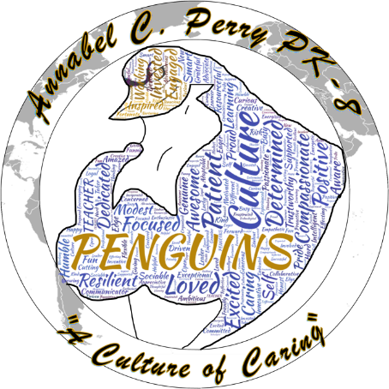

Annabel C. Perry PreK-8 is proud to be a “B” School.

MISSION STATEMENT
The mission of Annabel C. Perry PreK-8 is to create “A Culture of Caring” in a safe and nurturing environment by being open-minded about other cultures, showing compassion toward others, and reflecting on individual behaviors to promote internationally-minded people.

VISION STATEMENT
The vision of Annabel C. Perry PreK-8 is to develop internationally minded students, through inquiry-based learning and a curriculum that fosters cultural awareness.

IB LEARNER PROFILE: SEPTEMBER
Communicator- We express ourselves confidently and creatively in more than one language and in many ways. We collaborate effectively, listening carefully to the perspectives of other individuals and groups.
Communicador – puedo compartir mis ideas con otros en muchas formas y diferentes lenguajes. escucho a otros.

ANNABEL C. PERRY PREK-8
Candidate School for International Baccalaureate (IB)
- Primary Years Program (PYP)
- Middle Years Program (MYP)

International Baccalaureate (IB)Candidate school for: Primary Years Program (PYP) and the

STUDENTS TAKE “ACTION” IN IB

INTERN/ASSISTANT PRINCIPAL’S NEWS
ENVIRONMENTAL ISSUE: LANDFILL BUILD-UP

Social entrepreneurship is extended through recycling projects.
Members of our learning community support student action of caring for our planet by keeping plastic out of landfills.
Please send in clean plastic shopping bags and bottle caps to be used in recycling projects.

We can’t wait to celebrate all of the exciting things that your childs’ positive beahvior brings them!

Go Penguins!

Genevieve Leydig, Ed.D

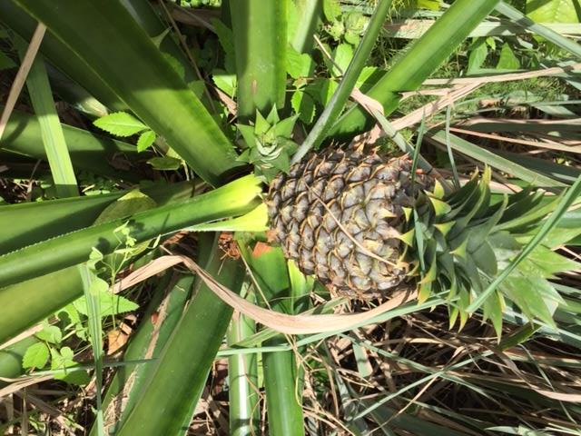

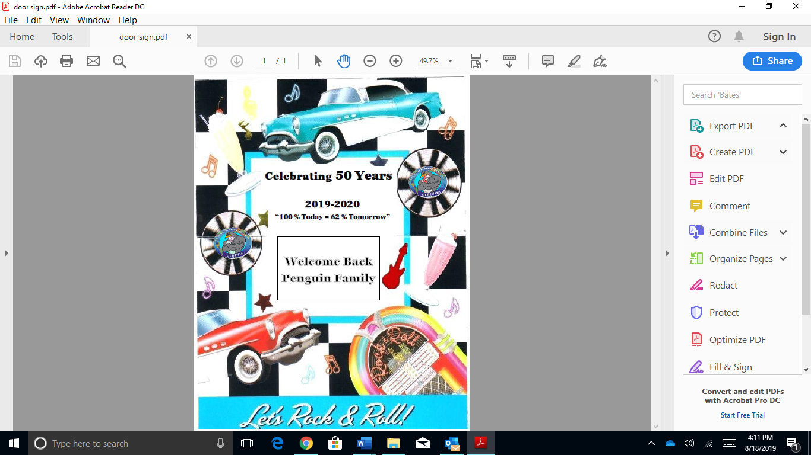
PARENT NEWS
To show international-mindedness, students take- action by linking their learning to real-life issues and opportunities to support positive and social change. Here’s how:

SOCIAL ENTREPRENEURSHIP and LIFESTYLE CHOICE

SCHOOL GARDEN: Our student- created school garden is used as a cross-curricular learning lab. The garden enables students to make informed decisions about the foods they eat. Students are developing critical thinking skills in science by analyzing health issues, the healing powers of plants and the effects healthy food choices have on the human body.

Hello again! It has been a great start to the year! This month we are focusing on our Positive Behavior Project. Our students will soon be earning their Penguin Bucks to shop in our amazing store. They can earn their money by simply doing what is right and going above and beyond. CARE is our school motto and we hope that you can review this with your students at home.

C: Control My Behavior
A: Act Responsibly
R: Respect Others
E: Engage in Learning

Readers Are Leaders!

The NEW media center is up and running! Students are excited to check-out books for their enjoyment. They will be using Beanstack, a mobile app, to log independent reading, track their completion of learning activities, write reviews, earn virtual badges, and real world incentives.

Please download Beanstack from the app store to your mobile device.

Interim Report will be issued on September 18. If you have any questions or concerns, please write a note in your child’s agenda book requesting a conference with his or her teacher.

REMINDERS

-Breakfast begins at 7:30 A. M.
-Class starts at 8:00 A. M.
-School dismisses at 2:00 P. M.
-Grades 3-8 dismisses on the East
-Grades K-2 dismisses on the West
-Return Back-to-School forms
-Complete Free/Reduce Priced
Lunch forms

CURRICULUM UPDATES

ELA: Kindergarten students are working on letter names and sounds. They are asking and answering questions about key details in text. Grades 1-5 are working on key ideas and details in informational text and literature. Grades 4th and 5th are learning how to write an informational text.
ELA grades 6-8: Main idea, Summarize text, and cite Text evidence. Students will determine a central idea of a text and how it is conveyed through particular details; provide a summary of the text distinct from personal opinions or judgments; cite textual evidence to support analysis of what the text says explicitly as well as inferences drawn from the text

MATH: Our goal for students is to provide a curriculum that is rich and challenging. Students explore and describe observations, explain their thinking, and ask questions. They are encouraged to use multiple approaches to solve problems and show different ways of thinking. It is our mission to matriculate/prepare problem-solvers who view challenges as an opportunity to think flexibly, innovatively, and efficiently.
Resources include but are not limited to:
GoMath- A comprehensive Grade K-8 mathematics program developed to support the State Standards for Mathematics and the NCTM Curriculum Focal Points.
IReady: A proven effective instruction and practice program that has the rigor required to raise student achievement on the Florida Standards Assessment, FSA. Reflex Math/IXL - Takes students at every level and helps them quickly build fluency and confidence required to pass standards.

Science: Students in grades K-8 are working on Nature of Science standards. Things you can do at home to help build your child's inquiry skills are:
- Help your child to observe, infer, and ask questions about the natural world around them.
- Have your child research answers to their questions.
- Do a small investigation at home!
-Your child should communicate their findings by writing or telling someone about the investigation.

TEACHER OF THE YEAR
Congratulations to our instructional Teacher-of-the-Year, Mrs. Lewis. As a middle school math teacher leader, Mrs. Lewis has been a great asset to our ACP Penguin Family. Mrs. Lewis is dedicated to both student and staff success by mentoring younger teachers and pushing her students to maximize their potential. Evidence of this is her 100% Algerbra passing rate. She helped lead ACP to a District best 96% acceleration rate.
NON-INSTRUCTIONAL
EMPLOYEE OF THE YEAR

SCHOOL VOLUNTEERS
DATES TO REMEMBER
National Suicide Prevention Week -September 8-14
Hispanic Heritage Month September 15- October 15
School Advisory Council (SAC)
September 18, 2019
Picture Day
September 18-19, 2019
Wear any color polo shirt EXCEPT green
The 10th annual Choose Peace/Stop Violence Week September 20-27
International Day of Peace September 21
“Dads Take Your Child to School Day”
September 25, 2019
Rosh Hashanah: No school
September 30, 2019

Annabel C. Perry PreK-8 encourages families to get involved in education by volunteering.
How Do I Become a BCPS volunteer?

-Go to Browardschools.com
Complete and submit a volunteer application.
-Check application status. Wait one week and contact the school or department you selected to check your approval status.
-Get a volunteer badge at the school or department. This badge may be used at any District location during the school year.

Congratulations to Mr. Pollard, Security Specialist, on being named Non-Instructional Employee of the Year. With safety and security as our top priority, his leadership has allowed us to initiate new security measures that will ensure the safety of our students.

Website: https://www.browardschools.com/perryelem

