Welcome Back Penguins!

PENGUIN PRESS


Annabel C. Perry PreK-8
“A Culture of Caring”
Vol.1, Issue 1

PRINCIPAL’S NOTE

Annabel C. Perry PreK-8 is proud to

announce our school grade.

B
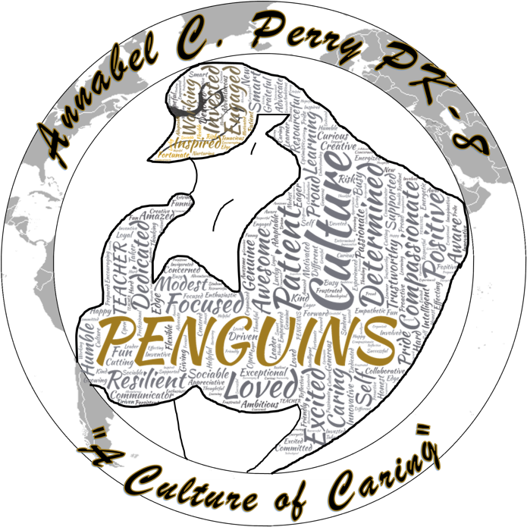

Happy 2019-2020 Penguin Family. It
is with great pride that I announce
Annabel C. Perry PreK-8 has the
distinction of being identified as a “B”
school. The hard work and
commitment from students, staff,
and community does not go
unnoticed as we work collectively
toward a common goal.

The goal is providing every student
with a world-class education,
introducing new initiatives, and
believing that every student can and
will achieve. As we kick off a new
year, my promise to you is that every
student will be surrounded and
SCHOOL COUNSELOR’S NEWS:

Parents/Guardians,

I hope you and your family had a fun and relaxing summer vacation. I am delighted to be a new member of this phenomenal Penguin Family! It is apparent how close-knit and welcoming the Annabel C. Perry PreK-8 community is and I feel very lucky to be a part of it. As a School Counselor, my primary responsibility is to promote the academic, career, and social/emotional development of all students. It is my goal to meet each and every student; whether it’s one on one or during classroom presentations.

I am excited to work with your children and get to know you throughout the school year. Please do not hesitate to contact me if there is anything I can do to assist your children in any way.

Leslie J. Dorsett,
National Board Certified School Counselor
supported by nothing but caring
professionals committed to
excellence. Please feel free to reach
out to me any time at
thomas.correll@browardschools.com
and follow our journey this year on
Twitter @Annabel_C_Perry.

Sincerely,
Thomas J. Correll, Principal

MISSION STATEMENT
The mission of Annabel C. Perry PreK-8 is to create “A Culture of Caring” in a safe and nurturing environment by being open-minded about other cultures, showing compassion toward others, and reflecting on individual behaviors to promote internationally-minded people.

VISION STATEMENT
The vision of Annabel C. Perry PreK-8 is to develop internationally minded students, through inquiry-based learning and a curriculum that fosters cultural awareness.

IB LEARNER PROFILE: AUGUST

Inquirer- Students will nurture their curiosity and develop skills for inquiry and research. They know how to learn independently and with others. They will learn with enthusiasm and sustain their love for learning throughout life.

ANNABEL C. PERRY PREK-8
Candidate School for International Baccalaureate (IB)
- Primary Years Program (PYP)
- Middle Years Program (MYP)

International Baccalaureate (IB)Candidate school for:Primary Years Program (PYP) and the

PARENT NEWS
THANK YOU

ASSISTANT PRINCIPAL NEWS: ELEMENTARY

Welcome to the 2019-2020 school year. We are excited to partner with you to make this a spectacular school year. It was a pleasure to see so many familiar and new faces during our kick-off event.

Parents, if you are interested in providing input into the performance evaluation of Annabel C. Perry PreK-8 instructional and/or administrative evaluation, please contact our office at 754-323-7050 by April 10th, 2020.

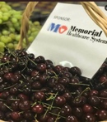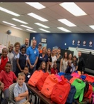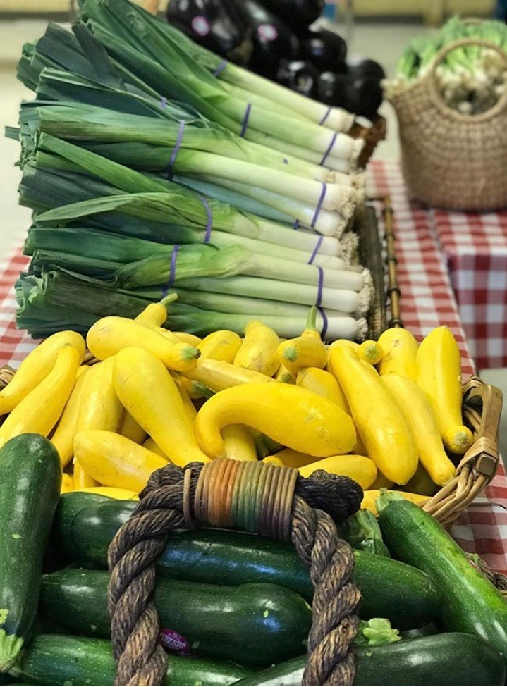

As always, if you have any
questions or concerns please do not hesitate to contact me or the front office. Let’s have a great year! Go Penguins!

Genevieve Leydig, Ed.D
Assistant Principal

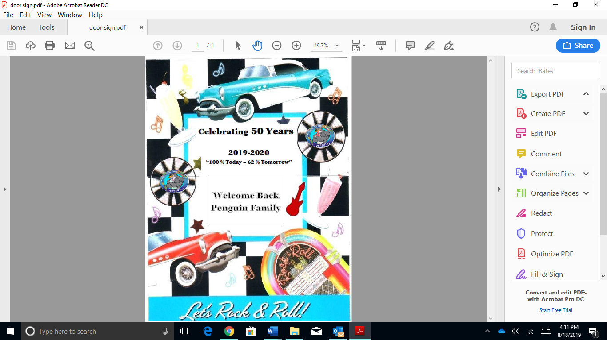
REMINDERS

-Breakfast begins at 7:30 A. M.
-Class starts at 8:00 A. M.
-School dismisses at 2:00 P. M.
-Grades 3-8 dismisses on the East
-Grades K-2 dismisses on the
West
-Return Back-to-School forms
-Complete Free/Reduce Priced
Lunch forms
To the following partners for supporting our Back-To-School Bash and providing school supplies.

Apple Bees: for providing 300 breakfast plates to our parents and students
Mobile School Pantry: for the fresh fruits and vegetables
Kink Couture: for styling girl’s hair
Sheridan Tech School
Barbers: for providing haircuts for male students
Memorial Hospital for pop-ups
Empowerment Squad and
Harvest Drive: for equipping students with school tool

Welcome back Penguin Family! We are getting ready for an amazing year. I am sure you all heard that we are offically a B school based on last years FSA data. We are very proud of this accomplishment and want to thank all of you for your
support.

In the coming weeks, all kindergarten through fifth grade students will be taking multiple diagnostic assessments. The
purpose of these assessments is to allow us as a school to get
a distinct pinpoint as to where each student is acadmemically.

PERFORMANCE EVALUATION

"Parents interested in providing input into the performance evaluations of Annabel C. Perry PreK-8 instructional and/or administrative evaluations may contact our office at 754-323-7050 by April 10th, 2020."

ENVIRONMENTAL TOPIC

Please help us to reduce, renew and recycle.

Send in clean:
-water bottle caps
-detergent bottle tops
-jar lids, etc.
Thank You

SOCIAL EMOTIONAL LEARNING (SEL) GRADE 6-8

-Increase academic achievement
-Improve attitude toward self
and others
-Increase social-emotional skills
-Decrease behavior problems
-Decrease emotional stress

INTERN PRINCIPAL NEWS: MIDDLE

Welcome to the 2019-2020 academic school year at Annabel C. Perry Pre K-8! I am very excited to serve as your Intern Principal; my goal is to serve and support you and your child throughout their academic journey. I am committed to making your child’s journey to EXCELLENCE a positive and rewarding experience.

I encourage all families to get involved in their child’s education by checking your child’s agenda book each evening, volunteering in the school, communicating with your child’s teacher, attending SAC/PTA meetings and parent workshops. We also encourage you to utilize our school’s website in order to receive up to date information on the many events we have taking place at our school.

Jennifer Williams-O'Neal, Ed.S.
Intern Principal

Intern Principal

NEW STAFF
CURRICULUM GRADES 6-8 IFC’s
ELA: Kindergarten students are working on letter names and sounds. With support and prompting they will ask and answer questions about key details in a text. Grades 1-5 are working on key ideas and details in informational text and literature. Grades 4th and 5th are also working on learning how to write an informational text.

CURRICULUM GRADES PK-5 IFC’s
MARK YOUR CALENDAR
A big “Welcome” to our new Penguin Family members. We are glad you joined us.

Ms. Dorsett: Guidance
Ms. McCord: Middle ELA
Ms. Burt: Middle Science
Ms. Diaz: Spanish
Ms. Trail: 5th grade Science
Ms. Kelly: Gen. Clerk
Mr. Mauricin: Teacher Assistant
Ms. Gauvreau: Middle ELA
Mr. Cummings: Security
Mr. Perrine: Security
Ms. Sease: Security

Labor Day: No School
September 2, 2019
Open House
September 5, 2019, 6PM
Rosh Hashanah: No School
September 9, 2019
Interim Reports Issued September 13, 2019
School Advisory Council (SAC)
September 18, 2019
Picture Day
September 18-19, 2019
Wear any color polo shirt EXCEPT green
No school
September 30, 2019

ELA Cluster:
Main idea, Summarize text, and cite Text evidence. Students will determine a central idea of a text and how it is conveyed through particular details; provide a summary of the text distinct from personal opinions or judgments; Students will cite textual evidence to support analysis of what the text says explicitly as well as inferences drawn from the text.

Website: https://www.browardschools.com/perryelem

