Maple Valley Public School

2024-2025 North Dakota Smart Stay Open Plan

“Raider Pride”

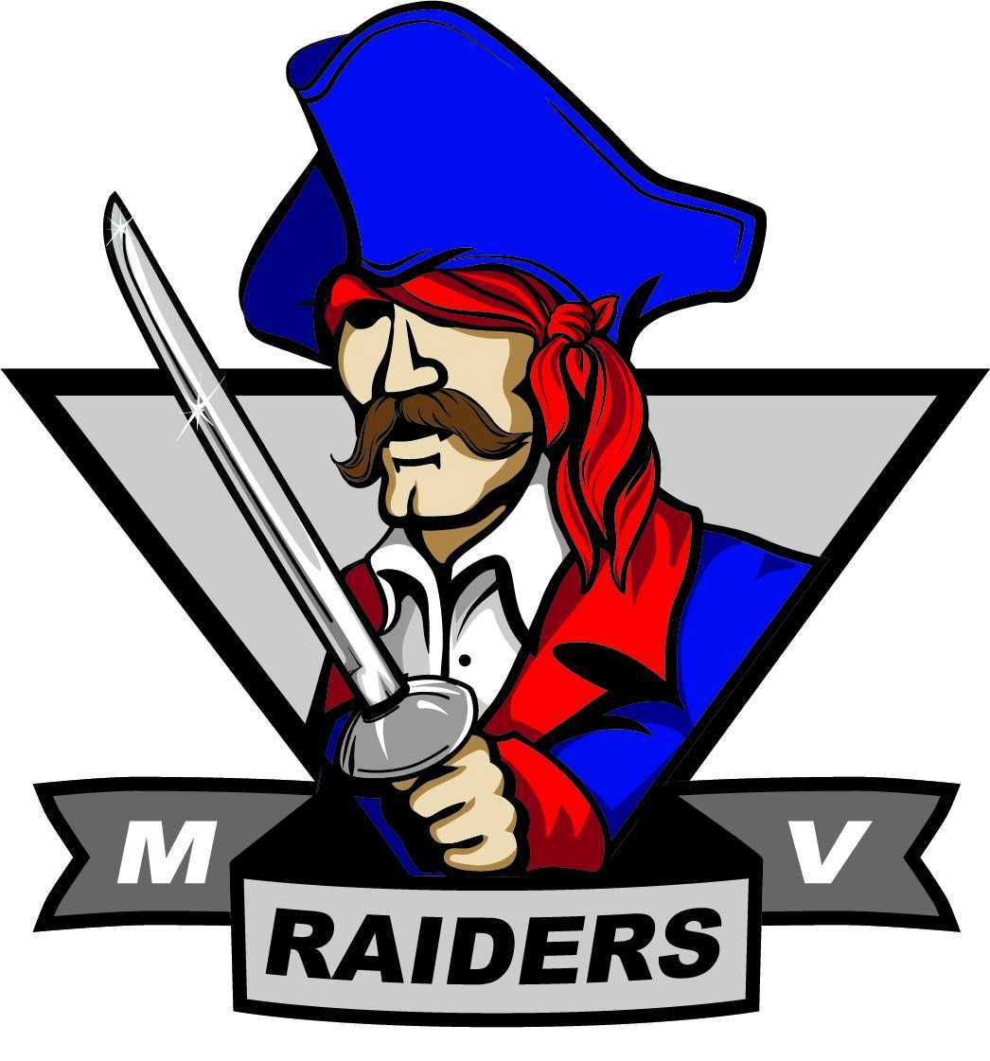

“Raider Strong”

**7/10/24**

Contents

Letter from the Superintendent ………………………………………………page 3

Who Are We ……………………………………….………………………...page 4

Vision Statement ……………..………………………………………………page 4

Mission Statement ……………………………………………………………page 4

Acknowledgements …………………………………………………………..page 5

Maple Valley Public School District ………………………………………...page 6

2021-2022 District Strategic Focus …………………………………………..page 6

Background …………………………………………………………………..page 7

Educational Planning for Re-opening …………………………………….... page 7

Health and Safety of Students and Staff ………………..…………………....page 8

General Background ………………………………………………………….page8

District Practices and Procedures …………………………………………….page 8

COVID-19 Response Team ………………………………………………….page 8

Health Screenings ………………………………………………………...….page 9

Exclusion/Inclusion …………………………………………………………..page 9

In School Quarantine ………………………………………………………...page 9

Inclusion ………………………………………………………………….…page 10

Cases of COVID-19 in School ……………………………………………...page 10

Cloth Face Coverings ………………………………………………...…..…page 10

Physical Distancing ………………………………………………………....page 11

Adults ………………………………………………………………...…..…page 12

Maple Valley Preschool …………………………. ………………………...page 12

Maple Valley Elementary ……………………………..……………………page 12

Maple Valley High School ………………………………………………….page 13

Special Education …………………………...………………………………page 13

Physical Distancing in Specific Spaces ……………...……………………..page 14

Hand Hygiene ………………………...…………………………………….page 15

Cleaning and Disinfecting …………………………………………………..page 15

Educating Students in Any and All Environments …………………………page 16

Conclusion ………………………………...………………………………..page 17

References …………………………………………………………………..page 17

# Letter from the Superintendent

**7/10/24**

Raider Nation:

With the help and understanding of all in Raider Nation we have been successful with face to face instruction at Maple Valley. With the constant support from our students, parents and patrons we will continue this current process. Our parents continue to be very supportive.

As part of the requirements for the North Dakota Department of Public Instruction, schools are required to update their “Smart Restart” plans to start the school year and then to update them every six months through the 2024 school year. The purpose of this letter is to inform you and provide you the North Dakota Smart Updated Restart plan that is being implemented for Maple Valley Public School. As our mission statement says, “Engaging students in a world-class education, preparing them for lifelong success”, we need them here. In order to truly be engaged, we need as much face-to-face interaction as we can provide.

Please remember this is a working document. If and when adjustments are made, we will communicate the changes to all of you.

Our goal is to have everyone in school and to provide them with a top-notch education while keeping everyone safe. If you don’t feel comfortable with having your children in school, face to face, or with the guidelines that are set, please communicate that with the administration.

Please remember that we are all in this together. With all of us working together, we can accomplish our goal of providing a high-quality of education while keeping everyone safe and healthy. If you ever have any comments or concerns, please feel free to call or stop in.

Sincerely,

Daniel Larson

Superintendent

# Maple Valley Public School District

Who Are We:



Vision Statement:

Attend, Engage, Succeed

Mission Statement:

The mission of the Maple Valley School is Engaging students in a world class education, preparing them for lifelong success.

# Acknowledgements:

**Maple Valley Public School District Board of Education:**

**Joey Bata, President**

**George Richman, Vice President**

**Jennifer Koller, Director**

**Dustin Theurer, Director**

**Megan McKay, Director**

**Bryce Kasowski, Director**

**Amanda Olauson, Director**

**Dan Wendel, Director**

**Sara Zaun, Director**

**District Leadership Team**

**Daniel Larson, Superintendent also 24/7 COVID Coordinator 701-490-4647**

**Mike Nygaard, High School Principal**

**Courtney Storhoff, Elementary Principal**

**District Emergency Response Team Advisory Group**

**Daniel Larson, Superintendent Students**

**Mike Nygaard, High School Principal Parents**

**Courtney Storhoff, Elementary Principal Support Staff**

**Cathy Janish, Business Manager Teachers**

**Avery Lock, SRO**

**Derek Bear, Tech Coordinator**

**Lindsey Johnson, Stratagist/Teacher**

**Jessica Theurer, Lower Elementary Teacher School Board**

**Nathan Hoots, K-12 PE Teacher/Activities Director Sara Zaun**

**Stephanie Blom Megan McKay**

**Tony Kuznia, Custodian**

**Rhonda Nelson, Kitchen**

**Julie Kaspari, Counselor**

**Kerry Due , City County Health**

**Maple Valley Public School District**

# 2023/2024 District Strategic Focus:

The following is an articulation of ongoing district commitments for 2023-2024:

Focus 1: Student Outcomes - Expectations, Proficiency & Mastery:

Engaging students in a world class education, preparing them for lifelong success

*Stay- Open Priority: 1.S.O.1*

*Social-emotional learning will be provided to all students.*

Focus 2: Educational Approach - Equity, Empowerment and Opportunity:

A high quality, personalized education is provided to every student.

*Stay- Open Priority: 2.S.O.1*

*Every student will have access to high quality, engaging, student centered instruction in all delivery models.*

Focus 3: Parent & Community Engagement:

Parent and community partners are welcomed and fully engaged in supporting and enhancing student learning.

*Stay- Open 3.S.O.1*

*The district will have regular and open communication with stakeholders regarding plans to address the education of all students during the COVID-19 pandemic.*

*Stay- Open Priority 3.S.O.2*

*The District will involve stakeholders in COVID-19 response decision through the inclusion of parent/community representatives on the COVID-19 Response Team.*

Focus 4: A Culture of Professional Excellence:

The District will recruit and retain caring, highly qualified staff with diverse experiences and backgrounds.

Professional development will be evidence based, continual and strategically aligned.

*Stay- Open Priority 4.S.O.1*

*The District will provide training to all district staff regarding the District Stay- Open Plan, best practices in cleaning, distance learning, social emotional learning (trauma informed) and additional training regarding COVID-19 as necessary.*

Focus 5: Operational Resources:

The District will provide the fiscal resources and infrastructure necessary to ensure an outstanding 21st Century education for every student.

*Stay- Open Priority 4.S.O.1*

*The District will provide the fiscal resources and personnel to effectively execute the District Stay- Open Plan.*

# Background:

To start the 2021-2022 school year, the North Dakota Department of Public Instruction is requiring all schools to update their “Smart Restart” plans to explain how the district will open and stay open. This plan must be updated every six months through the 2024 school year.

<https://www.nd.gov/dpi/sites/www/files/documents/Covid-19/NDK12restartguide.pdf>

(Also found on the Maple Valley School website: <https://www.maple-valley.k12.nd.us/>)

# Educational Planning for *Stay- Open*

In preparation for the return of students in the fall of 2021 the District Administrative Team continues to explore options for educating all district students within the following assumptions:

* 1. Any *Stay- Open* plan must include health and safety guidance provided by national, state, and local health authorities.
  2. The dual concepts of local control and flexible decision making will be central to any *Stay- Open* plan.
  3. Any *Stay- Open* plan will allow the district to shift along the continuum if health and safety guidelines change.

# Health and Safety of Students and Staff:

The health and safety of our students and staff are the top priority when *Staying- Open* Schools for in-person learning this fall.

Practices and procedures within this plan may be modified as circumstances dictate.

## General Background

Current evidence suggests that COVID-19 spreads between people through direct, indirect (through contaminated objects or surfaces), or close contact with infected people via mouth and nose secretions. These include saliva, respiratory secretions or secretion droplets. These are released from the mouth or nose when an infected person coughs, sneezes, speaks or sings, for example. People who are in close contact (within 3 feet) with an infected person can catch COVID-19 when those infectious droplets get into their mouth, nose or eyes. Among the most effective measures include; masks, physical distancing, hand washing, and cleaning frequently touched surfaces.

# District Practices and Procedures:

## COVID-19 Response Team:

The District Emergency Response Team identified in the District Emergency Operations Manual will serve as the core of the COVID-19 Response Team. The current membership includes School Board Representatives, the District Administrative Team (Superintendent, Business Manager, ES and HS Principals), SRO, support personnel (custodial, transportation, food service), teachers with identified roles and will be bolstered with the addition of local health officials, 2 parents representing the elementary and high schools and student representatives.

The DERT will evaluate, and review processes and procedures related to the *Stay- Open* and any COVID-19 specific responses of the Maple Valley Public School District.

## Health Screenings

The list of symptoms of COVID-19 infection has grown since the start of the pandemic and the manifestations of COVID-19 infection in children, although similar, is often not the same as that for adults. School policies regarding temperature screening and temperature checks must balance the practicality of performing these screening procedures students and staff with the information known about how children manifest COVID-19 infection, the risk of transmission in schools, and the possible lost instructional time to conduct the screenings. Temperature checks as a general screening tool upon entry at school will not be used. This reflects the current position of the American Academy of Pediatrics: *“The epidemiology of disease in children along with evidence of the utility of temperature screenings in health systems may further justify this approach. Procedures using texting apps, phone systems, or online reporting rely on parent report and may be most practical…. and likely to identify the most ill children who should not be in school.”* The primary screening mechanism for students and staff will be a self-screening for COVID-19 symptoms before a student or staff member goes to school. The District will educate staff, students, and families about the signs and symptoms of COVID-19, and when they/their children should stay home and when they can return to school.

**Maple Valley will not have a perfect attendance award this school year. Please keep your student home when they are ill.**

# Exclusion/Inclusion

Schools should coordinate decision-making around a student’s care with the family and the family’s healthcare provider if there are specific health concerns, chronic disease, or complex social or emotional dynamics in the home.

<https://www.health.nd.gov/diseases-conditions/coronavirus/travel>

## Exclusion:

Students and staff will be excluded from in-person school activities, if they:

* Show symptoms of COVID-19, such as a cough, shortness of breath, difficulty breathing, chills, repeated shaking with chills, muscle pain, headache, sore throat, or new loss of taste or smell
* Students and staff with fever greater than 100.4°F and no specific diagnosis should remain at home until they have had no fever for 24 hours without the use of fever reducing medications (e.g., Advil, Tylenol).
* Test positive for COVID-19
* Have a significant new rash, particularly when other symptoms are present
* Have large amounts of nasal discharge in the absence of allergy diagnosis

Students and staff will be excluded from school until they are no longer considered contagious per local health official guidance.

## In School Quarantine

If the above signs and symptoms begin while at school, the student (or staff member) must be sent home as soon as possible.

Ill students will be separated from well students. Staff contact will be limited as much as reasonably possible, while ensuring the safety and supervision of the ill student(s) until they leave.

Materials, toys and furniture touched by the student who is sent home should be thoroughly cleaned and disinfected.

## Inclusion

Healthy students and staff with the following symptoms/conditions are not excluded from in person school activities:

Allergy symptoms (with no fever) that cause coughing and clear runny nose may stay if they have medically diagnosed allergies and follow medical treatment plans.

Well-controlled asthma

## Cases of COVID-19 in School

If COVID-19 is confirmed in a student or staff member:

* Open outside doors and windows and use ventilating fans to increase air circulation in the area.
* Clean and disinfect all areas such as offices, bathrooms, common areas and shared electronic equipment used by ill persons, focusing especially on frequently touched surfaces.
* Ensure safe and correct use and storage of cleaning and disinfection products, including storing products securely away from children.
* Decisions about full school closure will be made based on guidance from local health officials.
* Anyone diagnosed with COVID-19 should self-isolate according to guidelines set forth by the North Dakota Department of Health.
* The superintendent will follow the most current guidelines set by the NDDOH on isolation.
* The ND DOH will be in contact with the positive

## Cloth Face Coverings

According to the Center for Disease Control, “face coverings should be worn by staff and students (particularly older students) as feasible and are most essential in times when physical distancing is difficult. Maple Valley will not mandate mask wearing.

Students and families will be instructed how to properly wear (cover nose and mouth) a cloth face covering, to maintain hand hygiene when removing for meals and physical activity, and for replacing and maintaining (washing regularly) a cloth face covering.

Additional information regarding face coverings include:

* **Face coverings (including masks) will be provided by the student/family**
* Students, staff, and families will be taught how to properly wear face coverings
* Face coverings should be washed daily by families
* Maple Valley School will have face coverings available for purchase and extra disposable face masks for student unable to provide their own.

## Physical Distancing

Physical distancing, sometimes referred to as social distancing, is the act of keeping people separated with the goal of limiting the spread of the COVID-19 virus. It is fundamental to lowering the risk of spread, as the primary mode of transmission is through respiratory droplets by persons in close proximity. The District recognizes there is a conflict between optimal academic and social/emotional learning in schools and strict adherence to current physical distancing guidelines. For example, the Centers for Disease Control and Prevention (CDC) recommends that schools "space seating/desks at least 6 feet apart when feasible." Six feet between students is not practical in district classrooms without limiting the number of students. Evidence suggests that spacing as close as 3 feet may approach the benefits of 6 feet of space, particularly if students are wearing face coverings and are asymptomatic.

The following guidelines from the American Academy of Pediatrics will be followed:

## Adults

For all of the identified settings, physical distancing by and among adults is strongly recommended.

## Maple Valley Preschool (Pre-K)

In Pre-K, the relative impact of physical distancing among children is likely small based on current evidence and certainly difficult to implement. Therefore, Pre-K should focus on more effective risk mitigation strategies for this population. These include hand hygiene, infection prevention education for staff and families, and spending time outdoors.

Higher-priority strategies:

* Utilize outdoor spaces when possible.

Lower-priority strategies:

* Face coverings (cloth) for children in the Pre-K setting may be difficult to implement.
* Reducing classmate interactions/play in Pre-K aged children may not provide substantial COVID-19 risk reduction.

## Maple Valley Elementary School

The relative impact of physical distancing among children is likely small based on current evidence.

Higher-priority strategies:

* Desks should be placed 3 to 6 feet apart when feasible (if this reduces the amount of time children are present in school, harm may outweigh potential benefits).
* Utilize outdoor spaces when possible.
* Particular avoidance of close physical proximity in cases of increased exhalation (singing, exercise); these activities are likely safest outdoors and spread out.

Lower-priority strategies:

* The risk reduction of reducing class sizes in elementary school-aged children may be outweighed by the challenge of doing so.
* Similarly, reducing classmate interactions/play in elementary school-aged children may not provide enough COVID-19 risk reduction to justify potential harms.

## Maple Valley High School

There is likely a greater impact of physical distancing on risk reduction of COVID in secondary schools than early childhood or elementary education. There are also different barriers to successful implementation of many of these measures in older age groups, as the structure of school is usually based on students changing classrooms. Suggestions for physical distancing risk mitigation strategies when feasible:

* Particular avoidance of close physical proximity in cases of increased exhalation (singing, exercise); these activities are likely safest outdoors and spread out.
* Desks should be placed 3 to 6 feet apart when feasible.
* Classroom configuration to maintain a minimum of three feet
* Reduce the number of students in the hallways at passing

## Special Education

Every child and adolescent with a disability is entitled to a free and appropriate education and is entitled to special education services based on their individualized education program (IEP). Students receiving special education services may be more negatively affected by distance-learning and may be disproportionately impacted by interruptions in regular education. It may not be feasible, depending on the needs of the individual child and adolescent, to adhere both to distancing guidelines and the criteria outlined in a specific IEP. Attempts to meet physical distancing guidelines should meet the needs of the individual child and may require creative solutions, often on a case-by-case basis.

## Physical Distancing in Specific Enclosed Spaces

School Bus

* Encourage alternative modes of transportation for students who have other options.
* Drivers should be a minimum of 6 feet from students;
* Minimize the number of people on the bus at one time within reason.
* Have windows open if weather allows.

Hallways

* Consider creating one-way hallways to reduce close contact.

Playgrounds

Enforcing physical distancing in an outside playground is difficult and may not be the most effective method of risk mitigation. Outdoor transmission of virus is known to be much lower than indoor transmission.

Meals/Cafeteria

School meals play an important part in addressing food security for children and adolescents.

* Create separate lunch periods to minimize the number of students in the cafeteria at one time.
* Utilize additional spaces for lunch/break times.
* Utilize outdoor spaces when possible.
* Create an environment that is as safe as possible from exposure to food allergens.
* Wash hands or use hand sanitizer before and after eating.
* Individuals preparing food must wear PPE including gloves

# Hand Hygiene:

Maple Valley Public School District will put procedures and resources in place to ensure the proper hand hygiene for all students and staff.

Hand washing with soap and water, or hand sanitizer will be available at the following times:

* Arrival to school
* Before eating, handling food, or feeding students
* After using the toilet or helping a child use the bathroom
* Before and after handling facial coverings
* After playing outdoors
* Before and after cleaning
* Prior to switching rooms or locations
* Before dismissal

Maple Valley Public School District will provide training and visual reminders to students and staff on the proper procedures for hand washing in the schools.

# Cleaning and Disinfecting:

Maple Valley Public School District staff will engage in frequent cleaning based on guidance from the Centers for Disease Control through each day to reduce the spread of the virus within our schools.

District staff will receive training in proper procedures to effectively clean district buildings.

A cleaning schedule of high-touch surfaces will be created and followed within the school for routine cleaning and disinfecting of the high-touch areas at a minimum of three times per day (beginning, middle, and end). These areas include, but are not limited too;

* Door handles, stair rails, drinking fountains, light switches, desks, tables, chairs, carts, trays, playground equipment, and educational supplies.

All cleaning products will be EPA approved and follow the recommendations from local public health and the CDC.

The additional considerations for cleaning and disinfecting will include:

* Use of disinfectants when students are NOT present
* Proper concentration of disinfectants
* Keeping all chemicals out of reach of children
* Use of alcohol wipes to clean keyboards, electronics, and classroom supplies
* Use of nonirritating disinfectants to avoid triggering breathing issues of students and staff

Educating Students in Any and All Environments

|  |
| --- |
| Plan A- In-Person Learning Without Restrictions  Students would return to school and all restrictions lifted |

|  |
| --- |
| Plan B- In Person Learning with Restrictions  Students return to school following the new safety requirements and the *Stay- Open* modifications to accommodate health and safety requirements  Examples of Restrictions:   * Utilizing alternative school spaces to accommodate physical distancing guidelines |

|  |
| --- |
| Plan D- Remote Learning  Student learning will be delivered using on-line and paper resources away from the school campus. This plan will also be available at the beginning of the school year for students that have special health and educational needs. |

# Conclusion:

# In conclusion, it is the goal of the Maple Valley School to provide the highest quality of education in the safest means possible. We understand that not everyone will agree or like these guidelines, but please keep in mind that these are set by the health departments for the safety of our entire Raider Nation. Change is not always easy and takes time. With your continued support, we will get through this “new” normal.

# References:

ND Smart Restart from NDDPI

<https://www.nd.gov/dpi/sites/www/files/documents/Covid-19/NDK12restartguide.pdf>

NDDPI

<https://www.nd.gov/dpi/parentscommunity/nddpi-updates-and-guidance-covid-19>

**American Academy of Pediatrics**

<https://services.aap.org/en/pages/2019-novel-coronavirus-covid-19-infections/clinical-guidance/covid-19-planning-considerations-return-to-in-person-education-in-schools/>

CDC

<https://www.cdc.gov/>

NDDOH

<https://www.health.nd.gov/>

City-County Health (Barnes County)

<http://www.citycountyhealth.org/home.html>