**Drawing and Painting 1**

**Mrs. Luthi   
Email** luthi@west-fargo.k12.nd.us

**Hours** 8:00-3:45 – stop by any time.   
   
**CLASS UNITS:**

**Unit 1** – Tree, Cylinders, linear perspective, Stages of creativity, study of eyes, 6 depth techniques, Contour Drawings, observational drawings, watercolor, acrylic, marker/ink application,

**Unit 2** – Portrait - Study of skulls, nose, mouth, and face, grid system, value studies, graphite, Color Pencil techniques, Pastel Techniques, acrylic,

**History** - incorporated throughout the units.

**Portfolio** – Power point – will work on the whole semester. Profile of graduate ~ creativity

**PROJECTS:** Will create works of art in the 2 units.

9 x 12 – 12 x 18 work from concepts/sketches from your sketchbook.

Will have requirements for each work.

**MEDIA (materials):** Here are some materials we will explore:

**Charcoal/conte Shading Pencils – Ebony Markers/Ink  
 Acrylic Color pencils Pastels Watercolor Digital Mixed Media**

ALL the above materials are supplied by the school.

**EVERY DAY** should have 3 items – **SKETCHBOOK, PENCIL, and CHARGED IPAD**

**TESTS:** small quizzes and 12 vocabulary terms

**SKETCHBOOK Expectations**

Sketchbooks are supplied by the school and will be given out next week after adds/drops are completed.

Drawing and Painting 1 is creating a book of drawings, notes, brainstorming lists, ideas and concepts. Need your sketchbook with you in school and at home.

Work from front to back – don’t jump around in your sketchbook.

You should be adding to your sketches on your own time throughout the unit. At the end of the unit, you will be turning in your sketchbook for a grade. Each unit, you should be adding OVER 60 minutes.

**Grading Sketchbook**  Sketches done in class graded as 4/3/2/1/0.

4 what was expected in class – used all time wisely

3 small amounts missing

2 missing items/not using time wisely

1 very little attempt/not using time wisely, distracted.

0 not in sketchbook, couldn’t find it.

If you are absent – will be required to sketch pages on your own time.

All items are in power points – directions, videos.

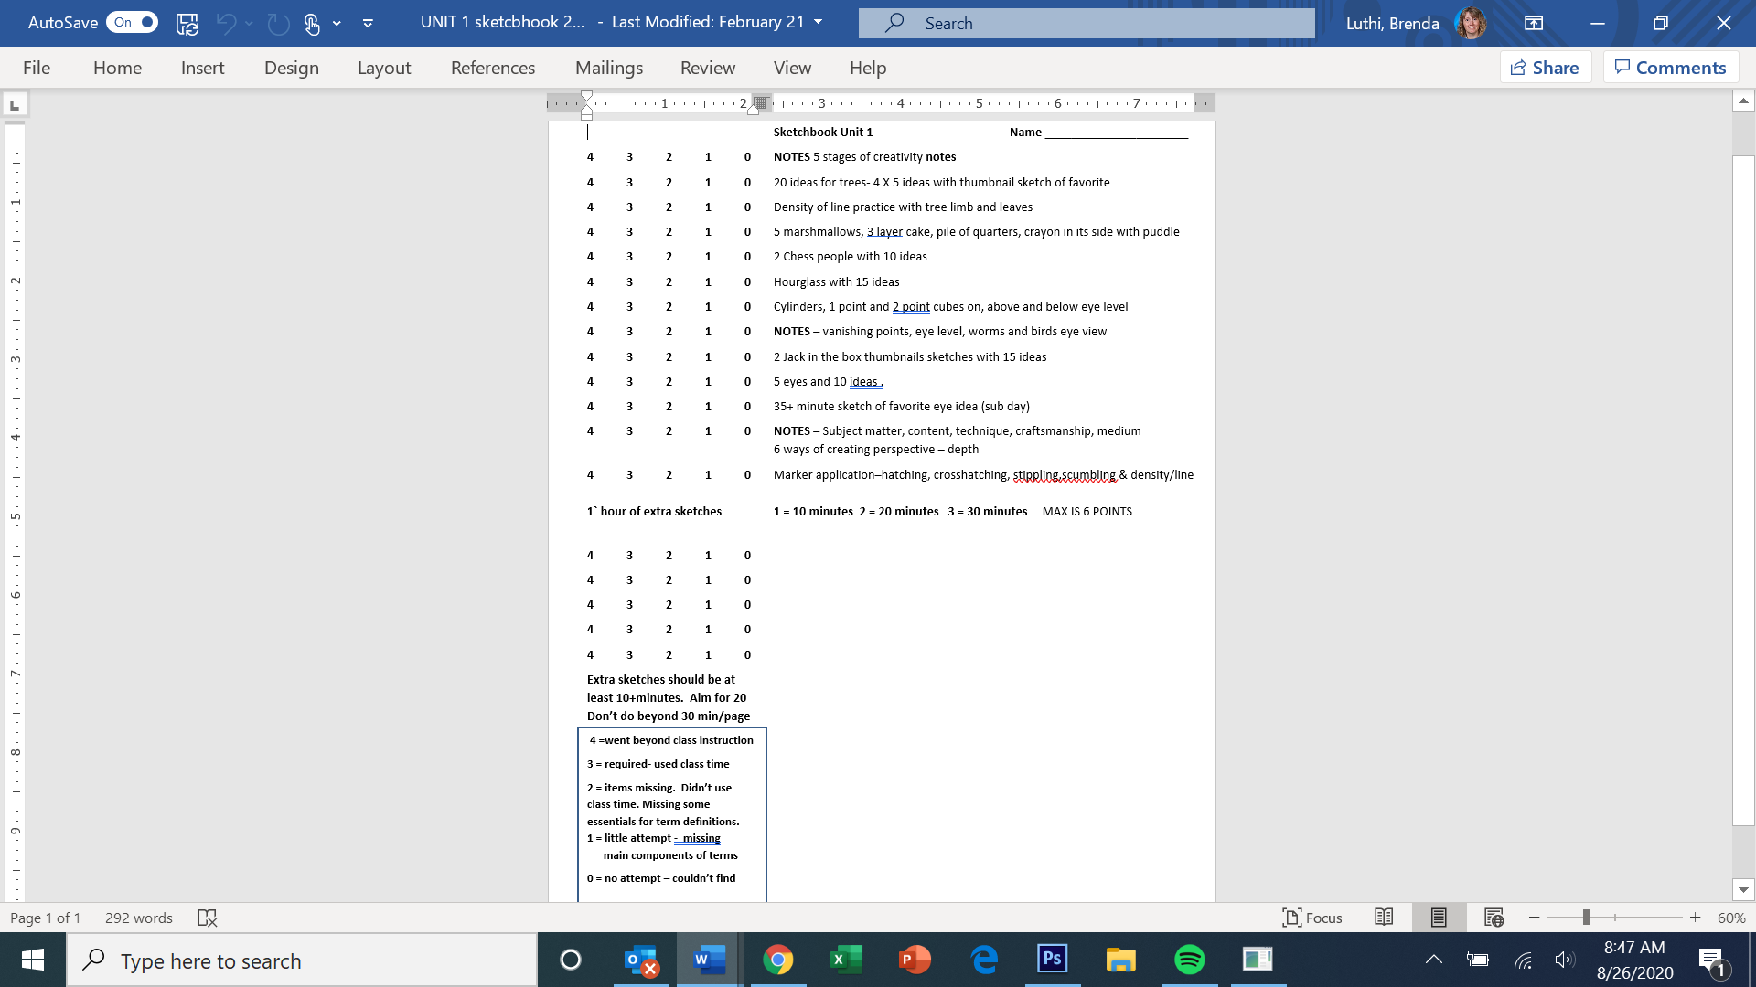 **Sketchbook Sample**

Grade sheet

**ONLINE**

Schoology   
 Unit 0 - syllabus  
 Previous folder on top – with all units that we have completed.

Go in Order and complete tasks in order because they build on each other.

**INCOMPLETE/LATE/MISSING POLICY:**

**It is your responsibility** to check your grades daily to see what you are missing (tests, worksheets, terms, drawings, etc.)

You will be missing points in your sketchbook if you don’t have the required items from class.

You have a week after the assignment is due to complete projects, assignments and other course work.

Updating grades every Wednesday/Thursday.

First week- assignment is marked missing.

Second week - assignment is scored ‘0’.

If you are constantly missing items, the ‘missing’ and/or ‘0’ will be given sooner.

**Make a plan to stay current with grades. Typically a ‘0’ will place you on ineligible list.**

**HIGH SCHOOL POLICY:**

Can’t have any artwork with these items: gangs, alcohol, tobacco, drugs, violence, excessive blood, hatred, language or symbols. (ex. Mushrooms, cigarettes, decapitated heads, ).

Our policy is - if adults are offended or little children should not see it, you cannot make/create it.

**MISC.**

**Bathroom – EHALL pass.** Can’t leave the first 10 minutes and last 10 minutes of class. You will create the pass and I will use your ipad to accept pass. YOU must have me END your pass. If you don’t, you will forfeit ehall pass privilege.

**Cell phones** – Absolutely no phones in sight. Should be in your backpack or pocket. Can’t be on the desk, can’t be on a pile of your books, can’t be in your lap, can’t be on your seat. It is BELL to BELL.

**Ipad** – only for research when doing research. NO videos, no music videos, no sporting events – nothing.

* I will take cell phones and ipads.

**Airpods/earbuds** – not during instruction, both are out of ears. Hoods.

**Be Present** – being present during instruction, no heads on tables, eyes on screen, pencils down.

**Bell – in seat is on time.** Walking in the door when the bell is ringing or not in sit is tardy.

**No Food in classroom:** Can only be the food the teacher has provided. (no breakfast, no lunch)

**No Beverages that don’t have a ‘screw on lid’**: If lid could pop off (dropped), it is not approved.

**HOW CAN I GET THE BEST GRADE IN class ???**

**\*\* EFFORT ** Do all the assignments ** PRACTICE ** Turn in assignments on time **EFFORT\*\***

Visual art grades are determined *by the willingness of a student to participate in classroom activities*. The *effort extended by a student, not the artistic skill, is the most responsible evaluation method in art*.

If you put forth you best effort and show me the best work of art you know how to create you will have a good grade if you finish all your assignments with the given information and do well on the tests.

** Creativity in art is the skill of problem solving in original and unique manner. Work on creating combinations and designs to **WOW** your viewer. Art centers on *the process* *and the thinking* involved in creating original images.   
  
One grows in creativity by trying, taking risks in your art, working/effort and positive thing. GO FORTH & CONQUER!