**4th Grade’s Supply List**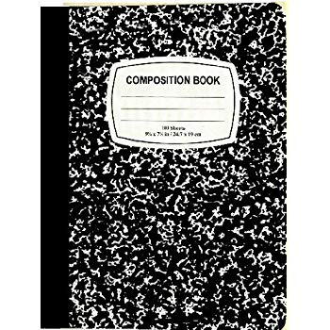

**Please bring in the following personal supplies.**

* 2 hardcover composition books (9.75 x 7.50 inch wide ruled white sheets, black marble cover)
* 1 folder of your child’s choice to be used as their homework folder.
* soft pencil case
* Headphones or Earbuds to keep at school (inexpensive ones are fine)

**Please bring in the following classroom supplies to be shared with the class.**

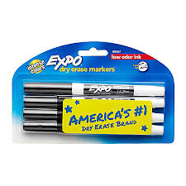

* Fine tip Thin Black Expo Markers (at least two packs)
* 1 pack of 2 to 4 glue sticks
* 1 box of crayons (24 colors)
* 1 box of 12 colored pencils
* 1 box of 12 thin markers
* Two 12-packs of sharpened pencils
* Highlighters multi-color pack
* 3 boxes of tissues
* 1 roll of paper towels

|  |
| --- |
| Additional Requests: |
| * Colored Cardstock * White Cardstock * Quart-size bags * Gallon-size bags * Sandwich-size bags |

*Please note that these supplies are required within the first week of school. Thank you, and we are looking forward to a fun and exciting year!*