Woodcrest Kindergarten Supply List

2024-2025 School Year

Below you will find a list of items your child will need for kindergarten. These items can be brought to the Open House/Meet & Greet (August TBA) or the first few days of school.

**Please label ALL items with your child’s name:**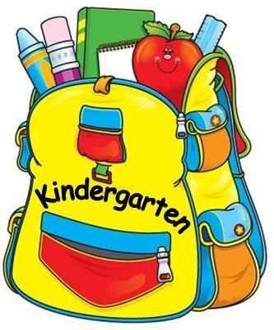

* 2 - sturdy plastic two-pocket 3 prong folders
* 2 boxes of Crayola washable thick markers (10 count)
* 2 boxes of Crayola washable thin markers (10 count)
* 1 pair of Fiskars kid scissors (blunt)
* 3 boxes of Crayola crayons (24 count)
* 2 boxes of Crayola Colors of the World Skin Tone crayons (24 count)
* Reusable water bottle (preferably with straw)
* 2 plastic pencil boxes that snaps shut 8”x4.5”x2” 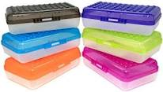
* personal headphones that fold up to fit in shoe organizer 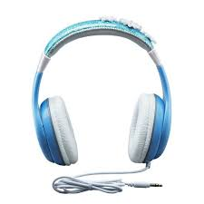

(must cover the ear, not go in the ear)

**Please do not label the following items:**

* Large backpack or school bag (Please be sure that

the backpack is large enough to hold your child’s folder, lunchbox, and district issued chromebook)

* 2 packs black dry erase thin markers (4-6 count)
* 12 pack of glue sticks (not glue bottles)

**\*OPTIONAL** **Classroom items**

* 1 large box of tissues
* 1 roll of paper towels
* Gel Hand Sanitizer Pump (32 oz) (fragrance free)
* 1 box sandwich or snack size bags
* 1 box of gallon one-zip bags (slider preferred)
* 1 box of Crayola washable Colors of the World markers (8 or 10 count)

**Thank you and have a great summer!**