**2024-2025**

**Ranch View Middle School**

**School Accountability Committee**

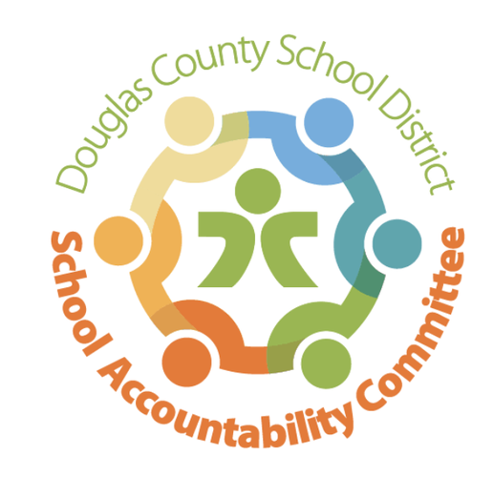

Date: September 9, 2024

Time: 4:15-5:30 pm

Location: RVMS Library

**Meeting Minutes**

4:15 Meeting called to order

**Present:** Christie Hurt, Erin Kyllo, Craig Moody, Lucas Kruse, Erin Turley, Kate Welsh, Sonya Illg. Minutes approved prior to meeting and will be posted on RVMS website for parents. Voted on new members and roles.

**Celebrations:** Erin Kyllo

Welcome back to school! Peek at the Pack for incoming 7th graders was a success. We had 349 students attend. Our welcome back assembly was on Aug 16, TRHS students were here to help teach our students the chants, great school spirit! Our back to school dance/night was highly attended on Aug 20. Pod War monthly update: Grey is leading, 7 Tundra, 7 Arctic

**Dates determined for next 3 meetings: Nov. 11, Jan 27, and May 12**

* + SAC Meeting Norms
    - Chair leads discussions and ensures a respectful conversation
    - Members will stay actively engaged
    - Follow district guidelines for meetings (timeframes, meeting minutes, etc.)
    - Decisions made on a majority vote

**New Business:** Erin Kyllo

Enrollment Numbers 833 in building and eDCSD

2 EA Openings/Night Custodian

Community Service Day-October 4, 2024

CMAS Achievement and Growth Data, I-ready testing

CMAS 7th grade ELA 69% 8th grade ELA 64%. 7th grade math 47% and 8th grade math 52%

iReady 7th grade ELA 65% 8th grade ELA 59%. 7th grade math 49% and 8th grade math 38%

Professional Learning Communities (attending conference in Dec)

Parent/Teacher Conferences September 17 & 18 (dinners provided by Erin and PIT crew)

Bond initiative 5A

School-wide Happenings

* + - Fall Music Concert-October 10
    - Fall Dance-October 25
    - Pit Crew Wolf Tracks Run and Walk-October 26 (fundraiser)

Teacher Report-Craig Moody. No teacher concerns shared. Updated SAC on athletics and StuCo events.

**District Accountability Committee:** need rep

**PIT Crew Organization:** Sonya shared the fundraiser information for the upcoming race and their planned breakfasts and lunches for staff. Update on Boo Grams.

**Community Report:** Jenny Parks was not in attendance

**Open forum for guests:** N/A

**Next Meeting:** Nov. 11 @4:15 in the RVMS Library