Temecula Valley Air Force Junior Reserve Officer Training Corps CA-933

Mighty Flying Bears  
NEWSLETTER

horizontal line

February 19, 2020

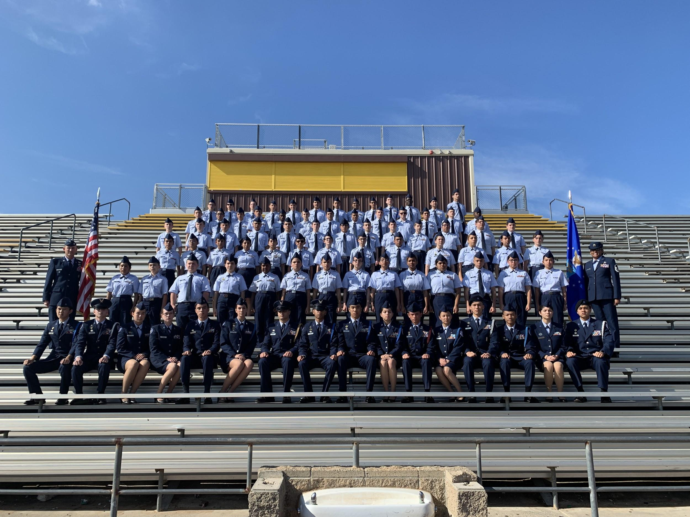

# **Introduction**

Welcome to the Mighty Flying Bears Newsletter! Our mission is to develop citizens of character dedicated to serving their nation and community. In other words, we are building better citizens of America. Our goals are to instill in cadets: values of citizenship, service to the United States, personal responsibility, and sense of accomplishment.

February Recap

Cadet Hannah Rosario

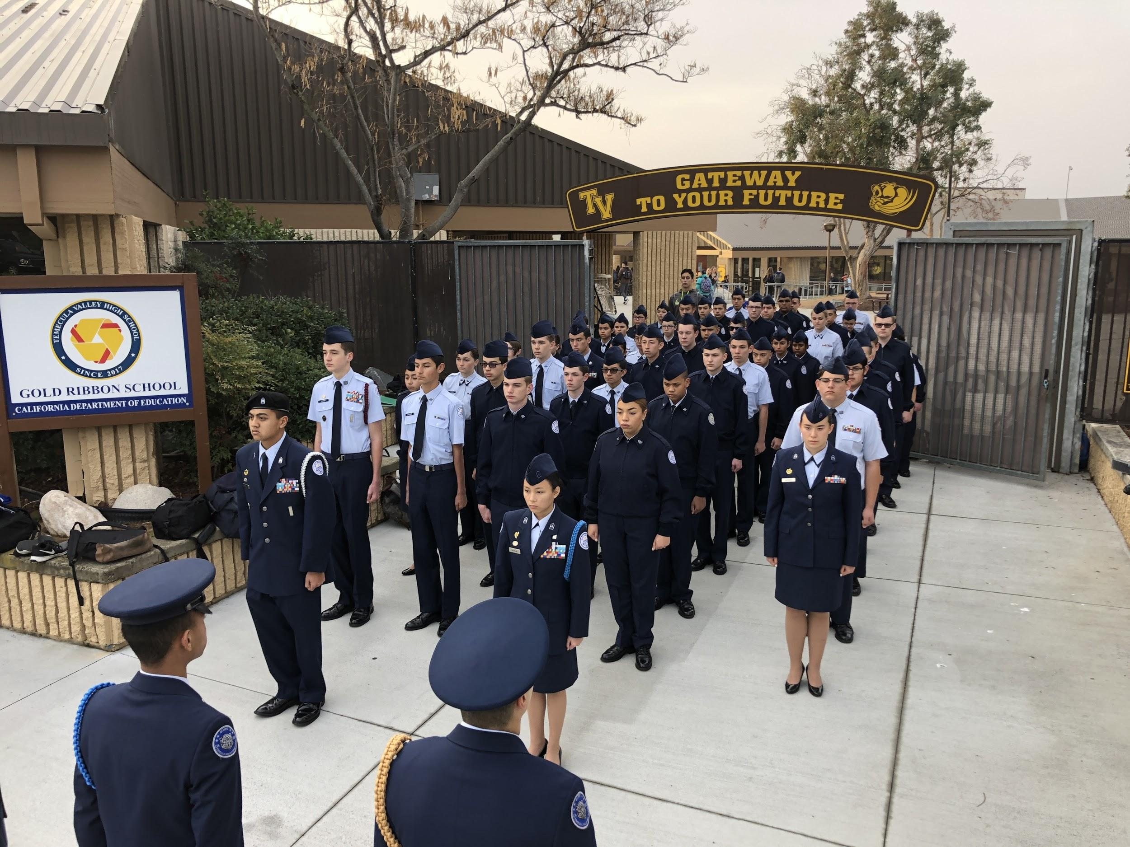

It has been a fulfilling dive into 2020 so far! There are plenty of events that will be coming up soon, such as the beginning of the drill competition season! San Jacinto has been completed while SCIDM, the Southern California Invitational Drill Meet, is up next for the Drill Teams of CA-933!

Earlier this year one of our cadets, Patrick Bogan, was given a scholarship from the AFJROTC Flight Academy - the first cadet from our unit to be given this amazing offer. This will help Cadet Bogan in becoming an amazing pilot in the future! Congratulations Cadet Bogan!

This month, we will be a part of the Golden Bear Welcome, in which soon-to-be freshmen will tour our campus to see what it’s like to be a high schooler. This event, along with the APT club visits at Temecula Middle School and Margarita Middle School, will help future cadets answer their questions. Our goal is to interest students into becoming future cadets in our unit.

Future Pilot

Cadet Samantha Alvarado

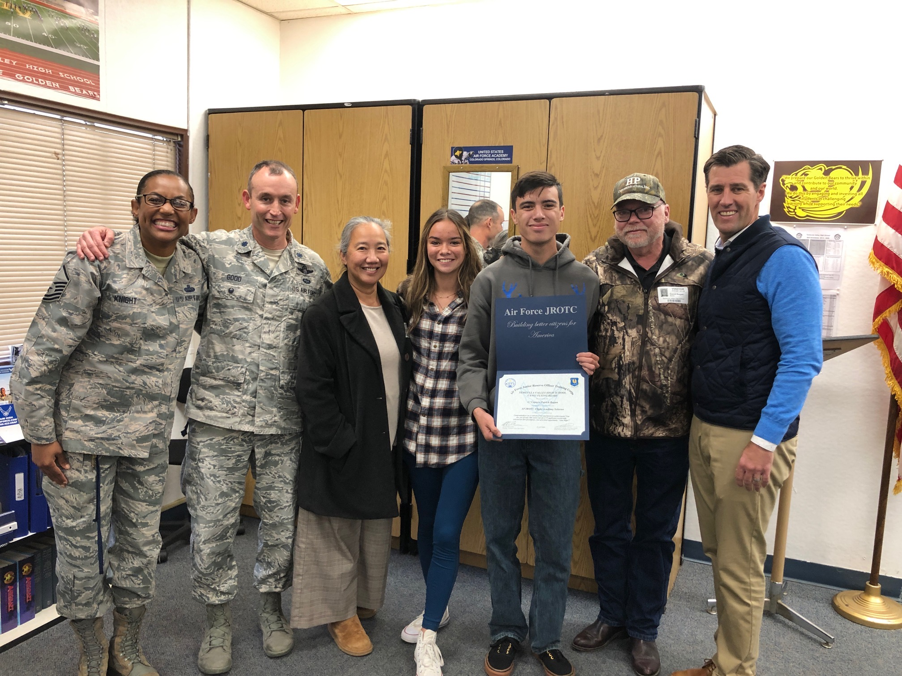

*Left to right: MSgt Knight, Lt Col Good, Vonny Bogan, Karlie Bogan, Patrick Bogan, David Bogan, Principal Allen Williams*

The Air Force Junior ROTC Flight Academy program awards scholarships to 200 students who will be attending a flight school over the summer at one of 15 partnering universities. The AFJROTC Flight Academy is an 8-week summer aviation training program conducted at partnering universities nationwide. This program is valued at approximately $22,500. The money will cover transportation, room and board, academics, and the flight hours required to earn a private pilot license at one of 15 cooperating universities during the summer.

Over 2,575 cadets applied for one of 200 scholarships to be awarded. On 21 January, our own Cadet Patrick Bogan was selected for the program for the second time in his high school career. He is among the 200 Air Force Junior ROTC cadets to receive the scholarship from Headquarters Air Force Junior ROTC and is the first ever awardee of this prestigious scholarship from Temecula Valley High School. To his surprise, Cadet Bogan’s family, accompanied by Principal Allen Williams, came and delivered the news to his 6th period AFJROTC class.

Now a senior, Cadet Bogan will attend the Flight Academy program this upcoming summer. He will be attending his dream school of Embry Riddle Aeronautical University in the fall.

Military Ball

Cadet Alexander Bowen

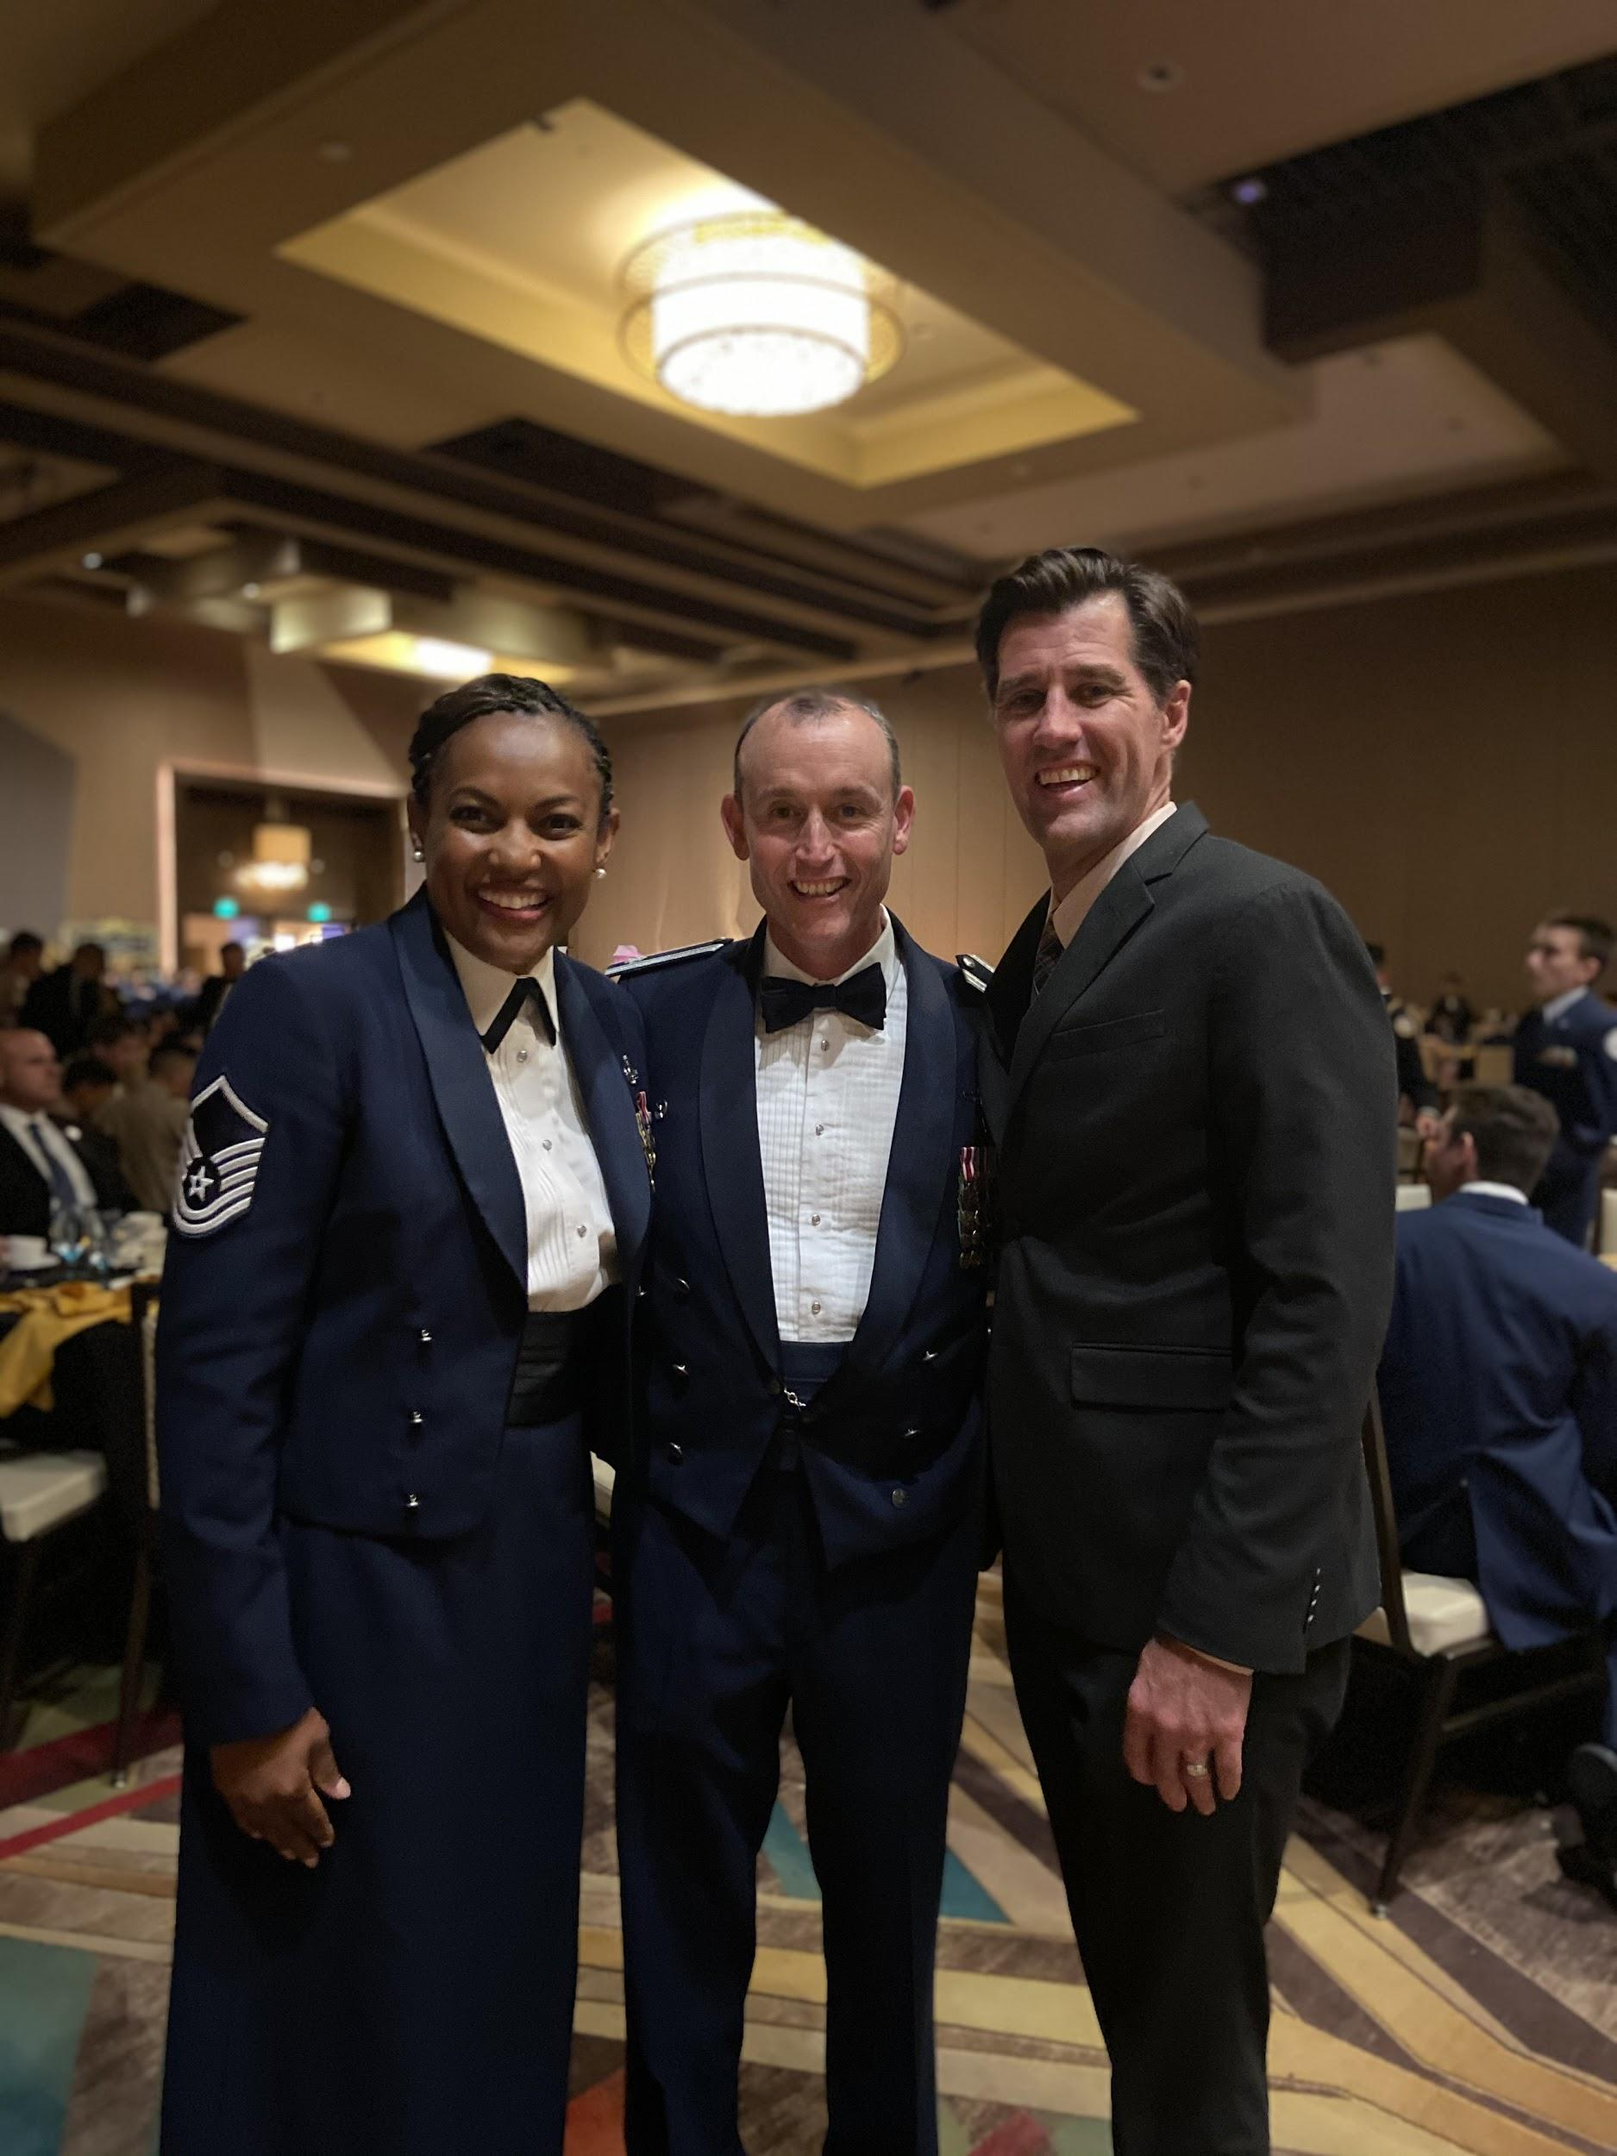*Left to right: Master Sergeant Lucrica Knight, Lt Colonel Michael Good, Principal Allen Williams*

The military ball is an annual formal function hosted by each branch of the military. The history of the military ball dates as far back to 1895. Its main purpose and meaning is to honor fallen veterans, prisoners of war, and those missing in action. It is also a time of giving a formal toast to our military leaders and to continue traditional military customs.

Our JROTC unit partners from Chaparral and Murrieta Mesa attend this fun-filled event held at Pechanga Resort and Casino in one of their many wonderful ballrooms. The event starts at 1730 and runs until 2300. It is generally held the Thursday prior to President’s Day weekend in February. Male cadets arrive in their formal uniforms, while female cadets typically arrive in gowns. Seniors then line-up, getting ready to start the night. To start the night, seniors are announced by name and walk down the aisle in between the sharp-looking sabre team, the night then proceeds with a series of ceremonies including: POW/MIA remembrance, Service Flag presentation, and the announcement of the Royal Court.

After the ceremonial portion of the night, cadets are dismissed to eat. The food, as described by our very own Cadet Jensen, is, “Professionally cooked by amazing chefs and the desserts are exquisite.” After eating, talking, and laughing at the table, the best portion of the night begins: the dancing. Cadets get up and have the most fun of the year with their fellow cadets and sister schools.

San Jacinto Color Guard Meet

Cadet Hannah Rosario

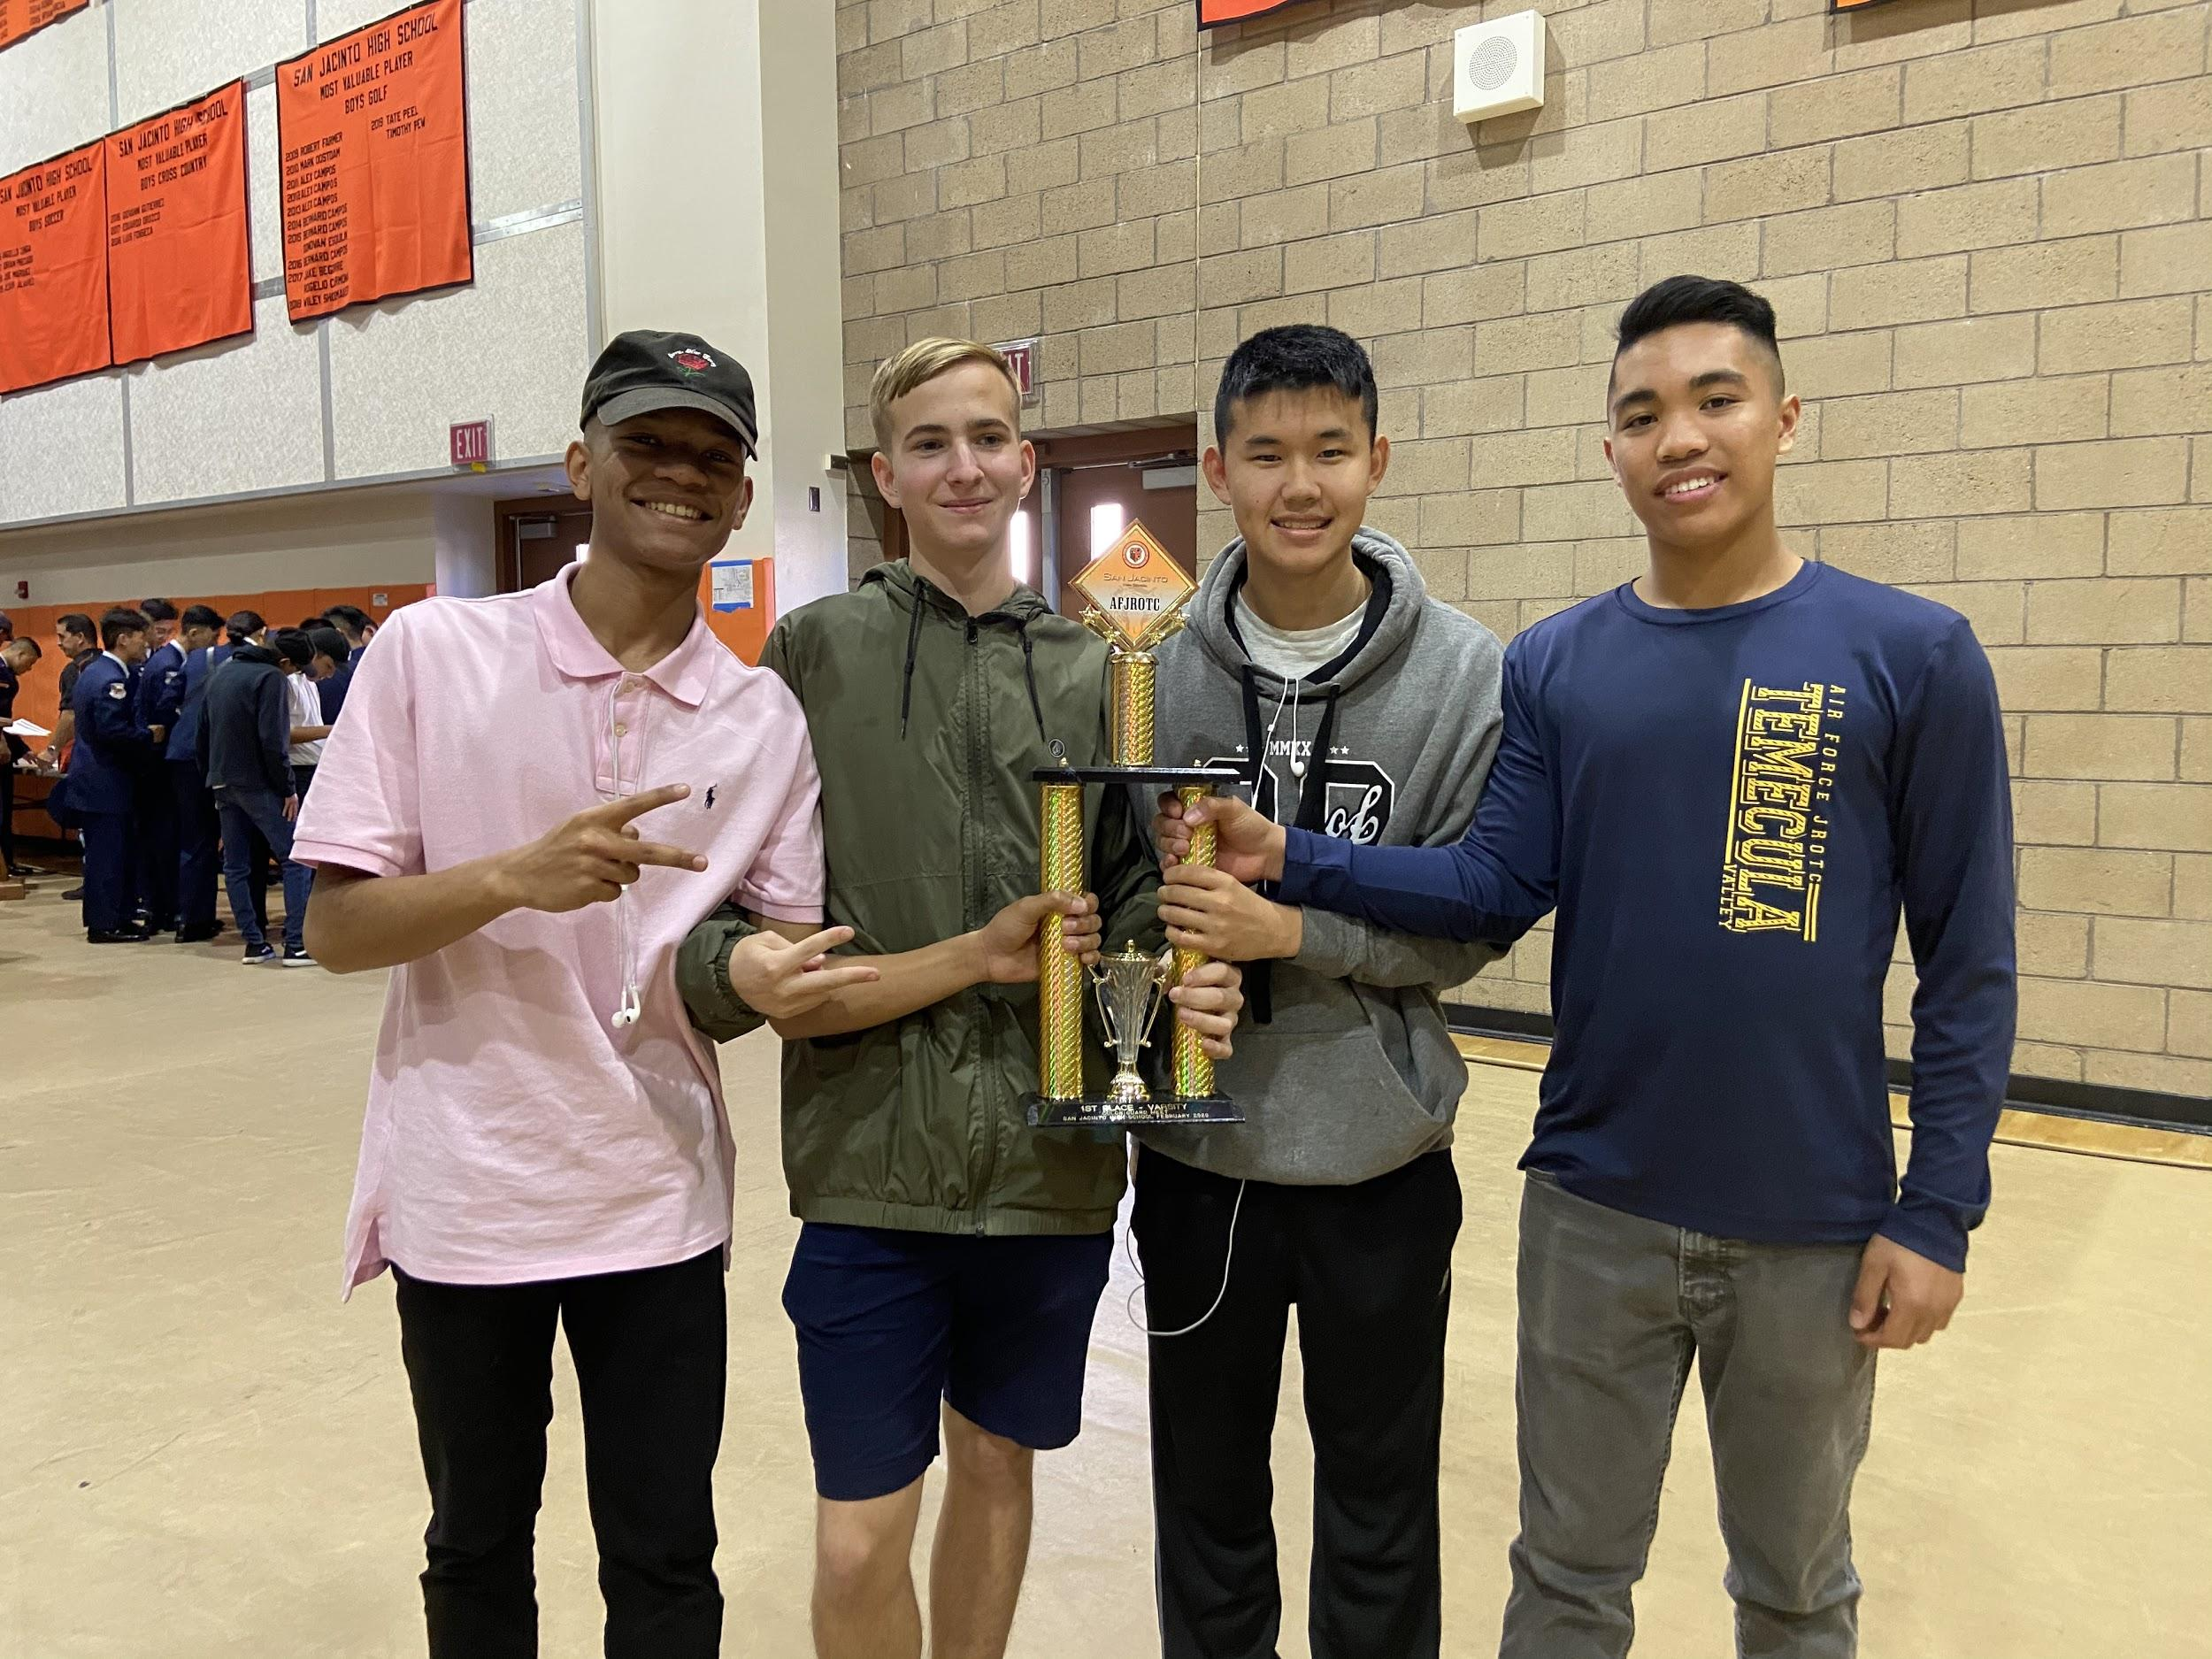

*From left to right: Jayden Campbell, Mason Lundgren, Joseph Choi, Jerrin Concepcion*

On the first of February, Temecula Valley kicked off the month by competing in the San Jacinto Drill Meet! This particular competition included our JV and Varsity Color Guard teams. A total of sixteen teams competed from different schools, to include the first-ever out of state color guard team for this meet.

After arriving around 0745 our Color Guard teams were ready to check in! The day started with the opening ceremony at 0800, which concluded with a demonstration by the San Jacinto High School Color Guard. By 0845, the Varsity team began getting ready to compete by their scheduled time of 0915. The JV team would then compete at 1045. After a thrilling ride for both the teams, Lt. Col. Good offered the cadets a treat to IHOP while awaiting the awards ceremony after all other teams have competed.

Making our way back with full stomachs, the teams could not wait to find out if they had placed! After observing the last Color Guard team, each team from every school was called into formation in front of the awards table. There cadets, instructors, and teachers from the hosting San Jacinto High School stood before us and spoke to the hard work put into each of the competing teams. With everyone on the edge of their seats, our very own Varsity Color Guard team came in first place!

After a long, fulfilling, and successful day at San Jacinto, the next competition will be at the Southern California Invitational Drill Meet (SCIDM). Where our Armed and Sabre drill teams will be competing with high school and collegiate teams from all over California.

Meet The Team!

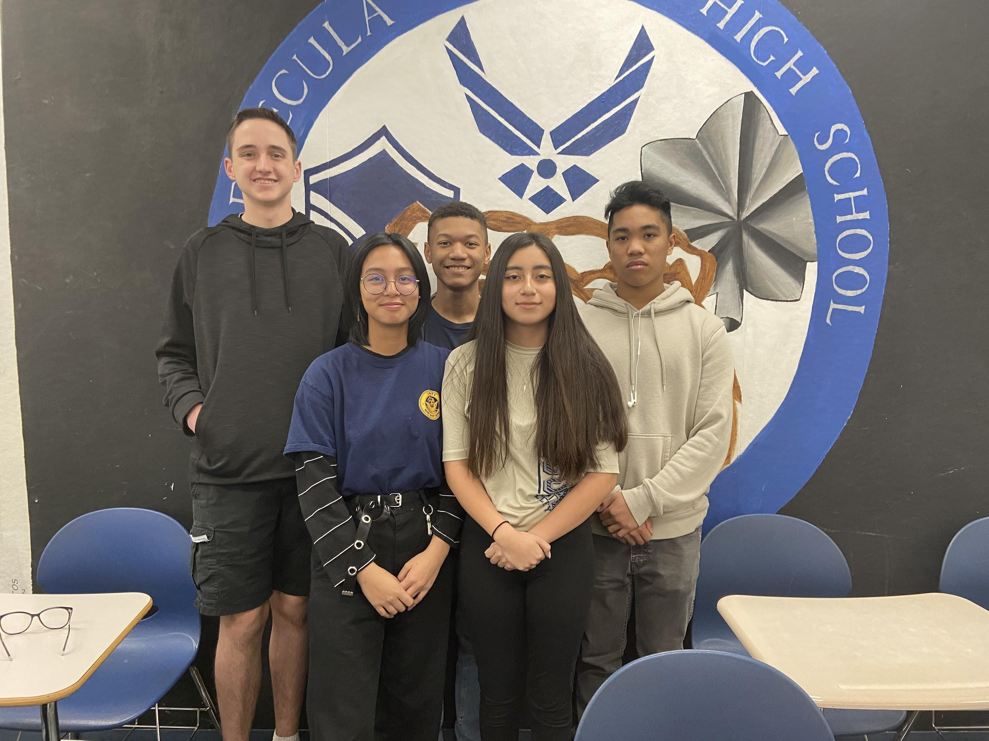

**Newsletter team (Left to right) :**

*Creative Director/Editor:*

C/ Alexander Bowen

*Reporter/Editor:*

C/ Hannah Rosario

*Graphics Editor/Researcher:*

C/ Jayvion Campbell

*Editor in Chief:*

C/ Samantha Alvarado

*Executive Editor:*

C/ Jerrin Concepcion

Keep up with CA-933!

Follow us on:

Instagram

@tvhs.afjrotc

To stay updated daily and see drill team performances and interviews

Twitter

@TVHSAFJROTC

For weekly reminders

Remind

@tvafj

For daily reminders and updates about the program