CA-933 MODEL ROCKETRY GUIDE

PURPOSE

This guide is for the use of AFJROTC CA-933 cadets desiring to earn the award of the AFJROTC Model Rocketry Badge. It is intended for educational use only and cadets should always operate with safety as their paramount concern. To be awarded the Model Rocketry badge, cadets must complete each of the following:
1. Successfully build, launch, and recover a single-stage model rocket
2. Successfully build, launch and recover a multi-stage rocket
3. Pass a written test on the information found in this guide
4. Act in at least one of the following capacities during a live launch:
a. Range Control/Launch Officer
b. Range Safety Officer
c. Flight Recovery Officer
d. Flight Spotter
e. Flight Recorder
Our goals:
1. Demonstrate your knowledge of rockets through a written test where you will identify, list, and analyze the history, science, components, and launching of rockets.
2. Construction of one model rocket.
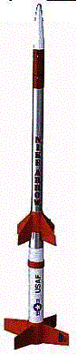
3. Successfully launch and recover your rocket.
Sources:
1. Quest Science Model Rocketry Teaching Guide #9500 (1992);
2. Quest Aerospace Education, Inc., Launching Procedures (undated);
3. Aerospace Science: The Science of Flight (2001);
4. Aerospace Science: The Exploration of Space (1994);
5. NASA Glenn Research Center (http://www.grc.nasa.gov/www/k-12/airplane/shortr.html).

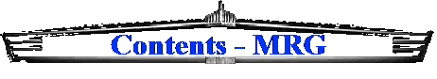

Chapter 1
A Brief History of Rockets ………..……………………………………………… 5
Chapter 2
Basic Rocket Principles …………………………………………………………. 7
Newton’s First Law ……………………………………………………………….. 7
Newton’s Third Law ……………………………………………………………… 8
Newton’s Second Law …………………………………………………………... 9
Chapter 3
Constructing Your Model Rocket …………………………………………….. 12
Engines (Motors) ………………………………………………………………… 12
Chapter 4
Launching Your Model Rocket …………………………………………………. 14
Launch Position Duties ………………………………………………………….. 14
Site Selection ………………………………………………………………………. 15
Launch Preparation ……………………………………………………………….. 15
Countdown Procedure ……………………………………………………………. 16
Recovery Procedure ………………………………………………………………. 17
Misfire Procedure ………………………………………………………………….. 17
Chapter 5
Safety …………………………………………………………………..……………. 18
NAR Safety Code ………………………………………………………..………… 20
Chapter 6
Glossary of Rocket Terms ……………………………………………………… 22

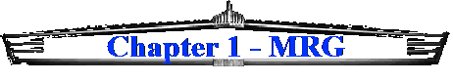 |  | 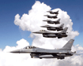

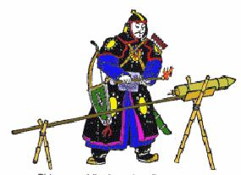
A Brief History of Rockets
Rocketry has been around for a long time. The Chinese have reportedly been using them since at least 100 AD and used them for the first time in battle in 1232 AD. These rockets were called “fire arrows.” This battle marked the first time rockets were used as weapons of war. Prior to this, they were used for noise makers and firework displays.

In 1405, a German engineer (Von Eichsteadt) used gunpowder as a propellant in a rocket for the first time. A British artillery expert, Col William Congreve, put fins on a rocket for the first time in the 1800s. The fins help to stabilize the rocket in flight. Despite this stabilization, the rockets were not accurate enough to hit a specific target, unless it was a city-sized target. Col Congreve’s rockets were used by the British against Fort McHenry in the War of 1812. Their “red glare” were the inspiration for Francis Scott Key in the writing of what is now our National Anthem. Because of their inaccuracy, however, rockets were seldom used for military purposes until World War I.
In World War I, rockets were used in flares to light the battlefield, to carry messages, and to carry lifelines to wrecked ships along the coastlines.
In World War II, we began to see rockets placed on attack aircraft to strafe ground targets. Today, rockets have many applications. In addition to the examples above, they are used in artillery, to assist aircraft in taking off from short airfields, as boosters on the space shuttle, etc.
All of the above examples used solid propellants in the rocket engine. Solid propellants are dry, compacted powder or other similar agents that are formed into the engine core. Once it is ignited, the burn rate and duration cannot be controlled or stopped. The engine will burn until there is no more propellant. This is a significant drawback to using solid propellant rocket engines for space travel. The pilot of the spacecraft needs to control the speed and thrust of the engine to control the flight of the spacecraft.
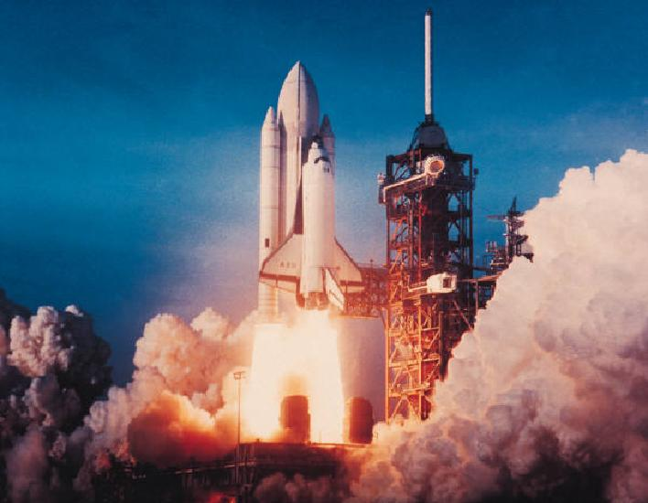
This problem was overcome with the development in the 1920s by Robert H. Goddard of rocket engines that used liquid propellants. Mr. Goddard’s work earned him the title “Father of Modern Rocketry.” Most of these liquid propellant engines use binary liquids. Binary meaning the rockets use two types of liquid that, when mixed together, combust. These fuels include: liquid oxygen (oxidizer), alcohol (fuel), kerosene (fuel), etc. The pilot can control the flow of propellant (thrust) to the engines and shut it off when needed. The major disadvantages to liquid propellant, however, are:
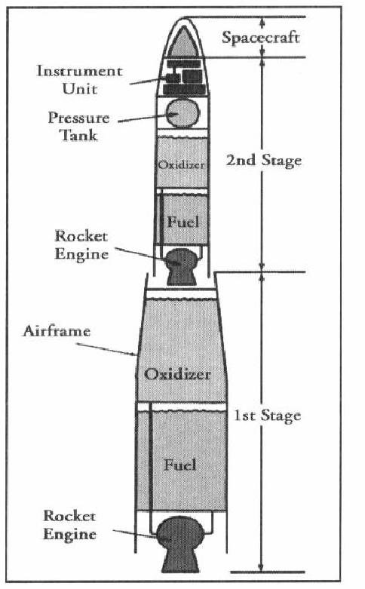
· Large size of storage tanks needed for the fuel (see Fig. 1).
· Fuels are explosive when mixed, therefore care must be exercised when fueling and defueling the rocket.
Today, there are many advanced rocket engines in use. They include:
· Resistojet Engines
· Arc Jet Engines
· Ion Engines
· Plasma Engines
· Gas Core Nuclear Engines
· Fusion Engines
· Photon Engines
For our class, we work with the solid propellant engine because that is the type we will be using to launch your model rockets. These are explained in Chapter 3, Constructing Your Model Rocket.
The scientific foundations of modern rocketry were laid by the work of Sir Isaac Newton (1642-1727). Newton developed some ‘laws’ that explain how rockets work and why they are able to function in the vacuum of outer space. These “laws” impact the design of all rockets and will be discussed in detail in the next chapter.

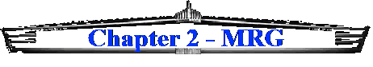

Basic Rocket Principles
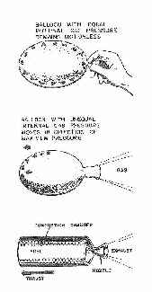
A rocket in its simplest form is a chamber enclosing a gas under pressure. A small opening at one end of the chamber allows the gas to escape, and in doing so provides a thrust that propels the rocket in the opposite direction. A good example of this is a balloon. Air inside a balloon is compressed by the balloon's rubber walls. The air pushes back so that the inward and outward pressing forces are balanced. When the nozzle is released, air escapes through it and the balloon is propelled in the opposite direction. With space rockets, the gas is produced by burning propellants that can be solid or liquid in form or a combination of the two.
The science of rocketry began with the publishing of a book in 1687 by the great English scientist Sir Isaac Newton. His book, entitled Philosophiae Naturalis Principia Mathematica (Principia), described physical principles in nature. In the Principia, Newton stated three important scientific principles that govern the motion of all objects, whether on Earth or in space. Knowing these principles, now called Newton's Laws of Motion, rocketeers have been able to construct the modern giant rockets of the 20th century such as the Saturn V and the Space Shuttle. Here, in simple form, are Newton's Laws of Motion:
- Objects at rest will stay at rest and objects in motion will stay in motion in a straight line unless acted upon by an unbalanced force.
- Force is equal to mass times acceleration.
- For every action there is always an opposite and equal reaction.
As will be explained shortly, all three laws are really simple statements of how things move. But with them, precise determinations of rocket performance can be made.
Newton's First Law
This law of motion is just an obvious statement of fact, but to know what it means, it is necessary to understand the terms rest, motion, and unbalanced force.
Rest and motion can be thought of as being opposite to each other. Rest is the state of an object when it is not changing position in relation to its surroundings. If you are sitting still in a chair, you can be said to be at rest. This term, however, is relative. Your chair may actually be one of many seats on a speeding airplane. The important thing to remember here is that you are not moving in relation to your immediate surroundings. If rest were defined as a total absence of motion, it would not exist in nature. Even if you were sitting in your chair at home, you would still be moving, because your chair is actually sitting on the surface of a spinning planet that is orbiting a star. The star is moving through a rotating galaxy that is, itself, moving through the universe. While sitting "still," you are, in fact, traveling at a speed of hundreds of kilometers per second.

Motion is also a relative term. All matter in the universe is moving all the time, but in the first law, motion here means changing position in relation to surroundings. A ball is at rest if it is sitting on the ground. The ball is in motion if it is rolling. A rolling ball changes its position in relation to its surroundings. When you are sitting on a chair in an airplane, you are at rest, but if you get up and walk down the aisle, you are in motion. A rocket blasting off the launch pad changes from a state of rest to a state of motion.
The third term important to understanding this law is unbalanced force. If you hold a ball in your hand and keep it still, the ball is at rest. All the time the ball is held there though, it is being acted upon by forces. The force of gravity is trying to pull the ball downward, while at the same time your hand is pushing against the ball to hold it up. The forces acting on the ball are balanced. Let the ball go, or move your hand upward, and the forces become unbalanced. The ball then changes from a state of rest to a state of motion.
In rocket flight, forces become balanced and unbalanced all the time. A rocket on the launch pad is balanced. The surface of the pad pushes the rocket up while gravity tries to pull it down. As the engines are ignited, the thrust from the rocket unbalances the forces, and the rocket travels upward. Later, when the rocket runs out of fuel, it slows down, stops at the highest point of its flight, then falls back to Earth.
Now that the three major terms of this first law have been explained, it is possible to restate this law. If an object, such as a rocket, is at rest, it takes an unbalanced force to make it move. If the object is already moving, it takes an unbalanced force, to stop it, change its direction from a straight line path, or alter its speed.
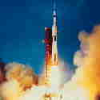
Newton's Third Law
For the time being, we will skip the second law and go directly to the third. This law states that every action has an equal and opposite reaction. If you have ever stepped off a small boat that has not been properly tied to a pier, you will know exactly what this law means.
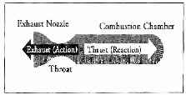
A rocket can lift off from a launch pad only when it expels gas out of its engine. The rocket pushes on the gas, and the gas in turn pushes on the rocket. The whole process is very similar to riding a skateboard. Imagine that a skateboard and rider are in a state of rest (not moving). The rider jumps off the skateboard. In the third law, the jumping is called an action. The skateboard responds to that action by traveling some distance in the opposite direction. The skateboard's opposite motion is called a reaction. When the distance traveled by the rider and the skateboard are compared, it would appear that the skateboard has had a much greater reaction than the action of the rider. This is not the case. The reason the skateboard has traveled farther is that it has less mass than the rider. This concept will be better explained in a discussion of the second law.
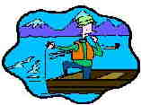
With rockets, the action is the expelling of gas out of the engine. The reaction is the movement of the rocket in the opposite direction. To enable a rocket to lift off from the launch pad, the action, or thrust, from the engine must be greater than the mass of the rocket. As the exhaust gas leaves the rocket engine it must push away the surrounding air; this uses up some of the energy of the rocket. Moving through the air causes friction, or as scientists call it, drag. The surrounding air impedes the action-reaction. In space, however, even tiny thrusts will cause the rocket to change direction because there is no drag from air friction and the exhaust gases can escape freely.
Newton's Second Law
This law of motion is essentially a statement of a mathematical equation. The three parts of the equation are mass (m), acceleration (a), and force (f). Using letters to symbolize each part, the equation can be written as follows:
f = ma
By using simple algebra, we can also write the equation two other ways:
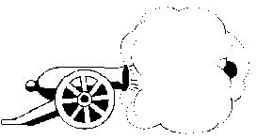
a = f/m
m = f/a
The first version of the equation is the one most commonly referred to when talking about Newton's second law. It reads: force equals mass times acceleration. To explain this law, we will use an old style cannon as an example.
When the cannon is fired, an explosion propels a cannon ball out the open end of the barrel. It flies a kilometer or two to its target. At the same time the cannon itself is pushed backward a meter or two. This is action and reaction at work (third law). The force acting on the cannon and the ball is the same. What happens to the cannon and the ball is determined by the second law. Look at the two equations below.
f = m(cannon) * a(cannon)
f = m(ball) * a(ball)
The first equation refers to the cannon and the second to the cannon ball. In the first equation, the mass is the cannon itself and the acceleration is the movement of the cannon. In the second equation the mass is the cannon ball and the acceleration is its movement. Because the force (exploding gun powder) is the same for the two equations, the equations can be combined and rewritten below.
m(cannon) * a(cannon) = m(ball) * a(ball)
In order to keep the two sides of the equations equal, the accelerations vary with mass. In other words, the cannon has a large mass and a small acceleration. The cannon ball has a small mass and a large acceleration.
Let's apply this principle to a rocket. Replace the mass of the cannon ball with the mass of the gases being ejected out of the rocket engine. Replace the mass of the cannon with the mass of the rocket moving in the other direction. Force is the pressure created by the controlled explosion taking place inside the rocket's engines. That pressure accelerates the gas one way and the rocket the other.
Some interesting things happen with rockets that don't happen with the cannon and ball in this example. With the cannon and cannon ball, the thrust lasts for just a moment. The thrust for the rocket continues as long as its engines are firing. Furthermore, the mass of the rocket changes during flight. Its mass is the sum of all its parts. Rocket parts includes engines, propellant tanks, payload, control system, and propellants. By far, the largest part of the rocket's mass is its propellants. But that amount constantly changes as the engines fire. That means that the rocket's mass gets smaller during flight. In order for the left side of our equation to remain in balance with the right side, acceleration of the rocket has to increase as its mass decreases. That is why a rocket starts off moving slowly and goes faster and faster as it climbs into space.
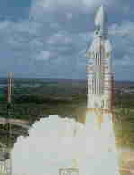
Newton's second law of motion is especially useful when designing efficient rockets. To enable a rocket to climb into low Earth orbit, it is necessary to achieve a speed, in excess of 28,000 km per hour. A speed of over 40,250 km per hour, called escape velocity, enables a rocket to leave Earth and travel out into deep space. Attaining space flight speeds requires the rocket engine to achieve the greatest action force possible in the shortest time. In other words, the engine must burn a large mass of fuel and push the resulting gas out of the engine as rapidly as possible.
Newton's second law of motion can be restated in the following way: the greater the mass of rocket fuel burned, and the faster the gas produced can escape the engine, the greater the thrust of the rocket.
These three laws of Sir Newton are the basic principles guiding rocket construction and flight still today. Now, continue to Chapter 3 and begin constructing your rocket

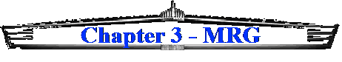

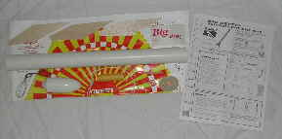
Constructing Your Model Rocket
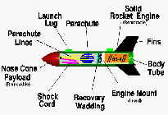
For their first model (the single-stage rocket), all cadets will use a commercial model rocket kit designed for the ‘beginner level.’ These kits typically come complete with all rocket components needed for completion of the project as well as detailed instructions in its assembly. Cadets will complete the majority of the assembly at home. Club meeting time will be used for discussions on the information in this guide and for instructor help on completing your projects. The instructor will not construct your rocket for you. You can collaborate with fellow cadets, but the actual construction of your rocket must be done by you. At all times, cadets will adhere to the NAR Safety Code.
The multi-stage rocket may be constructed from a commercial kit or of your own design. Again, NAR Safety Code considerations will be observed at all times in the construction of your rocket.
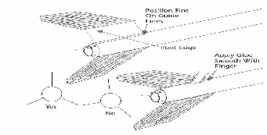
Remember, our goals are to demonstrate your knowledge of rockets, your ability to construct a rocket, and your ability to successfully launch and recover your rocket. The elaborateness or simplicity of your design will not impact the award of your badge.
During the construction of your rocket, take special care when attaching the stabilizing fins to the body tube. The fins should be evenly spaced around the body tube, perpendicular to the surface of the body tube, and parallel with a line drawn through the center of the body tube. Figure 2 illustrates the correct and incorrect way to attach the fins.
Engines (Motors)
Because we are only looking to demonstrate your knowledge, actual rocket flights will be limited to using A-series or B-series engines only (detailed in the next paragraph). Using larger engines will only increase the likelihood of being unable to recover your rocket.
Determining which engine (motor) to use in your rocket is very important. Most commercial rocket kits will have specific engine recommendations for that particular rocket. As stated earlier, we will use solid propellant engines in all of our rockets. Solid propellant engines are ideal for our uses because they are: safe, easily transported, and, to some degree, we can control the duration of the engine burn. They are safe because the oxidizer and propellant are already mixed and formed into the motor. We do not have to worry with filling fuel tanks, mixing them, etc. The motors are small, less than three inches long and less than an inch in diameter, so they are very easy to transport. We can control the burn duration by selecting the appropriate motor. The motors have designators such as, A8-3. The “A” indicates the engine has a maximum impulse of 2.5 newton seconds. With each increase in letter (i.e. “B”), this maximum impulse doubles. The “8” indicates the motor has an average thrust of 8 newtons. Finally, the “3” is the amount of time in seconds between motor burnout and ejection of the recovery system. As you can see, through careful selection of the motor, we can control several aspects of our rocket flight.
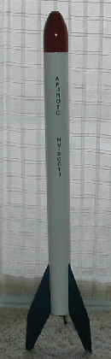
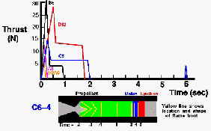
Motor Burn Durations
“Big Betty”
(Completed model rocket from a commercial kit.)

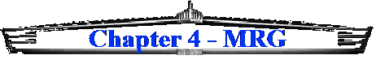

Launching Your Model Rocket
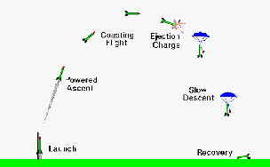
The actual launching of your rocket will be accomplished as a group with each cadet rotating through the various launch positions. Each of these positions is described below. The materials we will be using and the nature of launching a solid fuel rocket call for extreme caution to be exercised throughout the launch sequence. It is the duty of every cadet to ensure safety measures are followed at all times.
Launch Positions
Range Launch Officer (RLO): responsible for all aspects of the launch. This officer is the senior officer for the launch and has the final say on whether a launch will go or not. When the RLO is satisfied that everything is safe and ready to go, they will instruct the Range Safety Officer (RSO) to insert the arming key into the launch controller. The RLO will then perform the countdown (see below) and signal the launch.
Range Safety Officer (RSO): responsible for ensuring the launch will be safe. The RSO will ensure the range is adequate (see below), the launch pad is operable, the launch key is only inserted when told to do so by the RLO and then immediately removed after the launch, all spectators are at least 30 feet from the launch pad, and that only the RLO, RSO and the launcher are within 30 feet of the launch pad. When satisfied that all of the above are complied with, the RSO will signal the RLO.
Flight Recovery Officer (FRO): responsible for recovery of the rocket. The FRO will deploy cadets downrange from the launch pad prior to launch, track the rocket during flight, and recover the rocket when it lands.
Flight Spotter (FS): responsible for tracking the rocket during flight. The FS will monitor the flight of the rocket and assist the FRO as necessary.
Flight Recorder (FR): responsible for keeping a record of the flight. The FR will record the following information in the Flight Log Book: take off time, max altitude achieved (FR will compute this), Cadet launching the rocket, type of rocket, the RSO, the RLO, the FRO, the FS, and the FR.
Launcher: the cadet whose rocket is on the launch pad. The launcher is responsible for ensuring their rocket meets NAR Code, is prepped for launch, for preparing the engine/igniter, and actual launch of the rocket.
Launch Site Selection
All launches will be performed at an approved location. The stadium or baseball fields should satisfy our requirements and be convenient for all cadets. The instructor will determine where to set up the launch pad.
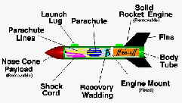
Launch Preparations
1. Parachute Recovery Wadding should be positioned between the rocket motor and the recovery system to prevent scorching of the parachute or streamer. The wadding should loosely fill the body tube for a depth of approximately two body tube diameters. Crumble the wadding loosely to get maximum bulk and a good seal against the wall of the body tube.
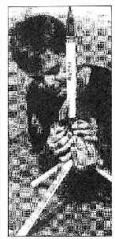
2. Recheck the recovery system of your model to be sure it has been prepped and packed per its instructions. Your parachute or streamer should fit loosely inside the rockets body tube so it can deploy easily. Lightly dust your parachute with baby or talcum powder to keep it from developing a set shape inside your rocket body tube. This technique is especially effective if the weather is hot and humid or is very cold.
3. Check the nose cone fit to be sure it’s snug, but not too tight. If it’s too loose, add a small piece of tape to the shoulder of the nose cone. If it’s too tight, lightly sand the shoulder of the nose cone and/or stretch the end of the body tube slightly by inserting the pointed end of the nose cone into the body tube and gently twist it back and forth a few times.
4. To select the correct rocket motor consult the current commercial catalog for your rocket, product packaging or instruction sheet for recommended rocket motors to use in your model. Follow all igniter and rocket motor installation procedures.
5. Install the igniter into the rocket motor per the igniter instructions.
6. When placing the rocket motor into the easy-lock motor mount, be sure the motor mount clip is securely positioned over the end of the rocket motor.
7. Unwind the wire leads from the Launch Controller and place the controller the full length of the wire leads away from the launch pad (at least 15 feet). The RSO will ensure the launch controller is disarmed and is in good working condition. Micro-clips must be clean. Attach the controller’s micro-clip leads to the launch pad by tying them to one of the launch pad legs with a single over hand knot. Micro-clip lead wire should be pulled apart so each individual micro-clip lead is 6 inches to 8 inches long.
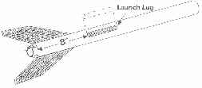
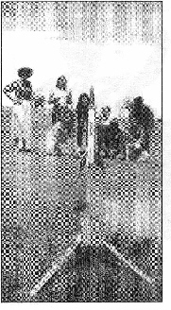
8. ALWAYS USE CAUTION WHEN BENDING OVER YOUR LAUNCH PAD TO AVOID EYE INJURY. Remove the launch rod safety cap and lower the rocket onto the launch pad positioning it on the Launch Rod Stand-Off several inches above the blast deflector. The launch lug on the rocket’s body tube should glide easily over the launch rod. Check to be sure there are no rough surfaces or obstructions on the launch rod which could hinder the lift-off of the model. For eye safety keep the tip of the launch rod covered with the Launch Rod Safety Cap until you are just ready to begin the countdown.
9. The RSO will ensure the Safety Key is removed from the launch controller before the launcher hooks the micro-clips to the igniter. Attach one micro-clip lead to each igniter where the copper wire is exposed. The micro-clips must not touch each other or the blast deflector. Use the Launch Rod Stand-Off, an empty motor casing or piece of tape wrapped around the launch rod to position the rocket several inches above the blast deflector to keep the micro-clips from touching it and shorting out. For best results bring one micro-clip lead around each side of the Launch Rod Stand-Off and hook up to the igniter.
COUNTDOWN PROCEDURE
When the rocket is ready to launch:
- The RSO will:
  - Remove all spectators to at least 30 feet away from the launch pad.
  - Make sure the sky is clear of low flying aircraft.
  - Ensure wind conditions are gentle (<20 mph).
- The RLO will
  - Ensure the launch pad is properly prepared.
  - Deploy the FRO and their team.
  - Ensure the FR and FS are ready.
  - Obtain the attention of all individuals in the launching and recovery areas.
- At this time the RLO will instruct the RSO to arm the Launch Controller with the Safety Key. The arming light should go on. If the arming light does not go on, remove the Safety Key and check the battery power, electrical connections and igniter installation. Clean micro-clips with sand paper if necessary.
- When the rocket is armed, the RLO will announce to the spectators in a loud vice, “the rocket is armed, and counting...5...4...3...2...1 Lift-Off!”
- If at any time during the countdown, an unsafe condition is observed by anyone, they will shout, “Halt the launch!” The FSO will immediately remove the Safety Key from the launch controller. When the unsafe condition has been cleared, the RLO will begin the countdown procedure at step number one above.
- When the launcher hears the RLO say, “Liftoff!” (and not before!), they will push the launch button down momentarily until the rocket motor begins thrusting, then release it. The rocket should lift-off from the launch pad almost instantly.
- The RSO will immediately remove the Safety Key from the launch controller and keep it with them until a new RSO is assigned or until the next time the RLO directs them to arm the launch controller.
- The RSO will recap the launch rod with the safety cap in between each launch.
RECOVERY PROCEDURE
The FRO and FR will track the flight of the rocket until the recovery system is deployed and the rocket is returning gently back to Earth. If the recovery system malfunctions, all cadets must be prepared to alert the spectators that the rocket is returning to Earth faster than normal and to be “heads-up” and aware of the area where the rocket will impact the ground. When the rocket lands, the FRO and their team will return the rocket to the launcher.
MISFIRE PROCEDURE
Occasionally, at the end of the countdown the rocket will fail to lift-oft because the rocket motor did not ignite. This usually occurs because the igniter was not making the proper contact with the surface of the rocket motor’s propellant.
If the rocket fails to launch when the launch button is pushed, the RLO will declare loud enough for all to hear, “Misfire!”
The FSO will then disarm the launch controller by removing the Safety Key and wait one minute before approaching the launch pad.
If the arming light glows, but the motor does not ignite, the launcher will try repositioning the micro-clips on the igniter. The RLO will then repeat the countdown procedure.
If rocket motor still does not ignite, disarm the launch controller and wait one minute before approaching the pad.
Disconnect the micro leads from the igniter and then remove the model from the launch pad.
Remove the old igniter from the motor nozzle, clean the micro-clips and install a new igniter.
Repeat the countdown procedure.

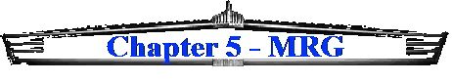

Safety

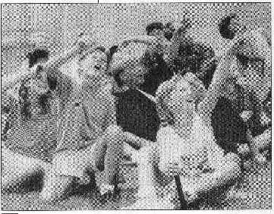
All cadets must make safety their number one concern during the construction, launch and recovery of their model rockets. Adherence to the NAR Safety Code is mandatory at all times. During construction, cadets will use caution with any sharp tools while cutting, paints and their fumes, sharp or pointed objects, and be aware of their surroundings to not put anyone else in jeopardy. While launching their rockets, cadets will follow the directions of the RLO/RSO and this guide without fail. During recovery operations, cadets will exercise care through awareness of the geography, fellow cadets, and the rocket returning to earth. Failure to comply with these and any other adopted safety regulations may result in removal from the Rocket Club and the Corps of Cadets. Safety is our foremost concern and our goal is zero mishaps!

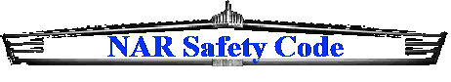


FLYING MODEL ROCKETRY
SAFETY
N.A.R. MODEL ROCKET SAFETY CODE
1. MATERIALS. My model rocket will be made of lightweight materials such as paper, wood, rubber, and plastic suitable for the power used and the performance of my model rocket. I will not use any metal for the nose cone, body, or fins of a model rocket.
2. MOTORS. I will use only commercially-made NAR-certified model rocket motors in the manner recommended by the manufacturer. I will not alter the model rocket motor, its parts, or its ingredients in any way.
3. RECOVERY. I will always use a recovery system in my model rocket that will return it safely to the ground so it may be flown again. I will use only flame resistant biodegradable recovery wadding if required by the design of my model rocket.
4. WEIGHT AND POWER LIMITS. My model rocket will weigh no more than 1,500 grams (53 ounces) at lift-off and its rocket motors will produce less than 320 Newton-Seconds (4.45 Newtons equals 1.0 pound) of total impulse. My model rocket will weigh less than the motor manufacturers recommended maximum lift-off weight for the motors used, or I will use motors recommended by the manufacturer for my model rocket.
5. STABILITY. I will check the stability of my model rocket before its first flight, except when launching a model rocket of already proven stability
6. PAYLOADS. My model rocket will never carry live animals except insects, or a payload that is intended to be flammable, explosive or harmful.
7. LAUNCH AREA. I will launch my model rocket outdoors in a cleared area, free of tall trees, power lines, buildings, and dry brush and grass. My launch area will be at least as large as that recommended in the following table.
Motor Type Minimum Site Dimensions (feet)
A 100
B 200
C 400
8. LAUNCHER. I will launch my model rocket from a stable launch device that provides rigid guidance until the model rocket has reached a speed adequate to ensure a safe flight path. To prevent accidental eye injury, I will always place the launcher so the end of the rod is above eye level or I will cap the end of the rod when approaching it. I will cap or disassemble my launch rod when not in use and I will never store it in an upright position. My launcher will have a jet deflector device to prevent the motor exhaust from hitting the ground directly. I will always clear the area around my launch device of brown grass, dry weeds, or other easy-to-burn materials.
9. IGNITION SYSTEM. The system I use to launch my model rocket will be remotely controlled and electrically operated. It will contain a launching switch that will return to ‘Off’ when released. The system will contain a removable safety interlock in series with the launch switch. All persons will remain at least 15 feet from the model rocket when I am igniting model rocket motors totaling 30 Newton-Seconds or less of total impulse and at least 30 feet from the model rocket when I am igniting model rocket motors totaling more than 30 Newton-Seconds of total impulse. I will use only electric igniters recommended by the motor manufacturer that will ignite the model rocket motor(s) within one second of actuation of the launching switch.
10. LAUNCH SAFETY. I will ensure that people in the launch area are aware of the pending model rocket launch and can see the model rocket’s lift-off before I begin my audible five-second count down. I will not launch a model rocket so its flight path will carry it against a target. If my model rocket suffers a misfire, I will not allow anyone to approach it or the launcher until I have made certain the safety interlock has been removed or that the battery has been disconnected from the ignition system. I will wait one minute after a misfire before allowing anyone to approach the launcher.
11. FLYING CONDITIONS. I will launch my model rocket only when the wind is less than 20 miles per hour. I will not launch my model rocket so it flies into clouds, near aircraft in flight, or in a manner that is hazardous to people or property.
12. PRE-LAUNCH TEST. When conducting research activities with unproven model rocket designs or methods I will when possible, determine the reliability of my model rocket by pre-launch tests. I will conduct the launching of an unproven design in complete isolation from persons not participating in the actual launching.
13. LAUNCH ANGLE. My launch device will be pointed within 30 degrees of vertical. I will never use model rocket motors to propel any device horizontally.
14. RECOVERY HAZARDS. If a model rocket becomes entangled in a power line or other dangerous place, I will not attempt to recover it

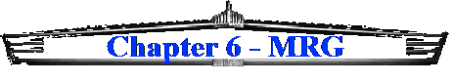

Glossary of Rocket Terms
Acceleration - The rate of change in an object’s speed (usually measured in g’s).
Accelerometer - A device that measures acceleration (usually in g’s).
Aerodynamics - The branch of physics that deals with forces exerted by air in motion.
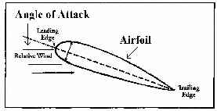
Airfoil - A surface (wing or fin) designed to provide lift, control, or a stabilizing effect.
Airflow - The movement of air across a surface.
Airframe - see fuselage.
Angle of Attack - The angle at which a wing or fin moves in relation to the relative air stream (wind).
Apogee - The highest point in a rocket’s flight.
Armed - The condition of the electrical ignition system after the safety key is inserted; ready to-launch condition.
Average Thrust - The total impulse of a rocket motor divided by the thrust duration.
Balsa Wood - An extremely light wood, with a high strength-to-weight ratio. Ideal for building flying models.
Blast Deflector - Metal plate protecting launcher base and ground from hot rocket exhaust.
Blow-Through - A motor failure where the propellant blows out of the front end of the motor. Multi-stage motors use this method to ignite propellant in the next stage.
Body tube - A cardboard or plastic cylinder that comprises the fuselage of a model rocket.
Boost - The extra power given to a rocket during lift-off, climb or flight.
Booster - A detachable portion of the rocket which contains an engine to give the main rocket an initial velocity. The booster separates from the main body after burnout and tumbles to the ground.
Boost-glider - A model rocket which, through a change in its weight distribution or form, becomes a glider at apogee. A B/G ejects its motor after burnout, unlike a rocket glider.
Boost phase - The part of a model rocket flight during which the motor is providing thrust.
Burn - The total amount of time the propellant is burning in the engine.
Burnout - The point at which a motor ceases to produce significant thrust, even if the ejection charge is still burning.
Burnout velocity - The speed of a rocket at the instant the propellant has been used up.
Burnout weight - The weight of a rocket after all propellant has been used up.
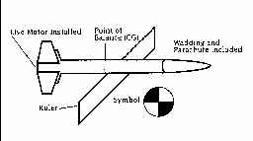
Center of gravity - The point in a rocket’s length where it’s weight is evenly balanced. Abbreviation: CG.
Center of pressure - The ‘balancing point’ for aerodynamic forces acting on a rocket. Abbreviation: CP.
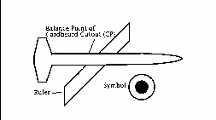
Chamber pressure - The pressure exerted on the walls of the combustion chamber of a rocket motor by the burning propellant gases.
Check light - Launch controller’s indication of electric continuity (ready to ignite).
Cluster - A group of model rocket motors working as a single unit, ignited simultaneously. The total thrust of a cluster is equal to the thrust of the motors added together.
Coast - The flight of a model rocket immediately following propellant burnout and before the ignition of the ejection charge.
Coefficient of drag - A measure of how easily a shape moves through air.
Combustion - The action of burning.
Configuration - The external shape or form of a rocket.
Continuity - The condition of a launch system having a complete electrical circuit to allow ignition.
Countdown - A count in reverse order in seconds, of the time remaining before the launch.
Deceleration - The rate of decrease in an object’s speed, usually measured in g’s.
Deflector - See Blast Defector.
Delay charge - A slow burning chemical added to the rocket motor to provide a time delay between burnout and activation of recovery system.
Dihedral - The upward or downward tilt of a wing with respect to the horizontal. (Also see: Polyhedrol)
Dope - A strong lightweight lacquer paint sometimes used on balsa and paper but not on most plastics.
Downwash - The vertical downward motion of the airflow caused by an airfoil or a wing.
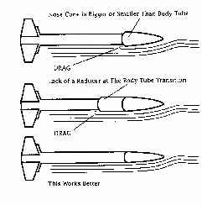
Drag - Aerodynamic forces acting to slow an object in flight.
Ducted Ejection - Method of passing ejection gases through tubes to a particular area; system of ducting hot ejection gases until they are cool before the deployment of the recovery device.
Duration - The length of time a model rocket motor produces thrust. The length of time a model rocket is airborne.
Ejection charge - A chemical added to the rocket motor to produce gas pressure at a very fast rate to activate the recovery system.
Elevation angle - The vertical angle recorded by trackers, used to figure altitude.
Elevon - An aerodynamic control surface that controls pitch and roll.
End-burning - Solid propellant rocket motor which is ignited at the nozzle end and burns through to the forward end; Versus a core burning which burns from the center to the sides.
Engine - See Motor.
Exhaust velocity - The velocity of the exhaust leaving the nozzle.
Fillet - A layer of glue placed at the joining of a fin (or other model rocket component) and the body tube (or other component). The fillet adds strength to the joint and cuts drag.
Fin - In rocketry, an airfoil attached to the fuselage, which helps guide the flight.
Finishing - The art of producing a quality surface on the model rocket. A well-finished rocket will allow a model to perform better than a model not so well done.
Flight duration - The length of time during which a model rocket is in flight.
Frangible - The quality of a model rocket being made of fragile materials to minimize damaging whatever it may hit by accident.
Fuel - The substance burned with an oxidizer to produce thrust in a rocket motor.
Fuselage - The body, or main structure of a rocket. Also called the air frame.
“g”- A unit of measurement of acceleration, equal to the rate at which objects fall toward Earth (32 feet per second).
Gantry - A crane-like structure used to erect, assemble, and service large rockets. It is next to the rocket during launch preparations, but rolled away before launching.
Glide phase - The non powered descent of a boost glider or rocket glider.
Grain - The direction of the fibers in balsa wood. Also describes the fineness of solid propellant.
Ground support - Equipment consisting of launch controller, launch pad, and any related devices.
Horizontal- Level or parallel with the horizon.
Igniter - An electrical device which starts combustion of the propellant in a model rocket motor.
Ignition - The moment when a rocket motor’s propellant starts to burn.
Ignition system - The complete electrical system including batteries, micro chips, and associated circuits and components.
Impulse - A force which produces motion.
Jet propulsion - The forward propulsion of a rocket by the rearward discharge of a high speed stream of gases.
Krushnik Effect - When the motor is recessed forward in the body one diameter of the body, thrust is very ineffective.
Laminar flow - Airflow near the surface of a body which is not turbulent. Usually found at the front of a smooth body.
Launch - The liftoff of a rocket after ignition.
Launch controller - An electrical device used to send current to an igniter. Launch controllers normally have several safety features, such as a spring-loaded switch, a continuity check light and a safety key.
Launcher - see Launch pad.
Launch lug - Small pieces of balsa tubing or plastic that allows the rocket to be guided in early flight from the launch pad.
Launch pad - Structure used to support a launch rod, rail or tower which guides a model in a vertical path. Includes a blast deflector.
Launch rail - Rail with a special cross section which guides a model during its first few feet of flight.
Launch rod - Round rod used to support and guide a model in a vertical path during the first few feet of flight.
Launch system - Combination of launch pad and ignition system.
Launch tower - Generally a structure in which the rocket fins travel in slots to guide the rocket during liftoff.
Leading edge - The front edge of a fin, facing the direction of rocket travel.
Lead wire - The wire going from the launch controller to the micro-clips (and igniter).
Lift - The total aerodynamic force perpendicular to the relative wind and exerted upward to the wings. This allows aircraft to remain airborne.
Lift-off - The start of a rocket’s flight from it’s launch pad (‘blast-off’).
Longitudinal axis - The axis from the front to tail of an aircraft; movement about this axis is called roll.
Mach number - The ratio of the speed of an object to that of sound. A body moving at a Mach number of one (Mach 1.0) has a velocity of approximately 1100 feet per second (sea level, normal atmospheric pressure).
Micro-clips - Small clips with flat jaws that are used to connect launch controller wires to igniter leads.
Mini motor - The smaller size model rocket engine; 1.75 inches long by 0.500 inches in diameter; used in high performance rockets or for small launch sites.
Mishap -an accident involving damage to property and/or injury to human beings or animals.
Momentum - The product of a moving object is velocity times it’s mass.
Monopropellant - A propellant mixture which contains both the oxidizer and the fuel in a single compound.
Motor – Non-metallic motors produced commercially under controlled conditions specifically for use in model rockets. Sometimes called an engine by mistake (engines are generally machines with moving parts).
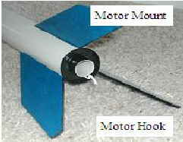
Motor classification - A system of coding used to designate a model rocket motor’s performance parameters.
Motor hook - A clip which secures the nozzle end of the motor to prevent it from being ejected when the ejection charge ignites.
Motor mount - A structure positioned in a model rocket body to prevent the engine from moving forward during acceleration while allowing a free forward travel of the ejection gases.
Motor pod - Assembly housing model rocket motor which detaches from rest of glider when ejection charge operates.
Multi-stage rocket - A rocket having two or more stages which operate one after the other.
Mylar - A lightweight and strong plastic sometimes used for streamers and parachutes. Some Mylar has a silvery coating to make it highly visible from the ground.
NAR(The National Association of Rocketry) - Official organization which certifies motors, validates competition records, sets safety standards and promotes model rocketry.
Newton - The amount of force needed to move a mass of one kilogram with an acceleration of one meter per second each second; one Newton is equal to 0.225 pounds of force.
Newton-second - The metric unit of impulse. A newton second is one newton of force applied for one second.
Newton’s Third Law - For every action there is an equal but opposite reaction.
Nose cone - The front end of a model rocket, generally tapered in for streamlining.
Nozzle - The narrow open end of a model rocket motor (usually ceramic) that directs the flow of exhaust gases.
Nozzle blow - A model rocket motor failure in which the nozzle is forcibly expelled.
Ogive - Curved shape of most nose cones, versus straight side found in true conical shape.
Oxidizer - A part of a rocket’s propellant must be oxidizer. This substance produces oxygen to support combustion.
Oscillation - A periodic motion, such as the rolling, pitching, or yawing of a rocket, or a combination of these.
Parachute - An umbrella shaped device, made of fabric or lightweight plastic and attached to an object by shroud lines. Used to slow the fall of a body through the atmosphere.
Parallel Ignition - Method of simultaneously igniting two or more motors in a cluster.
Parasite glider - Small boost glider attached to base of larger rocket for boost.
Payload - Any objects to be lifted that are not a functional part of the rocket itself.
Payload section - A compartment in the rocket designed to carry and protect a payload (also called payload capsule).
Pitch - Rotational movement around the lateral axis of the rocket.
Polyhedral - A modification of dihedral, wherein the different wing panels are tilted upward at varying angles.
Pound-second - The English unit of total impulse, now replaced by the newton-second.
Powered flight - The “boost phase” of a model rocket flight.
Pressure Distribution - The variation of air pressure over a surface, such as the pressures around wing’s airfoil.
Propellant - The source of energy in a rocket motor; a combination of a fuel and oxidizer.
Propulsion - Act of driving forward or propelling.
Range - Complete outdoor launch facility with all features and equipment needed.
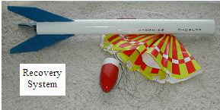
Recovery system - A device incorporated into the design of a model rocket for the purpose of returning it safely to earth. All model rockets must use some form of recovery system.
Recovery wadding - Flame-resistant material packed between the model rocket motor and the streamer or parachute to protect it from the hot ejection charge.
Reducer- Round tapered balsa fitting used to connect body tubes of different diameters.
Relative wind - The apparent motion of the air in relation to a body in it; motion may by caused by a body moving in relation to still air.
Rocket glider - A model rocket that, through a change in weight distribution or configuration, becomes a glider after engine burnout. Similar to a boost glider, but it retains it’s engine after burnout. Also known as R/G.
Roll - Rotational movement of a rocket about a longitudinal axis.
Root edge - The edge of a wing or fin attached to the fuselage.
Rudder - A moveable or fixed aerodynamic control surface used to cause yaw movement, or to prevent such movement, to keep an aircraft or rocket on a fixed horizontal path.
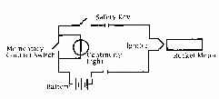
Safety key - A special key used to arm a launch system. No power can get to an igniter without use of a safety key.
Screw eye - Metal eye screwed into nose cone (or payload compartment base) to attach parachute and shock cord.
Shock cord - An elastic cord used to attach the nose cone and parachutes to the body of the rocket. This absorbs the shock force of the ejection charge.
Shroud line - The string used in making parachutes.
Smoke trail - Most model rocket motors put out a stream of smoke during the coasting phase to allow visual tracking.
Snap swivel - Used to attach parachute or shock cord. Parachute may be changed easily from one rocket to another.
Solid propellant - A rocket in solid form; usually consisting of a mixture of fuel and oxidizer.
Sounding rocket - Term for research rockets used to obtain data on the upper atmosphere.
Span - The overall distance between the fin tips of a rocket.
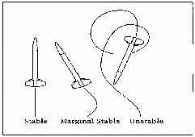
Stability - The tendency of a rocket having the proper center of gravity/center of pressure relationship to maintain a straight course.
Stabilizer - A fixed surface, generally the tail surfaces on conventional models.
Stage Coupler - Tubing used to properly position one stage to another.
Staging - See Multi-stage rocket.
Standard motor - A model rocket motor of the usual size, 2.75 inches by 0.690 inches in diameter.
Streamer - A strip of flexible material that serves in place of a parachute when a fast recovery is desired.
Stuffer tube - A smaller tube placed inside a larger body tube to direct ejection gases to a particular area.
Supersonic speed - The speed at which a model rocket breaks the sound barrier.
Sustainer engine - Single or upper stage motor equipped with a delay charge and ejection charge.
Swing test - Pre flight test to check the stability of a model rocket.
Telemetry - The science of transmitting data from a rocket back to receiving equipment on the ground.
Theodolite - An optical instrument for precision measurement of azimuth and elevation angles when tracking.
Throat - The smallest opening of the nozzle of a rocket motor.
Thrust - The propulsive force developed by the rearward ejection of gases during the combustion of the fuel.
Thrust duration - The length of time a model rocket produces thrust.
Thrust phase - The period of time during which the propellant burns and the rocket motor produces thrust.
Thrust ring - Ring positioned in a model rocket body tube or engine mount to prevent the motor from moving forward during acceleration.
Time delay - The time between the burnout of the motor and the activation of the ejection charge.
Tip - The end of a fin outermost from the fuselage.
Touchdown - The moment when rocket makes contact with the earth.
Tracker - Person staffing a theodolite or other device used for measuring rocket altitude.
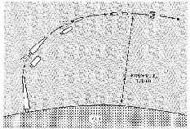
Trade-offs - Compromises made in model rocket design involving weight, diameter, and drag to achieve best overall effect.
Trailing edge - The rear edge of a fin or wing surface.
Trajectory - The flight path of a projectile, missile, rocket or satellite.
Turbulent flow - Uneven air movement over the surface of a body in which the air movement is not smooth.
Velocity - A rate of motion in a given direction, measured by distance moved per unit of time.
Vertical - At right angles to the horizon.
Vertical axis - The axis going in a vertical direction from the glider’s center of gravity; movement about this axis is called yaw.
Vortex - Corkscrew turbulence of air at a specific place on a flying rocket.
Wadding - See Recovery wadding.
Warp - A twist in a surface.
Weathercock - Tendency of a rocket to turn into the wind, away from a vertical path.
Wind tunnel - An enclosed chamber through which air is forced at different velocities. Used to test the stability and flight characteristics of rockets in model or full-size form.
Yaw - Rotation of a craft about its vertical axis

