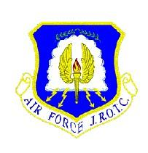

CA-20052
CADET HANDBOOK
2024 - 2025



“THE WOLFPACK”

TABLE OF CONTENTS
TITLE PAGE
- INTRODUCTION LETTER …………………………………………………………………3
- CADET AGREEMENT LETTER …………………………………………………….……4-5
- UNIFORM INSPECTION CHECKLIST ………………………………………...……6
- CORE VALUES/HONOR CODE……..……………………………………………….………..7
- BEHAVIOR EXPECTATIONS/PROHIBITION ON PHYSICAL DISCIPLINE AND HAZING……...8-9
- AFJROTC CHAIN OF COMMAND/CADET CREED..…………………….……………...9-10
- COURSE INFORMATION (GENERAL) ……………………………………...……..…..10-13
- PHYSICAL FITNESS PROGRAM ……………………………………………………...13-14
- EXTRA-CURRICULAR ACTIVITIES ………………………………………………….14-16
- AWARDS/PROMOTION PROGRAM/RESERVE CADETS……………………………..…16-19
- AFJROTC MISSION STATEMENT/GENERAL KNOWLEDGE ………………….……...20-22
- MILITARY DRILL COMMANDS ……………………………………………………...22-23
- FLAG DETAIL/ PLEDGE OF ALLEGIANCE / AIR FORCE SONG …………………….….23-24
- RIBBONS/AWARDS/CHART.…………………………………………………..............24-42
- AFJROTC UNIFORM WEAR/CADET RANKS………………………………….…….43-79
- COMMAND & STAFF FUNCTIONS ……………………………………………….......80-86
- UNIFORM REPLACEMENT COSTS…………………………………….….………87
- COURSE SYLLABUS ………………………………………………………………..88-100

Dear Parents and Cadets, 14 August, 2024
On behalf of Great Oak High School and the U.S. Air Force, welcome parents as well as new and returning cadets, to the Air Force Junior Reserve Officer Training Corps (AFJROTC)! We look forward to providing your sons and daughters quality education and training in a safe, enjoyable environment. We are excited about starting a new school year with your cadet. Our mission is: “Building Better Citizens for America”. The program will teach Aerospace Science and Leadership Education, and offer the cadets a chance to learn more about themselves, the community, and the potential to succeed! The schedule includes physical training twice per week, military drill once per week, academics twice per week, and uniform wear/inspection once per week. Cadets participate in extracurricular events and curriculum-related activities, which enhance our classroom studies and team-building skills. We encourage you to get involved in these activities and experience what AFJROTC is about!
This year, the Instructor Staff will instruct Aerospace Science, Leadership Education and Physical Training. A monthly calendar of events will be posted on the AFJROTC website; be aware there can be occasional short notice requests that may arise, requiring your cadet to verbally notify you. In the event your child is temporarily unable to perform PE, wearing the PE uniform will remain a requirement for participation points. Please provide a note from your child’s health care provider to the school nurse, which we will place in your child’s file.
When cadets are absent for testing, they will receive a “0” grade in Infinite Campus with an annotation stating “until made up” [late work, inspections, P.E. testing]. Late work will ONLY be accepted for excused absences and extenuating circumstances. Also, each cadet will be responsible to have access to a Flash Drive and/or know how to use Google Docs for JROTC assignments.
The cadet corps will be led and managed by the cadet officers and noncommissioned officers. These leadership opportunities are competitive and rewarding as they assist in developing leadership and management skills, useful for post-secondary applications. Throughout the academic year, cadets will have community service and co-curricular activities which will not only be fun and interesting, but also provide community service credit 3 towards graduation. Rank advancement, earning ribbons and positions of advancement are competitive. Cadets will be expected to follow the rules and procedures outlined in this handbook.
Please help us ensure you and your child reads this cadet guide and understands policies. Your signature confirms understanding by both you and the cadet. If you have any questions or feedback, please do not hesitate to call us at Great Oak High School: (951) 294-6450 ext. 3902.
-Great Oak High School AFJROTC Instructor Staff

AIR FORCE JUNIOR OFFICERS TRAINING CORPS
(AFJROTC) CADET AGREEMENT

FORWARD

AFJROTC offers credit as elective courses through Great Oak High School. It is a unique course of
instruction because the Air Force has established certain requirements that must be met before credit can
be given. This agreement, like an educational contract, serves to communicate general guidelines
concerning requirements and encourages a commitment to develop self-discipline and responsibility.

It must be understood that participation in AFJROTC does not commit or obligate any student to
military service. It does not guarantee special consideration if a student chooses to enter the service.
However, a cadet who completes two or more years of AFJROTC may qualify for advanced rank upon
enlistment in the military.
AGREEMENT

Our course curriculum is two-fold – Leadership and Aerospace Science. Each month a quiz or test will
be given; valued at 100 points. Over each term, cadets must present a PowerPoint presentation to the
class. Each presentation is worth 100 points. Academics equate to 40% of the student’s grade. Uniform
Inspections equate to 30%. Physical Fitness and PT Uniform Wear equate to the final 30%.
Additionally, a total of 10 community service hours within JROTC must be accomplished each term for
promotion.

Uniform Inspections are graded every Wednesday (this may change, hence the importance of
parents/cadets reviewing the AFJROTC webpage every weekend).

If a student is present on inspection day, BUT does not wear the uniform (for whatever reason),
the cadet receives a ZERO and must make it up by wearing the uniform the next day they attend
school; this will change the cadet’s grade to a 70 maximum. We need to teach cadets the meaning
and execution of responsibility and the consequences of not being prepared. If cadets do not dress
out and participate in PE on Mondays and Fridays, then each time 25 points will be deducted from their
PT uniform inspection scores (10 points for the correct shirt/10 points for the correct shorts/ 5 points for
bringing a water bottle).

The Military Awards Night event is a MANDATORY function and part of the cadet’s grade. Parents,
please be aware that your cadet is available for the awards event. Please schedule events/appointments
around Military Awards Night date To Be Determined, on campus in the GYM. By signing this letter,
you acknowledge the instructor’s expectations.

Please view the GOHS AFJROTC website for additional information.
______________________________ _____________________________
PARENT PRINT NAME AND SIGN CADET PRINT NAME AND SIGN
Uniform Inspection Checklist

5 points: Hat/Cover | Must be on hand, clean, no loose strings
5 points: Buttons/Zippers | No missing buttons & zippers all fastened
10 points: Hair | Within regulation, see cadet guide for further specifications
10 points: Shoes/Socks | Black long socks with pants, shoes must be clean and shined
10 points: Pants/Skirts | Pants-Wrinkle free, back button fastened and touching the shoe. Gig line: Shirt and Belt must be in alignment (vertical line from shirt through pants)  Skirts-Wrinkle free, free of pleats, clean, not less than 2 inches above or below the knee (MUST wear stockings)
10 points: Shirt/Tie | Clean, ironed, no strings
10 points: Collar | Inside collar is free of grease and grime
10 points: Accouterments | Ribbons, rank placement, ropes, etc. are placed and worn correctly.
10 points: Jewelry | Female- Earring studs only; 3 rings maximum, no string/rubber bracelets, no facial piercings or visible tattoos, neutral nail polish only  Male- No earrings, 3 rings maximum, no string/rubber/nonconservative bracelets, no facial piercings or visible tattoos
10 points: Facial Hair/Tattoos | See cadet guide for further specifications
10 points: Bearing | Keeps military bearing, eyes straight, does not lose composure

*** Note: If a cadet isn’t exhibiting Military Bearing at all times, 10 points will be deducted from their score for each offense ***
MILITARY BEARING: While in formation cadets must keep eyes looking forward, no talking.

Uniform guidelines are in adherence with AFI 36-2903, Dress and Personal Appearance of Air Force Personnel. Multiple infractions of the same offense will result in a (0) grade for uniform wear for that day or until the infraction is corrected. For example, if a cadet’s hair is out of regulation 10 points will be deducted. If the following week it is still out of regulation, the cadet will receive a (0) for uniform wear. Failure to meet the above standards may cause dismissal from the program. We request parents/guardians to acknowledge, by signing this document; the requirements set by CA-20052 AFJROTC and return no later than 23 August. All cadets must have a signed agreement to remain in the corps. We appreciate your support!

PARENTS … IMPORTANT NOTE:

ONLY SHIRTS CAN BE WASHED IN THE WASHER MACHINE. ALL BLUE PANTS AND SKIRTS MUST BE DRY CLEANED, OR THEY WILL SHRINK … WILL NOT ACCEPT PANTS/SKIRTS WHICH HAVE SHRUNK.

THREE TIMES A MONTH WE HAVE A BLUES-ONLY UNIFORM INSPECTION, USING THE CHECKLIST ABOVE … THE ASSESSMENT IS CONDUCTED BY A FLIGHT COMMANDER, VALIDATED BY STAFF, AND THE GRADE RANGES FROM 0 TO 100 POINTS.

UNITED STATES AIR FORCE CORE VALUES

INTEGRITY FIRST
SERVICE BEFORE SELF
EXCELLENCE IN ALL WE DO

THE CADET HONOR CODE

“ON MY HONOR, AS AN AFJROTC CADET, I WILL NOT LIE, CHEAT, OR STEAL, NOR TOLERATE THOSE WHO DO.”

AFJROTC MISSION STATEMENT

Develop Citizens of Character, Dedicated to Serving Their Nation and Community

I _______________________, PROMISE TO ABIDE BY THE AFJROTC HONOR CODE AND I UNDERSTAND THAT IF I VIOLATE THE HONOR CODE I MAY BE REMOVED FROM AFJROTC.

I WILL FOLLOW THE INSTRUCTIONS OF MY AFJROTC INSTRUCTOR(S) AND
THE CADET OFFICERS APPOINTED OVER ME. IF I FEEL THAT I NEED TO
QUESTION ANY INSTRUCTIONS, I SHALL SPEAK WITH MY INSTRUCTOR. I
WILL NOT BRING THE PROGRAM OR THE AIR FORCE INTO DISREPUTE
(DISGRACE) BY GETTING SUSPENDED OR CAUSING BEHAVIORAL ISSUES WITH ANY TEACHER OR NEGATIVE BEHAVIOR IN THE COMMUNITY OR WITH MY PEERS. I REPRESENT, GREAT OAK HIGH SCHOOL.

_______________________________ _______________ CADET SIGNATURE DATE

PARENTS, PLEASE ACKNOWLEDGE THAT YOU ARE AWARE OF OUR AFJROTC WEB PAGE, LOCATED ON
THE GREAT OAK HIGH SCHOOL WEB PAGE. THE CADET GUIDE HIGHLIGHTS THE CORRECT WAY TO WEAR THE UNIFORM, PERSONAL GROOMING WHILE IN UNIFORM, EXPECTATIONS, AND GENERAL KNOWLEDGE.

_____________________________________
PARENT SIGNATURE

BEHAVIOR EXPECTATIONS

Cadets are expected to conduct themselves in a proper manner at all times, on campus and within the community. Every effort will be made to get a cadet’s inappropriate behavior “back on track”. Cadets unwilling/unable to behave appropriately may be dismissed from AFJROTC as the negative behavior brings the program into disrepute. Cadets who consistently demonstrate good citizenship will be provided additional responsibility and recognition.

For a successful learning environment, the following are student expectations:

- All students will sign and obey the AFJROTC Honor Code.
- No food or drink (except bottled water) in class.
- Cadets will not wear hats, hoods, sunglasses, or bandanas in the classroom.
- Cadets using profanity will be removed from the class and not receive credit for missing class.
- Cadets may use computers after permission from the instructors is granted; not permitted to use personal software on School/Air Force computers. Cell phones will be gathered by the instructor and returned to the parent ONLY if taken away.
- Cadets are expected to be in class when the final bell rings. Cadets not arriving on time will be handled according to Great Oak High School parent/student handbook policies; the same applies for PE.
- Writing on desks, textbooks, or tampering with computer/classroom equipment will result in possible suspension, parent contact, or restitution of damages.
- Cheating or any attempt at cheating will NOT be tolerated! Any cadet found cheating or attempting to cheat will receive a grade of “F” and parent contact will be made. Repeated violations may result in dismissal from the AFJROTC program. Violations of integrity will be added to high school transcripts and may affect the cadet’s future.
- All cadets are expected to be respectful. Military courtesy will be adhered to at all times, addressing cadets by Sir or Ma’am or by their cadet rank.
- Items left in the classroom will be removed every afternoon. Items still remaining at the end of each week will be taken to the school lost and found.
- Wear of the AFJROTC uniform is required and is expected to be within guidelines set forth in Air Force JROTC Instructions.
- Not wearing the AFJROTC uniform on assigned uniform days will result in an “F” grade for that uniform day. Failure to wear the uniform for 3 or more uniform days will result in removal from the program. This includes Physical Training uniforms.

The above rules and policies may seem demanding – They are not, most of our cadets are able to consistently meet these standards and behave appropriately.
CADETS SHOULD BE THOROUGHLY FAMILIAR WITH THE CADET GUIDE/AIR FORCE JUNIOR ROTC UNIFORM AND AWARDS GUIDE AND REFER TO IT WHEN THERE IS A QUESTION CONCERNING PLACEMENT OF BADGES, PATCHES, AND INSIGNIA.

PROHIBITION ON PHYSICAL DISCIPLINE AND HAZING

Any form of hazing, whether verbal or physical, will not be tolerated within any AFJROTC unit or activity. In addition, requiring cadets, individually or as a group, to perform any physical action as a reprimand, punishment, or for failure to perform will also not be tolerated. Cadets will not condone or encourage any type of hazing or initiation rituals.
- Examples of prohibited physical activities include, but are not limited to: push- ups, running laps, or any inappropriate physical contact such as shoving, pulling or grabbing.
- Any form of verbal abuse, teasing, public rebuke or any attempt to otherwise humiliate a cadet is prohibited.
- This prohibition is applicable to all AFJROTC unit activities, and includes instructors, cadets and any personnel involved with or participating in an AFJROTC unit or activity.
- Unauthorized Clubs. No unit may encourage, facilitate, or otherwise condone secret societies or private clubs as part of the AFJROTC program.

CA-20052 CADET GROUP CHAIN OF COMMAND

Every cadet in AFJROTC is required to know the Cadet Group Chain of Command. During the school year, a quiz will be performed. Please visit our website; https://www.tvusd.k12.ca.us/domain/11157

Cadet Officer and Enlisted Calls
The Cadet Officer/Senior NCO Call is scheduled as required at 0800 and is a MANDATORY event and part of the cadet’s grade.
The Cadet Enlisted Call is scheduled as required during lunch and is a MANDATORY event and part of the cadet’s grade.

The Air Force Junior ROTC Cadet Creed

I am an Air Force Junior ROTC Cadet

I am connected and faithful to every Corps of Cadets who serve their community and nation with patriotism.

I earn respect when I uphold the Core Values of Integrity First, Service Before Self, and Excellence in All We Do.

I will always conduct myself to bring credit to my family, school, Corps of Cadets, community, and to myself.

My character defines me. I will not lie, cheat, or steal. I am accountable for my actions and deeds.

I will hold others accountable for their actions as well.

I will honor those I serve with, those who have gone before me, and those who will come after me.

I am a Patriot, a Leader, and a Wingman devoted to those I follow, serve, and lead.

I am an Air Force Junior ROTC Cadet.

COURSE INFORMATION
(GENERAL)

ENROLLMENT QUALIFICATIONS

To be eligible for enrollment and continuance in the AFJROTC program, a student must be:

- Enrolled in and attending a regular course of instruction at Great Oak High School.
- Physically fit /or willing to participate in the AFJROTC’s Physical Fitness Program.
- Selected by the Aerospace Science Instructors based on the principal of not having any “F” grade in JROTC and good campus behavior.
- In conformance with the high standards of personal grooming and conduct as set forth with this instruction.
- Willing to do a minimum of 20 hours of community service annually, 10 per Semester.

DISENROLLMENT

A cadet may be dis-enrolled for any of the following reasons:

- Failure to maintain acceptable standards including behavior.
- Failure to maintain personal appearance (hair and grooming) and uniform standards after being identified by the SASI or ASI.
- Indifference to training.
- Disciplinary reasons.
- Any other reason deemed appropriate by the principal and the AFJROTC instructor.

COURSE REQUIREMENTS AND EXPECTATIONS

Students are expected to accept the responsibility of actively taking part in learning with the goal of achieving their personal best. All cadets will show reasonable and cooperative behavior so learning is not disrupted. This applies in the classroom and throughout Great Oak High School campus.

- Field trips or during the school day community service events will not be attended when a cadet has 2 Failures in any current classes.
- Students are accountable for their grades – this is imperative for the cadet to work hard; instructors will inform cadets of the Kitty Hawk program to assist struggling cadets academically.
- 48 Hours prior to the community service or field trip, the Instructors will check Infinite Campus to view each cadet present grades.

It is the cadet’s responsibility to learn and be accountable for their actions/study habits/grades.

A variety of assessments will be given, assessments cover each chapter taught in both AS and LE.

Each cadet is expected to attend Awards Night (May), this event is mandatory and cadets will be graded on their attendance.

All cadets are expected to be excellent citizens at all times, on and off campus. Every attempt will be made to help cadets use good study habits to promote success. It is expected that cadets will:

- Follow directions carefully.
- Solve problems at the lowest level thoughtfully and reasonably.
- Work cooperatively and responsibly. - Respect themselves and others.

COMMUNITY SERVICE

Community service is another integral part of the AFJROTC curriculum. Each student will be required to participate in a minimum of 5 hours of community service projects, and will receive a service ribbon for completion of 5 or more hours of service. This participation must occur within the AFJROTC program and each cadet will be responsible to keep up with their hours. Community service hours will also be updated and tracked in the AFJROTC Wings computer system. Instructors in conjunction with cadets will plan service projects, and each cadet will have numerous opportunities throughout a school year to serve their school and community.

PROGRAM BENEFITS

For participating cadets, the greatest benefits to be derived from AFJROTC are individual growth, development, better informed, and more responsible citizens. In addition, your instructors will explain each of the following benefits that are available to cadets through enrollment in AFJROTC courses:

- Academy Nominations – Up to three nominations for an Air Force Academy appointment may be submitted by the principal for those cadets who:
- Desire an Air Force Academy appointment and meet all Air Force Academy qualification requirements.
- Scholarships – Cadets who have taken AFJROTC for at least two years and are enrolled in their senior year can qualify for ROTC scholarships. These scholarships can cover most of the cadets’ college education expenses (normally tuition, books, and $250 per month spending money).
- Two, Three, Four Year Certificates– Cadets will be awarded an AF Form 1256 Certificate of Training, for successful completion of 2 academic program years of AFJROTC with SASI concurrence. AFJROTC Form 310, AFJROTC Certificate of Completion, will be awarded to all cadets for successful completion of 3 academic program years of AFJROTC with SASI concurrence. AFJROTC instructors administering a 4-year program have the option of issuing an updated Certificate of Completion after 4 academic program years. [AFJROTCI 36-2001 10.2.1]
- Membership in the Cadet Corps is an extremely worthwhile endeavor and prestigious organization on the Great Oak High School campus. In addition, AFJROTC offers the following opportunities:

  - Participation in parades and state and local ceremonies.
  - Field trips related to AFJROTC curriculum.
  - Cadet social events.
  - Cadet competitions.
  - Counseling on vocational and educational opportunities.
  - Leadership training and experience

AFJROTC CURRICULUM 4-YR PROGRAM AEROSPACE SCIENCE

Academics are taught in 4-year sequences. The fourth year is available for Seniors. For organizational purposes they are separated from the Leadership Education courses. In practice, however, the overlap is considerable. For example, writing and speaking skills are categorized as “Leadership Hours” but can and should be incorporated into the Aerospace Science courses. Additionally, many of the Aerospace Science topics are helpful in the Leadership Education classes.

The overall objectives for academic courses are for the cadet to develop:

- An appreciation of the basic elements and requirements for national security.

- Respect for and an understanding of the need for constituted authority in a democratic society.

- Patriotism and an understanding of one’s personal obligation to their country.

- Broad-base knowledge of the aerospace age and fundamental aerospace doctrine.

- The desire to complete high school and pursue higher educational goals or skills.

- An understanding of the Air Force and military as a possible career path.

LEADERSHIP EDUCATION
Leadership education is an integral part of each year’s instruction. We break down each year’s activities into Academics and Leadership. In practice, however, the overlap is considerable. Additionally, many after-school activities provide the proving ground for newly learned leadership skills. Activities such as drill teams, clubs, and the formal cadet corps’ operation all require considerable responsibilities. To describe the leadership portion of the curriculum as being 288 hours (72 hours per year) is technically true; in practice it is highly understated.

The course objectives for Leadership Education are:

- Know the AFJROTC mission and organization, customs and courtesies, and the meaning and purpose of standards, discipline, and conduct.

- Comprehend why the elements of effective communication skills are important to the dynamics of individual and group behavior, and a key to effective leadership.

- Comprehend why obtaining a degree or skill after high school is important to having a civilian or military career.

- Know the various management theories and the management process, and how values and ethics are formed for an individual and society.

AFJROTC PHYSICAL EDUCATION (PE)

The AFJROTC Physical Education program is very similar to the GOHS PE program except it is administered in a military fashion. To ensure good order and discipline, it is imperative that cadets get changed quickly and be ready to participate when the Physical Training Sergeant commands “FALL IN.” If cadets do not demonstrate a sense of urgency, then good order and discipline is lost as well as wasted time waiting for cadets to show up … cadets who are taking too long to get ready. In a military environment, being late for a formation is intolerable.

CLOTHING REQUIREMENT

Cadets are expected to dress out for PE on the assigned days (Monday and Friday), in the required uniform. Required uniforms for PE are: Athletic shoes and socks, and the issued AFJROTC T-shirt (red AFJROTC T-Shirt) and gray Great Oak shorts. No other combination of clothing will be allowed. Cadets will also be required to bring a water bottle to every PE day. Failure to wear the proper PE clothing and bring a water bottle will result in a 25-point deduction from their weekly inspections. The PT uniform MUST be kept clean at all times; we encourage cadets to take their PT uniform home to be washed and not left in the lockers. They must learn to take pride in their uniform. Failure to keep it clean results in a 10-point deduction. Sweat shirts or warm undergarments may be allowed on cold days and can be worn under the Air Force PT shirt and aforementioned shorts. No other logo style sweatshirts will be allowed. Cadets who fail to dress out properly for PE will receive a “0” for the day. Continued failure to dress out for PE (4 times per semester) may result in removal from the AFJROTC program at the end of the semester.

MEDICAL EXCUSES

A written excuse from a physician will excuse the cadet from activities for the prescribed period of time.
Cadets will still be required to dress out for PE. A cadet, however, will only receive a passing grade for PE if he/she participates in health activities during the semester. All excuses from the physician or home must be taken to the health office for documentation. Written excuses from home will excuse the cadet for one day only and the student is still required to dress out. A maximum of three excuses from home will be allowed per semester.

GRADING

Cadets and Flight Leaders will be graded on a combination of the following criteria: participation, effort in aerobics or other sport/activity. Make up of missed PE days or failure to dress out will not be allowed due to scheduling constraints of the AFJROTC program. All cadets are encouraged to the maximum extent they are physically able. Remember, grades are based on effort put forth by the cadet and cleanliness of the PE shirt, not how physically gifted they are. The AFJROTC Physical Fitness Test test will be graded on completing the three fitness components; One-Mile Run (walking may be interspersed with running), Curl-Ups (Sit-Ups), and Push-Ups. PT performance will be considered in promotions.

EXTRA CURRICULAR ACTIVITIES
Falcon Squadron

Introduction
The Great Oak Falcon Squadron is an extension of the Great Oak Air Force JROTC. They share the same purpose of educating and preparing cadets for leadership, teamwork, and responsibility. Membership and contribution to the team is both voluntary and selective. The UAS equipment is expensive and can be dangerous if operated in an unsafe manner. It is expected that all cadets take their responsibilities seriously and seek assistance when necessary.

Practices:
Introduction Training Tuesday 7:30-8:20
Continuous Training Friday 7:30-8:20

Inventory
The drone team operates a variety of drones such as Alias drones (for training new cadets), Phantom 3 Standard, Phantom 3 Advanced, Mavic 2 Pro, Mavic Enterprise, Skydio 2, Tinyhawk, and Matrice 600 Pro.

Activities
Practice typically takes place on Tuesdays and Fridays. The drone team is present at many different events like football games, rallies, indoor gatherings, JROTC volunteer events, exhibitions to middle schools, and more. They fulfill many roles such as recording video, picture taking, delivery of small items, and American flag flyovers.
Membership
The drone team is open to all cadets and at all years. To be considered a member for a year cadets must attend 85% of the meetings and meet the academic requirements of at least a 2.0 GPA and no Fs.

Communications
Those interested in becoming one of the drone cadets should seek out and speak with our deputy commanders or commander.

Chain of Command
In order to solve problems at their lowest level there is a chain of command within the drone team. Issues follow this path: cadet has issues with “x”—>subject matter expert (SME) on “x”—>deputy commander—>commander and if needed advisory—>SASI. “x” can be a drone, asset, schedule, etc. The commander acts as commander for one semester before one of the two deputies is selected as the next semester's new commander. The unselected deputy still acts as a deputy and a new second deputy is selected from the pool of SMEs. Commanders whose time as commander is done gets moved to advisory and another member is selected to take the recently vacated SME position.

Legal Operation
All cadets within this team are required to attain an FAA TRUST certificate so that they may fly. This test covers the basic legality of drone flying and permits a cadet to use the Alias drone. In order to fly the drones used in real missions a cadet must have or be under the supervision of a cadet or instructor who has a Part 107. If cadets pass the FAA 107 test, CA-20052 will reimburse them for the cost of the test.

Accolades
There are many accolades associated with the drone team recognizing their hard work and contributions. These include blue cords, polos, badges, and the UAS ribbon. The specifics on what qualifies a cadet for these accolades are stated in the cadet guide. For more exact information on the operation of the team or roles within it, check the drone team website.

Armed/Unarmed Drill, Saber Team and Color Guard Teams and Practices
Drill and Ceremonies is an important part of the AFJROTC curriculum and is taught during the normal school day. Drill helps students develop teamwork, self-discipline, pride, and esprit de corps. All cadets will receive drill and ceremony instruction in the AFJROTC curriculum. Membership is open to all cadets. Each participating member may receive up to two ribbons. Drill teams and Color Guard are authorized and encouraged as they support the school and community while instilling spirit in the corps.
An extension of this basic drill is taught every:
Monday, Thursday, Friday 7:30 AM – 8:20 AM

Drill is to be treated like a sport; all cadets participating must attend at least 85% of practices.

These hours occasionally change, and the instructors will communicate any changes with cadets. If cadets attend this instruction it is important they commit themselves to their peers and their team. If cadets CANNOT show for practice it is their responsibility to contact their respective drill commanders by email, phone or text. If a drill member has not contacted an Instructor by 7:40 a.m., the cadet will receive a strike – 3 strikes and you will be off the team. Cadets will be placed on teams (IF THERE IS A VACANCY) based on their skills and desires. These teams will perform at various school and community activities, as well as, drill competitions throughout Southern California. Listed below are various extra-curricular activities offered in AFJROTC to all cadets.
Cadets involved in extracurricular activities are expected to be dedicated to and maintain regular attendance in all meetings and practices. Participants in extra-curricular activities enhance their chances for promotion to higher ranks.

Color Guard
The Color Guard is responsible for presenting the colors (American, State, and Service flags) for the playing of the National Anthem at special community and school events. The commander is responsible for organizing and training the members of Color Guard. Activities the Color Guard support may include: professional sports games, school varsity sports games, community functions, and other special events upon request. Members may receive up to two ribbons for participation and a school letter if the criteria listed below has been met.

Armed/Unarmed and Sabre Drill Teams
The drill teams present a marching performance at parades, special events, and drill competitions. The criteria listed below must be met.
NOTE: Teams are open to all cadets, but each cadet must not obtain an F in any class. This is a school environment and as such, grades are the most important thing … not drill. Cadets with an F in any class will not be allowed to participate in activities that may take them away from school academics. Studying should be the focus after school, not drill practice. Once GPA is at a 2.0 or F grade is improved upon, that member may return IF space allows. Grades are checked at Progress Report time/end of 1st term, and Progress Report time/end of Second term.
Note: AWARDS CAN ONLY BE EARNED WHILE A MEMBER IS IN GOOD STANDING. TO BE CONSIDERED IN GOOD STANDING, A CADET MUST BE ELIGIBLE, AN ACTIVE PARTICIPANT, AND HAVE NO OUTSTANDING DISCIPLINARY ACTION.

AWARD
Team Service Ribbon At least 30 hours of practice and 1 performance, with at least one being in a competition.

CLUBS

(2022-2023 School Year)

Cadets may participate in the many different AFJROTC sponsored clubs at GOHS. Each club will have a cadet officer in charge that will be responsible for the organization and management of the club. Current established clubs in AFJROTC:

Kitty Hawk Honor Society Drone Team
(Wednesday 0800-0825) (Tuesdays and Fridays 0730-0825)
Awareness Presentation Team(APT) Drill Team
(Thursday -0800-0825) (Mondays and Thursdays 0730-0825)
Flying Tigers (Private Pilot Club)
(Wednesday 0730-0815)

FUNDRAISING
In order to accomplish our mission and provide cadets with the multitude of opportunities throughout the school year, we need to raise funds. There are various fundraisers throughout the school year, such as the PDP Online. These fundraisers help offset the cost for corps events, such as drill competitions, social events, recognition programs, and other activities. As we continue to face budget cuts, each cadet should volunteer and do their very best to make each of our fundraisers successful. This is a graded task and if cadets believe that they are unable to participate they must talk to an instructor.

AWARDS / RECOGNITION

RECOGNITION PROGRAMS:
Flight of the Year: Given to a flight with outstanding cadets and excellent performance
Cadet of the Month: Each cadet will be selected based on their merit in the class; no F grades in school, community service, and no derogatory behavior. No cadet will win two consecutive months.

PROMOTION OF AFJROTC CADETS

GENERAL (SEE: https://www.tvusd.k12.ca.us/domain/11157)
There will be 2 promotion opportunities each school year; the FIRST is in August and the SECOND is in January. Promotion is granted if each cadet meets the requirements of promotion in each term:
First Year (Freshmen or 1st Year in the program)
- 1 Stripe: Airman
- 2 Stripes: Airman First Class
Second Year (or Sophomore Second year in the program)
- 3 Stripes: Senior Airman
- 4 Stripes: Staff Sergeant
Third Year (Junior or Third year cadet)
- 5 Stripes: Technical Sergeant
- 6 Stripes: Master Sergeant
Fourth Year (Senior)
- 7 Stripes: Senior Master Sergeant
- 8 Stripes: Chief Master Sergeant

AFJROTC has two types of rank … Permanent and Temporary. Every cadet is officially listed in our database with the rank as seen above. Temporary rank is for Officers. Officers will be determined based on many leadership facets. Both SASI/ASI and our top cadet leadership will discuss and decide who will be officers for the following year. One eliminating factor is that an officer CANNOT have an F-grade in any subject. Officers must lead by example and grades are important.
Cadet Commanders reserve the right to request demote cadets and revoke responsibility for failure to do their job after the first warning and after consulting the ASI/SASI. This discipline will promote program efficiency. Failure to perform can result in removal from the AFJROTC program at the discretion of the SASI [AFJROTCI 36-1001 2.4.1.1.3-5].

ELIGIBILITY CRITERIA:
The following eligibility criterion for promotion applies to the Great Oak AFJROTC program:
- Maintain a minimum “B” grade or better in AFJROTC.
- Have no F grades in any classes.
- Maintain a passing grade in AFJROTC physical fitness program.
- Have no suspensions or adverse reports at Great Oak High School during a promotion cycle.
- Completed 10 AFJROTC related community service hours each semester.
- If SASI, ASI, or Flight Commander reports a maximum of 2 violations for conduct at GOHS, that cadet will not be promoted.
- Due to officers being held to a higher standard, they must maintain a 3.0 GPA to obtain/retain their officer status and be eligible for promotion.
If a cadet has any questions regarding the promotion process they should contact their flight commander first and then one of the instructors. Promotions in the AFJROTC program are not a right, but provide cadets positions of greater responsibility and leadership based on a cadets’ sustained performance in the classroom and citizenship in the community.

RESERVE CADETS:
In accordance with AFJROTC Instruction 36-2001 Chapter 7.6.4, Reserve Cadet participation requirements such as uniform wear, community service events, etc., must be included in the unit’s Cadet Guide. A reserve cadet must have successfully completed at minimum, one year of AFJROTC, prior to requesting reserve cadet status. The reserve cadet status is good for only one academic year. It will not count for certificate purposes or academic credit. Participation in events and/or all community services will be offered and count towards graduation service credit. The uniform must be worn once weekly and inspected by a JROTC Instructor.

COURSE INFORMATION
(GENERAL)

GENERAL KNOWLEDGE

AFJROTC: Air Force Junior Reserve Officers Training Corps

Air Force DOB: 18 September 1947

Air Force Core Values: 1. Integrity first
- Service before self
- Excellence in all we do

JROTC Chain of Command:
Corp Commanders (CC): Cadet Col. Brianna Peralta, Cadet Col. Brianna Peralta
Cadet Senior Enlisted Leader (CMSgt): Cadet CMSgt Ethan Presto
Operation Squadron Commander (SS): Cadet Lt. Col. Simon Bricker
Mission Support Squadron Commander (OS): Cadet Lt. Col. Stephanie Maldanado

Air Force JROTC Mission Statement:

“Develop citizens of character dedicated to serving their nation and community ”
(Building better citizens for America)

Honor Code Pledge: “ON MY HONOR, AS AN AFJROTC CADET, I WILL NOT LIE, CHEAT NOR STEAL, AND I WILL NOT TOLERATE THOSE WHO DO.”

Air Force JROTC Goals: To instill:
1. Values of citizenship
- Service to the U.S.
- Personal responsibility
- Sense of accomplishment

Air Force JROTC Objectives: To:
1. Educate and train high school cadets
- Promote community service
- Instill responsibility, character, and self-discipline
- Provide instruction in air and space fundamentals

Air Force Ranks:
Enlisted: Airman Basic, Airman, Airman First Class, Senior Airman, Staff Sergeant, Technical Sergeant, Master Sergeant, Senior Master Sergeant, Chief Master Sergeant

Officers: Second Lieutenant, First Lieutenant, Captain, Major, Lieutenant Colonel,
Colonel, Brigadier General, Major General, Lieutenant General, General

Department of Defense is made up of: Departments of the Air Force, Space Force, Army, and Navy (includes the Marine Corps). The Coast Guard is in the Department of Homeland Security.

Air Force Units from lowest level to the highest: Element, Flight, Squadron, Group, Wing, Numbered Air Force, Command (AETC), Air Staff (Pentagon)
The Phonetic Alphabet: Alpha, Bravo, Charlie, Delta, Echo, Foxtrot, Golf, Hotel, India, Juliet, Kilo, Lima, Mike, November, Oscar, Papa, Quebec, Romeo, Sierra, Tango, Uniform, Victor, Whiskey, X-ray, Yankee, Zulu.

Time in the Air Force is expressed using the 24-hour clock. Noon is 1200 Hours, 6 P.M. is 1800
Hours and Midnight is 2400 Hours.

Who/What to Salute: Officers of higher rank, and when reporting to an officer…American Flag
outdoors… during National Anthem outdoors…when receiving and award
(“Shake, Take, Salute”) …Stand at attention: During the National Anthem and the Pledge of Allegiance indoors.

Addressing Air Force Members: Airman is “Airman” … Sergeant is “Sergeant” Chief Master Sergeant is “Chief” Officers Lieutenant to Colonel is “Sir”, “Ma’am” or their rank
General Officers are “General”
AFJROTC Cadets are “Mister” or “Miss”

Start of Class: All in seats prior to last bell, call room to attention upon SASI/ASI arrival, “Elements report”, Elements report “Good Morning/Afternoon sir/ma’am, Cadet (rank) (last name) reporting in for element(1,2,3 or 4) all cadets’ present or accounted for, with the exception of cadet (last name).” Flight commander makes the final report, and SASI/ASI fills in the attendance sheet.
End of Class: “Flight attention, dismissed.”

Uniform Information: Uniform day is Wednesday.

Combination 1: Blue service dress coat “with” tie/tab, nametag, hat, and ribbons.
Combination 2: Short sleeve shirt with tie and hat.
Combination 3: Short sleeve shirt, open collar, hat.
Combination 4: ABU uniform with appropriate name tapes and hat.
Combination 5: Physical training T-shirt, shorts, sneakers, socks

Note: Top 5 and/or your flight commanders will let you know your flight’s specific uniform instructions the day before and will also be sent out through remind.

MILITARY DRILL

The reasons why military drill is important for you to learn are very basic. If you keep them in mind during your drill and parade activities, these reasons will become a part of you whether you are the leader or the follower. Here are the purposes for which military drill was designed.

- Enables a cadet to move a unit from one place to another in an orderly manner.
- Teaches cadets to act in unison and together as a team.
- Teaches cadets to respond instantly and subconsciously to a word or command.
- Provides cadets a feeling of belonging and togetherness.
- Develops self-discipline and motivation.

Cadets will be evaluated each promotion cycle on Drill and Ceremonies. Drill is a very important part of the AFJROTC curriculum. It is absolutely necessary that each cadet become proficient in drill during the first semester.

FLIGHT DRILL SEQUENCE: 30 COMMANDS

- Fall in 16. To the rear march
- Open ranks march 17. To the rear march
- Ready front 18. Column right march
- Close ranks march 19. Forward march
- Present arms 20. Eyes right
- Order arms 21. Ready front
- Parade rest 22. Column right march
- Attention 23. Forward march
- Left face 24. Change step march
- About face 25. Column right march
- Forward march 26. Forward march
- Right flank march 27. Flight halt
- Left flank march 28. Left face
- Column right march 29. Right step march
- Forward march 30. Flight halt

FLAG DETAIL

- Flag detail will be performed on a rotation basis between each flight. Flight commanders will provide a minimum of three cadets per day to complete the flag detail. It is not necessary to be in uniform to complete this detail.

- It will be each cadet’s responsibility to complete this detail. Flags should be raised at 0800 each school day, and will be lowered at 1530 daily.

THE STAR-SPANGLED BANNER
O say can you see by the dawn’s early light,
What so proudly we hailed at the twilight’s last gleaming,
Whose broad stripes and bright stars, through the perilous skies,
O’er the ramparts we watched, were so gallantly streaming? And the rockets’ red glare, the bombs bursting in air,
Gave proof through the night that our flag was still there. O say, does that star-spangled banner yet wave
O’er the land of the free and the home of the brave.

THE AIR FORCE SONG
Off we go into the wild blue yonder,
Climbing high into the sun,
Here they come zooming to meet our thunder,
At’em boys, giv’er the gun!
Down we dive spouting our flame from under, Off with one hell-uv-a-roar!
We live in fame and go down in flame, Nothing’ll stop the U.S. Air Force!

RIBBONS
All ribbons should be in proper order based upon the AFJROTC ribbon chart located in the classroom. If a ribbon is awarded more than once, oak leaf clusters will be used to signify each additional award unless directed otherwise. Oak leaf clusters or stars should be placed on the ribbon using Elmer’s white glue. Order of precedence: The lowest ribbon will be worn at the lowest left position, and the highest ribbon will be worn at the top right. Refer to ribbon chart for order of precedence.
The Following is an excerpt from the Air Force Junior ROTC Uniform and Awards Guide with the criteria for the various awards and ribbons available:
Order of Precedence (an * represents a new ribbon or a name change).

Special Awards.

- Gold Valor Award
- Silver Valor Award
- Cadet Humanitarian Award
- Silver Star Community Service with Excellence Award
- Community Service with Excellence Award

National Awards.

- Air Force Association Award
- Daedalian Award
- Daughters of the American Revolution Award
- American Legion Scholastic Award
- American Legion General Military Excellence Award
- Reserve Organization of America Award
- Military Officers Association Award
- Veterans of Foreign Wars Award
- National Society United States Daughter of 1812
- National Sojourners Award
- Scottish Rite, Southern Jurisdiction Award
- Military Order of the Purple Heart Award
- Sons of the American Revolution Award
- Military Order of World Wars Award
- American Veterans Award
- Air Force Sergeants Association Award
- Tuskegee Airmen Incorporated AFJROTC Cadet Award
- The Retired Enlisted Association Award
- The Celebrate Freedom Foundation Award
- Air Commando Association Award
Non-Funded National Awards (i.e., NCOA, National Society, Daughters of Founders and Patriots of America, etc.) (Organization must be submitted to and approved by HQ AFJROTC: award criteria must be published in the Unit’s Cadet Guide or Operating Instruction)

AFJROTC Awards.

- Distinguished Unit Award with Merit
- Distinguished Unit Award
- Outstanding Organization Award
- Outstanding Flight Award
- Top Performer Award
- Outstanding Cadet Ribbon
- Leadership Ribbon
- Superior Performance Ribbon
- Achievement Ribbon
- Academic Ribbon
- Cadet Leadership Course Ribbon
- Special Teams Placement Ribbon
- All Services National Competition
- Air Force Nationals Competition
- Orienteering Ribbon
- Leadership Development Requirement Ribbon
- Drill Team Ribbon
- Color Guard Ribbon
- Saber Team Ribbon
- Marksmanship Ribbon
- Join Leadership Academic Bowl Team Ribbon
- Cyber Patriot Team Ribbon
- StellarXplorers Team Ribbon
- Raider Team Ribbon
- Military Model Building Team Ribbon
- Unmanned Aircraft Systems Ribbon
- Robotic Club/Team Ribbon
- Good Conduct Ribbon
- Service Ribbon
- Health and Wellness
- Recruiting Ribbon
- Activities Ribbon
- Attendance Ribbon
- Dress and Appearance Ribbon
- Longevity Ribbon
- Bataan Death March Memorial Hike Ribbon
- Patriotic Flag Ribbon
- COVID-19 Ribbon

Civil Air Patrol (CAP) Awards.

- General Carl Spaatz Award
- General Ira C. Eaker Award
- Amelia Earhart Award
- General Billy Mitchell Award
- General J.F. Curry Achievement Award

AFJROTC cadets are not authorized to wear ribbons/medals earned/issued from the United States Army, United States Navy, or United States Marine Corps AFJROTC programs unless they were previously enrolled in a sister service JROTC program. When authorized, AFJROTC cadets will wear AFJROTC ribbons above and to the left of other service JROTC ribbons or awards. Group ribbons according to service with the order of precedence determined by the regulations of each service. Other services’ ribbons are grouped by service in the following order: Army, Navy, and Marine Corps.

Badges or insignia from Active Duty, Guard, Reserve, or any other non- AFJROTC group are not authorized on the AFJROTC uniform. Badges, ribbons or insignia from middle school programs such as Youth Leadership Corps are not authorized on the AFJROTC uniform.
7.6.9. Valor awards from all services are worn ahead of all other ribbons from any service. The AFJROTC
Valor Awards will be worn first, with other services’ Valor Awards worn in the following order: Army, Navy, Marine Corps, and Coast Guard.

Descriptions and Criteria.

1.Gold Valor Award. Awards consist of a medal, ribbon, and certificate. The Gold Valor Award recognizes the most outstanding voluntary acts of self-sacrifice and personal bravery by a cadet involving conspicuous risk of life above and beyond the call of duty.

Forward recommendations for valor awards through HQ-OpsSupport@afjrotc.com for review and approval within 6 months of the incident. Include a detailed description of the situation, newspaper clippings (if available), statements by victims and observers, and any other information deemed appropriate to validate eligibility. In addition, submit a proposed citation to accompany the award. HQ-Ops Support will forward the valor award to the HQ AFJROTC Director for final approval. Upon approval, Operation Support will distribute the citation, medal, and ribbon for presentation.

2.Silver Valor Award. Awards consist of a medal, ribbon, and certificate. The Silver Valor Award is awarded to a cadet for a voluntary act of heroism which does not meet the risk-of-life requirements of the Gold Valor Award.

Forward recommendations for valor awards through HQ-OpsSupport@afjrotc.com for review and approval
within 6 months of the incident. Include a detailed description of the situation, 131
131 newspaper clippings (if available), statements by victims and observers, and any other information deemed appropriate to validate eligibility. In addition, submit a proposed citation to accompany the award. HQ-Ops Support will forward the valor award to HQ AFJROTC Director for final approval. Upon approval, HQ-OpsSupport@afjrotc.com distributes the citation, medal, and ribbon for presentation.

3.Cadet Humanitarian Award. Award consists of a ribbon and certificate. It is intended to recognize cadets who provide aid in response to a singular extraordinary event such as a natural disaster or other catastrophe that has placed or has the potential to place a hardship on their fellow citizens. This award is not to be used to recognize day-to-day service in the community.

Forward recommendations for humanitarian awards to HQ-OpsSupport@afjrotc.com for review and approval within 6 months of the incident. Include a detailed description of the situation, newspaper clippings (if available), statements by victims and observers, and any other information deemed appropriate to validate eligibility. In addition, submit a proposed citation to accompany the award. Upon approval, HQ-Ops Support distributes the citation and ribbon for presentation.

4.Silver Star Community Service with Excellence Award. Award consists of a ribbon with a silver star device and certificate. The Silver Star Community Service with Excellence Award will be an honor that emphasizes the value of community service, and establishes a greater sense of pride within the corps.


The award will be given to cadets in the Top 5% of units (approximately 45 units) who have the highest "per cadet average" community service hours.

"Countable" hours must be logged into WINGS and be accomplished IAW published guidance
(AFJROTCI 36-2001, Part 7)

Countable hours will be the period from 11 April (previous year) to 10 Apr (current year). HQ will use the last PSR cadet enrollment and the hours submitted in WINGS for that period to calculate the Top 5% units and notify the units earning the Award.

Instructors at the Top 5% units will determine which of their cadets have contributed to the unit earning the new award.

5.Community Service with Excellence Award. Award consists of a ribbon and certificate. It is intended to recognize those individual cadets who provide significant leadership in the planning, organizing, directing, and executing of a major unit community service project that greatly benefit the local community. This is not an award given to participants but to the key leader(s) of the project.

GOHS Varsity Letter(s): Presented to cadets who have completed 3 years of JROTC, earned a 3.5 or above G.P.A. and have 80 JROTC Community Service hours.

Graduation Blue Honor Cord: Presented to cadets who have completed 4 years of JROTC, earned a 3.5 or above G.P.A. and have 80 JROTC Community Service hours, successfully completed two AP or IB courses.

Forward recommendations for Community Service with Excellence Award to HQ- OpsSupport@afjrotc.com for review and approval within 6 months of completion of the project. Include a detailed description of the contributions of the individual(s) along with newspaper clippings (if available) describing the outcome of the project, letters of appreciation from civic leaders, or other information deemed appropriate to validate eligibility. Ribbon must be purchased from a local vendor using MilPer funds.

6.Air Force Association (AFA) Award. This AFA-sponsored award consists of a medal and ribbon and is presented annually at each unit to the outstanding second-year (in a 3- year program) or third-year cadet (in a 4-year program).

The award recipient must possess/meet the following personal characteristics and eligibility criteria: Positive attitude (toward AFJROTC and school).

Outstanding personal appearance (uniform and grooming).

Display personal attributes such as initiative, judgment, and self-confidence. Courteous demeanor (promptness, obedience, and respect for customs).

7.Daedalian Award. The Order of Daedalians is a fraternity of commissioned pilots from all military services. It is named after the legendary figure, Daedalus, and was organized by WWI military pilots who sought to perpetuate the spirit of patriotism, love of country, and the high ideals of self-sacrifice which place service to the nation above personal safety and position. This award is offered to encourage the development of these traits in cadets and to interest them in a military career. The medal is fashioned after an ancient Grecian plaque discovered by a Daedalian in the village of Lavadia, Greece and depicts Daedalus and his son Icarus fabricating their legendary wings of wax and feathers. The award also includes a ribbon. This annual award recognizes one outstanding third-year cadet at each unit that meets the following criteria:

Demonstrate an understanding and appreciation of patriotism, love of country, and service to the nation.

Indicate the potential and desire to pursue a military career.

Rank in the top 10% of their AFJROTC class.

Rank in the top 20% of their school class.

The SASI selects the recipient and requests the award from the nearest Daedalian Flight. A minimum of 90 days’ notice is required to allow the local chapter to obtain the award from their national headquarters and to schedule a Daedalian Flight presenter for the award. See Attachment 11 for list of award points of contact.

8.Daughters of the American Revolution (DAR) Award. This award consists of a bronze medal and ribbon. This award is presented annually to one third-year (in a 3-year program) or fourth- year cadet (in a 4-year program) that meets the following criteria:

Rank in the top 25% of their AFJROTC class.

Rank in the top 25% of their high school class.

Demonstrate qualities of dependability and good character.

Demonstrate adherence to military discipline.

Possess leadership ability and a fundamental and patriotic understanding of the importance of JROTC training.

The SASI and principal select the recipient and must request the award and a presenter not later than 1 March. The award devices and presenter can be requested from the nearest DAR chapter. See Attachment 611 for list of award points of contact.

9.American Legion Scholastic Award. This award consists of a bronze medal accompanied by a ribbon with a distinctive miniature attachment depicting a scholastic scroll. This award is presented annually to one second- or third-year cadet (in a 3-year program) or a third- or fourth-year cadet (in a 4-year program) based on the cadet’s overall scholastic achievements. Each cadet must:

Rank in the top 10% of the high school class.

Rank in the top 25% of their AFJROTC class.

Demonstrate leadership qualities.

Actively participate in student activities

The SASI, as chairman, with the ASI and at least one faculty member, selects the recipient and must request the award not later than 15 April. The award devices and presenter can be requested from the nearest American Legion Post. If there is no local post, contact the American Legion Headquarters. See Attachment 6-11 for list of award points of contact.

10.American Legion General Military Excellence Award. This award consists of a bronze medal accompanied by a ribbon with a distinctive miniature attachment depicting a torch. This award is presented annually to one second- or third-year cadet (in a 3-year program) or a third- or fourth-year cadet (in a 4-year program) based on the cadet’s general military excellence. Each cadet must:

Rank in the top 25% of their AFJROTC class.

Demonstrate outstanding qualities in military leadership, discipline, character, and citizenship.

The SASI, as chairman, with the ASI and at least one faculty member, selects the recipient and must request the award not later than 15 April. The award devices and presenter can be requested from the nearest American Legion Post. If there is no local post, contact the American Legion Headquarters. See Attachment 6-11 for list of award points of contact.

11.Reserve Officers Association (ROA) Award. This award consists of a bronze medal, ribbon, and certificate. This award is presented annually for military and academic achievement to an outstanding third year cadet (fourth-year cadet in a 4-year program). The recipient must possess individual characteristics contributing to leadership such as:

Positive attitude toward the AS curriculum.

Outstanding personal appearance (wear of the uniform, posture, and grooming).

Attributes of initiative, judgment, and self-confidence.

Courtesy (promptness, obedience, and respect).

Growth potential (capacity for responsibility, high productivity, adaptability to change).

Demonstrate the highest personal, ethical standards & strong positive convictions.

Rank in the top 10% of their AS class.

The SASI, as chairman, with the ASI and at least one faculty member, selects the recipient of the award. The local ROA chapter contacts each ASI before 15 Sept and furnishes the name of the ROA representative for presentation purposes. If no contact is made by 15 Sept, the SASI must communicate directly with the National Headquarters of the Reserve Officers Association. See Attachment 6-11 for list of award points of contact.

12.Military Officers Association of America (MOAA) Award. This award, formerly known as The Retired Officers Association Award, consists of a medal pendant with ribbon. This award is presented annually to an outstanding second-year cadet (third-year cadet in a 4-year program) who shows exceptional potential for military leadership. Each cadet must:

Be a member of the junior class.

Be in good academic standing.

Be of high moral character.

Show a high order of loyalty to the unit, school, and country.

Show exceptional potential for military leadership.

The SASI selects the recipient subject to the final approval of the sponsoring MOAA chapter. The SASI requests the award devices from the nearest MOAA chapter. A MOAA representative will make the award presentation. If a MOAA chapter is not available in the area, the SASI sends the request to the MOAA headquarters.

13.Veterans of Foreign Wars (VFW) Award. This award consists of a medal pendant with ribbon. This award is presented annually to an outstanding second- or third-year cadet in a 3-year program (third- or fourth-year cadet in a 4-year program) who is actively engaged in the AFJROTC program and who possesses individual characteristics contributing to leadership. Each cadet must:

Have a positive attitude toward AFJROTC.

Have outstanding military bearing and conduct.

Possess strong positive personal attributes (such as courtesy, dependability, punctuality, respect, and cooperation).

Demonstrate patriotism (being a member of the color guard or drill team) and actively promote Americanism.

Demonstrate leadership potential.

Attain a grade of “B” in AFJROTC with an overall average grade of “C” in all subjects for the previous semester.

Be active in student activities.

Not have been previous recipients of this award.

The SASI selects the recipient subject to the final approval of the sponsoring VFW chapter. The SASI requests the award from the nearest local post in February for presentation in April or May. A VFW representative will present the award at an appropriate ceremony. If no local post is available, or if the local post does not offer the award, obtain information by contacting the headquarters of the Veterans of Foreign Wars of the United States.

14.National Society United States Daughters 1812 Award. Awarded annually, at the SASI’s discretion, for academic excellence, leadership, military discipline, dependability, patriotism and upright character in speech and habits. This award consists of a ribbon, medal and certificate.

15.National Sojourners Award. This award consists of a ribbon, medal pendant, and certificate. This award is presented annually recognizing an outstanding first- or second-year cadet (second or third-year cadet in a 4 year program) who contributed the most to encourage and demonstrate Americanism within the corps of cadets and on campus. Each cadet must:

Be in the top 25% of their academic class.

Encourage and demonstrate ideals of Americanism.

Demonstrate potential for outstanding leadership.

Not have previously received the award.

The SASI selects the recipient subject to the final approval of the sponsoring National Sojourners chapter. The SASI requests the award from the nearest local chapter in February for presentation in April or May. A representative from the National Sojourners will make the award presentation at an appropriate ceremony. If no local chapter is available or if the local chapter does not offer the award, contact the headquarters of the National Sojourners.

16.Scottish Rite, Southern Jurisdiction Award. This award consists of a medal, ribbon, and certificate. This award annually recognizes an outstanding second-year cadet in a 3-year program or third-year cadet in a 4-year program. Each cadet must:

Contribute the most to encourage Americanism by participation in Co-Curricular activities or community projects.

Demonstrate academic excellence by being in the top 25% of class.

Demonstrate the qualities of dependability, good character, self-discipline, good citizenship and patriotism.

Not have been previous recipients of this award.

The SASI selects the recipient and requests the award from the nearest Scottish Rite Valley of the Southern
Jurisdiction at any time during the calendar year. With a 30- day notice, a representative of the Scottish Rite Valley of the Southern Jurisdiction will make the presentation at an appropriate ceremony. If no local unit is available, or if the local unit does not offer the award, obtain information by contacting the national headquarters of the Scottish Rite Valley of the Southern Jurisdiction. The star worn on the ribbon must be procured with private or unit funds and will not be furnished by the sponsoring organization.

17.Military Order of the Purple Heart Award. This award consists of a medal pendant with a ribbon. This award annually recognizes an outstanding second- or third-year cadet (third- or fourth-year cadet in a 4-year program) who is enrolled in the AFJROTC program and demonstrates leadership ability. Each cadet must:

Have a positive attitude toward AFJROTC and country.

Hold a leadership position in the cadet corps.

Be active in school and community affairs.

Attain a grade of “B” or better in all subjects for the previous semester.

Not have been a previous recipient of this award.

The SASI selects the recipient and requests the award from the nearest Military Order of the Purple Heart unit in February for presentation in April or May. A representative of the Military Order of the Purple Heart will make the presentation at an appropriate ceremony. If no local unit is available, or if the local unit does not offer the award, obtain information by contacting the national headquarters of the Military Order of the Purple Heart.

18.Sons of the American Revolution (SAR) Award. This award consists of a bronze medal with ribbon. This award recognizes an outstanding second-year cadet in a 3-year program or third-year cadet in a 4-year program who is enrolled in the AFJROTC program. The recipient must exhibit a high degree of leadership, military bearing, and all-around excellence in AS studies and not have previously received the award. Each cadet must:

Be currently enrolled in the AFJROTC program.

Be in the top 10% of their AFJROTC class.

Be in the top 25% of their overall class.

The SASI and the Principal select the recipient of the award not later than 1 March. The SAR national headquarters furnishes the secretary of each applicable SAR state organization a list of the AFJROTC units in their state. A representative of SAR will present the award and correspond directly with each unit within their area. The SASI decides for presentation with the applicable state society or local chapter

19.Military Order of World Wars Award. This award consists of a bronze medal pendant, certificate, and ribbon. This award is presented annually to an outstanding cadet who has committed to continue the aerospace science program the following school year. Selection is based on outstanding accomplishments or service to the AFJROTC unit. The SASI, with the concurrence of the principal, selects the recipient and completes the Military Order of the World Wars (MOWW) citation by summarizing the cadet’s outstanding accomplishments or service to the unit. The citation and request for the medal, certificate, and ribbon are sent to the nearest local chapter of the MOWW. The SASI will decide for a MOWW representative to make the presentation at an appropriate ceremony. If a local chapter is unavailable, contact the MOWW National Headquarters. If a member is not available, any active, reserve, or retired commissioned officer may present the award.

20.American Veterans (AMVETS) Award. This award consists of a medal pendant and ribbon. This award is presented annually to one qualified cadet that possesses individual characteristics contributing to leadership such as:

A positive attitude toward AFJROTC programs and service in the Air Force.

Personal appearance (wearing of the uniform, posture, and grooming, but not physical characteristics per se).

Personal attributes (initiative, dependability, judgment, and self-confidence).

Officer potential (capacity for responsibility, adaptability, and maintenance of high personal standards).

Obtained a grade of “A” (or the numerical equivalent) in their AS class.

Be in good scholastic standing in all classes at the time of selection and at the time of presentation.

The SASI selects the recipient of the award and submits a brief nomination letter and biographical sketch of the cadet to the state AMVETS department where the school is located. An AMVETS representative should make the presentation if a participating local post or department representative is available. See Attachment 6-11 for list of award points of contact.

21.Air Force Sergeants Association (AFSA) Award. This annual award consists of a medal pendant with a ribbon. This award recognizes an outstanding second- or third-year cadet in a three-year program (third- or fourth-year cadet in a 4-year program). The recipient must demonstrate outstanding qualities in military leadership, discipline, character, and citizenship. Each cadet must:

Be in the top 25% of the AFJROTC class.

Demonstrate outstanding qualities in military leadership, discipline, character, and citizenship.

Not have been a previous recipient of this award.

The SASI, as chairperson, with the ASI, recommends the recipient of the award at least 60 days prior to the desired presentation date, but not later than 15 April. The SASI requests the award and an AFSA presenter from the nearest AFSA chapter. If information on the nearest chapter is not available, or if there is no active AFSA chapter in the area, the SASI will contact the AFSA international headquarters to obtain the name and address of the division president whose area of responsibility is nearest the requesting school.

22.Tuskegee Airmen Incorporated (TAI) Air Force JROTC Cadet Award. This TAI sponsored award consists of a ribbon and a certificate. This award is presented annually to two cadets. Cadets may be first year, second-year, or third-year cadets (in a 3- or 4-year program) and must meet the following criteria:

Attain a grade of “B” or better in their AS class.

Be in good academic standing.

Actively participate in cadet corps activities.

Participate in at least 50% of all unit service programs.

The SASI and ASI select the recipients. This award is mailed to all units proactively by AFJROTC Unit SC-
065, C.A. Johnson Preparatory Academy not later than 1 March. AFJROTC Unit SC-065, C.A. Johnson Preparatory Academy will mail all award devices and certificates in one mass mailing. A follow-up report is required after the award is presented. Provide SC-065 the names and grades of the recipients and date award was presented on the supplied mail back form.

23.The Retired Enlisted Association (TREA) Award. Awarded annually, at the SASI’s discretion, for exceptional leadership to the most outstanding AFJROTC cadet while serving in an Enlisted Rank. The selected enlisted cadet must have shown outstanding leadership throughout the course of the school year. This award consists of a medal set with ribbon and a certificate from TREA.

24.The Celebrate Freedom Foundation. Awarded annually, at the SASI’s discretion, for outstanding performance in academics and cadet corps activities as a first or second year JROTC cadet. This award consists of a ribbon and a certificate.

25.Air Commando Association Award. Awarded annually at the SASI’s discretion for completing a one-page essay based on a historical AF Special Operations Mission possessing the thirteen critical attributes of success: integrity, self-motivation, intelligence, self-discipline, perseverance, adaptability, maturity, judgment, selflessness, leadership, skilled, physical fitness and family strength. This award consists of a ribbon and certificate

Non-Funded National Awards. (i.e., NCOA, National Society, Daughters of Founders and Patriots of America, etc.) (Organization must be submitted to and approved by HQ AFJROTC: award criteria must be published in Cadet Guide or Unit Operating Instruction)

26.Distinguished Unit Award with Merit (DUAM). Awarded to cadets enrolled during the same academic year in which 1) the unit receives a HQ AFJROTC evaluation with an overall rating of Exceeds Standards and 2) the unit is selected by HQ AFJROTC to receive the DUA. Both criteria must occur during the same academic year. The unit will receive a congratulatory letter and a certificate of recognition which will be posted in WINGS.

27.Distinguished Unit Award (DUA). Awarded to cadets enrolled during the academic year when a unit is selected by HQ AFJROTC to receive the DUA. The unit will receive a congratulatory letter and a certificate of recognition which will be posted in WINGS.

28.Outstanding Organization Award. Awarded to cadets enrolled during the academic year when a unit is selected by HQ AFJROTC to receive the OOA. The unit will receive a congratulatory letter and a certificate of recognition which will be posted in WINGS. OOA recipients do not receive a streamer.

29.Outstanding Flight Ribbon. Awarded each academic term to members of the outstanding flight under criteria determined by the SASI.

30.Top Performer Award. The Cadet Top Performer Award is a Headquarters, AFJROTC award presented to a maximum of 2% of the current unit cadet corps population (unduplicated headcount). This award is only presented during a formal Staff Assistance Visit or Unit Evaluation conducted by HQ AFJROTC personnel. The award consists of a certificate and a ribbon, which is presented by the Region Director during the visit, unless personal observation of the cadet warrants otherwise. Once awarded, the ribbon may be worn for the duration of a cadet’s tenure in AFJROTC. For each additional ribbon earned an additional bronze oak leaf cluster will be awarded.

All currently enrolled cadets may be considered, but specific consideration should be given to cadets not previously recognized for superior performance. SASIs may nominate a maximum of 2% of their cadets to their Region Director based on a cadet’s performance in the following key areas: Leadership and job performance: in primary duty and specifically in preparation for the unit’s assessment. Leadership qualities: involvement and positions held in Co-Curricular activities. Academic performance: nominee must be in good academic standing in all high school course work. Significant self-improvement. Community involvement. Other accomplishments.

31.Outstanding Cadet Ribbon. Awarded annually at the SASI’s discretion to the outstanding first-year, second-year, third-year, and fourth-year cadet. The recipient from each class must be of high moral character, demonstrate positive personal attributes, display outstanding military potential, and attain academic and military excellence.

32.Leadership Ribbon. Awarded at the SASI’s discretion for outstanding performance in a position of leadership as an AFJROTC cadet in corps training activities. Ensure recognition of cadets who have consistently displayed outstanding leadership ability above and beyond expected performance.

33.Superior Performance Ribbon. Awarded annually at the SASI’s discretion for outstanding achievement or meritorious service rendered specifically on behalf of AFJROTC. Present the ribbon for a single or sustained performance of a superior nature. Ensure award is presented in recognition of achievements and services which are clearly outstanding and exceptional when compared to achievements and accomplishments of other cadets.

34.Achievement Ribbon. Awarded for a significant achievement as deemed appropriate by the SASI. Individuals may not receive more than one ribbon during a 1-year period.

35.Academic Ribbon. Awarded for academic excellence as signified by attaining an overall grade point average of at least “B” for one academic term, in addition to an “A” average in AFJROTC.

36.Cadet Leadership Course Ribbon. Awarded for completion of an approved leadership school program of at least 5 days duration. Leadership ribbon as well as the Bronze Star can be ordered through EMAIL. For each additional Leadership School completion an additional bronze star will be awarded. Silver Star will be awarded for outstanding performance or leadership ability at a Leadership School instead of the Bronze Star. Limit the Silver Star to 10 percent of the class.

37.Special Teams Competition Ribbon. Awarded to team members for placing 1_{st}, 2_{nd} or 3_{rd} in an Air Force or Joint Service Competition to include Color Guard Teams, Rifle Teams, Drill Teams, Saber Teams, Academic Bowl Teams, CyberPatriot, etc.

38.All-Service National Competition Award. Is a medal/ribbon awarded to team members who competed at a Joint/All Service national-level competition to include Drill Teams, Color Guard Teams, Marksmanship Rifle Teams, Saber Teams, Academic Bowl Teams, Cyber Patriot, StellarXplorers etc. For each additional ribbon earned an additional bronze oak leaf cluster will be awarded. A single silver oak leaf cluster will be used for the award of the fifth bronze oak leaf cluster. Medal/Ribbon may be obtained from the host of the competition or purchased from a vendor using MILPER funds. Medal may not (ribbon may) be worn during competitions and regular uniform wear days.

39.Air Force Nationals Competition Award. Is a medal/ribbon awarded to team members who competed at an Air Force only national-level competition to include Drill Teams, Color Guard Teams, Marksmanship Rifle Teams, Saber Teams, Academic Bowl Teams, Cyber Patriot, StellarXplorers etc. For each additional ribbon earned an additional bronze oak leaf cluster will be awarded. A single silver oak leaf cluster will be used for the award of the fifth bronze oak leaf cluster. Medal/Ribbon may be obtained from the host of the competition or purchased from a vendor using MILPER funds. Medal may not (ribbon may) be worn during competitions and regular uniform wear days.

40.Orienteering Ribbon. Awarded to team members for completing a unit-specific Orienteering Program as part of unit curriculum. Criteria for this award will be established by SASI and published in Cadet Guide or Unit Operation Instruction.

41.Leadership Development Requirement (LDR) Leadership Ribbon. Awarded at the SASI’s discretion for leadership in AFJROTC co-curricular activities (such as dining-in chairperson, military ball chairperson, etc.). The recipient must have demonstrated exceptional leadership in achieving objectives through the coordinated efforts of others. This award may be earned a maximum of four times. An oak leaf cluster should be added to this ribbon for each additional award.

42.Drill Team Ribbon. Awarded for the completion of a complete year of unarmed and armed drill with 85% or better attendance(Not including sabers, and color guard). An oak leaf cluster should be added to this ribbon for each year of qualifying membership beginning with the second year.

43.Color Guard Ribbon. Awarded for the completion of a complete year of color guard with 85% or better attendance. An oak leaf cluster should be added to this ribbon for each year of qualifying membership beginning with the second year.

44.Saber Team Ribbon. Awarded for the completion of a complete year of sabers with 85% or better attendance. An oak leaf cluster should be added to this ribbon for each year of qualifying membership beginning with the second year.

45.Marksmanship Team Ribbon. Criteria for this award will be established by SASI and published in Cadet Guide or Unit Operation Instruction. An oak leaf cluster should be added to this ribbon for each year of qualifying membership beginning with the second year

46.Joint Leadership Academic Bowl (JLAB) Ribbon. Is a ribbon awarded to cadets who participate
in the Joint Leadership and Academic Bowl (JLAB) Practice Test and the subsequent rounds of JLAB competition. The award recognizesindividual efforts toward achieving a clear understanding of core subjects
including math, science, language arts, leadership, current events, and financial literacy. For each additional ribbon earned an additional bronze oak leaf cluster will be awarded.

47.Cyber Patriot Ribbon. Cadets must be a member of the Cyber Patriot team. Criteria for this award will be published in the unit’s Cadet Guide. For each additional ribbon earned an additional bronze oak leaf cluster will be awarded. A single silver oak leaf cluster will be used for the award of the fifth bronze oak leaf cluster. (This ribbon replaces the Cyber Patriot pin, which is no longer authorized for wear on the cadets uniform.)

48.StellarXplorers Ribbon. Cadets must be a member of the StellarXplorers team. Criteria for this award will be published in the unit’s Cadet Guide. For each additional ribbon earned an additional bronze oak leaf cluster will be awarded. A single silver oak leaf cluster will be used for the award of the fifth bronze oak leaf cluster. (This ribbon replaces the StellarXplorers pin, which is no longer authorized for wear on the cadets uniform.)

49.Raiders Team Ribbon. Cadets must be a member of the Raiders Team. Criteria for this award will be published in the unit’s Cadet Guide. For each additional ribbon earned an additional bronze oak leaf cluster will be awarded. A single silver oak leaf cluster will be used for the award of the fifth bronze oak leaf cluster.

50.Military Model Building Team Ribbon. Cadets who complete a model with an instructor in class are eligible for the Military Model Building Team Ribbon. For each additional ribbon earned an additional bronze oak leaf cluster will be awarded. A single silver oak leaf cluster will be used for the award of the bronze oak leaf cluster.

51.Unmanned Aircraft Systems (UAS) Ribbon. Cadets must be a member of the UAS team. UAS vehicles include multi-copters, drones, and remote-controlled aircraft/vehicles. Awarded for the completion of a complete year with the UAS team with 85% or better attendance. For each additional ribbon earned an additional bronze oak leaf cluster will be awarded. A single silver oak leaf cluster will be used for the award of the fifth bronze oak leaf cluster.

52.Robotics Ribbon. Cadets must be a member of the Robotics club/team. Criteria for this award will be published in the unit’s Cadet Guide. For each additional ribbon earned an additional bronze oak leaf cluster will be awarded. A single silver oak leaf cluster will be used for the award of the fifth bronze oak leaf cluster.

53.Good Conduct Ribbon. Will be awarded to cadets who have no disciplinary issues such as cheating, suspension, OCR, and detentions.

54.Service Ribbon. Awarded at the SASI’s discretion for distinctive performance in school, community, or AFJROTC service projects. Limit to members whose active participation in a service project contributed significantly to the goals of the organization. (NOTE: Participation in Drill Teams, Saber Teams or Color Guard Teams alone does not qualify for the Service Ribbon (see above criteria for these other ribbons) unless community service hours are also awarded.

55.Health and Wellness Ribbon. Awarded by the SASI for participation in the health and wellness physical fitness program. All cadets who participate in the unit’s wellness program will receive the Health and Wellness Ribbon. All cadets who score in the Physical Fitness Test’s 75-84 percentiles will receive a Bronze
Star device; 85-95 percentile they will receive a Silver Star device; and 96-100 percent they will receive a Gold Star device. Duplicate awards of the Bronze, Silver or Gold percentile will be denoted by the addition of another star on the ribbon. Should a cadet score in a higher percentile, only the star representing higher percentile will be worn. In no case will a cadet mix different color stars on the same ribbon. (NOTE: The Physical Fitness Test percentiles are computed automatically under the PFT-Mass Assessment in WINGS.)

56.Recruiting Ribbon. Awarded for outstanding effort in support of unit recruiting activities. The SASI awards this ribbon based on locally developed criteria, which must be included in the unit Cadet Guide or unit Operating Instruction.

57.Activities Ribbon. Awarded for participation in co-curricular activities other than those that qualify for the Color Guard, Drill Team, and Special Teams Competition ribbons. These include, but are not limited to orienteering teams, model rocketry clubs, AFJROTC academic teams, and AFJROTC sports teams. An oak leaf cluster should be added to this ribbon for each year of membership beginning with the second year. The SASI awards this ribbon using locally developed criteria which must be included in the Cadet Guide or unit Operating Instruction.

58.Attendance Ribbon. Criteria for attendance ribbon will be established by SASI and published in Cadet Guide or Unit Operation Instruction.

59.Dress and Appearance Ribbon. Criteria for dress and appearance ribbon will be established by SASI and published in Cadet Guide or Unit Operation Instruction. SASI will also include uniform inspection scoring as applicable.

60.Longevity Ribbon. Awarded for completion of each AS year.

61.Bataan Death March Memorial Hike Ribbon. To honor and remember the sacrifices of the victims and survivors of World War II’s Bataan Death March, AFJROTC units may conduct an optional 14-mile Bataan Death March Memorial Hike. This event must be accomplished on a locally-determined 14-mile course (trails, road courses, tracks, etc.). Units may complete the full hike in a span of one to no more than three days. Cadet safety must be monitored at all times and advanced planning for any first aid/medical attention is paramount. Cadets who fully complete the 14-mile hike are authorized to wear the ribbon. Additionally, no fees can be charged to participate in the Memorial March. However, units are encouraged to collect donations which will be given to reputable organizations that benefit disabled veterans such as The Air Force Association’s Wounded Airman Program, the Wounded Warrior Project, Special Operations Warrior Foundation, etc.

62.Patriotic Flag Ribbon. May be awarded for participation in non-color guard events specifically designed to honor our nation’s flag. Such events include flag raising ceremonies, flag retirement ceremonies, flag folding ceremonies, and historical flag demonstrations. SASIs may award this ribbon based on local criteria which must be clearly published in the unit’s Cadet Guide or Unit Operating Instruction.

63.Resiliency-19 Ribbon. Is a ribbon awarded by the SASI to any cadet who has displayed a high amount of resiliency to life events. Principally intended to denote resilience in the face of COVID-19 to cadets who were enrolled in AFJROTC or SFJROTC course of study from 1 March 2020 to 30 June 2022. A course of study is defined as any cadet who was enrolled, participated, and completed in an on-line, virtual, or on campus in person, AFJROTC or SFJROTC course during this period. The ribbon is now expanded to those who in the SASI’s discretion have overcome significant life challenges (significant illness, tragedy at home such as fire or destruction by storm) and have shown resilience to overcome those events and
press on as a cadet. For each additional ribbon earned an additional bronze oak leaf cluster will be awarded.

CAP Awards. Only five CAP ribbons (General Carl Spaatz Award, General Ira C. Eaker Award, Amelia Earhart Award, General Billy Mitchell Award, and the General J. F. Curry Achievement Award) may be worn on the AFJROTC uniform. Units should contact the nearest CAP unit to obtain awards, invite presenters, or obtain any guidance on criteria or presentation. A unit locator can be found at http://www.cap.gov/join/unitlocator/html.

Other Military JROTC Ribbons/Devices:
Cadets coming from other JROTC service programs are allowed to wear their earned
Ribbons/Awards/Devices. However, AFJROTC Ribbons/Awards and CAP ribbons take precedence over other service awards and will be mounted on ribbon bars in the following order of precedence:
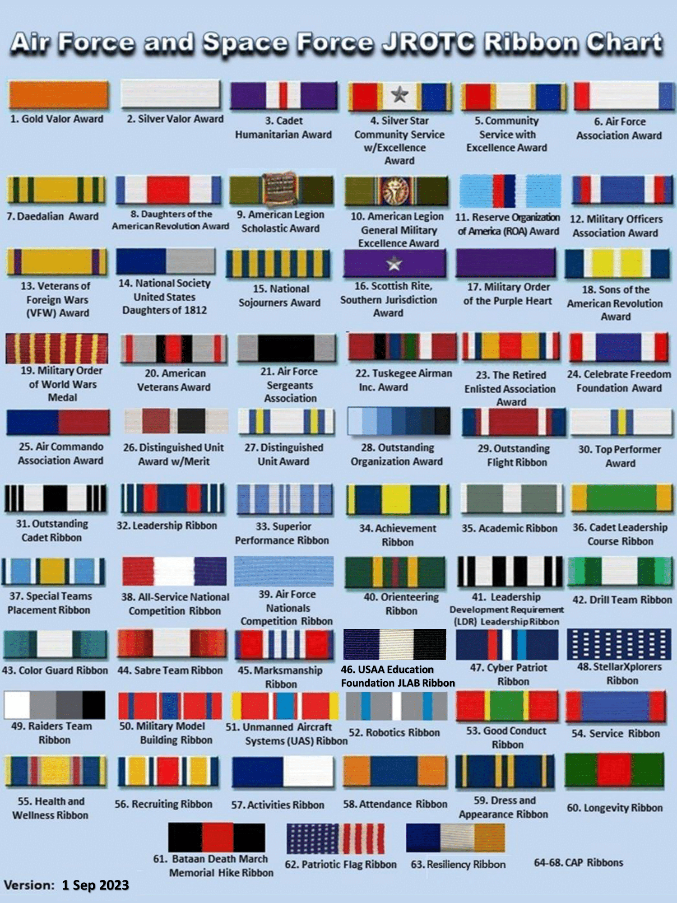

AFJROTC RIBBONS/AWARDS

ISSUE

When a cadet is issued uniforms, books, and other course materials, they will sign a Uniform and/or Book Issue Receipt form. The cadet's parent/guardian will also review and sign the form prior to filing. Cadets will also sign for books and course materials that are issued to them on a Great Oak High School book issue or other receipt form showing quantity, control number, and condition. Each item then becomes the property of the cadet who is responsible for its care. If the item is lost or willfully or negligently destroyed, beyond normal wear and tear, the cadet must pay for it at its current replacement cost. The Uniform and Book Issue Receipt form will contain the replacement costs for all accountable items. Any item substitution must be authorized by the SASI/ASI prior to purchase. Cadets will also sign for shoes and ABU/OCP boots on issue control documents; although once they are worn the dress shoes are not required to be returned. The ABU/OCP boots are required to be returned.

Cadets will be issued one complete, clean uniform with all accessories and insignia to include an Air Force blue name tag. Cadets will ensure their uniforms are properly dry cleaned and laundered during the school year.

ONLY THE BLUE SHIRT MAY BE WASHED IN A REGULAR WASHING MACHINE. ALL OTHER ITEMS OF THE BLUE DRESS UNIFORM MUST BE DRY CLEANED!

Cadets will return all items issued, except for dress shoes and socks, or pay for them at the end of the school year or upon disenrollment during the school year. They will return the cleaned uniform pressed and on hangers in a cleaner's plastic bag. Service dress, skirts, pants, ties, tabs, flight caps, and windbreakers are DRY CLEAN ONLY. All dry clean only items must be returned with a cleaning receipt. Instead of cleaning the uniforms themselves, cadets may pay a uniform cleaning fee of $20.00 (to the bookstore) when the time uniform is turned in (this will cover the cost of cleaning the uniforms for the final turn in only). Cadets are responsible for paying for cleaning during the remainder of the school year.

CERTIFICATES OF COMPLETION OF MILITARY TRAINING WILL NOT BE RELEASED
UNTIL ALL AFJROTC UNIFORMS, COURSE MATERIALS, AND EQUIPMENT ARE
RETURNED OR PAID FOR BY THE CADET. FAILURE TO PAY FOR ACCOUNTABLE ITEMS OR TO HAVE THEM PROPERLY CLEANED WILL RESULT IN COLLECTION ACTION BE INITIATED BY GOHS TO THE CADET’S PARENT/GUARDIAN.

WEARING OF THE UNIFORM

The uniform is the distinctive dress of a proud and honorable profession. All cadets must be responsible for maintaining the uniform in good order and wearing it both correctly and proudly.

The uniform will be issued to you free of charge. If you lose or damage it through neglect, you are responsible for the cost of the lost/damaged item(s). The price list for replacement items is located in the supply room with your signed uniform issue receipt. You can contact the Logistics Officer or instructor to obtain cost replacement information.

“Missing Uniform Wear Policy”

All cadets are required to wear the uniform on the appropriate uniform wear day. All cadets will be inspected weekly on their wear of the uniform. If you are absent or do not wear the uniform on the assigned uniform day (Wednesday), you will be allowed to makeup the uniform the next academic day you attend AFJROTC class. This is your responsibility, not the instructors or cadet staff. Cadets who do not meet the prescribed standards of military dress and appearance will be evaluated accordingly. Cadets who fail to wear the uniform on uniform days will receive an “F” grade for that class period. If you make up the uniform wear on your next AFJROTC academic day the grade will be changed to a “C”. Cadets who do not wear the prescribed uniform for 3 or more uniform wear days and do not makeup the uniform wear will receive a grade of “F” for that grading period. Four or more missing uniform wear days during the Semester will result in a grade of “F” for the Semester. Continued unwillingness or inability to wear the uniform will result in removal from the AFJROTC program.

Once you get the hang of wearing the uniform, it will become routine. All we instructors ask is that you give it your best effort and remain responsible.

THE AIR FORCE JROTC UNIFORM

The uniform worn by the AFJROTC is the same, with certain exceptions, as that worn by active duty Air Force personnel. Cadets will wear the uniform one day a week and at other times prescribed by the AFJROTC Instructors.

There are four combinations of cadet uniforms. See AFJROTC Uniform and Awards Guide, this handbook, and the Leadership I textbook for proper placement and maintenance of authorized uniform accessories.

You should wear the uniform when flying in military aircraft and when serving as a member of the color guard or drill team. Do not wear the uniform mixed with civilian clothing, and do not lend the uniform to anyone who is not a member of the AFJROTC program.

Just as the person on active duty, you are obligated to wear the uniform properly and proudly. In doing so, you uphold the dignity of the United States Air Force, CA-20052, Great Oak High School and yourself. With practice and attention to detail, all the dos and don’ts about the proper wear of the uniform and personal appearance will soon become automatic. You are responsible for your uniform, so pay attention to details; this will help you proudly represent your fellow cadets. Follow the regulations and suggestions designed to guide you in the proper wear of the uniform and in personal appearance. If there is any doubt about the proper wear of the uniform refer to one of your instructors.

General Guidelines

- Keep the uniform clean, neat, and properly pressed (NO Military Press).
- Wear the beret/garrison hat/flight cap as directed – remove when indoors.
- Keep all buttons buttoned.
- Items cannot stick out of the pockets. - Do not fill pockets with bulky items.
- Do not listen to MP3’s, Cell Phones, or other electronic devices while in uniform.
- Keep shoes shined, including the heels and edge of the soles.
- Keep all metal uniform devices such as belt buckles, badges, name tag, or insignia clean and shined.
- Cadets will refrain from Public Display of Affection (PDA), this includes kissing, holding hands, sitting on laps or any other displays of affection while in uniform.
- Cords – only one cord is authorized to be worn on the left shoulder.
- When in uniform necklaces will not be visible.
- Any watch worn must be conservative in appearance.
- Religious apparel must be concealed or worn only during religious services or at home. Do not wear items during parades, ceremonial details and functions. - Religious head covering Indoors: may wear plain, dark blue, or black religious head covering.
- Eyeglasses and sunglasses should be free of ornamentation on frames and lenses. Conservative, clear, slightly tinted or photosensitive lenses indoors or in formation. Conservative lenses and frames outdoors (faddish styles and mirrored lenses are prohibited). No sunglasses in formation. Not worn around the neck.

If the uniform does not fit properly, see the logistics officers or SASI/ASI. Do not wait until someone else calls attention to a problem. Check your appearance in a mirror. Bear in mind that how you look influences others around you.

Wearing of the Garrison Hat (Flight Cap)

The garrison hat/flight cap is an integral part of the Air Force uniform. It is important that you wear the hat properly and when directed from instructor staff and Air Force Instructions.

Great Oak High School has provided students and staff with exceptional overhead cover from the weather elements as you pass from class to class. Wherever the campus is covered is a “No Hat” area. But, once a cadet exits any of the campus gates, they will don the garrison hat/flight cap and wear it properly. Additionally, for corps activities off campus that require wear of the Air Force uniform, cadets are required to wear the garrison hat/flight cap.
Standards of Personal Appearance

Each member of the Air Force Junior ROTC must maintain high standards of dress and personal appearance. It is imperative that all members present a well-groomed appearance to their fellow citizens. Further, the need for personal cleanliness, safety, and proper wear of the uniform on the part of all members requires that certain minimum standards be established. Uniforms must be kept clean, neat, correct in design and specification, and in good condition. Uniforms will be kept buttoned, including pockets, and shoes will be shined and in good repair. Badges, insignia, belt buckles, and other metallic devices must be maintained in proper luster and condition.

Air Force JROTC Cadets Will Comply with the Following Standards:

MALE UNIFORM ITEMS
Belt:
Dark blue with silver tip, 1 1/4 inches wide and worn by threading through the belt loop to the wearer's left. The silver tip extends beyond the buckle to the wearer's left with no blue fabric showing. The male cadet "gig" line is the straight line formed by the front edge of the shirt, the belt buckle, and the trousers fly. Check frequently to ensure the "gig" line is straight.

Coat, Service Blue:
With arms hanging naturally, sleeves should end 1/4 inch from the heel of the thumb. Bottom of the coat should be fingertip length when hands are slightly cupped. All buttons must be buttoned and NOTHING is carried in outside pockets. Flat items may be carried in the inside pockets. The coat may be removed in classrooms or the media center when it becomes uncomfortably warm or when a lab coat must be worn, or it may be unbuttoned in the classroom to avoid binding or wrinkling. It will NOT be unbuttoned or removed in public areas (hallways, common areas, or cafeteria). When removed it will be hung up or carefully draped over a chair back. The coat must be put back on and BUTTONED before leaving the classroom. The coat will have the unit patch on the right sleeve and AFJROTC patch on the left sleeve as prescribed in AFJROTC Uniform and Awards Guide, dependent upon availability.

Cap, Blue Service (“Wheel Cap”):
This is an optional item for cadet officers that may be purchased by the cadet through the SASI/ASI. It is worn squarely on the head with two-finger spacing between the bridge of the nose and the bill of the cap. Service cap will have a plain visor.

Cap, Blue Garrison (“Flight Cap”):
Worn slightly to the right with vertical crease at the center of the forehead in a straight line with the nose and approximately one inch above the eyebrow. The crown will not be crushed. Flight cap will not have an officer silver braid.

Jacket, Light Weight, Blue Windbreaker:
Must be zipped up at least halfway. Cuffs of the sleeves should cover the wrists but not extend beyond. The windbreaker will not be worn over the service dress jacket or with civilian clothing. The jacket will have the AFJROTC patch on the left sleeve as prescribed in AFJROTC Uniform and Awards Guide, dependent upon availability.

Shirt, Light Blue, Short Sleeve with Epaulets:
With the arm bent at a 90-degree angle, the bottom of the sleeve should barely touch or come within one inch of the forearm. This shirt may be worn with a tie or with an open collar. If worn with an open collar, a white "V" neck tee shirt must be worn so that no top of the tee-shirt is exposed. When wearing a tie, all buttons will be buttoned. When not wearing a tie all buttons except the top button are buttoned. Under either option, the shirttail is pulled down into the trousers tightly and tucked at the sides to make it nearly form fitting. The only creases on the shirt are down the sleeves.

Socks:
Socks must be BLACK. Other dark colors are not authorized.

Tie, Blue:
The tie is secured by either a Windsor or four-in-hand knot. The tip of the tie must cover a portion of the belt buckle, but cannot extend below the bottom of the belt buckle. It is worn outside the shirt and is not tucked in. Pre-tied ties and the tie tack or clasp bearing the official Air Force Coat of Arms are not authorized.

Trousers, Dark Blue:
Trim fitted with no bunching at the waist or bagging at the seat. The bottom of the trousers will rest on the front of the shoes with a slight break in the creases. The back of the trouser leg will extend approximately 7/8 inch longer than the front. The trousers must be of matching material to the service coat and the cap. The rear pocket of the trousers will be buttoned always and articles should not be bulky and not be visible. The zipper tab will be pressed down to permit the "fly" to be neatly closed.

Shoes:
Black male oxfords. Shoes will be laced to the top and will be highly shined. The soles and heel edges will be coated with sole and heel dressing. Optional high gloss black corframs shoes or patent leather are authorized at the cadet's own expense.

Undergarments:
Will be worn with the uniform and will be conservative, commercial style, light in color.

Airman’s Battle Uniform (ABU)

The ABU is authorized as an optional uniform under the following conditions:
- The principal must approve ABU wear.
- The SASI will establish the unit ABU wear policy.
- ABUs may substitute for the standard service uniform no more than one uniform day per month.
- ABU name tags and insignia must be worn as indicated in the attachments of this guide.
- ABU footwear. Sage Green or OCP Coyote color boot
- White AFJROTC patch velcroed to left pocket

DRESS AND PERSONAL APPEARANCE OF AIR FORCE PERSONNEL

and are shown below: Chapter 7: Uniform and Awards, Operational Supplement, Change 1 General

Hair will be clean, well-groomed, and neat. If dyed will look natural. Hair will not contain excessive amounts of grooming aids, touch eyebrows when groomed or protrude below the front band of properly worn headgear. EXCEPTION: Hair may be visible in front of women's flight cap.
Hairnets may be worn as required for safety Made of cotton or a synthetic material; be of a conservative, solid color similar to the individual’s hair color, be strong enough to support and control hair; and contain no metal fasteners.
Wigs and Hairpieces must be of good quality and fit properly. For males, Members must have their medical records documented to wear a wig or hairpiece to cover baldness or disfiguration. Other male personnel will not wear wigs or hairpieces. When worn, wigs and hairpieces must comply with the same grooming standards for natural hair. Wigs and hairpieces will not be worn by personnel engaged in flightline activities.

Males
Men’s Hair. Keep your hair clean, neat, and trimmed. It must not contain large amounts of grooming aids such as greasy creams, oils, and sprays that remain visible in the hair.

Men’s Hair will be tapered appearance on both sides and the back of the head, both with and without headgear. A tapered appearance is one that when viewed from any angle outlines the member's hair so that it conforms to the shape of the head, curving inward to the natural termination point without eccentric directional flow, twists or spiking. A block-cut is permitted with tapered appearance. Hair will not exceed 2 1/2 inch in bulk, regardless of length and ¼ inch at natural termination point; allowing only closely cut or shaved hair on the back of the neck to touch the collar. Hair will not touch the ears or protrude under the front band of headgear. Cleanly shaven heads, military high-and-tight or flat-top cuts are authorized. Prohibited examples (not all inclusive) are Mohawk, mullet, cornrows, dreadlocks or etched design. Men are not authorized hair extensions.

Sideburns. If worn, sideburns will be straight and even width (not flared), and will not extend below the bottom of the orifice of the ear opening. Sideburns will end in a clean shaven horizontal line. See Figure below, orifice of the ear opening is at reference point A.
Mustaches. Male cadets may have mustaches; however they will be conservative (moderate, being within reasonable limits; not excessive or extreme) and will not extend downward beyond the lip line of the upper lip or extend sideways beyond a vertical line drawn upward from both corners of the mouth. See below, reference points B, C, and D.

Beards. Beards are not authorized unless for medical reasons, when authorized by a SASI on the advice of a medical official. SASI will submit a waiver request in WINGS for review by HQ AFJROTC Waiver Review board. Members will keep all facial hair trimmed not to exceed ¼ inch in length. Individuals granted a shaving waiver will not shave or trim any facial hair in such a manner as to give a sculptured appearance.

Fingernails. Male cadets are not authorized to wear nail polish.

Earrings. Male cadets in uniform may not wear earrings or any other type of facial piercings.
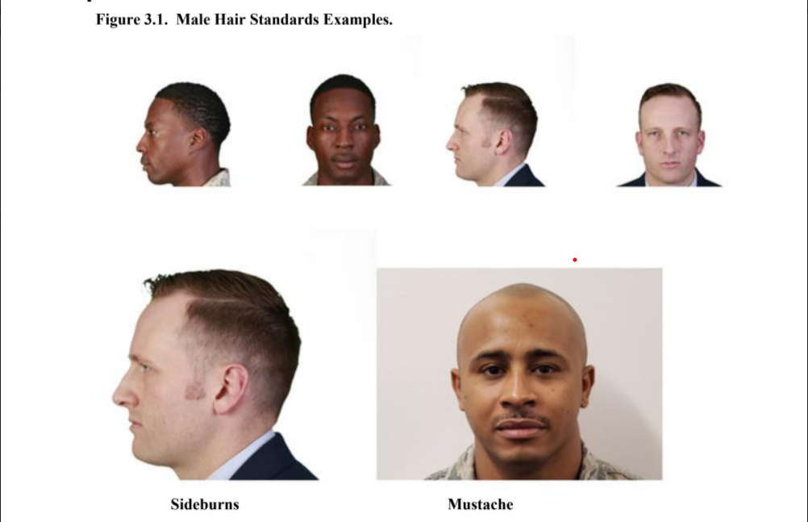
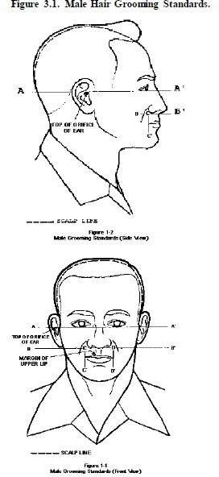

Bottom of ear orifice

Hair will not touch the ears

How to tie a Windsor Knot
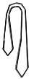
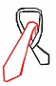

- Start with wide end of the tie on your right and extending a foot below narrow end
- Cross wide end over narrow and bring up through loop


- Cross wide end over narrow and bring up through loop

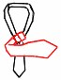

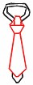
- Then put down through loop and around across narrow as shown

1
2
4

- Turn and pass up through the loop and...

- Complete by slipping down through the knot in front. Tighten and draw up snug to collar



How to tie a Four in Hand Knot?

1.Start with wide end of the tie on your right and extending a foot below narrow end

- Cross wide end over narrow and back underneath

- Continue around passing wide end across front of narrow once more

- Pass side end up through loop



- Holding front of knot loose with index finger, pass wide end down through loop in front

- Remove finger and tighten knot carefully. Draw up tight to collar by holding narrow end and sliding knot snug

FEMALE UNIFORM ITEMS

Service Coat, Blue:
Coats should follow the contours of the figure but allow ease of movement without pulling in the back of the waist. The sleeves should come to the base (heel) of the hand. The coat and slacks or skirt must match the color shade and material. Items will not be carried in the jacket pockets. The coat may be removed in the classrooms or the media center when it becomes uncomfortably warm. It may also be unbuttoned in the classroom to avoid binding or wrinkling. It will not be removed in school public areas such as hallways, common areas, or the cafeteria. When removed it will be hung up or carefully draped over the back of a chair. The coat will be put on and buttoned before leaving the classroom or media center. The coat will have the unit patch on the right sleeve and AFJROTC patch on the left sleeve as prescribed in AFJROTC Uniform and Awards Guide, dependent upon availability.

Flight Cap, Blue:
Worn with the crease straight with the nose, with insignia over the left eye, and worn one inch to one and one-half inches above the eyebrow.

Hose: Commercial sheer, nylon hose/thigh high’s in black or off-black, dark blue, dark brown, or neutral that complement the uniform and the cadet's skin color. Patterned hose is not allowed.

Socks: Black, commercial socks without design will be worn with slacks and oxfords.

Jacket, Light Weight, Blue Windbreaker:
Jackets must be zipped up at least halfway. Cuffs of the sleeves should cover the wrists but not extend beyond. Over blouse will not show below the jacket. The jacket will have an AFJROTC patch on the left sleeve as prescribed in AFJROTC Uniform and Awards Guide, dependent upon availability.

Blouse, Short Sleeve, Light Blue, and Pointed Collar:
May be worn with or without tab, except tab is worn with combination 1 (Service Dress Uniform). Blouses are worn tucked in.

Slacks, Blue:
Will fit naturally over the hips with no bunching at the waist or fullness in the seat. Bottom of the slacks will rest on the front of the shoes with a slight break in the creases. Back of the slacks will extend approximately 7/8 inch longer than the front. Slacks are tailored to straight hanging and any alterations to modify the leg shape must be approved by the SASI/ASI. Articles carried in the pockets will not be visible or present a bulky appearance.

Blue Belt:
With a skirt or slacks with belt loops, the silver tip end of the belt extends beyond the buckle facing the wearer's right; no blue fabric shows. Check frequently to ensure the "gig" line is straight.

Skirt, Blue:
Will be free hanging with zipper closure on the left hip. Length will be no shorter than the top of the kneecap and no longer than the bottom of the kneecap. Hose will be worn with the skirt.

Undergarments:
Will be worn with the uniform and will be conservative, commercial style, white, or tan in color.

Shoes:
Will be issued black oxford shoes to be worn with a uniform. Shoes will be laced to the top and highly shined. Optional scotch grain black leather or high gloss finish pumps are authorized for female cadets at their own expense. Optional high gloss black corfam or leather shoes are also authorized at the cadet's own expense. Heel height must not exceed 2 1/2 inches. Shoes will have plain closed toe and heel, and will not have any ornamentation such as bows, buckles, or straps.

Purse:
May carry a small black purse. The standard Air Force purse may be purchased and carried at the cadet's expense.

FEMALE PERSONAL APPEARANCE
Female cadets will not wear, carry, or expose on the uniform, pencils, pens, handkerchiefs, and jewelry to include ankle bracelets. One bracelet is permitted if it is neat and conservative and not wider than one inch. They may wear wristwatches, identification bracelets, and pearl, silver, diamond, or gold stud earrings if they do not extend or dangle below the bottom of the ear lobe. Earrings must be spherical or of plain design. They may wear no more than three rings at any one time.

Hair:
Hair must be clean, well groomed, and neat. Hair color if dyed will look natural, will not be worn in an extreme or fad style, contain excessive amounts of grooming aids, or exceed bulk standards. Hair will not touch eyebrows when groomed and may be visible in front of the flight cap. Hair must present a professional appearance. Plain and conservative pins, combs, headbands, elastic bands, and barrettes similar to natural hair color permitted to keep hair in place. Hair will not extend in length on all sides below an invisible line drawn parallel to the ground at the bottom or0 edge of the shirt collar at the back of the neck. Hair will not exceed 3 inches in bulk or prevent proper wear of the headgear. Hair will not include hair ornaments such as ribbons or jeweled pins.
- ponytails: Female cadets may wear their hair in up to two braids or a single ponytail with bulk not exceeding the width of the head and length not extending below a horizontal line running between the top of each sleeve inseam at the under arm through the shoulder blades. In addition, women’s bangs may now touch their eyebrows, but not cover their eyes.
Hair will be styled to present a professional appearance. Plain and conservative pins, combs, headbands, elastic bands, and barrettes similar to the individual’s hair color permitted to keep hair in place.
Hair will not be worn in an extreme or fad style or violate safety requirements. Hair will not extend in length on all sides below an invisible line drawn parallel to the ground at the bottom edge of the shirt collar at the back of the neck. Will not exceed 3 inches in bulk or prevent proper wear of headgear. Will not include hair ornaments such as ribbons or jeweled pins.
Nail polish may be worn if it is conservative, single color, and in good taste. Nail polish will not contain any ornamentation.
Cosmetics must be conservative and in good taste.

Example authorized scrunchie and hair clips

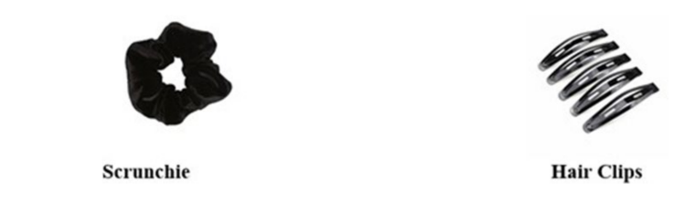

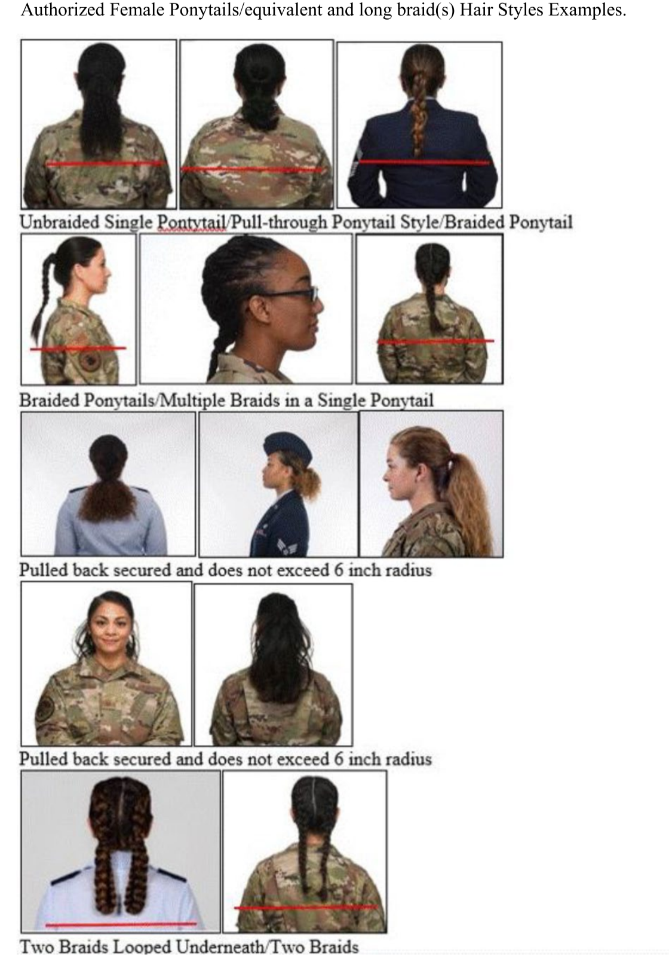
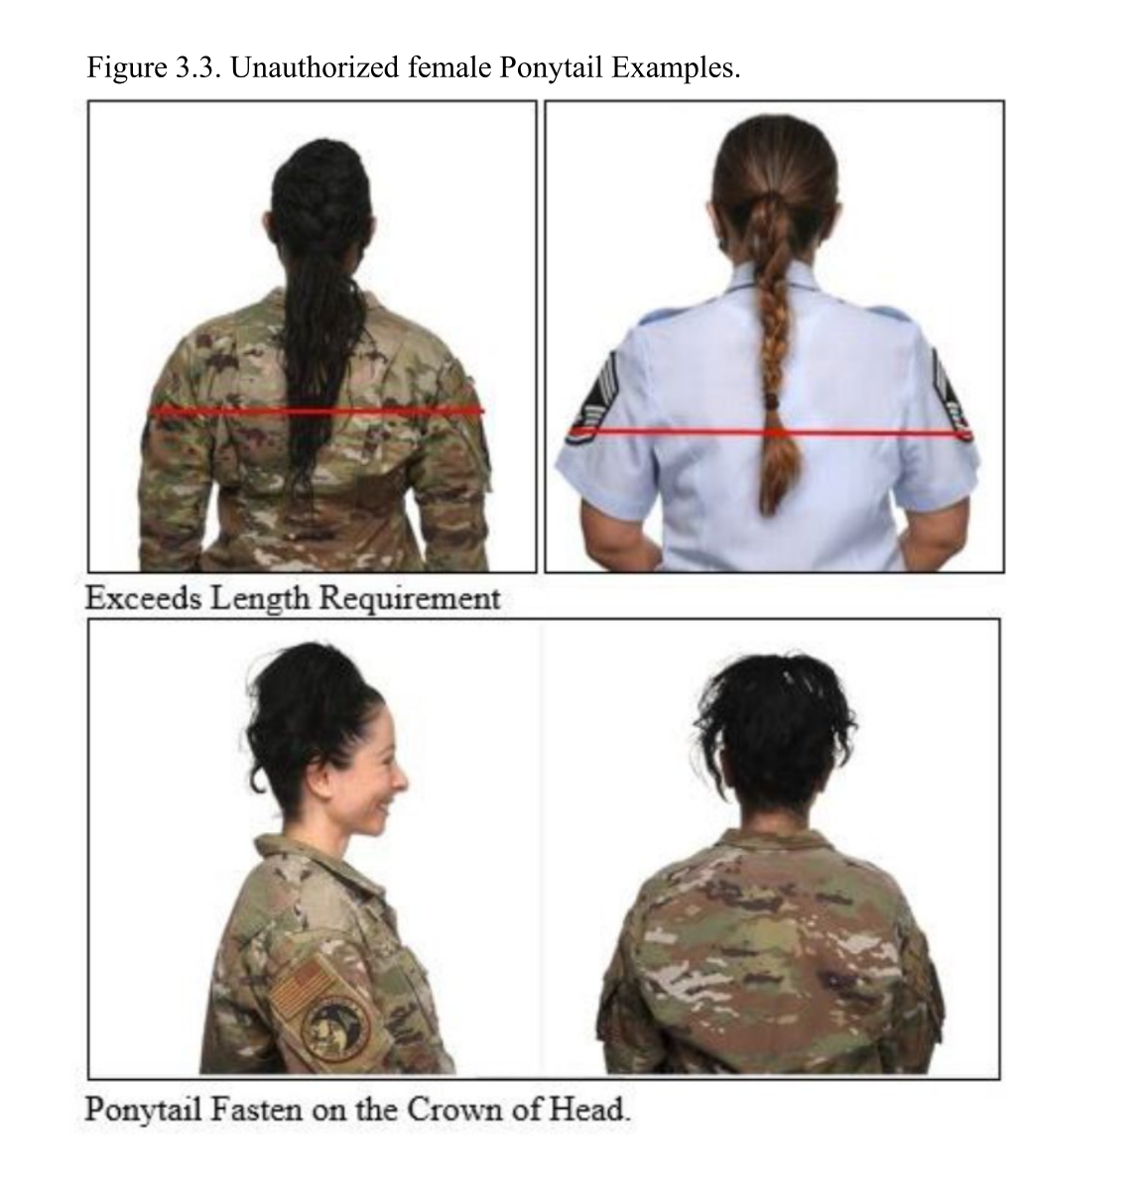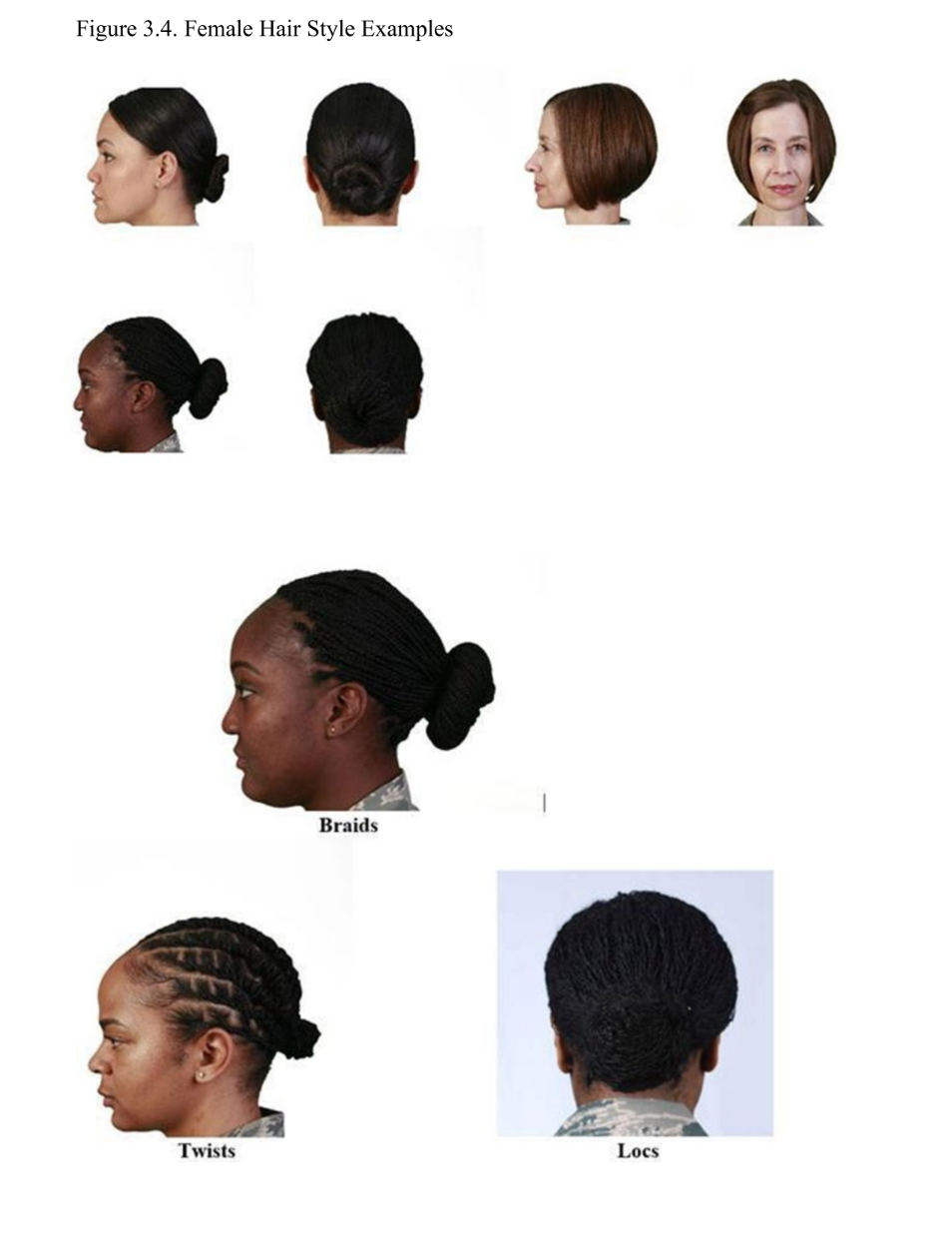
Cosmetics: Must be conservative and in good taste.

Fingernails:
Must be neat, clean, and nail polish, if worn, must be conservative, single color, in good taste, and not contain any ornamentation or design.

Earrings: May only wear one earring in each ear and it must be on the earlobe and must not extend beyond the lower portion of the earlobe. Earrings may have only one small spherical, conservative, diamond, gold, white pearl, or silver pierced or clipped earring per earlobe. Earrings must be matching and fit tightly to the lower portion of the earlobe without extending beyond the earlobe.

Attachment 7-1
Authorized Air Force JROTC Badges and Insignia
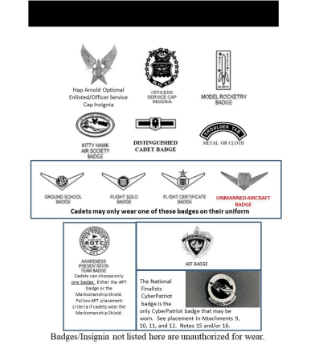

Attachment 7-1.1
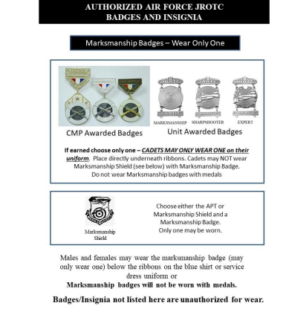
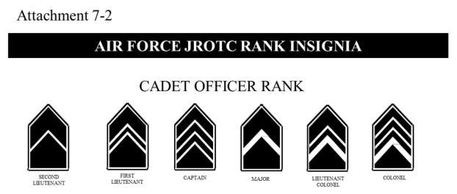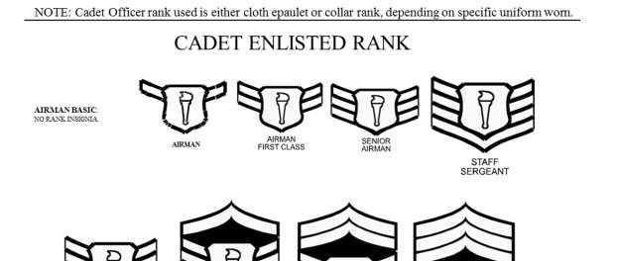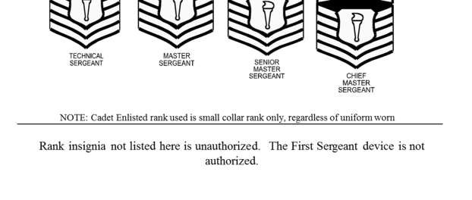

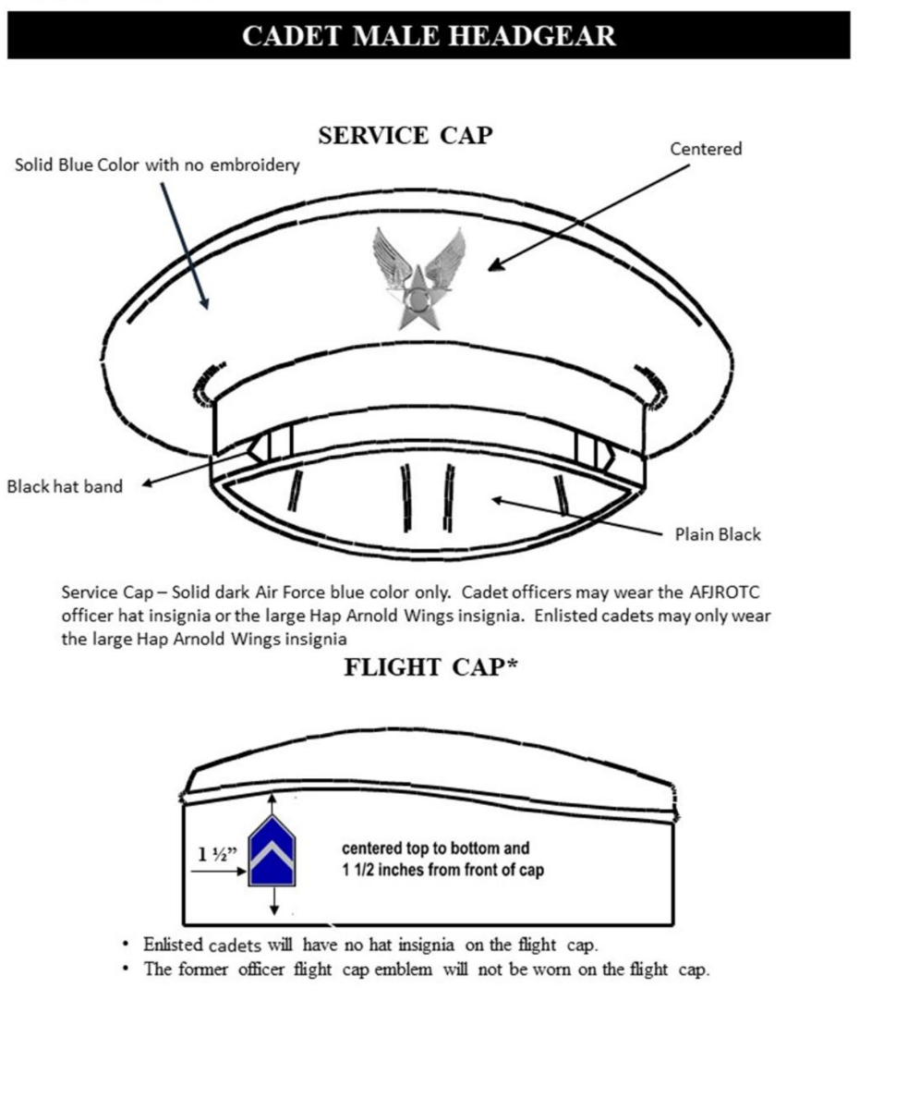
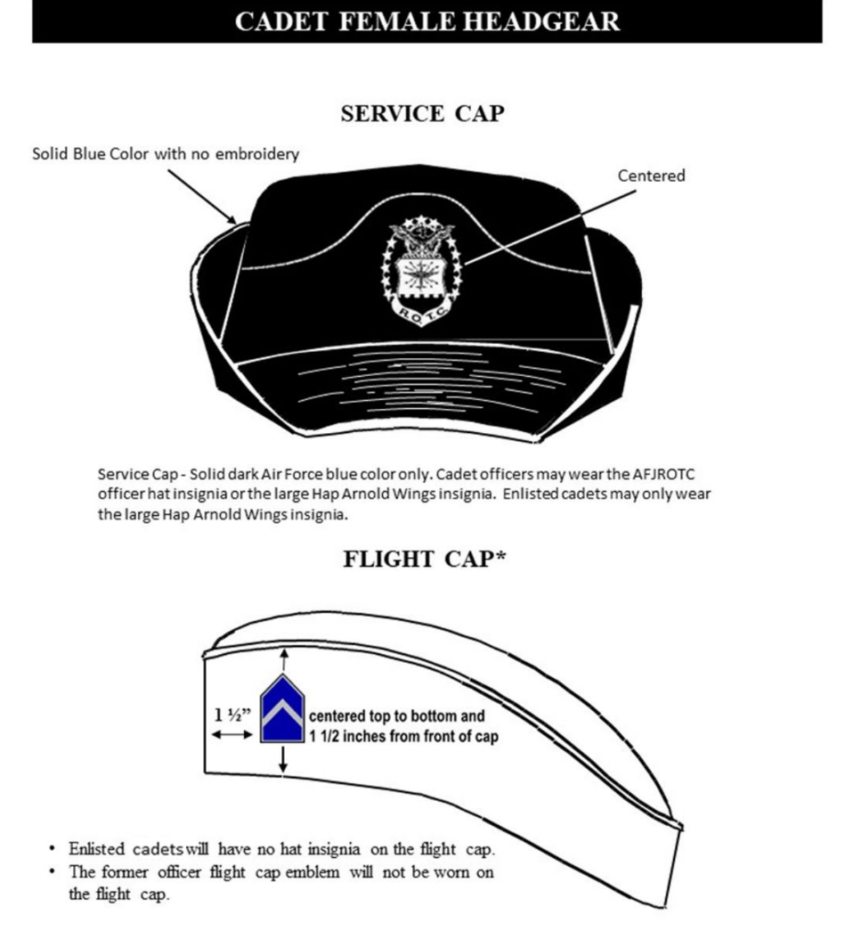
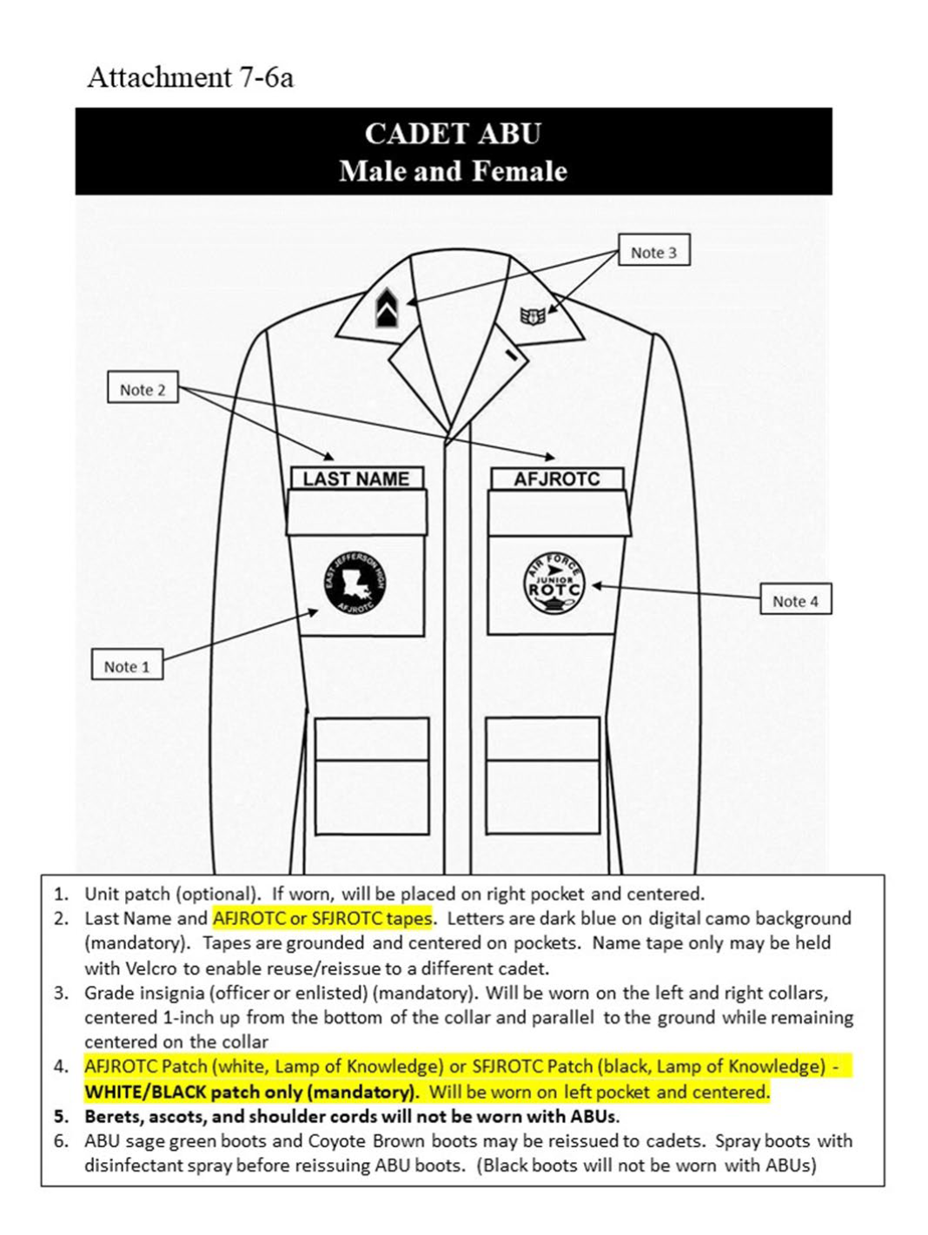
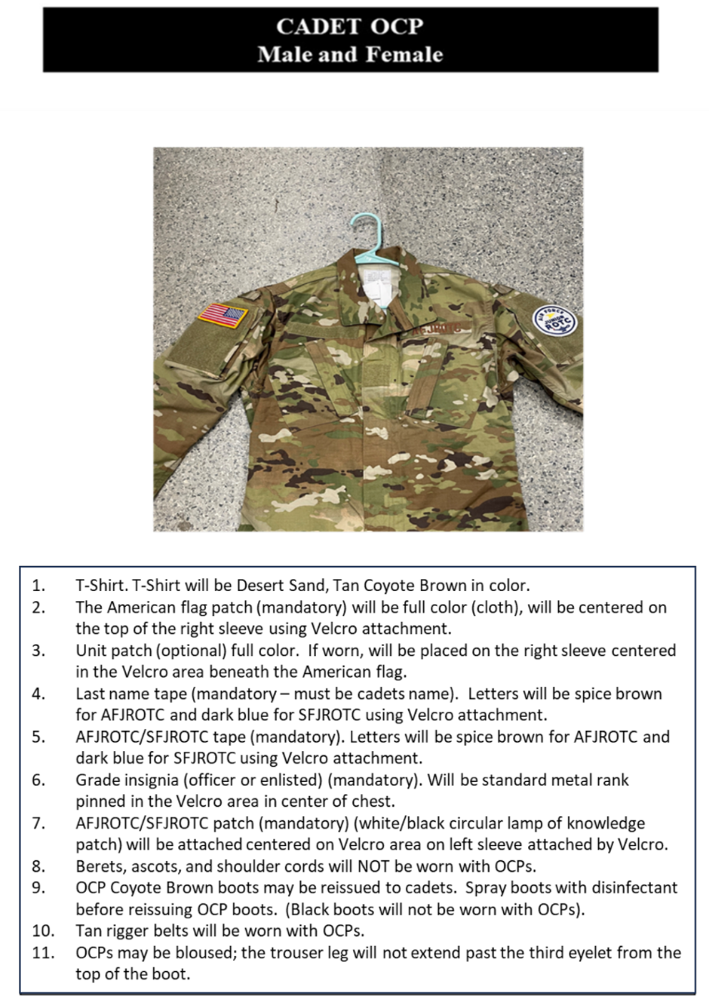
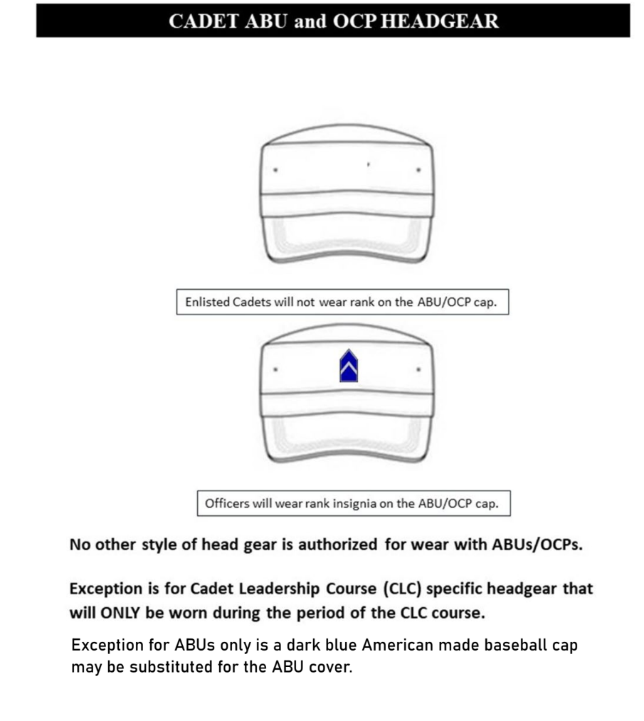
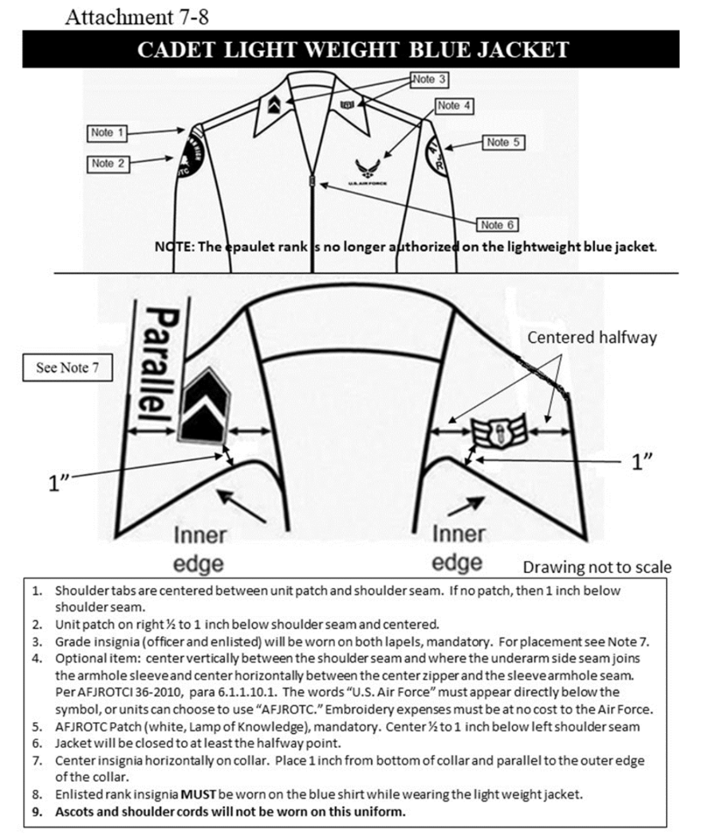

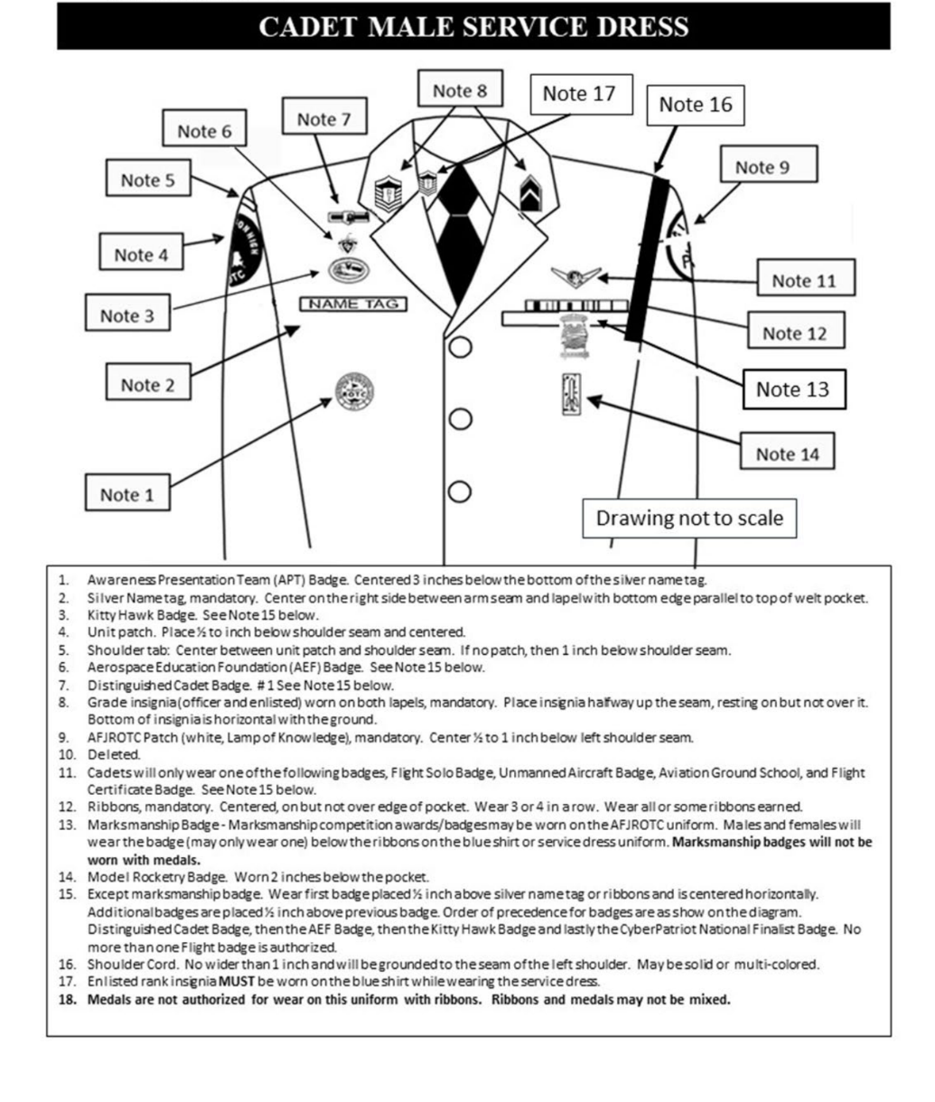

CADET MALE SERVICE DRESS
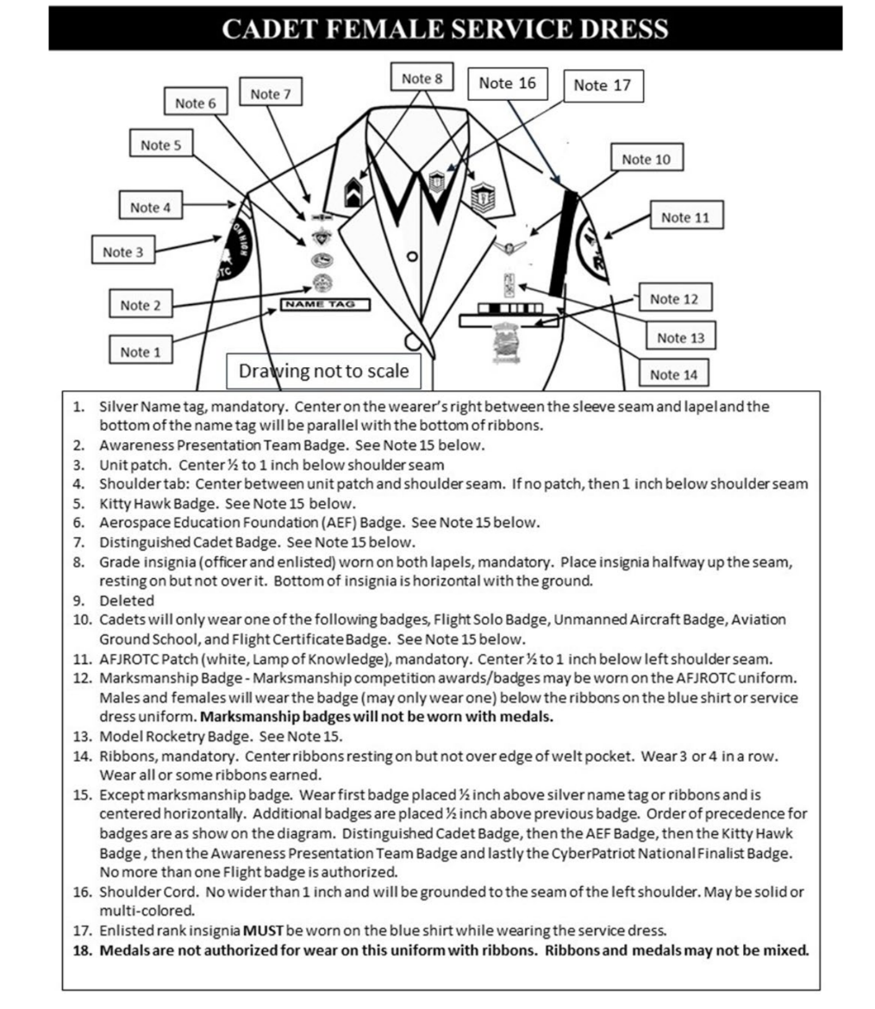

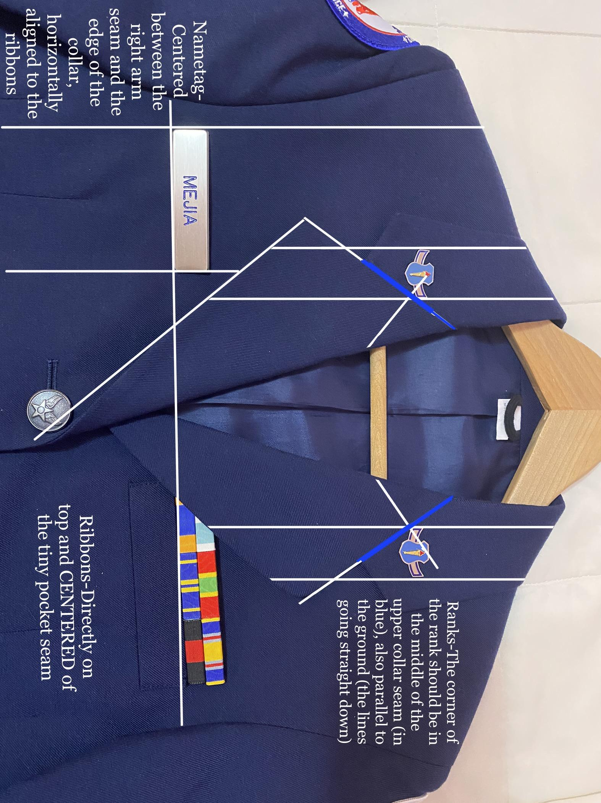
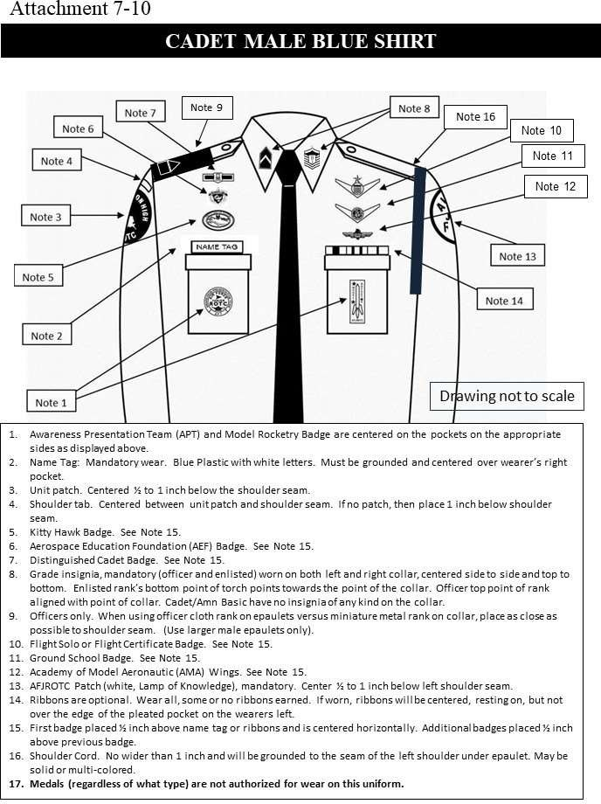

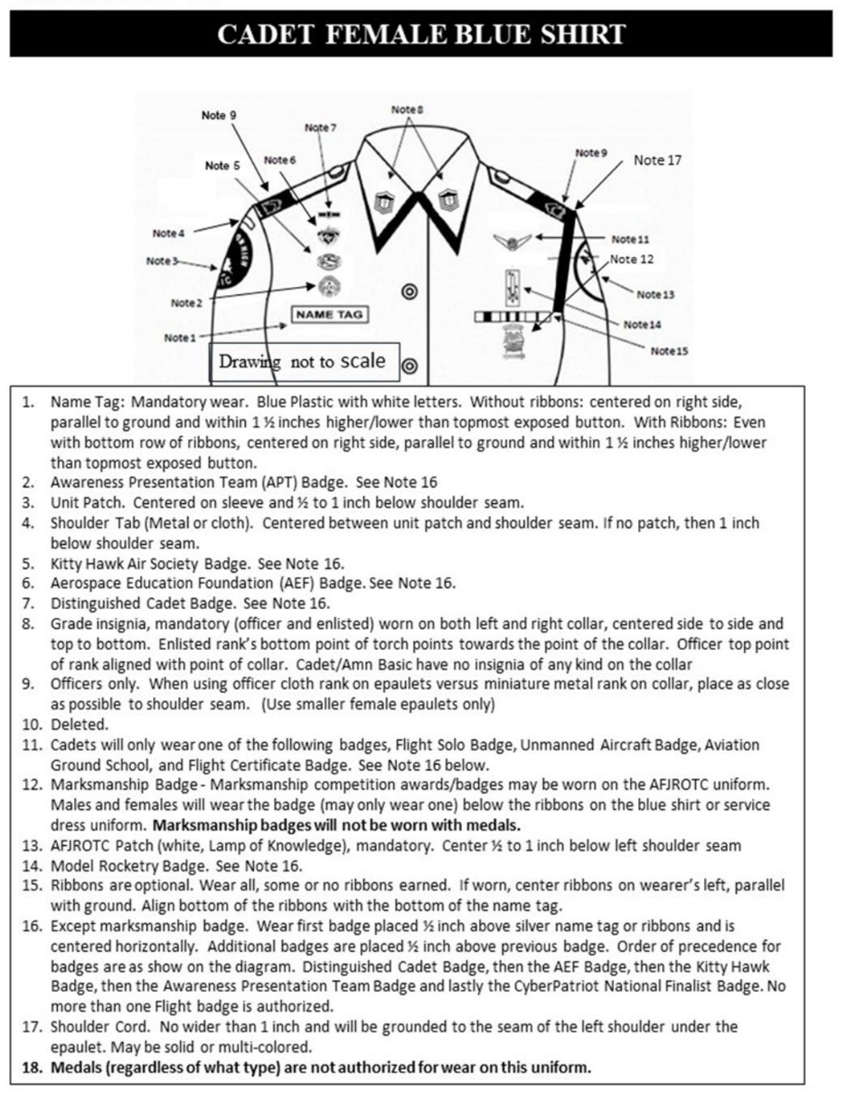

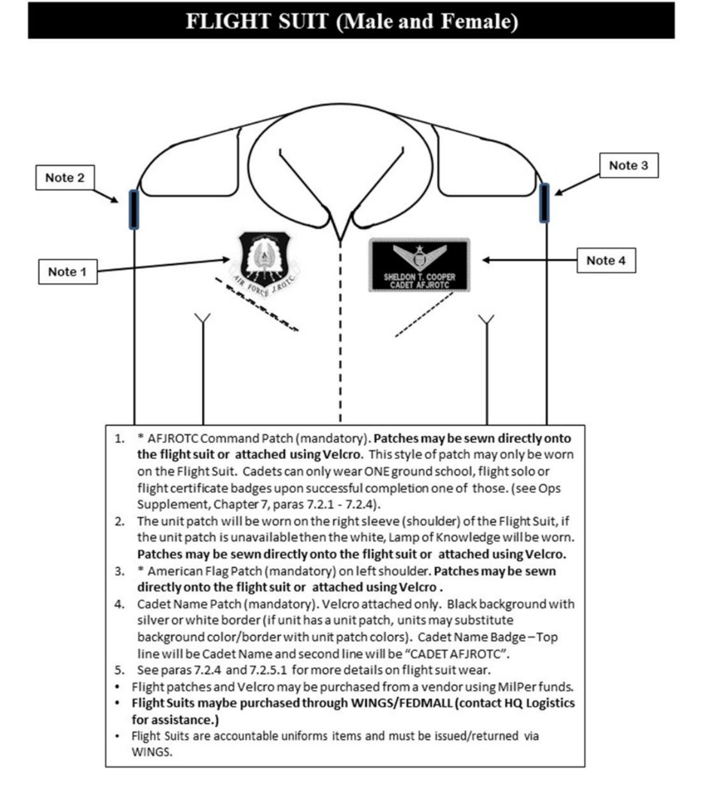
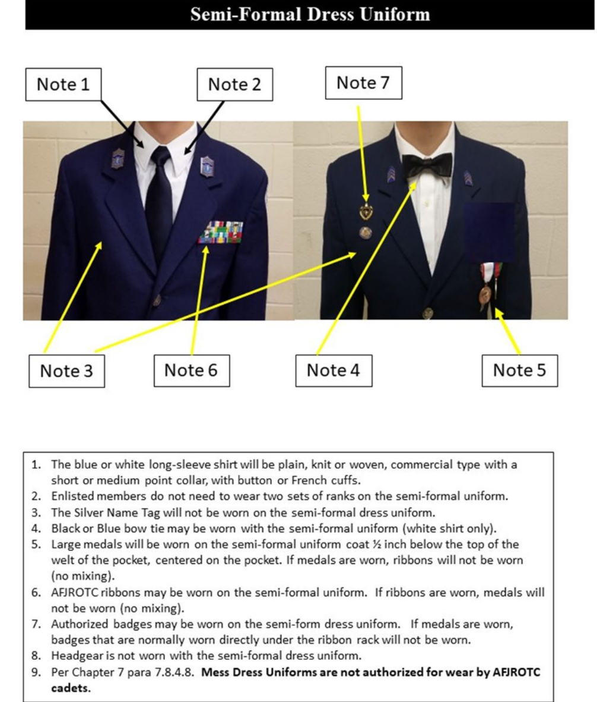
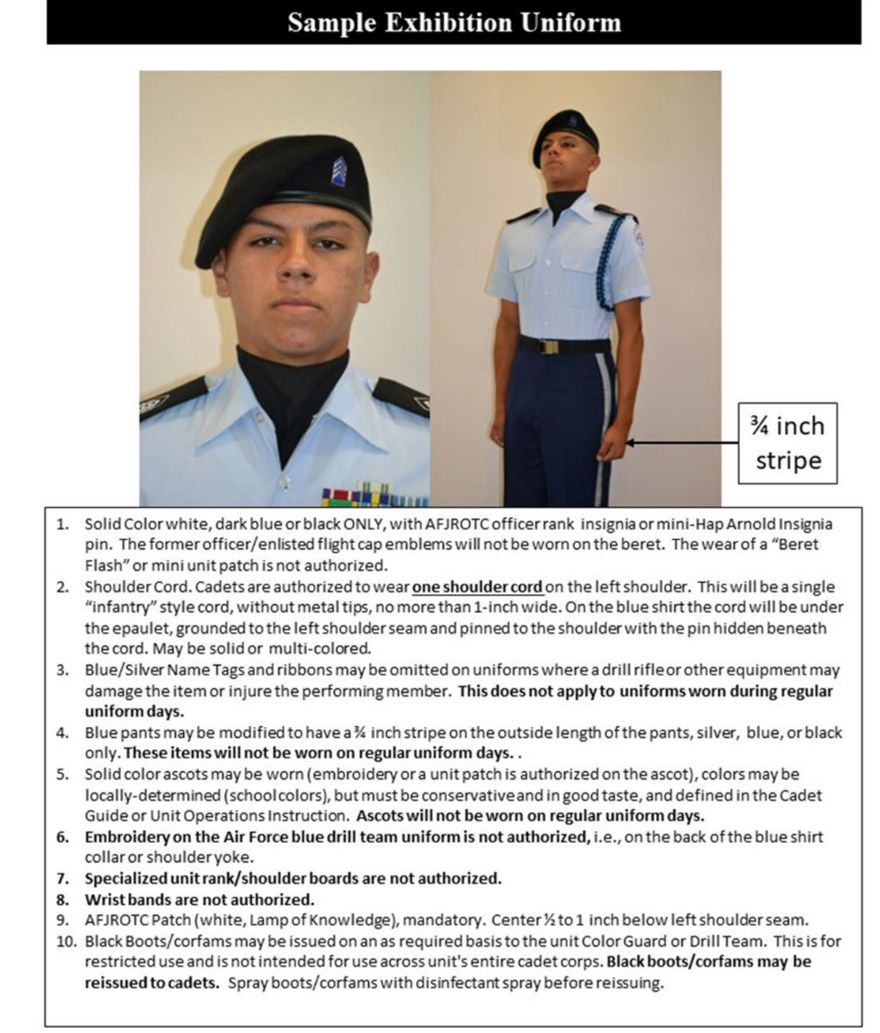
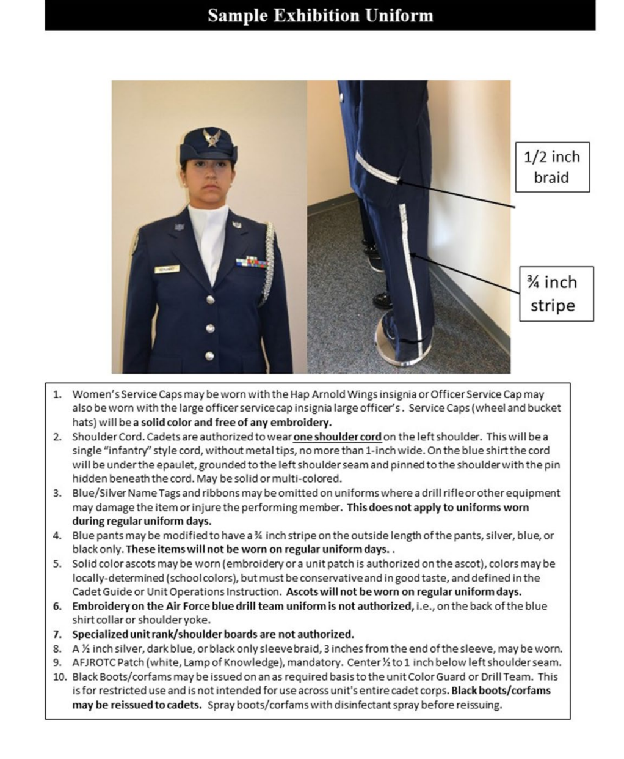
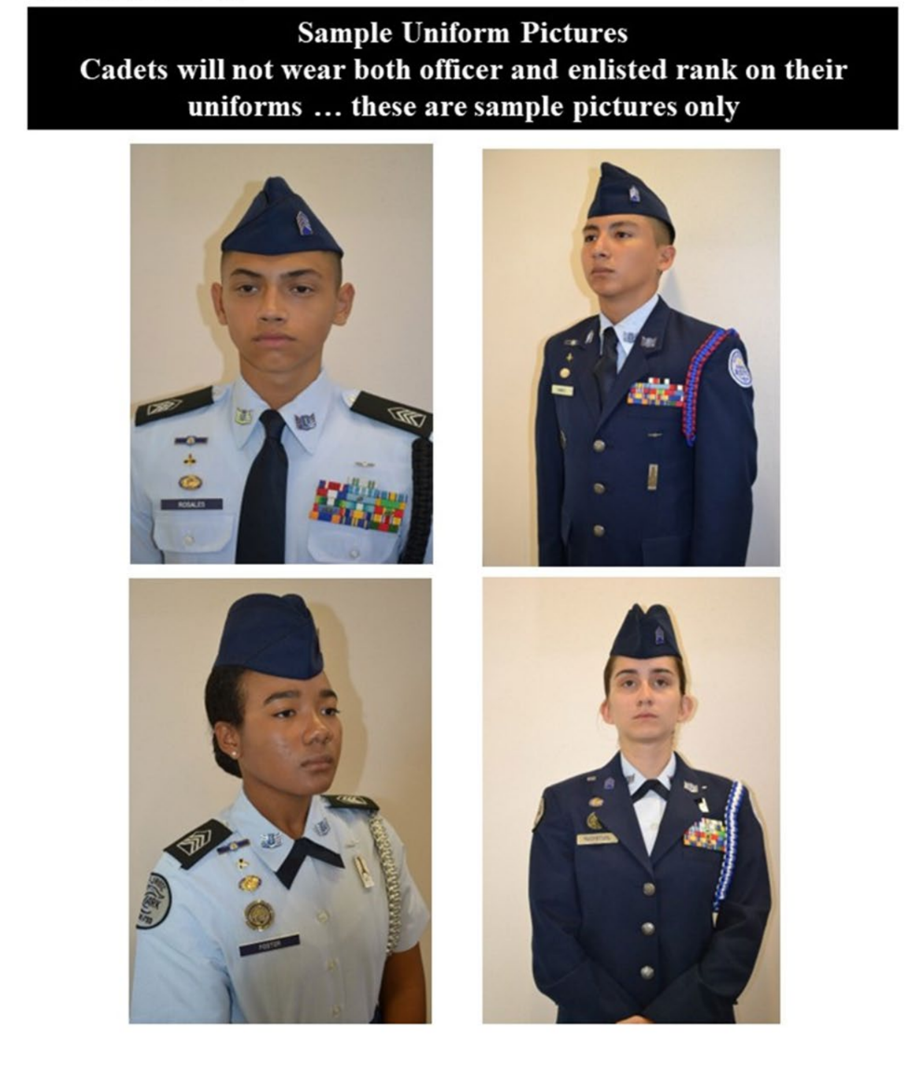

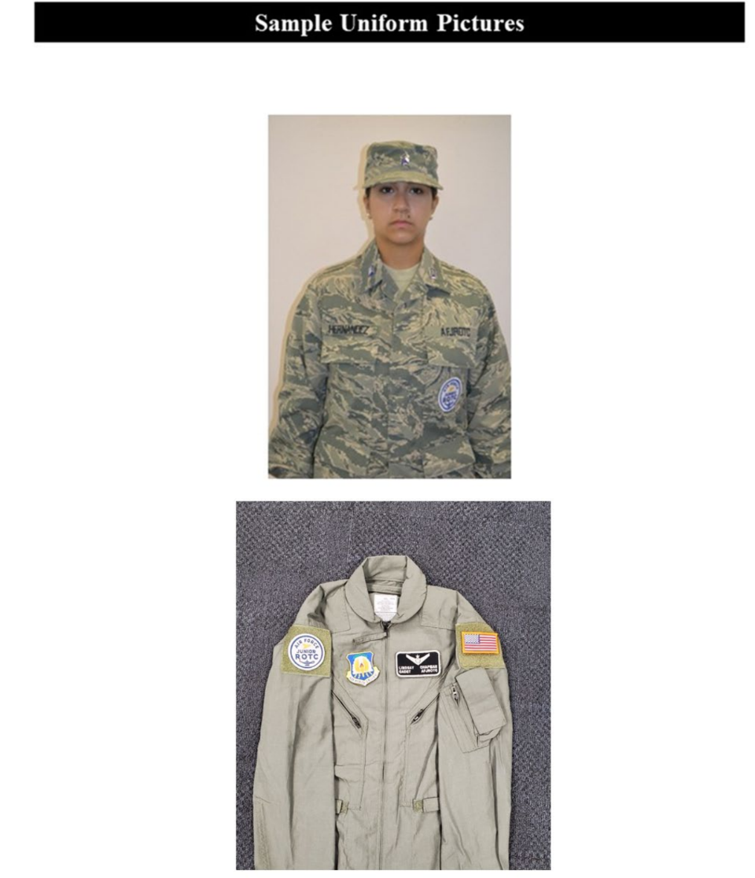

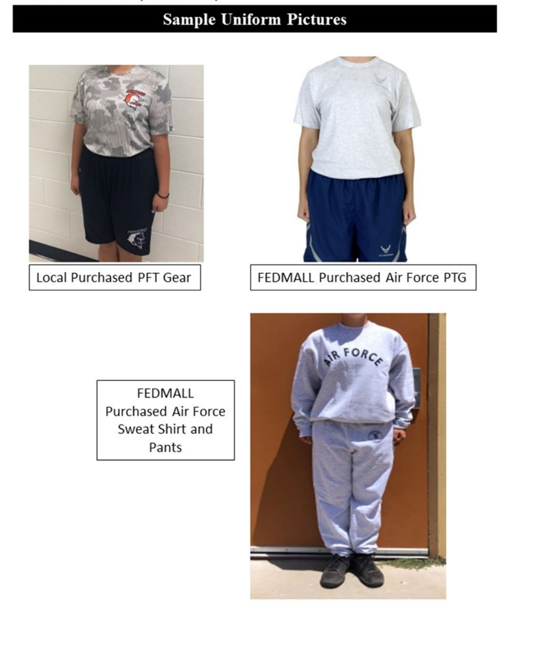

Religious Accommodation Request

Cadets seeking a religious accommodation waiver for grooming/appearance standards must first receive an approved waiver before they are permitted to wear the uniform with religiously accommodated grooming/appearance standards. Any religious accommodation or exception to policy regarding grooming/personal appearance requests, including, but not limited to shaving or hair length will be reviewed on a case-by-case basis.
Submit requests in WINGS (Unit Information | Unit Waivers | Dress and Appearance) with photos of the specific request, along with confirmatory letters from the parent(s) or guardian(s), the religious leader, the principal, and the SASI for AFJROTC approval. (NOTE: Exceptions to parent/guardian letter requirement would only be considered if the cadet has been deemed a ward of the state or otherwise as specified in state or federal law (and documented in the request package). In that instance, the SASI would make the cadet status known in their letter.)
The religious waiver request form can be found at: WINGS | Published Files | JROTC | AFJROTC Policy Letters | Religious Waiver Template

Transgender Uniform Change Request

Requests for a transgender cadet to be issued the uniform of their identified gender, and codified as
that gender in the AFJROTC data system, must be approved by AFJROTC.
Submit requests in WINGS (Unit Information | Waiver Request | Dress and Appearance) using the JROTC Preferred Gender Uniform Wear Waiver form. The form must be signed by the cadet, the SASI and the Principal who must all be in agreement. Before parental consent please contact your RD, who will contact JRS for guidance. This process is in place to protect cadets who may not be able to safely live in their affirmed gender at home. (Note: Exceptions to parent/guardian signature requirement would also be considered if the cadet has been deemed a ward of the state or otherwise as specified in state or federal law (and documented in the request package). In that instance, the SASI would make the cadet status known in their request form.)
The transgender waiver request form can be found at: WINGS | Published Files | JROTC | AFJROTC

COMMAND AND STAFF FUNCTIONS

COMMAND RESPONSIBILITIES: Cadet Officers are responsible for maintaining discipline
and for setting a proper example at all times. Whenever a cadet officer is absent, the next higher ranking officer/NCO is in charge.
ALL OFFICERS AND NCO’s with positions must maintain a “B” average in AFJROTC and a minimum 3.0 overall GPA for the 9 week grading period. If the GPA is less than 3.0 the cadet will be placed on academic probation for the next 9 weeks. At the end of the second 9 week grading period if GPA is still less than 3.0, the cadet will be removed from their position.

AUTHORITY AND RESPONSIBILITY: Cadet Officers are authorized to give orders to
cadets who are junior to them. This authority and responsibility will be confined to AFJROTC activities only and will not be carried over or permitted in other classes throughout the school. Cadet staff members have the authority to correct infractions observed on campus such as public display of affection (PDA), incorrect wear of the uniform, or other transgressions observed while not in class. Cadet staff members will notify instructors of any infractions observed if the cadet making the infraction is not willing to correct the problem when asked by a senior cadet. Cadet officers do not have the authority to excuse other cadets from scheduled classes, formations, or to change or modify existing orders or instructions.
CADET STAFF POSITION: Staff positions have been established as near to Air Force staff positions as possible. Titles similar to those of active duty situations are used. There are enough staff positions to provide sufficient opportunities and incentives for cadets to participate in AFJROTC program, but not so many that the positions have no responsibility or meaning. Consistent with their abilities and available time for AFJROTC activities, cadets will be given every opportunity to experience the function of a military organization. The AFJROTC Instructors will monitor and observe the assigned duties of all cadets.
CADET STAFF MEETINGS: The cadet group commanders, cadet mission support, cadet operations support, cadet superintendent and staff will conduct scheduled meetings on Wednesdays during class. Please note; if you can’t make it ensure you have representation/cover (take phone numbers of people within your chain).

CHAIN OF COMMAND: The chain of command is the primary channel of communication throughout the corps. The communication system must be a two-way channel of information flowing in both directions. Information flows from the Instructor’s and Cadet Commander through the corps to the individual cadet and from the cadet up through the system to the commander and instructors. The Chain of Command for AFJROTC cadets extend upward and downward as follows:

Senior Aerospace Science Instructor
Aerospace Science Instructor
Cadet Group Commanders
Cadet Senior Enlisted Leader (Cadet CMSGT)
Cadet Mission Support
Cadet Operations Support
Cadet Squadron Commanders
Cadet Flight Commanders
Individual Cadets

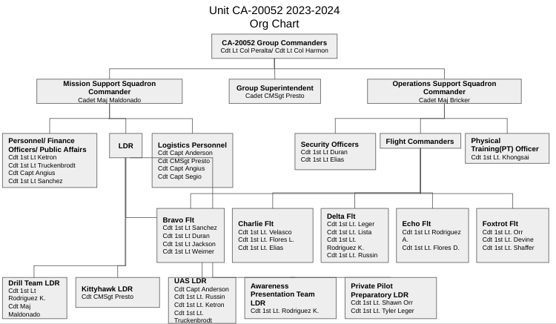

ASSIGNED DUTIES AND RESPONSIBILITIES
Basic duties and responsibilities for each are outlined below. These are not all inclusive, and each cadet is expected to seek out and complete tasks that will make the corps run smoothly. The primary leadership responsibility for each cadet Officer, cadet Senior NCO, and cadet NCO is to set the standards of performance in everything they do.
- CADET: Each cadet is responsible for conducting themselves in a manner to reflect credit upon themselves, the AFJROTC program, and Great Oak High School. Since each cadet wears their uniform once a week, your actions also reflect on the United States Air Force and your country. Whether in uniform or not, cadets are responsible for maintaining rules and regulations of the corps and school, and for carrying out instructions and orders of their superiors to the best of their ability.
- CADET OFFICERS AND STAFF NCO’s: Cadets have been promoted and selected for corps assignments based upon demonstrated performance and individual potential.
Continued enthusiasm, active participation, a positive attitude, and leadership by example are required to advance or remain in leadership positions. Cadet officers and staff NCOs are expected to set the example for junior cadets in every aspect of the AFJROTC program. The responsibilities of leadership must be demonstrated before the privileges of rank can be assumed. Extra effort and time will be required, especially of cadet officers and NCOs. Those selected for advancement who do not wish to accept the related and additional responsibilities and requirements should decline the promotion.

CA-20052 GROUP STAFF
(Please, visit our website:https://www.tvusd.k12.ca.us/Page/23903)

Group Commanders (CC)
- Commands and controls the Corps through effective staff and subordinate leaders.
- Ensures proper appearance, discipline, efficiency, training and conduct of the Corps.
- Administers Corps activities according to Air Force principles and procedures.
- Convenes and attends Cadet Boards as necessary.
- Presides over all Group Staff Meetings.
- Works closely and informs the SASI of all planned staff activities.
- Visits each Flight (once per term) to observe drill and uniform inspections
- Hosts the Annual Awards Night (month of April)
- Provides input, along with SASI and ASI for National Awards and Next Year’s Group Staff
- Assists the SASI/ASI as needed

Support Squadron Commander (SS)
- Ensuring proper maintenance of administrative and personnel files
- Learning the responsibilities and procedures of each functional area of Mission Support
- Performing other duties as assigned by the Group Commander

Senior Enlisted Leader (CMSGT)
- Commands and controls the Enlisted Corps through effective staff and subordinate leaders
- Advises Group Commanders
- Motivates enlisted cadets
- Attends group staff meetings and hosts enlisted calls

Operations Squadron (OPS)
- Supervises all security events
- Plans and organizes all AFJROTC activities/events (i.e. Parades, Community Service, Field Trips, Sports Day)
- Plans and organizes all AFJROTC Drill and Color Guard events (i.e. Parades, Drill Meets)
- Overseas the RC club; ensures Operating Instruction is in place
- Conducts spot checks on Color Guard, Drill, and RC to ensure compliance. Ensures permission slips and other school required documentation is completed (bus requests, parental permission slips, etc.)
- Attends Staff meetings
- Organize and Evaluate Monthly Recognition Boards
- Performs other related duties on the request of the SASI/ASI
- Ensures all cadets comply to uniform wear, campus wide
Flight Commanders’ Responsibilities:
- Assumes the responsibility and accountability for the flight’s uniform and grooming appearance discipline and overall classroom demeanor.
- Leads and directs the flight at all group and flight functions.
- Maintains a high degree of esprit-de-corps and discipline within the flight.
- Supervises the flag raising or lowering detail.
- Performs Military Drill to cadets and trains Deputy Flight CC on the 30-step commands.
- Attends Staff Officer meetings.
- Updates cadet folders to show community service hours
- Performs Flight Sergeant duties in the absence of the Flight Sergeant
- Ensures cadets keep the classroom clean and tidy and enforce the “No Eating” rule.
- During classroom instruction, the Flight Commander functions as a Teacher Assistant, takes attendance.

Physical Training Officer/Physical Training Leader
- PT Officer plans and oversees PT events and activities
- PTL takes charge of the Flight
- Determines who is present/absent
- Conducts warm up stretches
- Enforces rules and ensures professionalism during PT activity
- Maintains PT scores and forwards them to the SASI/ASI

Element Leaders
- The appearance, discipline, efficiency, training, and conduct of the cadets who make up the element.
- Ensuring that all cadet members of the element have the opportunity to develop leadership skills commensurate with their individual abilities.
- Teaching, observing, and evaluating members of their elements.
- Distributing and collecting necessary materials.
- Monitoring element’s academics/missed work.
- Performing other related duties assigned by the flight commander.

Logistics Flight (LG)
- Distributes Uniform Items; ensures cadets sign for the items they receive— parental approval letters must be signed first
- UpdateWINGS (With SASI/ASI present) to show what each cadet has received
- Ensure 100% accountability of “accountable” items; stock must match CIMS numbers
- Provide a once a week Uniform Exchange program (some items will only be replaced at a cash value to replenish our stocks)
- Collect uniforms (must be dry cleaned) of those cadets who are graduating or not returning
- Maintain stock levels; contact SASI/ASI of items that need purchasing
- Performs other related duties on the request of the SASI/ASI
- Logistics officers attend Staff meetings

Public Affairs (PA)
- Must assemble an effective team to manage numerous activities.
- Coordinates space and layout in the GOHS yearbook, and effectively implements school (T.V., yearbook and newspaper) media, extolling Corps benefits and activities.
- Focal point for internal/external public relations; meets guests and shows them where to go – notifies Administration of their arrival 24-hours prior.
- Updates the AFJROTC Web Page, calendar, email distribution list.
- Makes a yearly video for the Awards Night.
- Assists other Squadron commanders when help is required.
- Attends Staff meetings
- Performs other related duties on the request of the SASI/ASI

Personnel Squadron (DP)
- Compiles promotion/ribbon data on each cadet in the cadet’s folder and in
WINGS
- Enters Physical Training scores in WINGS
- Updates Cadet of the Month data to help determine “Cadet of the Month” and subsequent “Flight of the Year”
- Manages/Prepares Awards Night o Contacts National Representatives, Arranges Script, and ensures certificates are accomplished to show what each cadet earned and process the certificates for cadets have 3+ years in the program
- Updates/Manages each cadet’s information in WINGS to include all cadets have a signed copy of:
o Physical Training Permission, Uniform Letter, Community Service, Curriculum Standards, and other applicable letters that may be added
- Performs other related duties on the request of the SASI/ASI
- Attends Staff meetings

Drill Commander (Armed) (Unarmed) (Sabre) (Color Guard)
- Assumes responsibility and accountability for the team’s practices, competition, parade participation and other support requested
- Maintains a high degree of esprit-de-corps and discipline within the team
- Mentors members and sets an example with enthusiasm, dedication and team pride
- Manages team challenges to include discipline, coordination of activities, moral, and implements solutions as necessary
- Immediately reports all discipline challenges to the SASI/ASI
- Reports (written) list to SASI/ASI all tardy or missed practices from cadets
- Must maintain a weekly updated, accurate team roster, posting information for team practices on whiteboard
- Ensures Drill team equipment is clean
- Ensures accountability of drill team equipment
- Informs SASI/ASI when equipment needs purchasing
- Ensures only authorized Drill team personnel are in the Armory

Cords (worn on the left shoulder grounded to the shoulder seam, with no metal tips and no wider than 1-inch, with no extra loops inside or outside of the arm)
- Red and Blue: Top 5
- Red: Officers
- Black: Drill Team members who meet 85% attendance for one year and compete (this can be exhibitions or tap out participation on any drill team)
- Blue: Drone Squadron Commanders
- Silver/white: Color Guard Team members who meet 85% attendance for one year and compete (this can be exhibitions or tap out participation on any drill team)
- Green: Cadet of the Month
- Yellow: Senior NCO
- Gold and Red: Kitty Hawk Commanders
- Purple: Logistics Personnel
- Teal: Awareness Presentation Team Commanders
- Blue Graduation Honor Cord: 4 Year Cadets
Blue Polos/ Pins
- Drone Polo: 85% drone team attendance across 1 school year
- Drill Polo/ Pin: 85% drill team attendance across 1 school year and compete in 1 competition (exhibition/ regulation/ tapout)
- Color Guard Polo: 85% drill team attendance across 1 school year, compete in 1 competition (exhibition/regulation/tapout), and participate in 2 events

Uniform Replacement Costs

Male  Uniform | Price | Quantity Issued | Female Uniform | Price | Quantity | Initials
Service Coat | $109.31 |  | Service Coat | $99.39
Windbreaker | $86.16 |  | Windbreaker | $86.16
Flight Cap | $9.99 |  | Flight Cap | $8.92
Shirt | $14.47 |  | Shirt | $12.55
Pants | $38.74 |  | Pants | $30.60
Dress Shoes | $45.39 |  | Skirt | $32.45
Belt/Buckle | $5.85 |  | Dress Shoes | $49.52
Neck Tie | $5.70 |  | Belt/Buckle | $5.85
PT Shirt | $6.98 |  | Tab | $6.00
Beret  Ranks | $15.08 |  | PT Shirt | $7.20
Rope | $10.00 |  | Beret | $15.08
ABU Hat | $7.00 |  | Rope | 10.00
Ribbon Bar | Must replace if lost or damaged |  | ABU Hat | $7.00
 |  |  | Ribbon Bar | Must replace if lost or damaged

COURSE SYLLABUS
2024-2025 ACADEMIC YEAR

AS-I

AEROSPACE SCIENCE 100/LEADERSHIP EDUCATION 100
AFJROTC PHYSICAL FITNESS PROGRAM

CREDIT HOURS: One (1) hour of Physical Education/General Education Credit
INSTRUCTORS’ NAME: Col Scott Barberides, CMSgt William Jones, & MSgt George Macias
INSTRUCTION MATERIALS: Classroom Performance System, A Journey into Aviation
History/Citizenship, Character & Air Force Tradition

Course Description:
A Journey into Aviation History: Starting with ancient civilizations, the course progresses through to modern days. It emphasizes civilian and military contributions to aviation, the development and modernization of the United States Air Force, and a brief history of astronomy and exploration. The intent of this course is to provide the historical significance of human ingenuity and the events which led to modern day aviation.
Course Objectives:
- Know the aspects of Ancient Flight & their pioneers
- Know the milestones in the expansion of flight as it went mainstream
- Understand the evolution of the Air Force
- Comprehend the transition of flight from the propeller to jet era as well as commercial flight
- Know events of modern Air Force and its role in wars
- Examine the space and rocketry programs past, present and future

Semester I
Semester II | Chapter 1 - Ancient Flight  - Lesson 1: Discovering Flight  - Lesson 2: The Early days of Flight  Chapter 2 – Pioneers of Flight iii. The Wright Brothers
Chapter 2: Pioneers of Flight
i. Developing Aircraft ii. Air Power in World War I

Citizenship, Character & Air Force Tradition: An introductory course designed to provide a solid foundation about military traditions, citizenship, the United States government, wellness, health, fitness, and how to exercise self-control.

Course Objectives:
- Understand the history, organization, mission goals and objectives of AFJROTC
- Be aware of social behavioral norms and codes of conduct
- Establish health care methods necessary to maintain an active state of fitness and well being
- Know aspects of citizenship and their function within a governmental system
Semester I
Chapter 1 – Introduction to JROTC Programs
    - Lesson 1: Organization of the JROTC
ii. Lesson 2: The Military Uniform and Appearance Standards

Semester II
Chapter 1 – Introduction to JROTC Programs
    - Lesson 3: Customs and Courtesies
    - Lesson 4: Attitudes, Discipline and Respect
iii. Lesson 5: Ethics Values and Morals

Wellness: This course provides an exercise program focused on individual base line improvements in the AFJROTC Physical Fitness Program. The repetitions and run times are based on gender and age. Wellness is instrumental in developing citizens of character dedicated to serving our nation and communities. This program is provided as a tool to help the cadets develop individualized training programs to achieve lifetime health and wellness. Cadets exempted from participating in physical training for the day must have, on first notice, a note from parents. If the cadet is incapable of performing activities on more than one training day, then the cadet must have a note from a licensed healthcare provider. If a cadet chooses to not participate without documentation, a zero (0) grade will be input to Pinnacle.

Wellness Program Course Objectives are to:

  - Create a personalized training routine based on baseline, age, gender, and participation in the Presidential Physical Fitness Program. Cadets are responsible for wearing the assigned PT uniform on Monday and Friday; if not they are deducted points (10 for missing shirt/10 for missing shorts/ 5 for missing water, not to exceed 25 points) each fitness day.
  - Strive to complete the number of repetitions indicated by the Presidential Physical Fitness Program.
  - Perform all exercises at home to make adequate progress.
  - Participate and observe safety precautions including being hydrated before starting an exercise routine.

Grading Procedures:
Academic Leadership grade will be based on quiz scores, participation during discussions, and semester final exams. During quizzes and final exams cadets will be allowed to use notes taken from lecture, readings, or discussion. Fitness will be based on uniform wear and fitness tests. One grade will be input monthly for uniform inspection

Grade Percentage Required
- 90 or Above
- 89 – 80
- 79 – 70
F 69 and Below

Uniform Day: Wearing an AFJROTC uniform on assigned days (usually Wednesday); a graded component of Leadership Education (100 points). Cadets that do not wear the uniform on assigned days will receive a grade of “F” for that day. Cadets who habitually fail to wear the uniform as required will not receive a passing grade in this course.

If you have any questions or concerns please feel free to contact by phone or email;
Phone: (951) 294-6450 ext. 4111 Email: wjones@tvusd.us; gmacias@tvusd.us Sbarberides@tvusd.us

Scott Barberides, Col, USAF (ret.) William Jones, CMSgt, USAF (ret.)
Senior Aerospace Science Instructor Aerospace Science Instructor

George Macias, MSgt, USAF (ret.)
Aerospace Science Instructor

COURSE SYLLABUS
2024-2025 ACADEMIC YEAR

AS-II

AEROSPACE SCIENCE 200/LEADERSHIP EDUCATION 200
SCIENCE OF FLIGHT/COMMUNICATION AWARENESS, AND LEADERSHIP
AFJROTC PHYSICAL FITNESS PROGRAM

CREDIT HOURS: One (1) hour of Physical Education Credit
INSTRUCTORS’ NAME: Col Scott Barberides, CMSgt William Jones & MSgt George Macias
INSTRUCTION MATERIALS: Classroom Performance System, The Science of Flight, Leadership Education II Communication, Awareness, and Leadership.

Course Description for The Science of Flight: The course is designed to complement materials taught in math, physics, and other science related courses and support a Science, Technology, Engineering, and Mathematics (STEM) education. It is aligned with the National Science Education Standards, the National Math Standards and Expectations, and ISTE National Educational Technology Standards for Students.

The Science of Flight Objectives are to:
- Analyze the elements of flight
- Evaluate how atmospheric conditions affect flight
- Evaluate how flight affects the human body
- Analyze flight navigation and the purpose of aerial navigation aids
1st Semester:
  - How Airplanes Fly
    - Chapter 1: How Airplanes Fly
ii. Chapter 3: Flight and the Human Body
2nd Semester:
  - How Airplanes Fly
    - Chapter 4: Flying from Here to There
Course Description for Leadership Education II: focuses on the AFJROTC mission to “develop citizens of character dedicated to serving their nation and community”. This is accomplished through better communications, increased awareness of self and others, and improved leadership. Woven throughout this course is the underlying theme of developing personal integrity while emphasizing leadership and other values, such as service and excellence.

Leadership Education II: Communication, Awareness, and Leadership Objectives are:
- Apply the key factors of effective communication
- Know the ways in which personal awareness affects individual actions
- Know the key elements of building and encouraging effective teams
- Apply the key behaviors for becoming a credible and competent leader

1st Semester:
  - Unit 1 Learning, Communication,
  - and personal development
    - Chapter 1: Learning and Communication
ii. Chapter 2: Communicating Effectively
2nd Semester:
  - Unit 2 Building Personal Awareness
    - Chapter 4: Understanding Your Action
  - Unit 3 Understanding Groups and Teams
    - Chapter 6: Solving Conflicts and Problems
  - Unit 4 Preparing for Leadership
    - Chapter 7: Leadership Model
Wellness: This course provides an exercise program focused on individual base line improvements in the AFJROTC Physical Fitness Program. The repetitions and run times are based on gender and age. Wellness is instrumental in developing citizens of character dedicated to serving our nation and communities. This program is provided as a tool to help the cadets develop individualized training programs to achieve lifetime health and wellness. Cadets exempted from participating in physical training for the day must have, on first notice, a note from parents. If the cadet is incapable of performing activities on more than one training day, then the cadet must have a note from a licensed healthcare provider. If a cadet chooses to not participate without documentation, a zero (0) grade will be input to Pinnacle.

Wellness Program Course Objectives are:
- Create a personalized training routine based on baseline, age, gender, and participation in the Presidential Physical Fitness Program. Cadets are responsible for wearing the assigned PT uniform on Monday and Friday (Exception AS300 & AS400 PT on Monday); if not they are deducted points (10 for missing shirt/10 for missing shorts/ 5 for missing water, not to exceed 25 points) each fitness day.
- Strive to complete the number of repetitions indicated by the Presidential Physical Fitness Program.
- Perform all exercises at home to make adequate progress.
- Participate and observe safety precautions including being hydrated before starting an exercise routine.
Grading Procedures:
Academic Leadership grade will be based on quiz scores, participation during discussions, and semester final exams. During quizzes and final exams cadets will be allowed to use notes taken from lecture, readings, or discussion. Fitness will be based on uniform wear and fitness tests. Uniform grades will be input accordingly.

Grade Percentage Required
- 90 or Above
- 89 – 80
- 79 – 70
F 69 and Below

Uniform Day: Wearing an AFJROTC uniform on assigned days (usually Wednesday); a graded component of Leadership Education (100 points). Cadets that do not wear the uniform on assigned days will receive a grade of “F” for that day. Cadets who habitually fail to wear the uniform as required will not receive a passing grade in this course.

If you have any questions or concerns please feel free to contact by phone or email;
Phone: (951) 294-6450 ext. 4111 Email: wjones@tvusd.us; gmacias@tvusd.us Sbarberides@tvusd.us

Scott Barberides, Col, USAF (ret.) William Jones, CMSgt, USAF (ret.)
Senior Aerospace Science Instructor Aerospace Science Instructor

George Macias, MSgt, USAF (ret.) Aerospace Science Instructor

COURSE SYLLABUS
2024-2025 ACADEMIC YEAR

AS-III

AEROSPACE SCIENCE 300/LEADERSHIP EDUCATION 300
GLOBAL AWARENESS/LIFE SKILLS AND CAREER OPPORTUNITIES
AFJROTC PHYSICAL FITNESS PROGRAM

CREDIT HOURS: One (1) hour General Elective Credit
INSTRUCTORS’ NAME: Col Scott Barberides, CMSgt William Jones & MSgt George Macias
INSTRUCTION MATERIALS: Classroom Performance System, .pdf files from WINGS/Published Files/Directory/JROTC/Curriculum/LE300 Life Skill & Career 2013
Exploring Space Course Description: The textbook will begin with early astronomy and the basic interest in the universe from the Greeks through the Renaissance and Enlightenment ages. Students will be provided an in-depth view of the solar system, including Earth, the Sun, the Moon, and planets. The text also discusses the history of space travel and more modern space probes and robotics. Students will examine the effects of space on the human body. The text also investigates the history of rockets, launch vehicles, and the coordinated systems required for a successful launch into space. Finally, the text will offer a cybersecurity chapter that outlines the importance of cybersecurity in space and in daily life.

The Exploring Space Objectives are to:
- Explain the history of astronomy throughout time.
- Analyze the various elements of the solar system
- Investigate the components of space exploration and the current strategic plan for space exploration.
- Analyze the concept of cyber security and methods for staying safe online
1st Semester:
- Chapter 1: The History of Astronomy
- Chapter 2: The Solar System

2nd Semester:
- Chapter 3: Space Exploration
- Chapter 7: Cyber Security

Course Description for Leadership Education III: Students will learn how to become a more confident financial planner and to save, invest, and spend money wisely, as well as how to avoid the credit trap. They will learn about real-life issues such as understanding contracts, leases, warranties, legal notices, personal bills, practical and money-saving strategies for grocery shopping, apartment selection, and life with roommates. The Holland Interest Inventory and other self-assessments will help them to reveal their attitudes, aptitudes, and personal skills. This self-understanding will allow them to explore career paths and understand requirements that they will need to be successful at work and in life.

Leadership Education III: Life Skills & Career Opportunities Objectives are:
- Analyze the elements of successful financial management skills
- Create a plan to safeguard personal resources
- Analyze the different ways of pursuing a career path
- Analyze the requirements for applying to a college or university
1st Semester:
i. | Chapter 1: Charting Your Financial Course
ii. | Chapter 2: Managing Your Resources
iii.  2nd Semester: | Chapter 3: Explore Your Future
i. | Chapter 4: Aiming Towards A College Degree
ii. | Chapter 5: Charting Your Course
iii. | Chapter 6 Applying for Jobs
iv. | Chapter 7 Working for the Federal Government
Wellness: This course provides an exercise program focused on individual base line improvements in the Presidential Physical Fitness Program. The repetitions and run times are based on gender and age. Wellness is instrumental in developing citizens of character dedicated to serving our nation and communities. This program is provided as a tool to help the cadets develop individualized training programs to achieve lifetime health and wellness. Cadets exempted from participating in physical training for the day must have, on first notice, a note from parents. If the cadet is incapable of performing activities on more than one training day, then the cadet must have a note from a licensed healthcare provider. If a cadet chooses to not participate without documentation, a zero (0) grade will be input to Infinite Campus.

Wellness Program:
Course Objectives:
  - Create a personalized training routine based on baseline, age, gender, and participation in the AFJROTC Physical Fitness Program. Cadets are responsible for wearing the assigned PT uniform on Monday and Friday; if not they are deducted points (10 for missing shirt/10 for missing shorts/ 5 for missing water, not to exceed 25 points) each fitness day.
  - Strive to complete the number of repetitions indicated by the Presidential Physical Fitness Program.
  - Perform all exercises at home to make adequate progress.
  - Participate and observe safety precautions including being hydrated before starting an exercise routine.

Grading Procedures:
Academic Leadership grade will be based on quiz scores, participation during discussions, and semester final exams. During quizzes and final exams cadets will be allowed to use notes taken from lecture, readings, or discussion. Fitness will be based on uniform wear and fitness tests. Uniform grades will be input accordingly.

Grade Percentage Required
- 90 or Above
- 89 – 80
- 79 – 70
F 69 and Below

Uniform Day: Wearing an AFJROTC uniform on assigned days (usually Wednesday); a graded component of Leadership Education (100 points). Cadets that do not wear the uniform on assigned days will receive a grade of “F” for that day. Cadets who habitually fail to wear the uniform as required will not receive a passing grade in this course.

If you have any questions or concerns please feel free to contact by phone or email;
Phone: (951) 294-6450 ext. 3902 Email; wjones@tvusd.us gmacias@tvusd.us Sbarberides@tvusd.us

Scott Barberides. Col, USAF (ret.) William Jones, CMSgt, USAF (ret.)
Senior Aerospace Science Instructor Aerospace Science Instructor

George Macias, MSgt, USAF (ret.)
Aerospace Science Instructor

COURSE SYLLABUS
2024-2025 ACADEMIC YEAR
IV

AEROSPACE SCIENCE 400/LEADERSHIP EDUCATION 400
POLICY AND ORGANIZATION/PRINCIPLES OF MANAGEMENT
AFJROTC PHYSICAL FITNESS PROGRAM

CREDIT HOURS: One (1) hour General Elective Credit
INSTRUCTORS’ NAME: Col. Scott Barberides, CMSgt William Jones & MSgt George Macias
INSTRUCTION MATERIALS: Classroom Performance System, Survival: Survive –Principles of Management

Course Description for Policy & Organization: This course has been designed to support 4th year Aerospace Science

Course Description for Principles of Management: This hands-on experience affords cadets the opportunity to put theories of previous leadership courses into practice. Planning, organizing, coordinating, directing, controlling, and decision making will be done by cadets. They will put into practice their communication, decision making, personal interaction, managerial, and organizational skills.

Principles of Management course objectives are to:
- Apply theories and techniques learned in previous leadership courses.
- Analyze how to develop leadership and management competency through participation.
- Analyze strengthened organizational skills through active incorporation.
- Evaluate how to develop confidence in ability by exercising decision-making skills.
- Evaluate Air Force standards, discipline, and conduct.

Course Description for Principles of Management: This hands-on experience affords cadets the opportunity to put theories of previous leadership courses into practice. Planning, organizing, coordinating, directing, controlling, and decision making will be done by cadets. They will put into practice their communication, decision making, personal interaction, managerial, and organizational skills.

Principles of Management course objectives are to:
- Apply theories and techniques learned in previous leadership courses.
- Analyze how to develop leadership and management competency through participation.
- Analyze strengthened organizational skills through active incorporation.
- Evaluate how to develop confidence in ability by exercising decision-making skills.
- Evaluate Air Force standards, discipline, and conduct.

1st Semester:
Unit One: Introduction to Management
    - Chapter 1 Managers and Management
Unit Three: Organizing
    - Chapter 6 Managing Change, Stress and Innovation
2nd Semester:
Unit Four: Leading
    - Chapter 7 Foundations of Individual and Group Behavior ii. Chapter 8 Understanding Working Teams
Wellness: This course provides an exercise program focused on individual base line improvements in the AFJROTC Physical Fitness requirements. The repetitions and run times are based on gender and age. Wellness is instrumental in developing citizens of character dedicated to serving our nation and communities. This program is provided as a tool to help the cadets develop individualized training programs to achieve lifetime health and wellness. Cadets exempted from participating in physical training for the day must have, on first notice, a note from parents. If the cadet is incapable of performing activities on more than one training day, then the cadet must have a note from a licensed healthcare provider. If a cadet chooses to not participate without documentation, a zero (0) grade will be input to Pinnacle.

Wellness Program Course Objectives are:

- Create a personalized training routine based on baseline, age, gender, and participation in the Presidential
Physical Fitness Program. Cadets are responsible for wearing the assigned PT uniform on Monday and Friday; if not they are deducted points (10 for missing shirt/10 for missing shorts/5 for missing water, not to exceed 25 points) each fitness day.
- Strive to complete the number of repetitions indicated by the Presidential Physical Fitness Program.
- Perform all exercises at home to make adequate progress.
- Participate and observe safety precautions including being hydrated before starting an exercise routine.

Grading Procedures:
Academic Leadership grade will be based on quiz scores, participation during discussions, and semester final exams. During quizzes and final exams cadets will be allowed to use notes taken from lecture, readings, or discussion. Fitness will be based on uniform wear and fitness tests. Uniform grades will be input accordingly.

Grade Percentage Required
- 90 or Above
- 89 – 80
- 79 – 70
F 69 and Below
Uniform Day: Wearing an AFJROTC uniform on assigned days (usually Wednesday); a graded component of Leadership Education (100 points). Cadets that do not wear the uniform on assigned days will receive a grade of “F” for that day. Cadets who habitually fail to wear the uniform as required will not receive a passing grade in this course. If you have any questions or concerns please feel free to contact by phone or email: (951) 294-6450 ext. 3902 Email: wjones@tvusd.us gmacias@tvusd.us Sbarberides@tvusd.us

COURSE SYLLABUS
2024-2025 ACADEMIC YEAR
IV

AEROSPACE SCIENCE 410 SURVIVAL

Course Description for Policy & Organization: This course has been designed to support 2nd, 3rd, and 4th year Aerospace Science

Course Description for Survival: Survive - Return: The Survival text is a synthesis of the basic survival information found in Air Force Regulation 64-4 Survival Training. The survival instruction will provide training in skills, knowledge, and attitudes necessary to successfully perform fundamental tasks needed for survival. Survival also presents “good to know” information that would be useful in any situation. The information is just as useful to an individual lost hunting or stranded in a snowstorm

Principles of Management course objectives are to:
- Know the elements of surviving.
- Know how medicine procedures, clothing, and shelter can provide personal protection for a survivor in a survival situation.
- Know the necessities for maintaining life in a survival situation.
- Know how to travel and prepare for recovery in a survival situation.

1st Semester:

Unit One: The Elements of Surviving
Unit Two: Personal Protection

2nd Semester:

Unit Four: Necessities to Maintain Life
Unit Four: Orientation and Traveling

Grading Procedures:
Academic Leadership grade will be based on quiz scores, participation during discussions, and semester final exams. During quizzes and final exams cadets will be allowed to use notes taken from lecture, readings, or discussion. Fitness will be based on uniform wear and fitness tests. Uniform grades will be input accordingly.

Grade Percentage Required
- 90 or Above
- 89 – 80
- 79 – 70
F 69 and Below
Uniform Day: Wearing an AFJROTC uniform on assigned days (usually Wednesday); a graded component of Leadership Education (100 points). Cadets that do not wear the uniform on assigned days will receive a grade of “F” for that day. Cadets who habitually fail to wear the uniform as required will not receive a passing grade in this course. If you have any questions or concerns please feel free to contact by phone or email: (951) 294-6450 ext. 3902 Email: wjones@tvusd.us gmacias@tvusd.us Sbarberides@tvusd.us

Scott Barberides, Colonel, USAF (ret.) William Jones, CMSgt, USAF (ret.)
Senior Aerospace Science Instructor Aerospace Science Instructor

George Macias, MSgt, USAF (ret.)
Aerospace Science Instructor

