GSD Elementary School Supply List



**Pre-K & Kindergarten**

* Backpack
* Package of pencils
* Package of erasers
* Crayons
* Pencil Box
* Scissors
* Markers

First, Second, Third, Fourth & Fifth

* 1 Backpack
* 3 packs of notebook paper (wide rule)
* 3 packs of pencils (NOT mechanical)
* 1 pack of blue or black pens
* 1 box of crayons (24 count)
* 1 pack of markers (basic colors)
* 1 pack of colored pencils
* 5 glue sticks
* Scissors
* Pencil box
* 5 composition notebooks

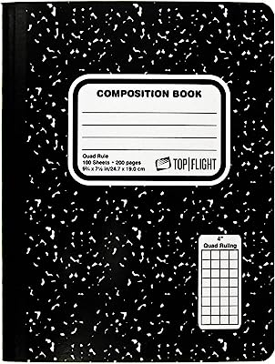

**Wish List**

* Kleenex
* Hand sanitizer
* Antibacterial wipes

GSD Middle School Supply List



**Middle School**

* 1 Backpack
* 3 packs of notebook paper (wide rule)
* 3 packs of pencils (regular/ mechanical lead)
* 1 pack of blue or black pens
* 1 pack of colored pencils
* 1 pair of scissors (blunt tipped)
* 3 multi-colored highlighters
* 3 packs of loose-leaf paper (wide or college ruled)
* 5 composition notebooks



**Wish List**

* Kleenex
* Hand sanitizer
* Antibacterial wipes