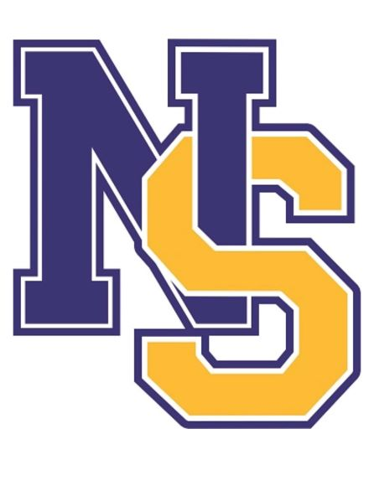

NORTH SALEM ATHLETIC

HALL OF FAME

APPLICATION

2023-2024

Application must be submitted by April 1, 2024
Induction is TBD

Please submit to:
Denise M. Kiernan, Director of Athletics
dkiernan@northsalemschools.org

NORTH SALEM STUDENT ATHLETE HALL OF FAME

ELIGIBILITY FOR NOMINATION

- Students eligible from graduating class of 1960 to 2022

- A student athlete can be nominated by a parent, coach or friend

- Three years of playing one varsity sport; two years of playing two varsity sports

NORTH SALEM STUDENT ATHLETE HALL OF FAME APPLICATION

Nominee for the “Hall of Fame”

Nominee’s Name ___________________________________________

Home Address _____________________________________________

Home Phone ________________________________

Email ______________________________________

Date of Birth ________________________________

Graduating Class _____________________________

Submitted By ________________________________

1. Athletic Accomplishments:

2. Academic Achievements:

3. Examples of Leadership, Citizenship, Character:

4. School and Non-School Activities:

STUDENT ATHLETE HALL OF FAME

Criteria: Checklist of accomplishments

1. Co-captain/captain of his/her team
2. Honorable Mention All League
3. All League
4. Honorable Mention All Section I
5. All Section I, All County
6. All State
7. Con Ed Award Recipient
8. Grade Point Average
9. Rank in class
10. Honor Society
11. M.I.P.
12. M.V.P.
13. Recipient of the Phil Adams Award
Recipient of the Emily Watson Award
Recipient of the Coach’s Award
14. Honor Roll
15. School activities
16. Community service
17. Sportsmanship
18. Citizenship
19. Leadership

INDUCTION CEREMONY

TBD

AWARDS

Each inductee will receive an engraved plaque and the school will receive one to be placed on our Wall of Fame in the high school gymnasium.

