­

**Brunch for Lunch**

Whole Grain Pancakes w/ maple syrup

Turkey Sausage

Baked Tater Tots

Baby Carrots

Pears

8oz Milk

**8**

**Brunch for Lunch**

Whole Grain Waffles w/ maple syrup

Scrambled Eggs

Baked Sweet Potato Fries

Chickpea Salad

Cantaloupe

8oz Milk

**13**

Hamburger or Cheeseburger on a Whole Grain Bun

Broccoli

Coleslaw

Peaches

8oz Milk

**21**

Whole Grain Chicken Patty on a Bun

Baked Sweet Potato Fries

Green Pepper Strips

Pears

8oz Milk

**19 17**

**Alternate Meals Also Available Daily**

**Sandwich Meal**

Boar’s Head Turkey, Ham & Cheese

With Veggie, Fruit & Milk

**Salad Meal**

Salad, Protein, Whole Grain Roll, Fruit & Milk

Homemade Macaroni and Cheese with Whole Grain Pasta

Broccoli

Celery Sticks

Grapes

8oz Milk

**29**

Whole Grain Mozzarella Sticks w/Marinara Sauce

Green Bean Salad

Baby Carrots

Apple

8oz Milk

Chicken Fried Rice Chicken tossed in an Asian Sauce w/Brown Rice or Grilled Cheese Sandwich

Zucchini

Chickpea Salad

Apple

8oz Milk

**Nachos**

Turkey Taco Meat

Tortilla Chips

Cheese & Salsa

Spicey Brown Rice

Black Bean Salad

Mexican Corn Salad

Pears

8oz Milk

**15**

Whole Grain Chicken Nuggets

Dipping Sauces

Baked French Fries

Celery

Mixed Fruit

8oz Milk

**12**

Baked Ziti with WG Pasta

Butternut Squash

Tomato & Cucumber Salad

Garlic Bread

Mixed Berries

8oz Milk

**6**

**Quesadillas**

Chicken and cheese or Cheese

Corn

Black Bean Salad

Banana

8oz Milk

**22**

**PEQUENAKONCK Elementary**

**Student Lunch – $3.00**

**Adult Lunch - $5.02 Plus Tax**

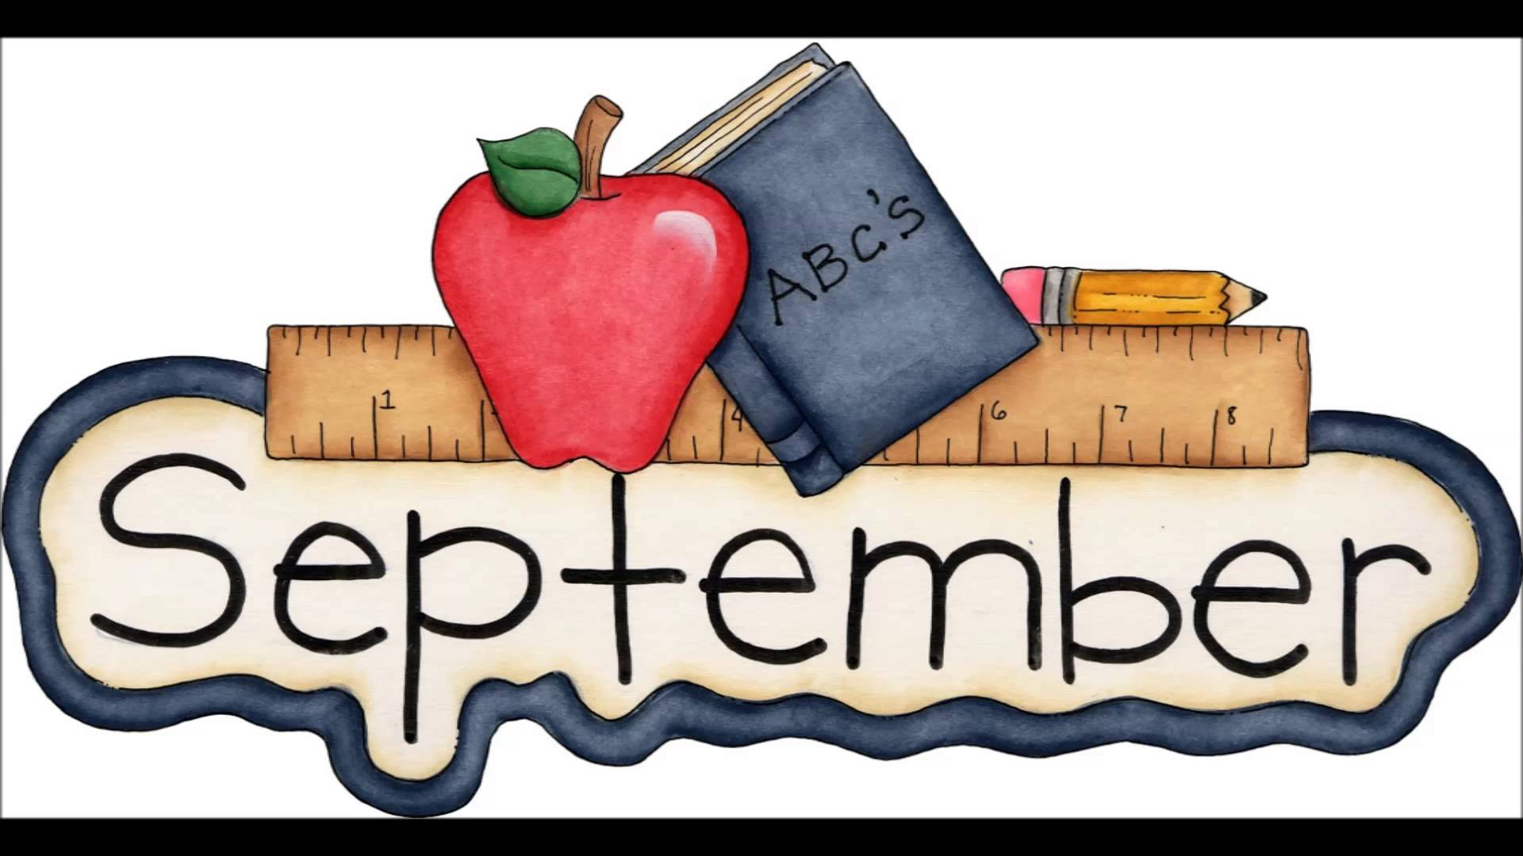



Fresh Baked Whole Grain Cheese or BBQ Chicken Pizza

Cauliflower

Red Pepper Strips

Apple

8oz Milk

**16**

**School Closed**

**Rosh Hashanah**

**School Closed**

**Rosh Hashanah**

Cheese Ravioli with Marinara Sauce

Broccoli

Celery Sticks

WG Breadstick

Orange

8oz Milk

**14**

Fresh Baked Whole Grain Cheese Pizza or Pepperoni Pizza

Roasted Cauliflower

Cucumber Slices

Pears

8oz Milk

**30**

Fresh Baked Whole Grain Cheese or BBQ Chicken Pizza

Chickpea Salad

Cucumber Slices

Pineapple

8oz Milk

**23**

**Brunch for Lunch**

Whole Grain Pancakes w/ maple syrup

Scrambled Eggs

Baked Tater Tots

Baby Carrots

Applesauce

8oz Milk

**20**

**Bagel Meal**

Whole Grain Bagel

Cheese/Yogurt

Vegetables, Fruit & Milk

**Parfait**

Yogurt Parfait w/Strawberries

Vegetables, Whole Grain Roll & Milk

**Items subjected to change!**

***Available Daily****:*

*Low Fat Milk*

*Fat Free White*

*&*

*Chocolate Milk*

***Food Allergies?***

***If you have a food allergy, please speak to the manager, chef, or your server.***

**Food Service Director**

Karen Seikovsky

914-669-5414 ext:2030

**7**

Fresh Baked Whole Grain Cheese Pizza or Pepperoni Pizza

Spinach

Garbanzo Beans

Watermelon

8oz Milk

**9**

**26**

**28**

**27**