Interior Decorating and Design Syllabus

Instructor: Mrs. Shelly Hurt-Geist Availability: 8:00-4:00
Classroom: 103M
E-mail: shurt-geist@west-fargo.k12.nd.us

Design your own living space! This class will introduce students to housing styles, design techniques, and housing elements, such as furniture, backgrounds, and floor plans. A final project will involve designing and decorating a room, with students being responsible for everything from choosing wallpaper, paint, and carpet to arranging furniture and fixtures. This course will sharpen creativity skills and give students a better understanding of various aspects of housing.
Required Materials (bring daily or leave in classroom):

- iPad
- Pen/Pencil
- Textbook

- Assignments
- Project Materials

Course Requirements:
The requirements for this course include daily work, quizzes, and projects. Class attendance and participation are essential elements as much of our work will be done in class through hands-on activities.

Units of Study:
Interior Design Portfolio
This class does have a portfolio component. Students will be expected to create each project assigned (whether large or small) and place it or photos in their final portfolio. Each unit’s homework/notes must also be included in the binder portfolio and organized in a professional way.​

- Introduction to Interior Design
- Architectural Styles
- Floor Plans and Evaluation
- Design
- Backgrounds
- Furnishing a Home
- Design Process
- Careers

Classroom Expectations:
These expectations are in place to ensure that we will have a safe and orderly classroom to allow each person the opportunity to reach his/her maximum potential.
- ELECTRONICS:
  - Phones and headphones/earbuds are not allowed to be used in the classroom.
- BE RESPECTFUL
  - For all people, equipment, and furnishings in the classroom.
  - Be courteous and cooperative to teacher and classmates and work as a team.
  - Request E-Hall pass at appropriate class times.
- BE ON TIME
  - In your SEAT when the bell rings.
- BE PREPARED
  - Come prepared for class with the required materials listed above.
  - Check the Schoology to see what is due!
- BE RESPONSIBLE
  - There is no food allowed unless it is part of the class activity. You can bring a drink with a lid that is able to close and must be kept away from sewing machines/materials!
  - Clean up after yourself. Throw away trash. Push in chairs before leaving. Stay in your seat/area until the bell.
  - Be on task – Worktime and time management is an important lesson to learn now.
  - Follow directions – Ask for clarification as needed.

Accountability for Assignments:
Homework and Make-Up Work: Completing homework is a requirement for this class. It is your job to work hard and get your assignments in on time.
- Lesson plans will be posted by Monday mornings on Schoology in the weekly folder structure.
- You must turn in all assignments on time. Homework assignments are due at the beginning of the class period. Any work turned in later is considered “late.” Late work will receive 75% of the earned credit. I will not accept late work beyond 2 days of the due date.
- You are responsible for getting make-up work from the teacher and handing it in on the required date.

Missed Work/Make-Up Work:
- Excused absences: If you are not present in class due to an excused absence (i.e. illness or family member emergency) on the day of a test or when an assignment is due, you need to be prepared to turn the work in on the day of the return to school.
  - If you know you will be gone in advance (i.e. sporting event, field trip, etc.) make arrangements with me prior to your absence.
- Unexcused absences: Missed work because of an unexcused absence will result in a ZERO (%).
- I will mark missing/late assignments in PowerSchool with the missing/late icons and will assign a 0 until it is turned in, so you see how it is affecting your grade. Once the unit is over, I will remove the icons and the 0 is permanent.

Grading Procedures:
  - Course grades are based on total points accumulated through daily work, homework, participation, labs, projects, and assessments.
  - Quarter 1 equates to 50% of semester grade. Quarter 2 equates to 50% of semester grade.
  - PowerSchool is the best place to find your current grade.
Current Grading Scale:
- A= 90-100%
All work will be assigned a point. Course grades will be calculated on a total points system. The percentage scale will be applied to your total points.
- B = 80-89%
- C= 70-70%
- D=60-60%
- F=59% and below

IF YOU HAVE EDUCATIONAL MODIFICATIONS:
The teacher and case manager will communicate regarding any accommodations or modifications that need to be made. As a student, it is important to advocate for yourself and let us know what is or is not working so we can help you succeed.
If at any time you need help, whether on an assignment, note taking, or just a general question, please come and talk to me. I am also available through phone or e-mail contact.

Mrs. Shelly Hurt-Geist

Standards and Objectives:
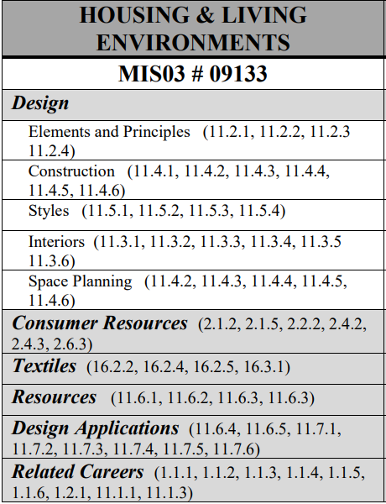

__________________________________________________________________________________

Interior Decorating and Design S:1 BDay Block 2
I have read the classroom syllabus and understand the expectations set forth. I plan to work hard and do my best in this class.

Student Printed Name: _____________________________________________

Student signature: _________________________________________________

Date: __________________

