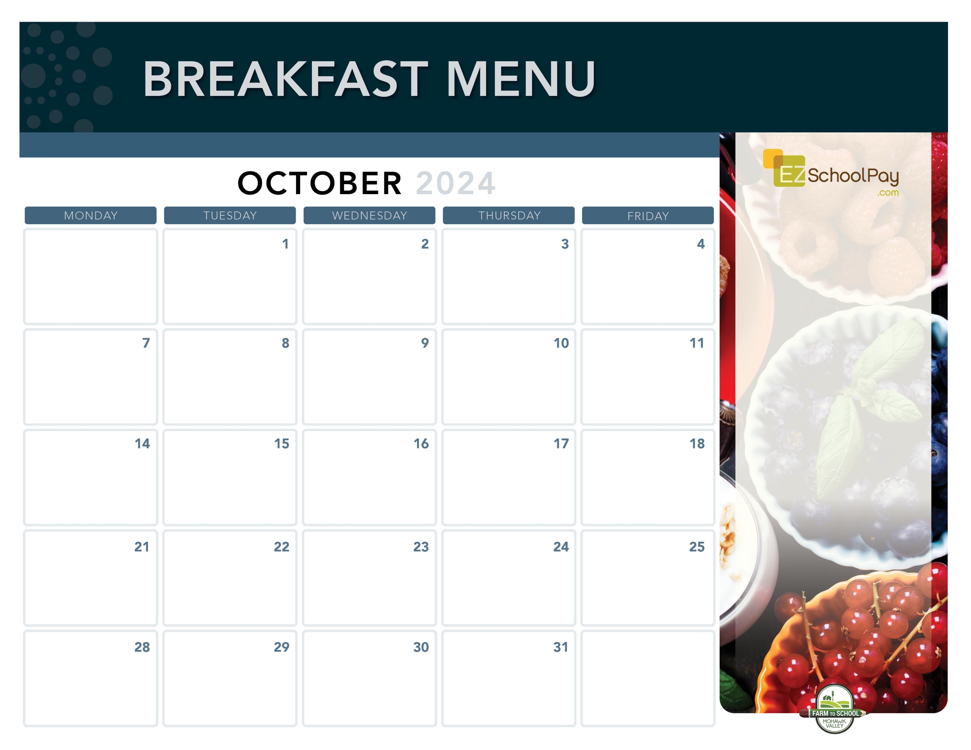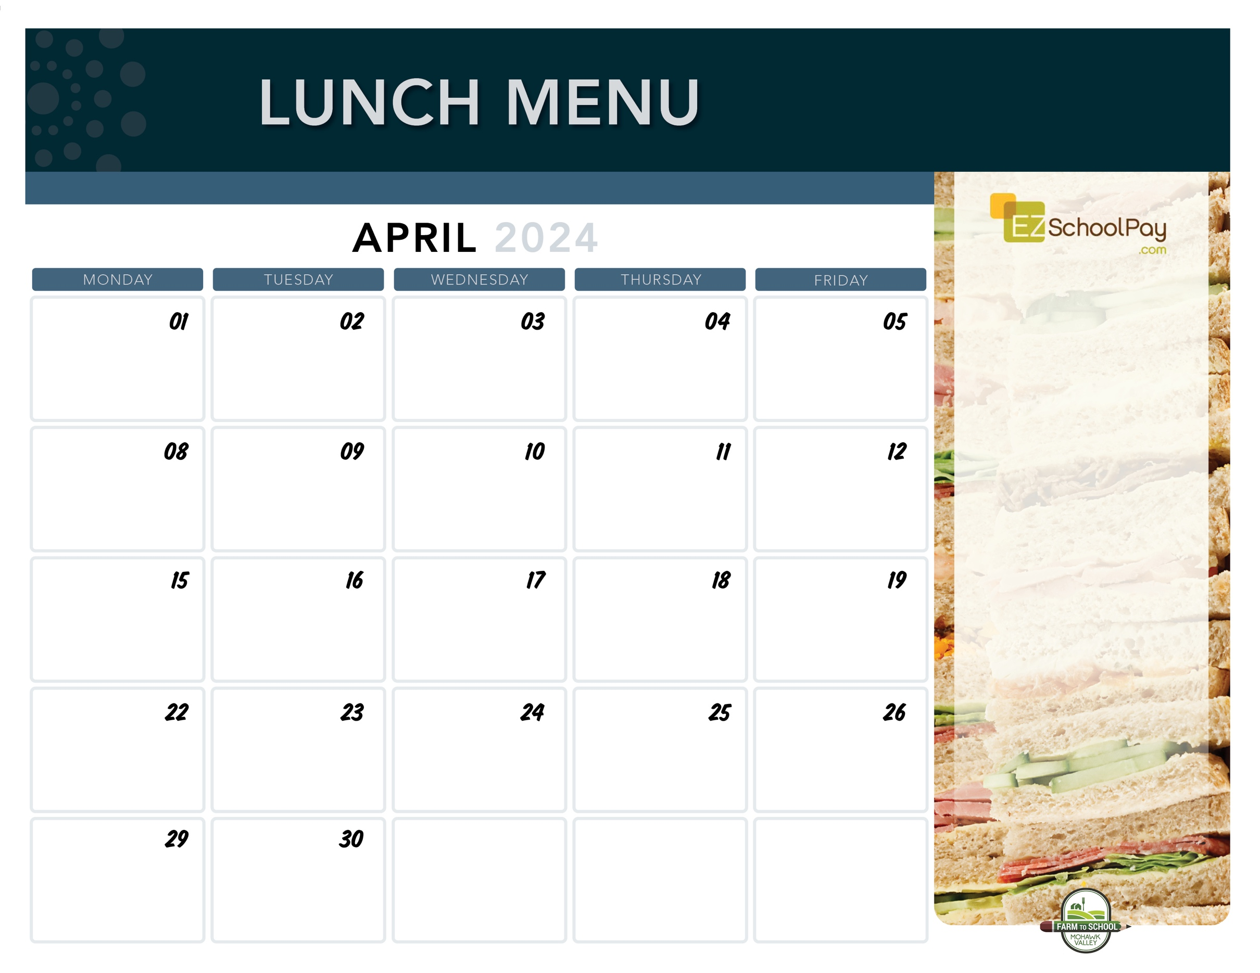­­­

Apple Frudel

**Elementary Early Release – 1:00 p.m.**

Assorted Whole

Grain Muffins &

Yogurt

Scrambled Eggs

& Toast

**Sauquoit Valley**

**Elementary School**

Homemade

Blueberry Muffin

or Muffin Bar

& Yogurt

Snackin’  
Waffle

Good

Morning Wrap

Whole Grain

Pancakes

**No School For Students!**

**Available Daily**

-Yogurt

-Assorted Whole Grain Cereals

-Fresh Fruit

-Chilled Fruit Juice

-Ice Cold New York State Milk

OHM BOCES Food Service is an Equal Opportunity Employer.

Pancake

Sausage Stick

Apple

Frudel

Breakfast

Sandwich

Apple

Frudel

Scrambled Eggs

& Toast

Mini

Cinni

Whole Grain Bagel with Cream Cheese

Zee Zee

Bar

Breakfast

Sandwich

**No School**

**Columbus Day**

Snackin’

Waffle

Whole Grain

Pancakes

Mini

Cinni

Breakfast

Pizza

Whole Grain Bagel with Cream Cheese

Breakfast is Free | Menu is subject to change | For more information, contact hdussault@oneida-boces.org