­­­ 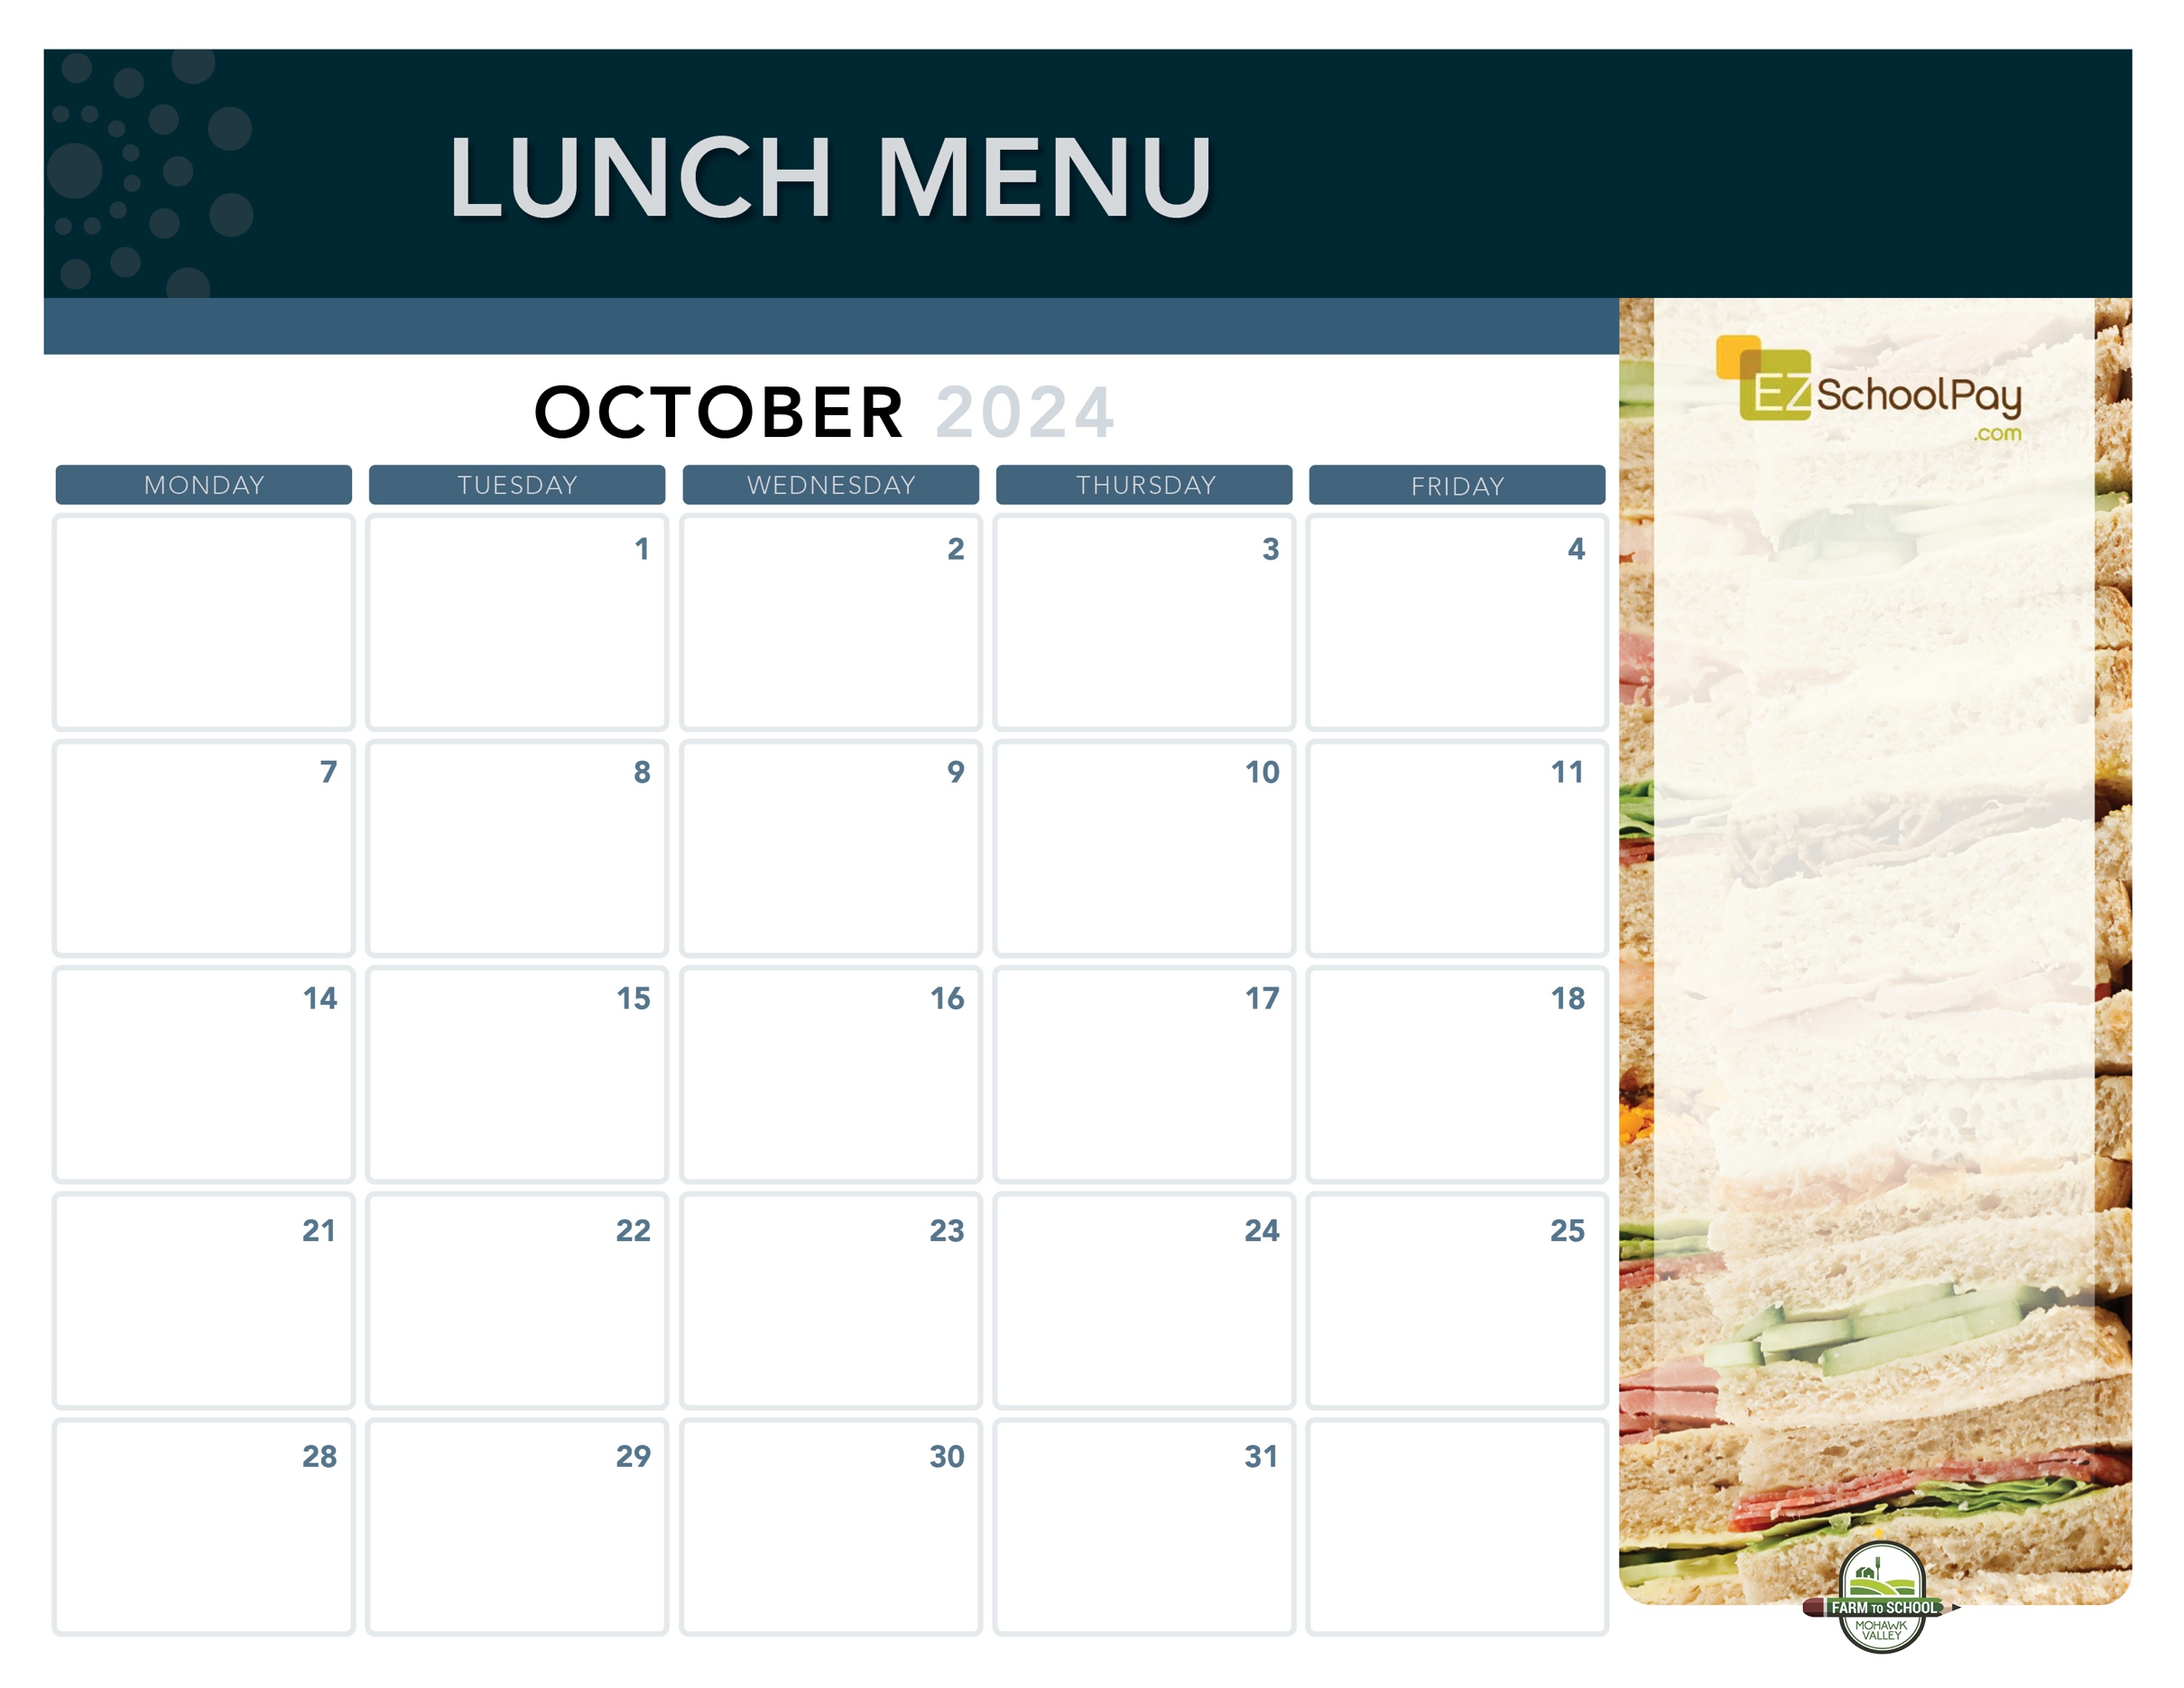

**No School**

**Columbus Day**

**Pizza Party!**

Cheesy Cheese or Buffalo Chicken Pizza

Fresh Green Salad **Elementary Early Release – 1:00 p.m.**

**Chicken & Cheese**

**Quesadilla**

Deli Turkey Sandwich

Corn

**Sauquoit Valley**

**Elementary School**

**Happy Halloween!**

**Dip N’ Sip**

**Grilled Cheese Sandwich &**

**Tomato Soup**

Mixed Deli Sandwich

**Game Day Buffalo**

**Chicken Dip with**

**Soft Pretzel & Celery Sticks**

Mixed Deli Sandwich

Grape Slushie

Roasted Cauliflower

**No School For Students!**

**Pizza Party!**

Cheesy Cheese or Hawaiian Pizza

Fresh Green Salad

**Dip N’ Sip**

**Grilled Cheese Sandwich &**

**Tomato Soup**

Deli Ham Sandwich

Substitute and daily Food Service Staff needed in a number of area schools -   
Call 315.223.6068 for more information

**Max Pizza Sticks**

Deli Ham Sandwich

Green Beans

**Italian Dunkers with Dipping Sauce**

Deli Ham Sandwich

Green Beans

**Happy National School Lunch Week!**

**Crispy Chicken Sandwich**

Deli Turkey Sandwich

Broccoli

**Brunch for Lunch!**

French Toast Sticks

Breakfast Sausage

Deli Ham Sandwich

Golden Hashbrown

**Available Daily**

Fresh Entree Salads

Party Plates

Peanut Butter & Jelly Sandwich

Fresh Sandwiches and Wraps

Assorted Fresh Fruit

Vegetable Cruncher Cups

Variety of Fresh Fruit & Juice

Ice Cold New York State Milk

**Local Items this Month**

Milk, Yogurt, Meatballs, Corn, Fresh Corn on the Cob, Rainbow Carrots, Potatoes, Cauliflower, Grape Slushie, Miss Mila’s Cookie

Local items are indicated with a star on the menu

OHM BOCES Food Service is an Equal Opportunity Employer.

**Macaroni & Cheese**

**Or Buffalo Style**

**Macaroni & Cheese**

Mixed Deli Sandwich

Carrots

**Mozzarella Sticks**

**with Dipping Sauce**

Deli Ham Sandwich

Green Beans

Black Bean Brownies

**New!**

**Homestyle**

**Chicken Tenders**

**Plain or Garlic Parmesan**

Goldfish Crackers

Tuna Salad Sandwich

Broccoli

**New York’s Own**

**Dino’s Meatball Sub**

Mixed Deli Sandwich

Rainbow Carrots

Miss Mila’s Cookie

**National Pizza Month**

**Pizza Party!**

Cheesy Cheese or Garlic Pizza

Fresh Green Salad

**World Smile Day**

**Pizza Party!**

Cheesy Cheese or Pepperoni Pizza

Fresh Green Salad

**Homestyle**

**Chicken Tenders**

**Plain or Buffalo**

Goldfish Crackers

Tuna Salad Sandwich

Broccoli

**Nachos & Queso**

Deli Turkey Sandwich

Corn

**Taco Tuesday**

Beef Tacos

Lettuce, Tomato & Cheese Cup

Deli Turkey Sandwich

Street Corn Salad

**Boneless**

**Chicken Bites**

**Dinner Roll**

Tuna Salad Sandwich

Broccoli

**Taco Tuesday**

Beef Tacos

Lettuce, Tomato & Cheese Cup

Deli Turkey Sandwich

Fresh Corn on the Cob

Lunch is Free | Menu is subject to change | For more information, contact hdussault@oneida-boces.org