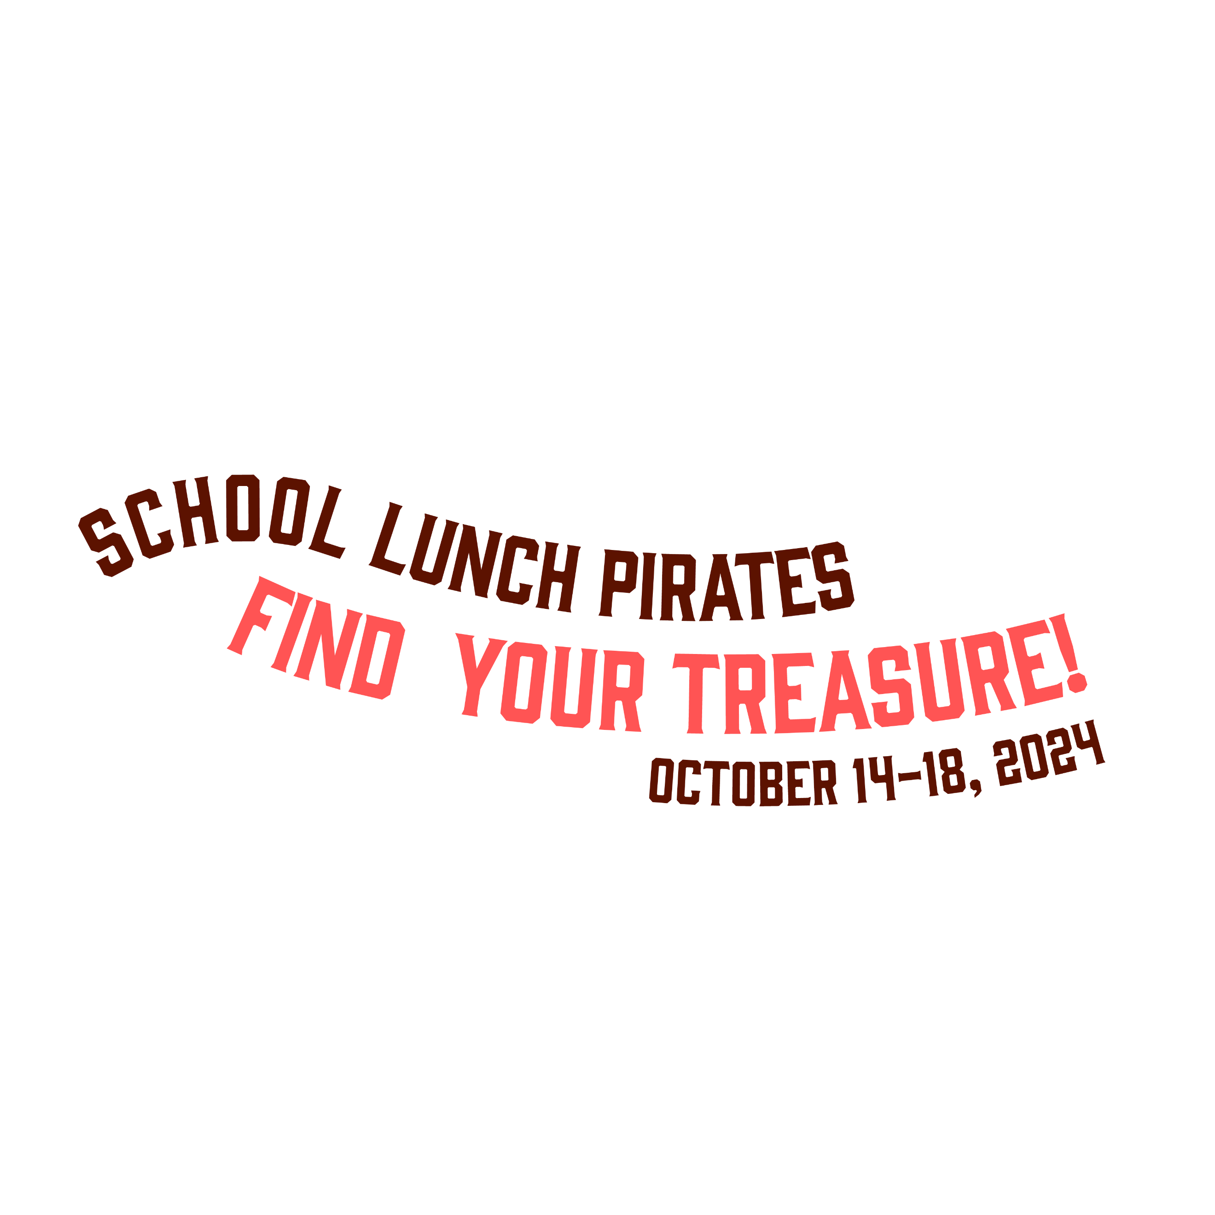

**Andover USD385 Schools Celebrate National School Lunch Week**

*“School Lunch Pirates: Find Your Treasure” Campaign highlights NSLW24*

To recognize the National School Lunch Program, serving nearly 30 million children each day, Andover schools will celebrate **National School Lunch Week from October 14-17, 2024**. The fun and creative campaign theme, “School Lunch Pirates: Find Your Treasure,” highlights the importance of a healthy school lunch to a student’s success both in and out of the classroom.

For NSLW this year we will be offering some new and exciting dishes for our students to experience. We get things started on **Monday** with Burrito Bowl. Students will have a variety of toppings to choose from to go along with the entre. **Tuesday** we will have Chicken Alfredo Flatbread. This will be presented much like a pizza with the ingredients contained on top. **Wednesday** will see the high schools serving Tatchos which is a bowl of tater tots with cheese sauce topped with taco meat. At the elementary and middle school level we will be having our chicken patty day. The shortened week wraps up on **Thursday** with Dorito Walking Tacos. This will be Doritos topped with cheese and taco meat.

The NSLW this year will be one you don’t want your children to miss. We look forward to seeing all of our Andover students for this special week and throughout the entire year.

“School lunches offer students fruits and vegetables, whole grains and milk, and meet federal nutrition standards limiting fat, calories and sodium,” said Aaron Miller, District Food Director, “National School Lunch Week helps us educate parents and students about all the wonderful benefits of our lunch program.”

The federally funded National School Lunch Program (NSLP) has been fueling students for success for 77 years. Students can enjoy the convenience of a healthy school lunch for just $3.30 elementary, $3.60 middle and $3.65 high school. Some students may qualify for free or reduced-price meals. Contact Bonnie Scarth at 316-218-4603 to learn more.

The “School Lunch Pirates: Find Your Treasure” campaign is made possible by the nonprofit School Nutrition Association. Parents and students can follow the fun on social media using the hashtags #NSLW24, #SchoolLunchPirates and #SchoolLunch.

For more information on National School Lunch Week, visit [www.usd385.org](http://www.usd385.org) or <https://schoolnutrition.org/nslw/>.