**BRANDYWINE HIGH SCHOOL**

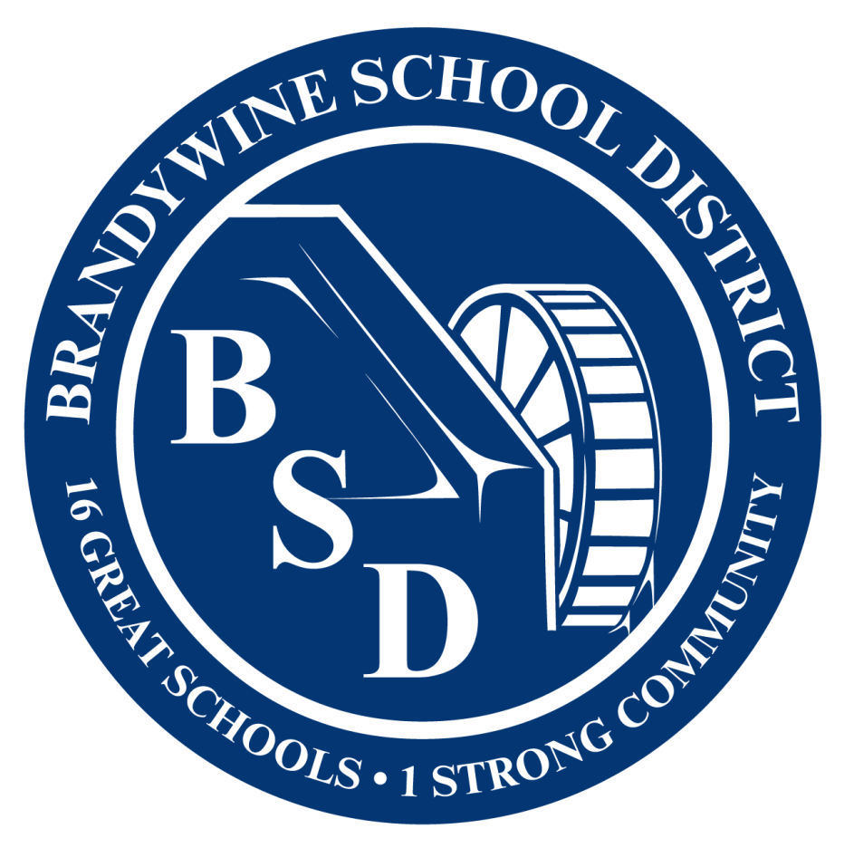

1400 Foulk Road(302) 479-1600

Wilmington, DE 19803 FAX (302) 479-1604



**Dr. Lisa Lawson** **Rebecca Reggio**

*Superintendent Principal*

September 15, 2024

Dear AP Students and Guardians:

Committing to taking an Advanced Placement (AP) class at Brandywine High School is a proud and serious decision that exposes students to the rigor and depth of knowledge required to show potential for success in collegiate coursework. Each AP class has a suite of tools and resources provided by the College Board through the student’s My AP Classroom account which uses the same login credentials as their College Board account. Some courses have required submissions to the College Board throughout the year and the teacher will make those details and deadlines clear in class. Students will take AP Exams from May 5-16, 2025 with scores available in July. Students were given “join codes” for each AP course during the first week of school to connect to their classes and indicate their decision to take the AP exam in May. Students should *not* create a duplicate College Board account if they do not remember their credentials, but should use the “forgot features” instead. Students must change the “undecided” intention to test as “Yes” or “No” in their My AP Classroom account for each exam.

The exam fees and fee reductions for this school year are listed on the next page. The Fall registration window and fees encourage students to commit to the exams early and stay engaged throughout the year, increasing their chances of earning college credits. New this year is that Brandywine High School is a Community Eligible Provision school meaning all students receive free breakfast and lunch. Despite this designation, guardians must still complete a Meal Benefit Form and select Yes in the box for Step 5, to allow for verification of whether or not a student qualifies for a fee reduction for AP exams (as well as SAT, ACT, and NCAA account fees, as applicable). These forms must be submitted in the school counseling office by the deadline and forms are available in both English and Spanish from AP teachers, the school counseling office, in the BHS AP Student Group on Schoology, or at<https://linqconnect.com/public/meal-application/new>. If a student qualifies or participates in the AVID program, they will be charged the reduced rate per exam. Any late order fees will apply to all students, and unpaid fees will become an obligation for events/graduation.

Please adhere strictly to all deadlines below as exceptions may not be possible for lateness.

|  |  |  |  |
| --- | --- | --- | --- |
| **Steps to Take** | **Description/Deadline** | **Due** | **Fee** |
| Join AP Course(s) | Use code from teacher for each AP class in My AP Classroom | 10/1 | N/A |
| Set Intention for Exam Registration | In My AP Classroom set exam registration to “Confirm” or “Remove”. Student remains in the class regardless of exam intention | 11/1 | N/A |
| Fee Reduction Forms | Submit completed Meal Benefit form (check Yes in Step 5) to School Counseling Office | 10/31 | N/A |
| On-Time Order | Registration decision is “Confirmed” in My AP Classroom and fee paid | 11/4-11/13 | $99 - most exams  $147 - Seminar / Research  $5 – each for fee reduced |
| Late Order | Exams ordered after the deadline | 11/14-3/12 | $40 *plus* base exam fee |
| Unused/Canceled Exam | Student changes their mind about or is a “no show” for a paid exam | After 11/14 | $40 replacing base fee |

Payment Options:

|  |  |
| --- | --- |
| **Electronic Payments from 11/4 - 11/13** | **In-Person Payments Monday-Friday 7:00am-2:30pm from 11/4 - 11/13** |
| Access link on the Brandywine High School website for Online Payment Portal using a credit/debit Visa, MasterCard, or Discover at: [BHS Payment Portal](https://www.velocitypayment.com/client/delaware/brandywineschooldistrict/bhs/index.html) or photo the QR code below. Please add all exam titles in the Description field when making an electronic payment. | Cash |
| A singular check for the total amount for all exams taken by all students in the household made out to “BHS AP” |
| Money Order made out to “BHS AP” |

If you wish to learn more about AP, you may visit the College Board website at:<https://apstudents.collegeboard.org/>. If you have questions about the processes for Brandywine High School, please contact me for more information. I wish you a fulfilling and successful school year in AP!

Sincerely,

Lisa Street, M.Ed.

Department Chair of School Counseling/College Board Test Coordinator

Email: Lisa.Street@bsd.k12.de.us

Website:<https://brandywine.brandywineschools.org/>