

**GSE Geometry**

Instructors: Rodney Wimbush

Dr. Julie Branan

Room 119

Emails: [Rodney.Wimbush@henry.k12.ga.us](mailto:Rodney.Wimbush@henry.k12.ga.us)

[Julie.Branan@henry.k12.ga.us](mailto:Julie.Branan@henry.k12.ga.us)

|  |  |
| --- | --- |
|  |  |

**COURSE DESCRIPTION**: Geometry is the second course in a sequence of required high school courses designed to ensure career and college readiness. The course represents a discrete study of geometry with correlated statistics applications. The course is divided into eight units.

|  |  |  |  |  |
| --- | --- | --- | --- | --- |
| Unit 1: Polynomial Expression  Unit 2: Geometric Foundations, Constructions and Proofs  Unit 3: Congruence  Unit 4: Similarity | | | Unit 5: Right Triangle Trigonometry  Unit 6: Circles  Unit 7: Equations and Measurements  Unit 8: Probability and Statistics | |
| **MATERIALS:** | | |  | |
| Calculator (TI-36X Pro is recommended)  3 ring binder  Geometric Compass | | | Ruler  Pencils  Notebook Paper | |
| **TI-36x Pro Calculator** | | **Geometric Compass** | | | |
| **Walmart Link** | **Amazon Link** | **Walmart Link** | | **Amazon Link** | |
|  |  |  | |  | |

**GRADING POLICY:** One unit of credit will be awarded at the end of the semester.

Tests: 40% Classwork/Homework: 40% Final Exam: 20%

It is required that students use their assigned Henry County Chromebook for all tests and quizzes. If you do not have a school-issued Chromebook or your Chromebook is broken, please contact me immediately and I will create a ticket.

**ATTENDANCE**: Attendance is extremely important. If you are absent, you are responsible for securing notes and making up any missed assignments. ***Class time will not be spent getting you caught up.***

**ASSIGNMENTS:** Each student is expected to attempt, complete, and check every assignment. Mathematics is learned by practice; therefore, expect homework every night.

**Homework is checked for a grade.** It is permissible to discuss problems with other students or relatives. It is not permissible to copy another student’s work. **Students are expected to check their answers at home and come prepared to ask questions in class.**

**TUTORING**: I am available to help you and to answer your questions when needed. It is imperative that you let me know immediately if you are having difficulty. Tutoring is available after school.

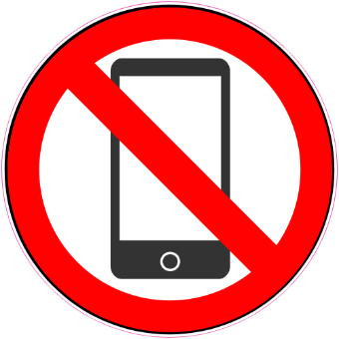

**BYOT FOR PERSONAL DEVICES:** Use of personal devices is **PROHIBITED**. You will need to bring your school-issued Chromebook CHARGED, EVERY DAY. Chromebooks are only to be used for appropriate, mathematical needs..

**CLASS EXPECTATIONS**:

***1. Show Responsibility 2. Be Ready***

***3. Be Respectful***

***Success in mathematics depends on effort – NOT ability.***

