Getting Your SchooLinks Student Claim Code

- From the homepage of the Aspen Parent Portal select the ‘Family’ top tab
- Select your student
- Your Claim Code is in the right hand column
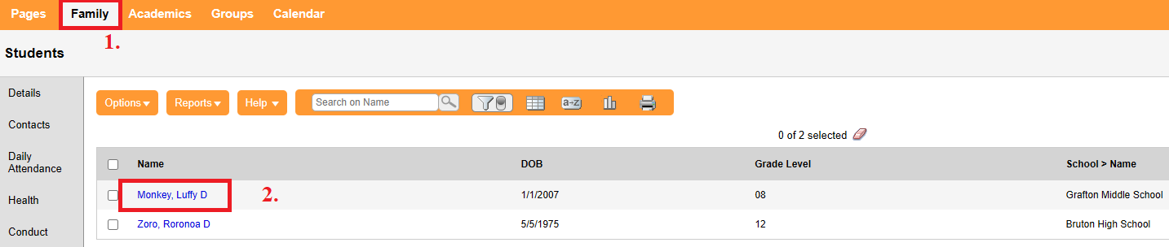
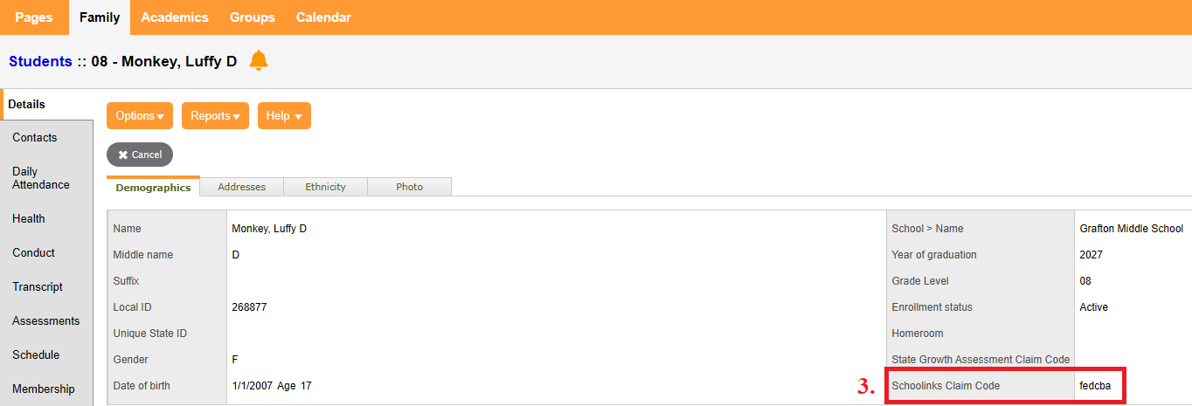

Getting Your SchooLinks Student Claim Code

- From the homepage of the Aspen Parent Portal select the ‘Family’ top tab
- Select your student
- Your Claim Code is in the right hand column

