Yearbook Senior Ads
Dear parents, guardians, and friends of seniors:
The time has come to honor your seniors by reserving space in Legend Yearbook (vol. 61). Senior Ads are color and come in two sizes. Placed in the back of the 2025 yearbook, the ads are a lasting testament of your senior’s achievements and will certainly be cherished by them for years to come.

**Order now to reserve your ad, as space is limited.
DEADLINE FOR RESERVING SPACE IS FRIDAY, NOVEMBER 15, 2024.

SIZES | PRICES
½ PAGE | $70
FULL PAGE | $125
(CASH and MONEY ORDERS accepted. Payment is due at the time of order.)

Student name: __________________________________________________
Student Phone: __________________________________________________
Guardian Name: _________________________________________________
Guardian Phone: _________________________________________________
Favorite Color: _______________________
Size: ______________ Order Amount: ____________

Give pictures, money, dedication, and form (in an envelope or manila folder)
to Mrs. Walker in Room 207 by Nov. 15th!!!!!
Example of two HALF-PAGE senior ads:

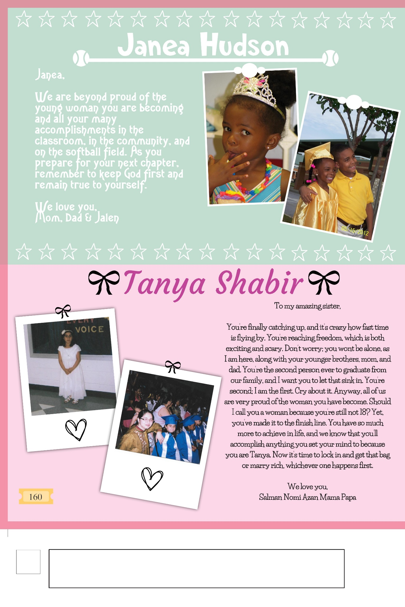

Example of a FULL-PAGE senior ad:
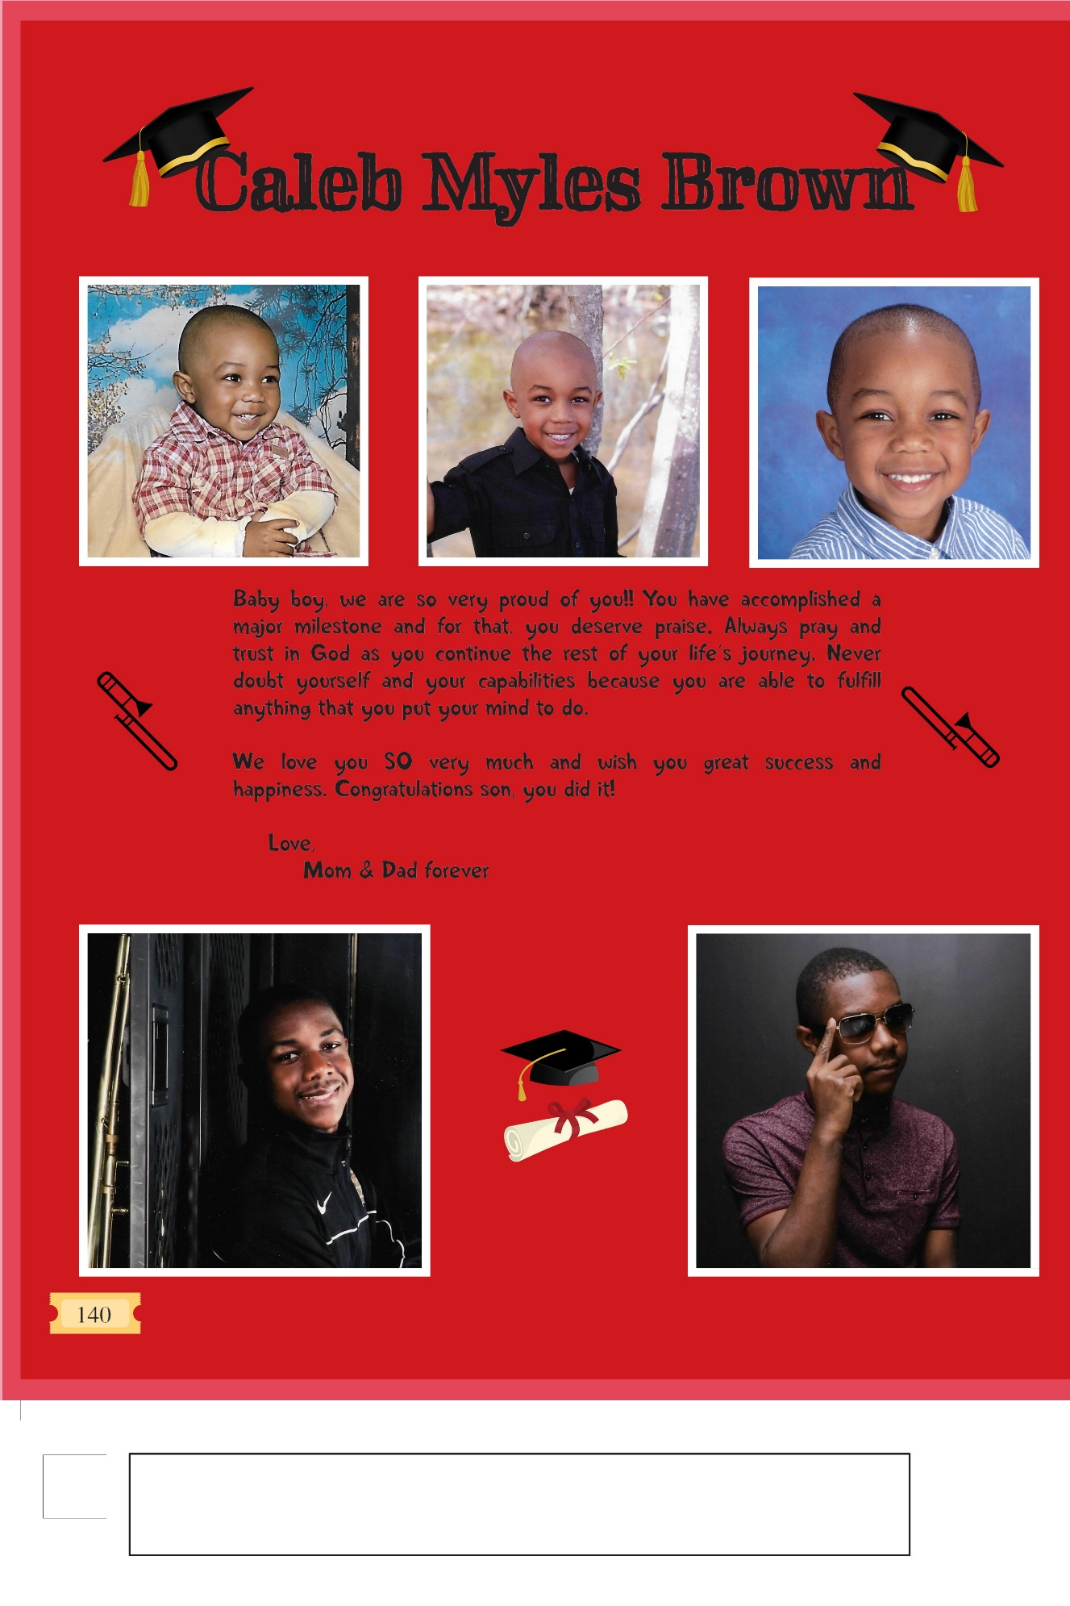

SENIOR QUOTES AND BABY PICTURES
DUE BY NOVEMBER 15, 2024!!!!
Senior Quotes must…
- Have 100 characters or less
- Abide by HCBOE policy standards
- NO PROFANITY, NO SEXUAL INNUENDO, NOT GANG RELATED!
- Quote MUST fit into boxes below – One LETTER per box. Skip a space/box between each WORD.
- Write in PEN – NOT pencil

BE CREATIVE!!!!!!

Senior Baby Picture requirements:
- Write your full name legibly on the BACK of the picture. (Sharpie is best)
- Write the name & room number of SECOND SEMESTER 3RD TEACHER on the back.
- Remember to come pick your picture back up AFTER Spring Break.
Please turn in baby picture and/or quote along with form to Mrs. A. Walker in room 207 by November 15th.

