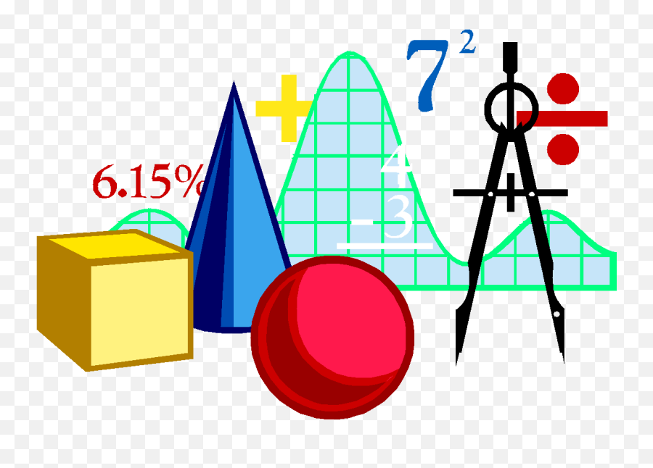  

**Geometry Syllabus 2024-2025**

***Mission: To offer inspiration through advanced instruction and authentic experiences.***

**Instructors:**

Ms. Valerie Russell, Ed.S. Math Education, Rm 206

Email: [valerie.russell@henry.k12.ga.us](mailto:valerie.russell@henry.k12.ga.us)

Please allow 24 hours for a response. Conferences can be scheduled via the counselors between 1:30-2:45pm.

**Math Department Philosophy:** We believe that by creating an environment conducive to learning, building positive rapport with associates, and employing differentiated instructional strategies, we can promote associate success. Furthermore, we believe that each associate can be successful in learning to value mathematics, become a mathematical problem solver, communicate and reason mathematically.

**Course Description:** Geometry is the second course in a sequence of three required high school courses designed to ensure career and college readiness. The course represents a discrete study of geometry with correlated statistics applications.

GSE Geometry will help associates gain an understanding of figures found in our three-dimensional world and their connections to mathematics. Associates will learn the language of geometry, the coordinate plane, slope, reasoning, proofs, angles, perpendicular and parallel lines, congruent triangles, triangle inequalities, similarity, circles, and probability.

|  |  |  |  |  |  |  |  |
| --- | --- | --- | --- | --- | --- | --- | --- |
| Unit 1 | Unit 2 | Unit 3 | Unit 4 | Unit 5 | Unit 6 | Unit 7 | Unit 8 |
| Polynomial  Expressions | Geometric Foundations, Construction and Proof | Congruence | Similarity | Right  Triangle  Trig. | Circles | Equations  & Measurement | Probability  &  Statistics |

**Course Objectives**

AAS associates will

1 Make sense of problems and persevere in solving them.

1. Reason abstractly and quantitatively.
2. Construct viable arguments and critique the reasoning of others
3. Model with mathematics.
4. Use appropriate tools strategically.
5. Attend to precision.
6. Look for and make use of structure.
7. Look for and express regularity in repeated reasoning.
   * Demonstrate mastery of standards
   * Explore properties associated with points, lines, and planes
   * Analyze related unit postulates and theorems
   * Utilize unit vocabulary and geometric tools
   * Describe connections between geometry and real word applications
   * Develop and evaluate formulas for area and volume
   * Investigate algebraic and geometric proofs
   * Discuss common misconceptions

* Fully charged Chromebook
* Chromebook charger
* 3-ring binder with 8 dividers
* Pencil (no pen is allowed)
* TI-30XS Scientific Calculator
* Clear Protractor
* Strong compass kit (no plastic)
* Graph Paper (units 2, 3, 6, 7)

**Required Supplies**

* Attend class daily.
* Be prepared for class.
* Respect yourself and others.
* Ask questions.
* Contribute new ideas.
* Work hard, and give your best effort.
* Complete all assignments on time.
* Cell phones are prohibited during class
* Complete the problem of the week for 5 extra credit points (optional)

***Dress and speak for success! Please follow all dress code regulations and refrain from using profanity or inappropriate language.***

**Expectations for Academic Success**

**Grade Calculation**

|  |  |
| --- | --- |
| **Summative Assessments = 40%** | **Formative Assessments = 40%** |
| * Authentic learning projects, exams, presentations, essays, labs | * Practice Work: classwork, homework, quizzes, labs, employability skills |
| **Culminating Final Exam/Project 20%** | |
| All courses will have a culminating exam or project that assesses associate learning of the semester’s course content. This exam/project will be 20% of the overall course grade. There | |

will be no exemptions.

**Make-up Work**

Associates who are absent are required to refer to the weekly agenda for make-up work. The associate will have the same number of days that they are absent to complete the make-up work.

**Late Work Policy**

Associates will be given until Friday 1pm to turn in any homework/classwork assigned for that week. Any work submitted after the due date will be accepted as 70% until the day of the unit assessment. After the unit assessment, any missing assignments will be replaced with the unit assessment grade. All assignments for the week are found on the weekly agenda in Google

Classroom.

**Employability/Soft Skills**

School-Wide Activities:

* + Dress for Success Days
  + Group Presentations

*The dates for the activities will be provided by the Admin. Team.*

**Trainer (Instructors Name)**

**Please sign this sheet (google form link) and return to your Trainer.**

**I**  **(associate/student name) certify that I have read and understood the syllabus, remediation policy, expectations, and the list of required materials in its entirety and understand the requirements stated within. I agree with all the policies stated within.**

**If you agree with the above statement, please sign and date in the appropriate line below.**

**Student Signature:**  **Date:**

**Parent Contact Information: Home Phone**

**Cell Phone**

**Parent/Guardian Signature:**  **Date:**