WELCOME TO

Mr. Brown’s Web Page

Welcome, to the academy of advanced studies. I will be your **Precalculus/Algebra 2** Trainer for this semester. It’s a pleasure to have you join my class. I’m looking forward to getting to know each and every one of you as we embark on this educational adventure together. Let’s work hard, support each other and make the most out of our time together.

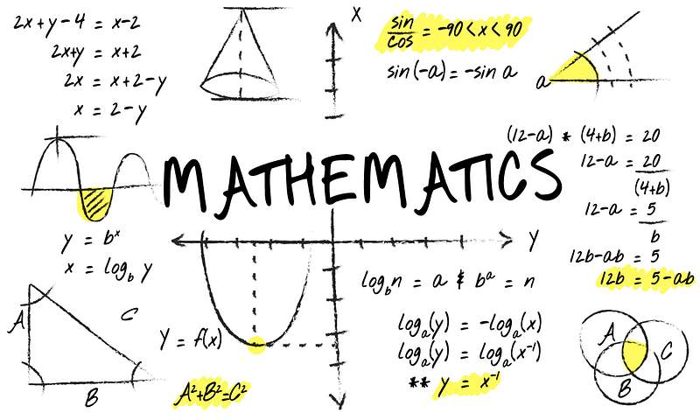

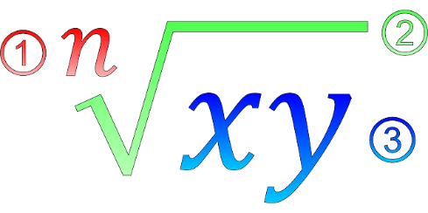

**Assignments, quizzes and tests**

**will be posted on the Google**

** Classroom format.**

**Please turn in assignments**

**on or before the due date.**

**Open House:**

**Tuesday July 30, 2024**

**@ 11:00am- 1:00pm**

**Classes begin:**

**August 1, 2024**