Ms. Toepke-Peterson— EL MTSS Syllabus
mtoepke@west-fargo.k12.nd.us 2024-2025

Bio

OVERALL GOALS

Organization
Create a functioning organizational system to manage classwork.

Time Management
Work bell to bell and prioritize work to be completed.

Email Communication
Compose a well-written email to adults about assignments/grades/concerns.

Listening Skills
Watch a mini lesson online to gain important life-long learner skills.

Self-Assessment
Assess your own behavior and learning to reach your learning goals.

Ms. Toepke’s Schedule — Room 212 J
 | 1  8:25 – 9:55 | Advisory WIN  10:00 - 10:20 | 2  10:25 - 11:55 | Lunch  11:55-12:25 | 3  12:30 - 2:00 | 4  2:05 - 3:35
A Days | Prep | 212 J | EL Biology  212J | Lunch | EL Biology  212J | MTSS SH 212J
B Days | EL Envi. Sci. 212J | 212 J | Hall Supervision/ Study Hall | Lunch | EL Earth Science 212J | Prep

Course Description
An EL MTSS (Multi-Tiered System of Supports) Study Hall is a structured academic environment designed to provide additional support to students who need it while offering elective credit for graduation.

Purpose: support learners who may be struggling academically or require extra help to meet grade-level expectations; Focus is on addressing individual learning needs and promoting academic success through grade checks and communication. As English Language ability lies at the core of student success, we will work to improve our proficiency of the English Language through World English 3 text and activities <30 minutes total per week. Time not utilized on these strategies will be used to complete other coursework.

BASIC Class Expectations

Beginning of class
- Sit in assigned seat
- Answer daily Schoology Starter
During class

- Participate in Group lesson and Complete World English assignments
- Work quietly on homework/missing assignments
- Stay in assigned seat
- Raise your hand if you need help
  - Work on other material while you wait
- No homework? Read, play FreeRice, ReadTheory, etc.
- No homework, does not mean you have free time.
End of class
- Identify work completed
- Identify uncompleted work
- Complete Daily Assessment on Schoology

More Expectations
- Be on time and prepared.
- Respect property/supplies within the classroom and follow instructions for cleaning spaces.
- Treat all peers, teachers, paras, and other individuals in the class with the utmost kindness and respect.
- No use of cell phones permitted.
- Ask for permission to use earbuds/headphones.
- No You-Tube.
- No food allowed in classrooms.
- Use all class time.
- Complete Lesson assignments by next class day.
- Any behavior, clothing, or activity that interferes with student learning will not be tolerated. (No Loud gum chewing.)
- Attendance for in class sessions is very important; make every effort to be here, on time, and prepared every day unless ill.
- Always Bring a pencil, charged iPad, Logitech Crayon, and charger (in case of emergency)
Semester Grades and Graduation Credit
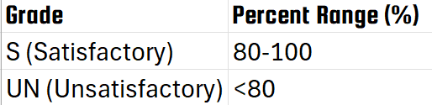
MTSS Study Halls count for credit towards graduation. Each semester can accrue .25 credits, for a total of .5 credits in a year to count towards your electives. Semester grades are recorded as Satisfactory (Credit) or Unsatisfactory (No Credit).

Weighted Grades and Quarters
Quarter grades are weighted.
- 40% Participation: present, prepared, on time, and on task
- 40% World Language Development: Completion of tasks to develop English Language Proficiency as outlined in our World English 3 texts in units 4-6
- 10% Weekly Grade Check: record grades in each class and missing work
- 10% Weekly Email: send an email to caring adults to fill them in on how your learning is going at WFHS

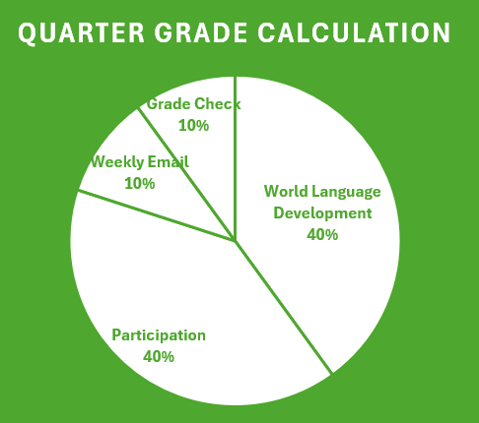
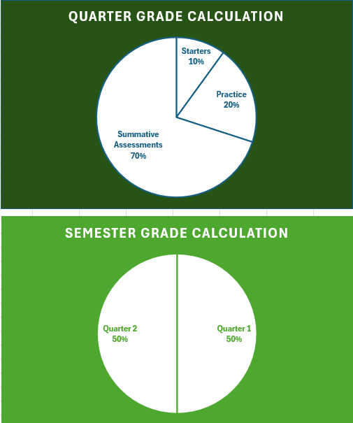
PowerSchool contain a letter grade for you throughout each quarter to help you assess your demonstrated abilities in this course.

World Language
Unit |  | Topics |  | Unit Goals
4 | The Body |  | - Discuss ways to stay healthy.  - Talk about healthy lifestyles.  - Suggest helpful natural remedies.  - Describe the benefits of a positive attitude.  - Explain an idea using details.
5 | Challenges |  | - Talk about facing challenges.  - Describe past accomplishments.  - Used too and enough to talk about abilities.  - Discuss steps toward a goal.  - Describe a personal challenge.
6 | Transitions |  | - talk about different stages in your life.  - Talk about the best age to do something.  - Ask questions to get more information.  - Discuss changes caused by technology.  - Describe an important transition in your life.

