August 27, 2024

Dear Gray’s Woods Families,

On behalf of the PTO Board, **Welcome Back Wolf Pack**!

The Gray’s Woods Elementary Parent Teacher Organization (GWE PTO) is a non-profit organization serving all students, staff and families at our school. There are no enrollment requirements and no membership fees - if you have a student attending Gray’s Woods, you are automatically a member.

Each year, the GWE PTO provides educational and social experiences for our GWE school community. The PTO fund covers school supplies and field trip expenses for all students, as well as teacher requested enrichment materials and opportunities such as educational grants and visiting authors. Our other major initiative each year is organizing community-building events for students to enjoy and families to connect. A summary of our annual events is included on the next page of this packet.

Creating memorable experiences takes a village and there are many opportunities to share your time and talents as a volunteer. We appreciate everyone’s help to make the school year events successful. As long-time volunteers move on as their children age out of Gray’s Woods, please consider joining the fantastic group of parent volunteers who make our events so memorable for our children. It’s also a great way to meet other families at the school!

Our first general meeting will be Wednesday, September 25 at 7:00pm in the GWE library. To stay in the loop with upcoming PTO events, please sign up for our email newsletter via this QR Code:

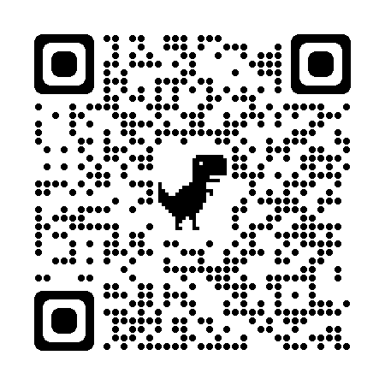

As a non-profit, we depend on fundraising to help facilitate the financial obligation of approximately $100/student to fund the initiatives outlined in this letter. Donations are tax-deductible, and we also welcome support from interested local businesses. In addition to accepting donations, we host several fundraisers in a variety of formats throughout the year.

If you would like to volunteer, please visit this link <https://www.signupgenius.com/go/805094CACA62DAAFF2-50702055-2024#/>

Link will also be shared in newsletters and on the Gray’s Woods PTO facebook page regularly.

The PTO Board is looking forward to another fantastic year with the Gray’s Woods Elementary Community! If you have questions, or are interested in getting involved - please connect with us at [**grayswoodspto@gmail.com**](mailto:grayswoodspto@gmail.com).

See you soon,

Kristi Mattzela, President Erin Garthe, Treasurer

Stacey McIntire and Cara Meehan, Secretary/Communications chairs Elizabeth Harvey and Beth Longerbeam, Event Chairs

**2024-2025 Events Outlook**

**Wolf Pack Challenge - (October 11th Donation Based Fundraiser + School Day Event)**

Students celebrate the joy in movement by running/walking/dancing their way around the upper school grounds, while families and volunteers cheer them on. The largest annual fundraiser, and students are eligible for awesome prizes!.

**Scholastic Book Fairs - October (10/31) and Spring (TBA):** Biannual book fair - Scholastic is the largest publisher of children's books and sales from the fair generate rewards and resources for classrooms (GWE teachers love books!)

**Staff Appreciation (Fall and Spring dates TBD):** Twice a year we show the amazing staff at GWE our appreciation. Typically our fall event is a luncheon before conferences and spring is a weeklong themed celebration with a variety of surprises.

**Visiting Author (TBD):** Gray’s Woods staff organize an author visit, funded by the PTO.

**Penguin Patch VIP shopping event (Nov/Dec date TBD):** Come shop for your favorite VIP and give them a gift to show them how special they are to you. Event will assure accessibility for all students regardless of ability to pay.

**Variety Show (Winter Evening 2025):** Showcasing our amazing talent pool onstage in the GWE multi-purpose room. Past shows have included musical acts, dancing, comedy, from all grades and even some *very special guest* appearances.

**Coast to Coast Fitness (6 weeks - Winter 2025):** This self-paced/self-reported program encourages students to stay active in those last dreary weeks of winter and provides “foot token” incentives and a special celebration for participation.

**STEAM Fair (Spring 2025 Evening Event):** Students are invited to practice their Science, Technology, Engineering, Art and Math skills by creating a project for showcase at the STEAM fair. In collaboration with the GWE Steam Specialsl teacher.

**Fun Fair (April/May 2025 Evening Event):** The Gray’s Woods grounds become a carnival with games, a bounce house, birdie golf, and delicious food! This event is also a major fundraiser, generated by admission tickets and other paid experiences.

**Other Initiatives**

**Gray’s Woods Garden Committee:** A small but mighty group helps keep the school garden looking its best, planting, weeding, and general garden care in conjunction with student participation. Ask your student about *salsa* in the fall.

**Spirit Wear:** PTO coordinates the inventory of GWE gear for sale at GWE events, as well as periodic spirit wear “Pop-Up” sales for a wider variety of options for special order. We typically work with Collegiate Pride for gear.

**School Supplies:** Student school supplies are ordered, distributed, and paid for by the PTO funds. (Yes, really!)

**Field Trips:** Gray’s Woods field trips are paid for by PTO funds.