Name: ________________________________ Period: _____________

Baldwin UFSD Social Studies Department Date: ______________

**Historical Thinking Terms**

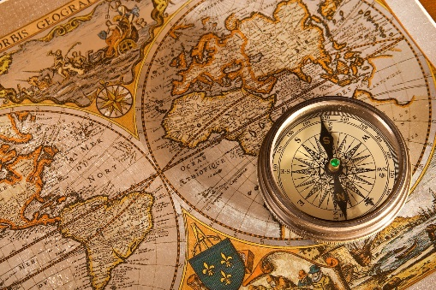**Audience**- the people giving or likely to give attention to something

* Who is Otto von Bismarck’s intended audience in the document?

**Bias**- an unfair act or policy resulting from prejudice

* How might the speaker’s background make her statements bias?

**Cause and Effect**- an occurrence that leads to a certain outcome

* Identify and explain a cause and effect relationship between the events found the in the document.

**Claims**- stating or asserting something as true without providing evidence or proof

* What claims does Adolf Hitler make about the treatment of Germany at the Versailles Conference?

**Comparison**- an examination of two or more objects, ideas, locations, concepts, or individuals to discover the similarities and differences.

* Compare the Golden Age of Pericles to Pax Romana.

**Convince**- to persuade someone to believe in something or to act in a certain way

* How does the poster convince the American people to support the war effort?

**Disparities**- lack of equality; differences

* How does the Hindu caste system show the disparities that existed in Indian society?

**Evaluate**- make judgments about the value of ideas or materials

* Evaluate President George Washington’s foreign policy advice on maintaining neutrality.

**Evidence**- facts or information supporting a claim

* What evidence does the author use to support the claim that the United States was falling behind in the areas of math and science to the Soviets?

**Geographical Context-** how geography impacted a civilization socially, politically, and/or economically

* Explain how the geographic context of Ancient Greece led to the development of city-states.

**Historical Context/Circumstances**- the historical conditions surrounding an event, idea, or historical development; events or facts that cause something to happen

* Explain how the historical circumstances led to Pax Romana.

**Hypothesize**- educated guess; to create an explanation with limited evidence

* Using the information in the document, hypothesize as to why the United States became involved in the Vietnam War.

**Perspective/Point of View/Position**- a particular attitude toward or way of regarding something

* Explain how the author’s point of view affects the document as a reliable source of evidence.

**Purpose**- the reason for which something is done or created

* What was the purpose of Winston Churchill’s “Iron Curtain Speech”?

**Reliable**- able to be trusted

* Explain how the author’s position affects the document as a reliable source of evidence.

**Turning Point**- a significant event, idea, or historical event that brings about a substantial change

* Identify a turning point associated with the events or ideas found in the document and explain why it is a turning point.