# The Manson Mountaineers

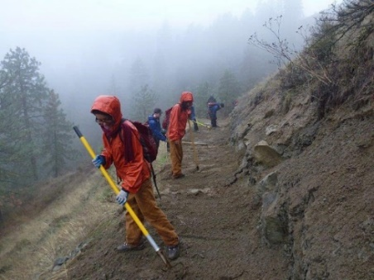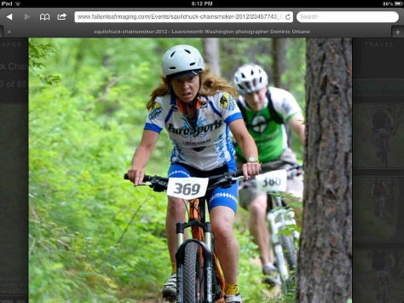We have a passion for ecology, conservation and wilderness adventure. We would like to connect our expertise, the love of mountain biking, and the joy being in the forest, with students in Manson who have never had any exposure or opportunity to experience these activities. We have spoken with some of the students at the Manson Secondary about this opportunity and it has been met with enthusiasm. Some of the students in Manson have never even been on a bike! Mountaineering is something that Manson students simply do not have access to. In comparison, Leavenworth (Cascade SD) has both a Nordic Ski Team and a Mountain Bike Team that competes against other students in the state. Students in Leavenworth have also participated in forestry projects, trail building, conservation and community projects.

Our vision is to pilot this opportunity as a club and potentially as a class which could include both science, vocational and physical education. These activities (mountain biking, hiking, trail maintenance, wilderness area clean up, bird counting…) would take place in Chelan County in conjunctions with forest service, parks and rec and community members who see a need or have a project. I envision a group of interested students who would take part in all or in some of the activities. The Manson Mountaineers could be active in the late spring, fall and summer. We might even consider winter activities such as Nordic Skiing and Snow Shoeing.