**Parent Access to Student Progress Center**

Make sure you are using Google Chrome or Internet Explorer 9 or 10. Go to the top right side of the CPSB website. [www.cpsb.org](http://www.cpsb.org/)

Click on: “A+ Grades”

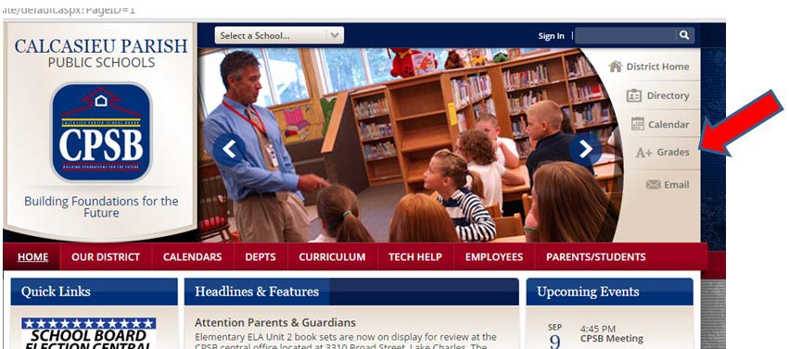

Register for Student Progress Center using the “Register New User” button.

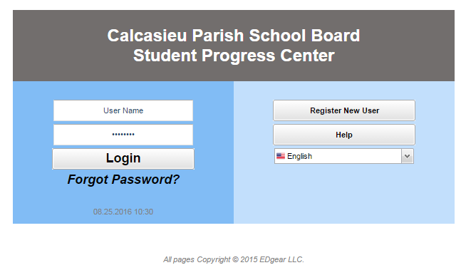

Once you pick District: 010 Calcasieu School District, fill out the other information. The parent information must match the student demographic information. The PSN number is provided by the student’s school.

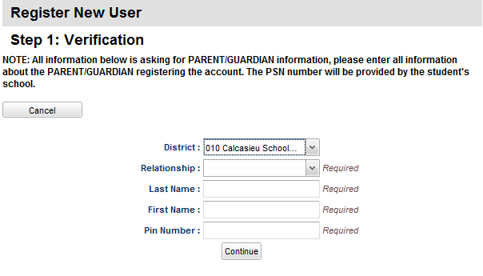

NOTES: This area requires PARENT/GUARDIAN name as appears on the form sent home. The Pin number is the PSN number located on the Student Information Form that was previously sent home.

The next screen will ask for a login name and password. This will be needed each time you choose to check your child’s grades, attendance, etc. ( If it doesn’t accept the login, try again including a number)

Once registered, the next screen will have the student’s name and/or picture. There will be a drop down box located at the top right corner (make selection). Click and select Student Registration Update.

Follow the directions for updating the information.

If any additional assistance is needed, contact Mrs. Brady at 217-4780 ext. 6204