
Course Number and Title: 3020 Consumer Math
Academic Credits: 1 credit
Course Delivery Format: In person (AIS)
Teacher: Mr. Matthew Mills

Teacher Summary:
I have been teaching for 10 years, spending my last 8 here at Susquehanna Township High School. I have my bachelor’s in mathematics and my master’s in education. I look forward to working with you and your family this year!

Teacher Phone: 717-657-5117 and 42313
Teacher Email: mmills@hannasd.org
Office Hours: By appointment only; please email to schedule an appointment.

Course Description:
Consumer Math will focus on everyday applications of basic mathematical principles. We will learn to compute wages given different methods of being paid. We will also practice using the mathematics associated with loans, purchases, insurance, and investments. We will explore the various options and decisions involved in savings and charge accounts.

Prerequisites:
None

Required Texts and Materials:
You will need a calculator (we have a classroom set you do not need to purchase), an instrument to write with and your school issued computer.

Recommended Texts and Materials:
None.

Course Outcomes:
- Students will be able to…solve real world problems involving Consumer Mathematics.

Units of Study/Pace of Course:
Unit | Major Topics | Standards Addressed | Approximate Length  of Unit | Assignments/  Assessments
Unit 1 | Gross Income | CC.2.2.7.B.3 | 16 Days | Lesson Quiz: T, S, P1, P2, P.3, 1.1, 1.2, 1.3, 1.4, 1.5, 1.7.  Quiz: 1.1 – 1.2, 1.1 – 1.5  Test: A, B, C…
Unit 2 | Net Income | CC.2.2.7.B.3 | 11 Days | Lesson Quiz: 2.1.1, 2.1.2, 2.2, 2.3,2.4, 2.5, 2.6.  Quiz: 2.1 – 2.3.  Test: A, B, C…
Unit 3 | Record Keeping | CC.2.2.7.B.3 | 7 Days | Lesson Quiz: 3.1, 3.2, 3.3  Quiz: 3.1 – 3.2  Test: A, B, C…
Unit 4 | Checking Accounts | CC.2.2.7.B.3 | 10 Days | Lesson Quiz: 4.1, 4.2, 4.3, 4.4, 4.5, 4.6.  Quiz: 4.1 – 4.4.  Test: A, B, C…
Unit 5 | Savings Accounts | CC.2.2.7.B.3 | 14 Days | Lesson Quiz: 5.1, 5.2, 5.3, 5.4, 5.5, 5.6, 5.7, 5.8.  Quiz: 5.1 – 5.4, 5.5 – 5.8  Test: A, B, C…
Unit 6 | Cash Purchases | CC.2.2.7.B.3 | 10 Days | Lesson Quiz: 6.1-2, 6.3, 6.4, 6.5, 6.6, 6.7.  Quiz: 6.1 – 6.3  Test: A, B, C…
Unit 7 | Charge Accounts and Charge Cards | CC.2.2.7.B.3 | 7 Days | Lesson Quiz: 7.1, 7.2.1, 7.2.2, 7.3.1, 7.3.2.  Test: A, B, C…
Unit 8 | Loans | CC.2.2.7.B.3 | 12 Days | Lesson Quiz: 8.1, 8.2, 8.3.1, 8.3.2, 8.4.1, 8.4.2, 8.5, 8.6.  Quiz: 8.1 – 8.2.  Test: A, B, C…
Unit 9 | Vehicle Transportation | CC.2.2.7.B.3 | 11 Days | Lesson Quiz: 9.1, 9.2, 9.3, 9.4, 9.5, 9.6, 9.7.  Quiz: 9.1 – 9.4  Test: A, B, C…
Unit 10 | Housing Costs | CC.2.2.7.B.3 | 13 Days | Lesson Quiz: 10.1, 10.2, 10.3, 10.4, 10.5, 10.6, 10.7, 10.8, 10.9.  Quiz: 10.1 – 10.3.  Test: A, B, C…
Unit 11 | Insurance | CC.2.2.7.B.3 | 6 Days | Lesson Quiz 11.1, 11.2, 11.3, 11.4.  Test: A, B, C…
Unit 12 | Investments | CC.2.2.7.B.3 | 15 Days | Lesson Quiz: 12.1, 12.2, 12.3, 12.4, 12.5, 12.6, 12.7, 12.8, 12.9.  Quiz: 12.1 – 12.3, 12.4 – 12.6.  Test: A, B, C…

Procedures for Late Assignment:
All assignments are due by the dates below in the marking period they are assigned.
Marking Period 1: 10/29/2024 3:00 PM
Marking Period 2: 1/21/2025 3:00 PM
Marking Period 3: 3/28/2025 3:00 PM
Marking Period 4: 6/3/2025 3:00 PM
*Dates may change slightly if there are schedule changes because of school closures.

Procedures for Redo Work:
Lesson Quizzes are learning opportunities. Students will submit each lesson quiz through a revision cycle with teacher feedback and should continue revising the document until they have achieved a 100%. Resources should be used.

Quizzes (NOT LESSON QUIZZES) come in two forms (A and B) students may attempt version A and if they are not satisfied with their performance on version A they may attempt version B. Quizzes are self-assessments. The use of resources is not recommended but students may use resources if they choose. A video review and teacher feedback of version A are available before the attempt at version B.

Tests are formal authentic assessments. Students may only use teacher provided resources. Personal electronic devices will be collected and returned after testing. Tests come in two forms (A and B). Students may attempt version B if they are not satisfied with their performance on version A. A video review and teacher feedback of version A are available before the attempt at version B.

Procedure for Extra Credit:
I do not offer extra credit; however, I can create a version C, D, E etc. of TESTS ONLY for any struggling students.

Calculation of Final Grade:
CATEGORY | PERCENT (%) OF GRADE
Unit Tests (Assessments) | 60%
Quizzes (Demonstration of Knowledge) | 30%
Lesson Quizzes (Learning Opportunities) | 10%
Total: | 100%

Grading Scale:
- A - 90% - 100%
- B - 80% - 89%
- C - 70% - 79%
- D - 60% - 69%
- F - 0% - 59%
Rubrics Associated with Course:
None

SOAR in the Classroom:
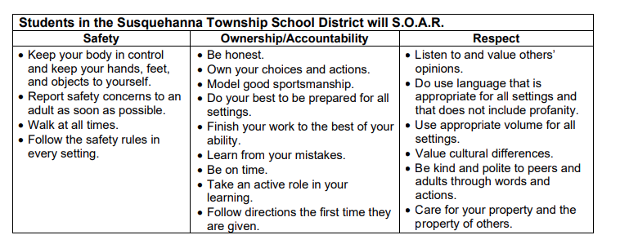

Class Attendance Policy:
Click HERE for the board approved attendance policy.

Cell Phone Policy:
Click HERE for the board approved electronic device policy.

Academic Integrity Policy:
Click HERE for the board approved academic integrity policy.

Pass Policy:
All students must use e-hall pass to sign out of class.

Academic Assistance Program (AAP):
Need additional assistance in the class? Come to AAP after school on Mondays, Tuesdays, and/or Thursdays from 2:37-4:30pm in the library. A certified teacher will be on staff to help with any work or questions you may have. Students may ride the 4:30pm late bus home from AAP.

