
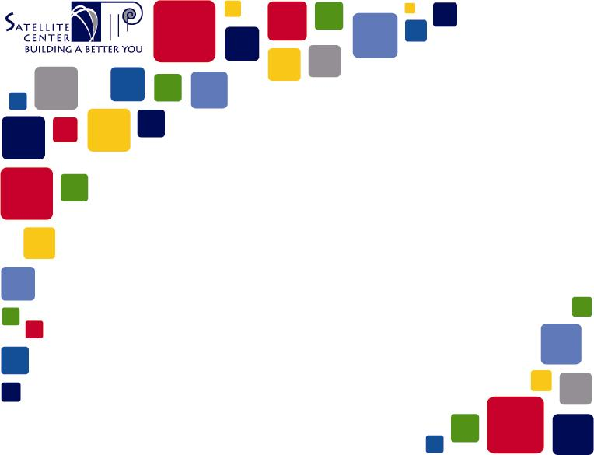
Dear Parent/Guardians,

As a student of the Satellite Center, your child participates in project based learning and/or dual enrollment courses. As part of some projects/dual enrollment classes, your child may need access to websites that are blocked by St. Charles Parish Public Schools’ web filter. This filter looks at set criteria to determine whether a website is acceptable for K-12 learning. The formula automatically blocks social media sites such as YouTube, and Twitter as well as Canva, Moodle, etc.. This is in compliance with the Child Internet Protection Act (CIPA). However, these websites are tools that enhance these projects or are required to completed dual enrollment coursework.

The Satellite Center facilitator may request access to a website as needed for the course work in these classes. With your permission, the district will grant access to these websites for your child for the duration of the project/dual enrollment course. This access will be evaluated in alignment with district policy and procedures.

Please contact me if you have any questions or concerns,

Elaine Fitzgerald
Administrator
Satellite Center
985-785-2080
efitzgerald@stcharles.k12.la.us

St. Charles Parish Public Schools has my permission to allow my child
access to websites as needed to complete project work/dual enrollment course work for the Satellite Center.

Parent’s signature Date

285 Judge Edward Dufresne Parkway, Luling, LA 70070 Phone: 9857852080 FAX: 985331-2536
www.stcharles.k12.la.us/satellite

