LA-932 CORPS OF CADETS
LE/AS-100 COURSE SYLLABUS
(AY 2014-2015, Semester 1)
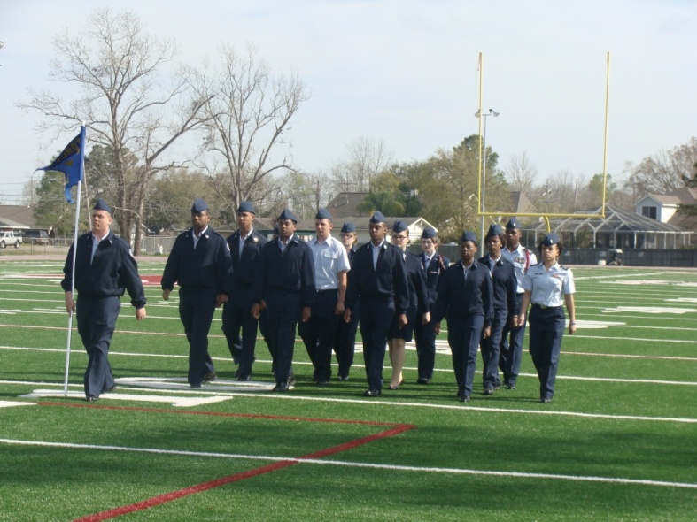

COURSE NAME: Introduction to Junior ROTC and Health/Aviation History
CREDIT HOURS: 1 Hr.
INSTRUCTORS’ NAMES: Colonel Reich
REQUIRED TEXT: Leadership Education 100 (V-7101T), Aerospace Studies 100 (V-7025T), Drill and Ceremony (V-2627)
COURSE DESCRIPTION: Leadership Education (LE) 100 introduces cadets to the Air Force Junior Reserve Officer Training Corps (AFJROTC) program, providing a basis for progression through the rest of the AFJROTC program while instilling the elements of good citizenship. It contains sections on cadet and Air Force organizational structure; uniform wear; customs and courtesies; health and wellness; fitness; individual self-control; and citizenship. Drill and Ceremony (LE- 500) introduces cadets to marching and other ceremonies, a basic discipline-building program necessary for leadership training. Aerospace Studies (AS) 100 covers the history of aviation, from balloons thru fixed-wing aviation, military combat and commercial aviation. An introduction to space travel is included. The Wellness Program, an important part of good citizenship training now and as adults, will consist of physical fitness training on Fridays and appropriate LE-100 programs blended into the state core wellness program. This enables JROTC to qualify each cadet for completing the state requirements for health (1 hour). The second semester JROTC program completes the second hour for high school graduation requirements.
COURSE OBJECTIVES:
- Know the purpose of AFJROTC history, mission, purpose, goals, and objectives;
- Understand military traditions and the importance of maintaining a high standard of dress and personal appearance;
- Know the importance of attitude, discipline, and respect and why values and ethics are so important; execute them on a daily basis.
- Know the importance of keeping yourself well and helping others stay well; develop a program to maintain fitness based on the Presidential Fitness Program.
- Motivate cadets to lead active, healthy lifestyles into their adult lives. This includes mental/emotional/social and physical health, nutrition, and substance abuse avoidance.
- Know the historical facts and impacts of the early attempts to fly.
- Know the major historical contributions to the development of flight.
- Know the contributions of the U. S. Air Force to modern aviation history.
- Know the key events of space exploration history.
- Execute drill and ceremony (LE-500) as a flight member and element leader.
- Exhibit good citizenship through activities and classroom decorum/ROARS.

UNIFORM DAY: Thursday (Wear of uniform a must!) (LE-500)
PHYSICAL FITNESS DAY: Friday (Wear of physical fitness uniform a must!) (Wellness). Cadets are required to accomplish the AFJROTC physical fitness permission form before engaging in physical fitness. Cadets will participate in the Presidential Fitness Program with results posted on WINGS. These pre and post test results are also recorded as the ROTC department’s Student Learning Target (SLT).
GRADING PROCEDURES: School policy is in effect. You will be evaluated in numerous categories and events; these include chapter testing (including the Classroom Performance System), classroom quizzes, reading-for-comprehension/writing skill (DHS policy) quizzes (using course materials), drill, uniform wear/inspection, physical fitness training, assignments, and classroom decorum/courtesy.
A: 100%-93; B: 92-86; C: 85-76; D: 75-69; F: 68-60; I: Incomplete
CURRICULUM-IN-ACTION (CIA) FIELD TRIPS: Cadets in good standing will be afforded the opportunity to learn more about aviation, the military, civics, history and world events by attending field trips to local venues, such as the Joint Reserve Base New Orleans, Armstrong International Airport, Keesler Air Force Base, NASA/Stennis Space Center, and local/regional drill events. Some of these events are day trips, some are overnight events. In any case, a parental permission form will need to be accomplished. Additionally, food and billeting are usually covered by the Air Force or the school. Any funding needed by you will be minimal. Instructors are present at all events, and parents/guardians are encouraged to attend as chaperones.
THE LA-932 CADET GUIDE: There are hard copies in the classroom and on-line at the LA-932 AFJROTC/Corps of Cadets website.
CLASSROOM CONDUCT: When the instructor enters the room, it will be called to attention. Once class starts, there will be silence unless recognized by the class leader or instructor. Cadets will also remain in his/her chair unless permitted to leave it. There is also no eating/gum chewing in class. Breaking the rules will result in a loss of points from your weekly Conduct Grade, your Good Citizenship grade.
Further misbehavior will lead to classroom dismissal/In School Detention (ISD) and possibly state referrals/court school/expulsion. It remains the right of the Senior Aerospace Science Instructor to retain you in the program following a series of bad conduct. All bad conduct is recorded for loss of grade. Your instructor will also notify the guidance office of poor behavior.

