LA-932 CORPS OF CADETS
AS-500 COURSE SYLLABUS
(AY 2014-2015, Semesters 1 and 2)
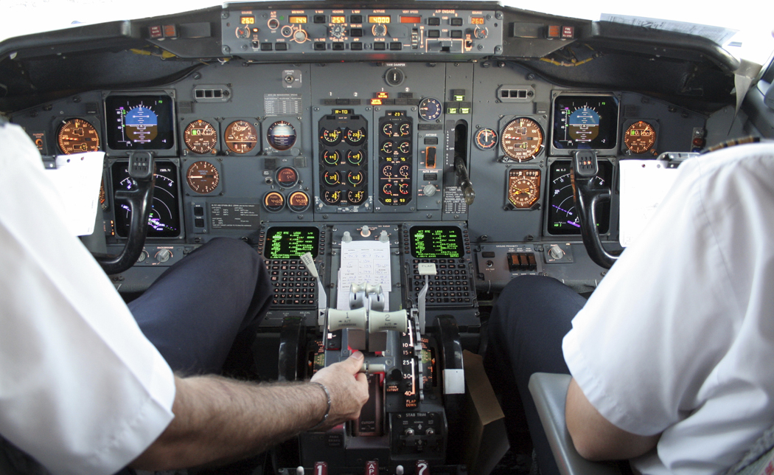

COURSE NAME: Federal Aviation Administration Ground School
CREDIT HOURS: 1 Hr.
INSTRUCTORS’ NAMES: Colonel Reich
REQUIRED TEXT: Jeppesen Private Pilot Manual (GS-JS 314500); Principals of Management (V-7401); Drill and Ceremony (V-2627)
COURSE DESCRIPTION: Aerospace Education (AS-500). This program is an FAA-approved (Part 141) school sponsored by the Air Force Junior ROTC program and taught by a certified FAA instructor. It is the ground portion of flight training required to obtain a private pilot license but at NO expense to a Destrehan High School student. It instructs students on the basic aerodynamics of flight, engine mechanics, instrumentation, airport operations, airspace control, weather, aircraft performance, navigation, and mission planning. Leadership Education (LE-400) continues; Drill (LE-500) continues. The Wellness Program, an important element of good citizenship training now and as adults, will consist of physical training on Fridays.

LEARNING OUTCOMES:
- Know the process for obtaining a private pilot license;
- Comprehend how each part of the aircraft enables steady flight;
- Comprehend basic aerodynamic principles on aircraft and how the pilot controls them;
- Execute steady flight on the flight simulator;
- Know how airports/airspace is categorized by law, understand how to operate within the constraints, and apply these skills on maps/charts;
- Know the rules of flight communications and sources of safety information;
- Know the reasons for weather, comprehend the impact on aviation, learn where to find the data, and apply skills to predict weather impact on flight operations;
- Comprehend the factors that affect flight and execute techniques to predict aircraft performance;
- Know the navigation aids available and learn how to use them in the cockpit;
- Plan, plot, and execute a flight profile (mission) on the simulator.
- Comprehend the human element of flight.
- Maintain cadet leadership per AS-400 standards.
UNIFORM DAY: Thursday (Wear of uniform a must!)
PHYSICAL FITNESS DAY: Friday (Wear of physical fitness uniform a must!) (Wellness) Cadets are required to accomplish the AFJROTC physical fitness permission form before engaging in physical fitness. Cadets will participate in the Presidential Fitness Program with results posted on WINGS. These pre and post test results are also recorded as the ROTC department’s Student Learning Target (SLT).
GRADING PROCEDURES: School policy is in effect. You will be evaluated in numerous categories and events; these include weekly chapter testing, uniform inspection, and physical fitness. The FAA-required Stage Tests (2) will be the midterm and final exams. The FAA Ground School Certificate is presented with a passing grade of 80%.
A: 100%-93; B: 92-86; C: 85-76; D: 75-69; F: 68-60; I: Incomplete
CIRRICULUM-IN-ACTION (CIA) FIELD TRIPS: Field trips to Armstrong International Airport and a local private airfield are planned. An incentive ride for each cadet is approved by DHS, if available.
THE LA-932 CADET GUIDE: There are hard copies in the classroom and on-line at the LA-932 website.

