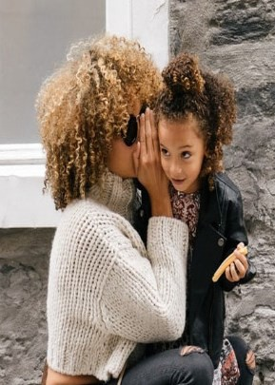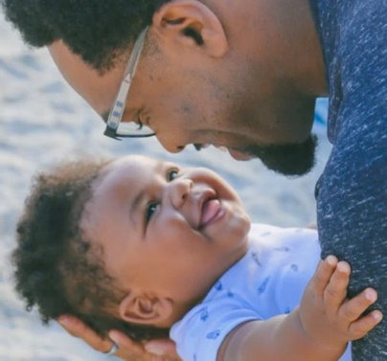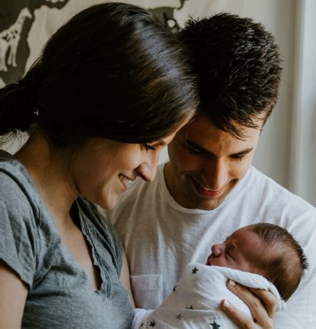

# brains are BUILT

**not born...**

Play 2 Learn

# Have You Heard?

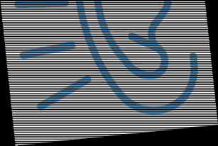

Over half of Gwinnett’s children are NOT READY to thrive when they enter Kindergarten!

Want to LEARN how to be your child’s

first best teacher through PLAY?

Gwinnett County Public Schools oﬀers a **BIRTH TO FIVE** program

for **you and your child** at elementary schools across the county!

‐Learn how to find the teachable moments in everyday activities

‐Learn how to engage with your child in play

‐Learn how to continue the learning at home or anywhere

For more information about Play 2 Learn at **Mason Elementary,**

Please contact.

Mary McCarthy

(770)232-3370

‐Learn about your child’s educational milestones

‐Learn how to get your child READY FOR SCHOOL