# LEAPMake the

## What is LEAP?

The Literacy & Entrepreneurship Advancement Program provides students with an enriching learning experience that allows them to earn Language Arts course credit while completing the Marketing Management Pathway requirements. Students will apply critical thinking/problem-solving skills as well as use foundations of marketing to form a business plan and acquire a business license.

Fostering high levels of collaboration between language arts and CTE teachers, LEAP improves reading and writing skills through real-world applications. As Marketing Management Pathway completers, students will be able to articulate ideas effectively to become productive members of a changing economic environment.

Entrepreneurial Focus

## Why Should You Make the LEAP?

LEAP students work and learn collaboratively in an engaging classroom environment that fosters creativity and innovation. If you have an interest in entrepreneurship and marketing and want to earn 3 course credits in 2 blocks, then LEAP is for you.

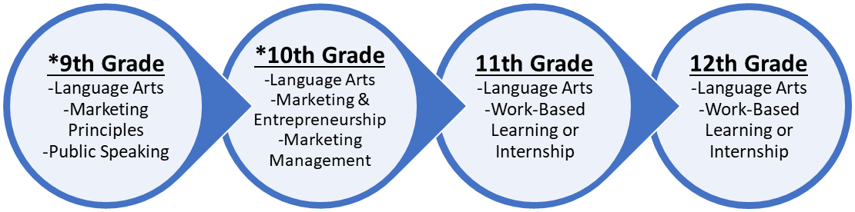

**Course Progression**

**\*One Block Yearlong Combo Course**

**For more information, please contact Nicole Lassiter or Stephanie Stone at**

[Nicole_Lassiter@gwinnett.k12.ga.us](mailto:Nicole_Lassiter@gwinnett.k12.ga.us) / [Stephanie_Stone@gwinnett.k12.ga.us](mailto:Stephanie_Stone@gwinnett.k12.ga.us)