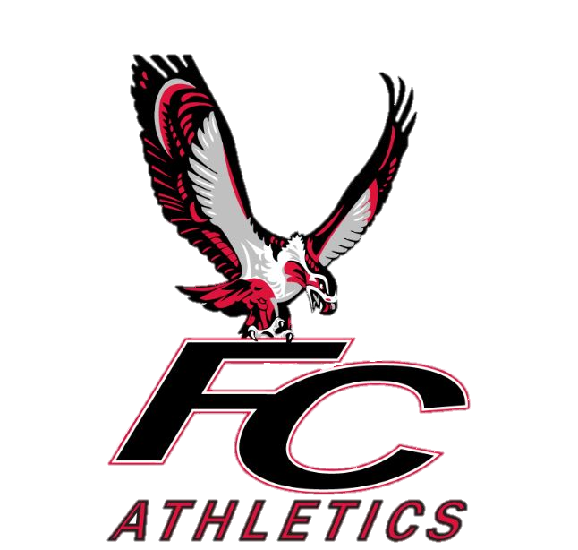

**FCS 2024 Cross Country Meet Schedule**

|  |  |  |  |  |  |
| --- | --- | --- | --- | --- | --- |
| **Date** | **Race** | **Location** | **Leave School** | **Race Time** | **Approx. Return** |
| Sat. 8/17 | Miller Landing Madness (Preseason race)  [Miller Landing Madness 8K/5K/3K Cross Country Run (runsignup.com)](https://runsignup.com/Race/FL/Tallahassee/MillerLandingMadness8K5K3K) | Elinor Klapp Phipps Park  (Tallahassee) | 5:30am | 8:00am (5K)  9:00am (3k) | 11:30 |
| Sat 8/24 | Dueling Summits | Elinor Klapp Phipps Park  (Tallahassee) | 5:30am | 8:00 am (Girls)  8:40 am (Boys) | 11:30 |
| Sat 9/7 | Hoka Nights of Thunder  [Nights of Thunder XC Fest](https://www.nightsofthunder.com/) | Apalachee Regional Park | Around 4:00pm | Evening race- exact time TBD  (HS ONLY) |  |
| Sat 9/14 | Wakulla Meet | 3Y Ranch- | 6:00am | 8:00 (HS Girls)  8:45 (HS Boys)  9:30 (MS Girls)  10:00 (MS Boys) | 12:00 |
| 10-28 to 11-2 | District Meet | TBD | TBD | TBD |  |

*There will be at least 3 more meets added to schedule in Sept and Oct. I will let everyone know ASAP when we have picked those meets!