Scranton School District

Parent/Student Handbook:



STEMM Academy Policies

2024 - 2025

**Table of Contents**

Academy Goals…………………………………………………………………………………………………………… 3

Overview ………………………………………………………………………………………………………………….. 4

2024 - 2025 School Calendar…………………………………………………………………………………………… 4

Academic/ Athletics Policy………………………………………………………………………………………………. 5

Academic Expectations………………………………………………………………………………………………….. 6

Application & Acceptance Process…………………………………………………………………………………….. 6

Attendance………………………………………………………………………………………………………………… 8

Attire/ Uniform…………………………………………………………………………………………………………….. 9

Backpacks/ Gym Bags/ Purses…………………………………………………………………………………………. 9

Behavior Expectations………………………………………………………………………………………………….. 10

Bell Schedule…………………………………………………………………………………………………………….. 11

Bussing…………………………………………………………………………………………………………………….13

Contact Information…………………………………………………………………………………………………….. 13

7th Grade Course Descriptions……………………………………………………………………………………….. 14

8th Grade Course Descriptions……………………………………………………………………………………….. .16

High School Course Descriptions…………………………………………………………………………………….. .18

Discipline…………………………………………………………………………………………………………………..20

Electronics……………………………………………………………………………………………………………….. 21

Entering and Exiting the Building……………………………………………………………………………………….21

Hallways………………………………………………………………………………………………………………….. 21

Homeroom…………………………………………………………………………………………………………………21 Lavatories………………………………………………………………………………………………………………… 22

Lockers…………………………………………………………………………………………………………………… 22

Lunch/ Breakfast Program …………………………………………………………………………………………….. 22

Physical Education Attire………………………………………………………………………………………………. 23

Removal/ Dismissal from Program……………………………………………………………………………………. 23

STEMM Academy Common Areas……………………………………………………………………………………. 24

Technology……………………………………………………………………………………………………………….. 24

Website ………………………………………………………………………………………………………………….. 24

***Please Note: Students are expected to follow all policies and procedures as outlined in the Scranton School District Student / Parent Handbook.***

**STEMM Academy Goals**

The Scranton School District STEMM Academy is an all day program with pathways in Computer Science, Engineering, and Medicine, located at Scranton High School. Any student in the city of Scranton in grades 7-12 is eligible to take part in the application process, as space is limited.

Courses are geared toward phenomenon and project based learning with focuses on STEMM (Science, Technology, Engineering, Mathematics, and Medical) topics. Students will be continuously presented with real-world problems and through the process of questioning, research, and iteration, students develop skills in critical thinking, collaboration, and leadership that are necessary for success beyond the classroom.

The STEMM academy offers unique opportunities for:

* Teamwork
* Technology Skills
* Problem Solving & Innovation
* Project Management Skills

Listed below are the two major goals for the STEMM Academy.

1. Offer the strongest possible academic background through a stimulating academic environment and a challenging, rigorous curriculum that is student-centered and focused on project-based learning
2. To be the regional leader in STEMM education by offering cutting edge technology, flexible learning spaces, and student engagement through community outreach projects

**Overview**

The Policies set forth in this handbook may be amended at the discretion of the administration.

**2024 - 2025 School Calendar**

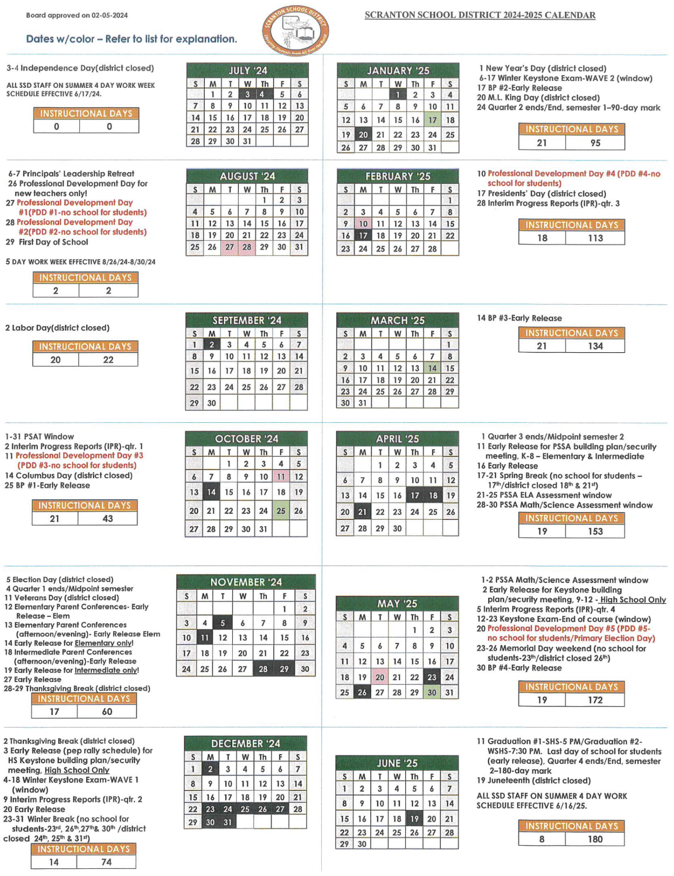

**Academic/ Athletics Policy**

Intermediate students who are accepted and enrolled in the STEMM Academy will be eligible to participate in all co-curricular activities, PIAA Athletic Junior High Programs (extracurricular), academic, and social activities at their home school (based on their registered address).

When a student enrolled in the STEMM Academy **enters 9th grade**, students whose home school would be West Scranton High School will be given a one time opportunity, **in 9th grade**, to select for which high school’s co-curricular, PIAA Freshman, JV or Varsity level Athletic Programs (extracurricular), academic, and social activities they wish to participate. Once selected, the student will be locked into that choice for the remainder of their high school career. This choice will be for all co-curricular, PIAA Freshman, JV or Varsity level Athletic Programs (extracurricular), academic and social activities that the student is eligible to participate in.

All students within Scranton High School’s boundaries will participate in co-curricular, PIAA Freshman, JV or Varsity level Athletic Programs (extracurricular), and social activities at Scranton High School only!

If a student whose home school would be West Scranton High School, leaves or is dismissed from the STEMM Academy due to falling short of expectations, the student will then return to West Scranton High School and be eligible for co-curricular, PIAA JV or Varsity level Athletic Programs (extracurricular), and social activities for West Scranton High School only!

**PIAA GUIDELINES:**

**7TH, 8TH GRADE JUNIOR HIGH PIAA ATHLETIC PROGRAMS**

*Includes: Softball, Baseball, Boys & Girls Basketball.*

Students who are accepted and enrolled in the STEMM Academy, and who are interested in participating and are eligible to join PIAA Athletic Programs (extracurricular) at the Junior High level will participate in those athletics at their home school (based on their registered address).

**7TH, 8TH GRADERS PARTICIPATING IN FRESHMAN PIAA ATHLETIC PROGRAMS**

*Includes: Cross-Country, Football, Boys and Girls Basketball, Wrestling and Boys and Girls Track & Field.*

Students who are accepted and enrolled in the STEMM Academy, and who are interested in participating and are eligible to join PIAA Athletic Programs (extracurricular) at the Freshman level will participate in those athletics at their *next year building of residence (see below)*.

Northeast Intermediate School students would be eligible to participate at Scranton High School.

South Intermediate School students would be eligible to participate at either Scranton High School or West Scranton High School based on the location of their registered address.

West Scranton Intermediate School students would be eligible to participate at West Scranton High School.

**9TH GRADERS PARTICIPATING IN FRESHMAN PIAA ATHLETIC PROGRAMS**

*Includes: Cross-Country, Football, Boys and Girls Basketball, Wrestling and Boys and Girls Track & Field.*

**9TH, 10TH, 11TH, 12TH GRADE JV AND VARSITY PIAA ATHLETIC PROGRAMS**

*Includes: Football, Tennis, Wrestling, Soccer, Cross-Country, Boys and Girls Tennis, Boys and Girls Basketball,*

*Boys and Girls Swimming and Diving, Softball, Baseball and Boys and Girls Track & Field.*

When a student is enrolled in the STEMM Academy and is eligible to participate at the Freshman, JV or Varsity level for PIAA Athletic Programs (extracurricular), students whose home school would be West Scranton High School will be given a one time opportunity **in 9th grade** to select for which high school’s athletic programs they will participate. Once selected the student will be locked into that choice for the remainder of their PIAA Freshman, JV or Varsity athletic career. If a student whose home school would be West Scranton High School is dismissed from the STEMM Academy due to falling short of expectations the student will then return to West Scranton High School and be eligible for PIAA Athletic Programs for West Scranton High School only! This choice will be for all PIAA athletics that the student is eligible to participate in.

All students within Scranton High School’s boundaries will participate in PIAA athletics at Scranton High School only!

**Academic Expectations**

Students enrolled in the STEMM Academy are expected to be passing all of their classes (minimum 70%). If a student cannot maintain an average grade of 70% by the first progress report, the STEMM Program Supervisor has the authority to hold a meeting with parents, teachers, building principal, and the guidance counselors to create an academic improvement plan. In the event the improvement plan is unsuccessful, a transfer back to the student’s home school will be recommended. Such transfers will be made at the end of the first quarter and with the recommendation of the teacher and guidance counselor.

**Application & Acceptance Process**

All students seeking enrollment in Scranton School District STEMM Academy must complete an application.

Please note that a new application is required each year for applicants seeking entrance into the program; even if you have submitted an application during a previous year and were not admitted, a new application is required. Students already admitted into the program do not need to reapply.

Forms must be fully completed and signed by a parent or legal guardian and handed in to the middle school guidance office.

**Application Process**

The application process will start in November of the current school year for entrance into the program for the following school year.

**Prerequisites:**

* Pre-Algebra in 7th Grade (Strongly Recommended)

All students who are interested are encouraged to apply!

All students that do not get accepted will be placed on a waitlist based on total score. Pending availability, those on the waitlist may be offered an opening prior to the first day of school each year.

**STEM Application Rating System\***

| **QUALIFIER** | **POINTS** |
| --- | --- |
| STEM Teacher Recommendation/ Evaluation | 10 |
| 5th Grade’s PSSA Math and Reading Scores | 20 |
| Project Based Assessment | 20 |
| School Attendance | 10 |
| Discipline History | 10 |
| Interview or Essay** | 10 |

*\*Scores will not be released and only used in the event there are more applicants than enrollment openings.*

*\*\*This qualifier is optional and will be used at the discretion of the STEM Program Supervisor*

The district reserves the right to make changes to the Application Process at any time. In the event of a change, Applicants will be notified.

The district may deny my student’s privilege for entry into the program due to any academic deficiencies and/or discipline infractions that have occurred during the course of the school year.

**Rating System Breakdown\*\***

* Teacher Recommendation/ Evaluation
  + This form will be sent to your teacher(s) and scored by a computer, this is not a recommendation letter.
* 5th Grade’s PSSA Math and Reading Scores
  + A student’s PSSA scores will be converted into the following point system for both Math and Reading:
    - Advanced: 10 pts
    - Proficient: 7.5 pts
    - Basic: 5 pts
    - Below Basic: 2.5 pts
    - No Score/ Unscorable: 0 pts*

*\*For students who do not take the PSSAs - 5th grade ELA & Math Benchmark data will be used instead*

* Project Based Assessment
  + A short 2 hour project and design based assessment done at each middle school*
  + Potential students will get a short 15 minute introduction to the project and then 45 minutes to complete the activity within a group. The last 45 minutes will be used for students to individually analyze their results/ design to answer analysis questions. Project collaboration, design, and analysis will be scored, using a rubric where necessary, by a blind committee chosen by the STEM Program Supervisor, average will be calculated and used

*\*PSSA accommodations will be afforded to any student who qualifies for PSSA accommodations*

* School Attendance
  + A student’s current attendance percentage will be converted into the following point system:
    - 90% - 100% 10 pts
    - 70% - 89% 7.5 pts
    - 50% - 69% 5 pts
    - 30% - 49% 2.5 pts
    - 29% or lower 0 pts
* Discipline History
  + A student’s discipline history will be converted into the following point system:
    - No discipline write ups 10 pts
    - 1 - 3 discipline write ups, no suspensions 5 pts
    - > 3 discipline write ups and/ or suspension(s) 0 pts
* Interview or Essay (only in the event of a tie for acceptance)
  + 2 - 5 minute express interview OR constructed response to a given prompt
  + Scored by a blind committee using a rubric; average will be calculated and used

*\*\*Students Identified as Special Ed or 504*

Upon acceptance of a special ed student or a protected handicapped student, an evaluation report/ record review must be developed for the special ed child, and the appropriate team needs to convene under IDEA or 504 to review the IEP or the 504 plan to be sure it can be implemented in the STEMM Academy, and a NOREP must be issued.

**Attendance**

A student’s attendance at school is very important to the educational process. If your child is going to be

absent from school, **please call the school by 8:30am**. Sporadic attendance can be extremely

detrimental to your child’s educational growth. We trust that your child will attend school regularly and

on time. When any student is absent, he/she will bring a written excuse stating the date and reason for

absence and signed by a parent or guardian on the first day back to school.

REMINDER: if attendance becomes problematic, a parent excuse **DOES NOT QUALIFY** as a legal excuse. As a means of monitoring student attendance, SSD is part of the Lackawanna County STARS Truancy Program. A copy is available at school.

The following steps will be taken in the event of truancy:

1. The principal will send a warning letter to the parent(s) of the child(ren) who have missed three (3)

days (total) of school and no excuse has been presented to the school, or if a child has been tardy

for a total of one (1) hour.

1. If the child(ren) misses two additional days of school and has no excuse, the Scranton School

District will schedule a Student Attendance Improvement Plan (SAIP) meeting with the family,

principal and a liaison from the Office of Youth and Family (OYFS). The purpose of the meeting is

to identify the barriers to getting the child(ren) to school.

1. If the child(ren) misses two additional days beyond the SAIP the family will be contacted and an

additional SAIP meeting may be scheduled.

1. If a child has more unexcused absences, charges will be filed at the magistrate level. A truancy

hearing will be held at a designated location. At this hearing, a needs assessment of the family will

be done. It is possible that Mediation will be provided to the family. Follow up will continue for

two or three months.

1. If attendance continues to be an issue following the first hearing, a contempt hearing will be

scheduled.

A maximum of ten (10) days of cumulative lawful absences verified by parental notification shall be

permitted during a school year. All absences beyond ten (10) cumulative days shall require an excuse

from a licensed practitioner of the healing arts.

The Pennsylvania Compulsory Attendance defines a student habitually truant after he or she has three (3)

unexcused absences from school. On the day following an absence, the student must present to the

homeroom teacher an excuse signed by the parent/guardian stating the reason for absence. If an excuse is

not received within three (3) days of the absence, the absence will be considered UNEXCUSED and/or

UNLAWFUL.

***ATTENDANCE - Special Privileges***

Special Privileges regarding school clubs and activities (dances, field trips, co-curricular events, awards day, etc.) can be denied due to excessive unexcused absences. In addition, failing two (2) classes or more and five (5) unexcused absences will prevent students from participation in school clubs and activities (dances, field trips, co-curricular events, awards day, etc.).

**Attire/ Uniform**

As a student of the Scranton School District, you are expected to take pride in your personal appearance. When you come to school well-groomed, wearing clothes that are neat, clean and in good taste, it is a positive reflection on you and your parents.

The Scranton School District has approved a Dress Code Policy for Students in the High Schools. A copy of the policy (general information, types/colors of attire, discipline guidelines) is located in Section A of this handbook. Please note: cargo pants, leggings, and hoodies are not allowed to be worn in school.

The following articles are considered recreational and are not proper for school – hats, scarves and bandanas, sunglasses and do-rags. Students are not allowed to wear any fad jewelry, trinkets, chains, apparel, or hairstyles which cause undue distraction in the classrooms or around the building.

The Principal reserves the right to rule in those cases where attire is contrary to your own or other’s best interest.

**Backpacks/ Gym Bags/ Purses**

Book bags and backpacks (large purses) are not permitted in the classrooms, physical education areas, auditorium, library or cafeteria. Only clear and mesh bookbags are permitted as per district policy. These items may be brought to school; however they must be secured in the student’s locker until the end of the school day. The same is true of purses that resemble backpacks.

Coats, jackets, hoodies are not to be worn to classes. They must be kept secure in a locker. Any student in violation of this policy will be subjected to a search of such items and may face disciplinary action.

**Behavior Expectations**

Students will be expected to follow the behavioral expectations layed out in the Scranton School District Parent/ Student Handbook. In the event a student’s behaviors are not in accordance with district policy, the SSD discipline policy will be followed and if needed students may be transferred back to their home schools.

|  | **Bus** | **Lockers** | **Hallways** | **Classrooms** | **At Lunch** |
| --- | --- | --- | --- | --- | --- |
| **Respect Self** | Stay in seat  Face forward | Use only your assigned locker  Keep track of your things | Walk directly to where you need to go  Maintain personal space | Walk directly to class  Get there before the bell rings  Keep track of your things | Walk directly to where you need to go  Keep track of your things  Stay in seat |
| **Respect Others** | Inside voices  Polite language  Share your seat  Keeps hands to yourself  Report safety concerns | Be efficient  Inside voices  Polite language  Be courteous of others’ belongings  Report safety concerns | Inside voices  Polite language  Stay to the right  Keeps hands to yourself  Report safety concerns | Inside voices  Polite language  Keeps hands to yourself  Be courteous of others’ belongings and opinions  Report safety concerns | Inside voices  Polite language  Keeps hands to yourself  Be courteous of others’ belongings  Report safety concerns |
| **Respect Environment** | Keep bus clean  Keep aisle clear  No open food or drinks | Place litter in cans/ recycling  Keep your locker clean and the floor clear | Place litter in cans/ recycling  Keep walls and floors clean  No open food or drinks | Place litter in cans/ recycling  Keep your desk clean  No open food or drinks | Place litter in cans/ recycling  Keep your area clean |

**Bell Schedule**

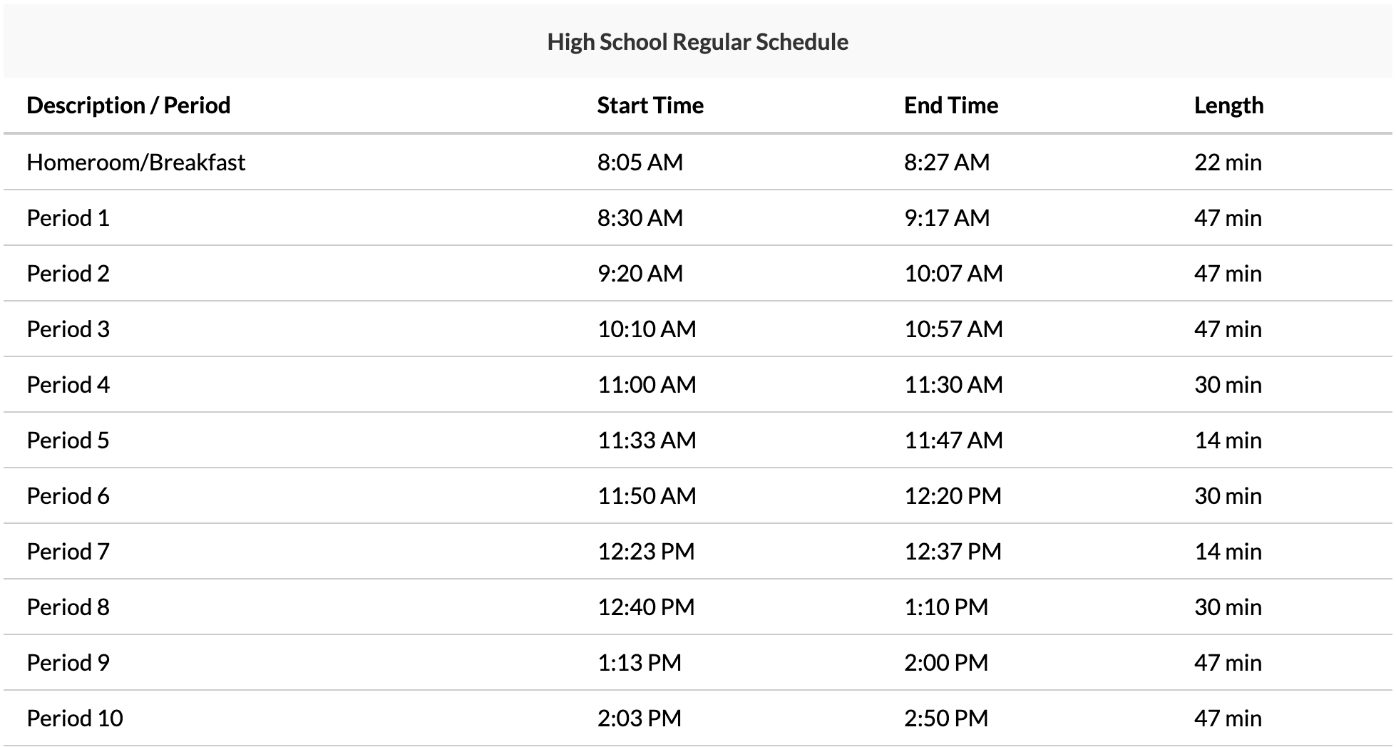

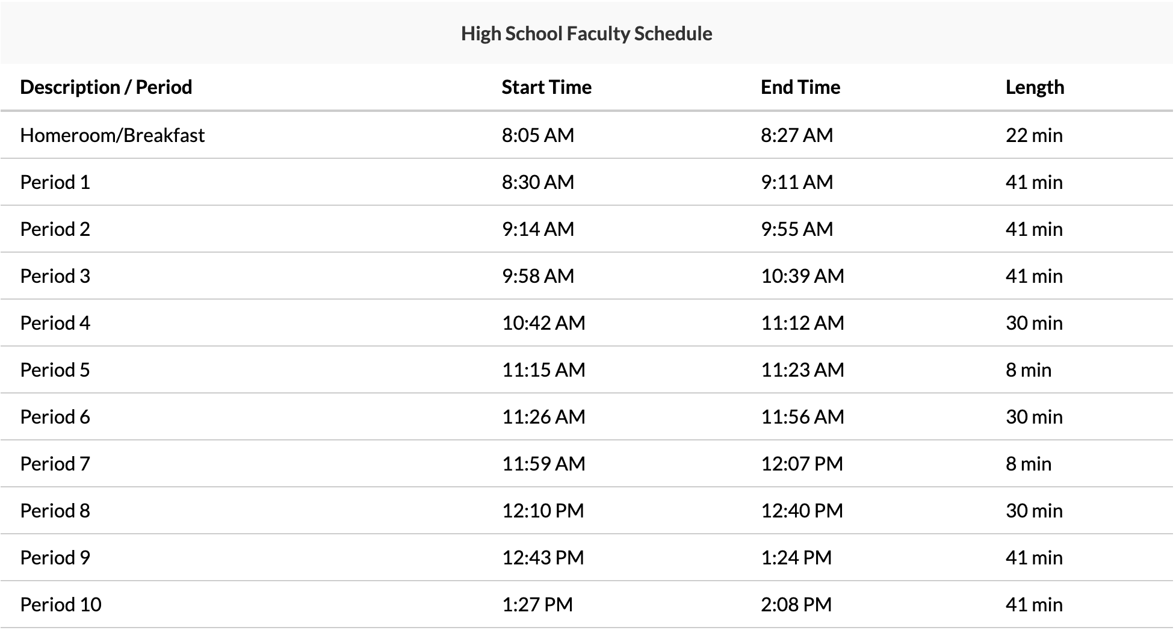

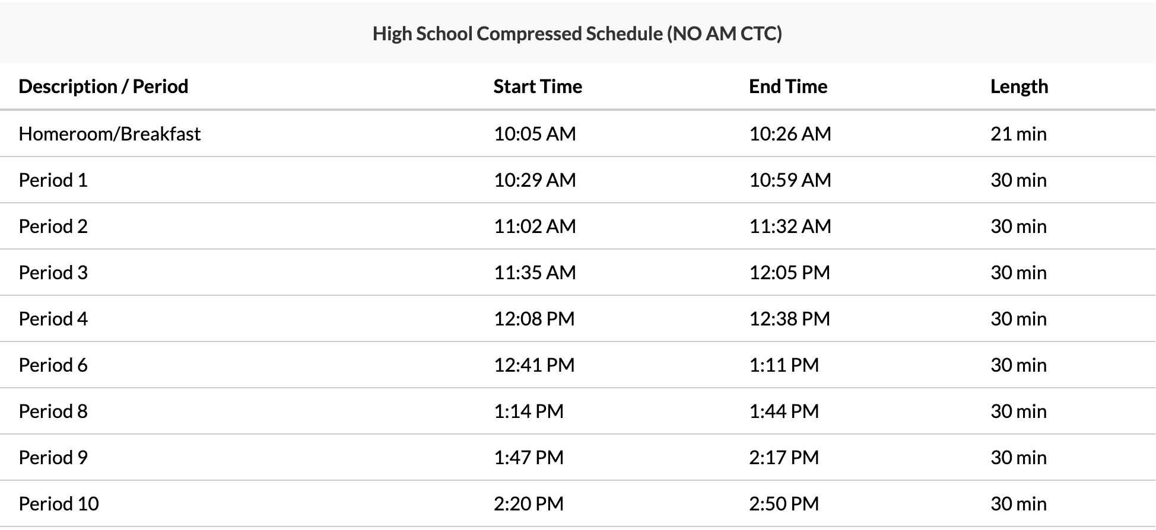

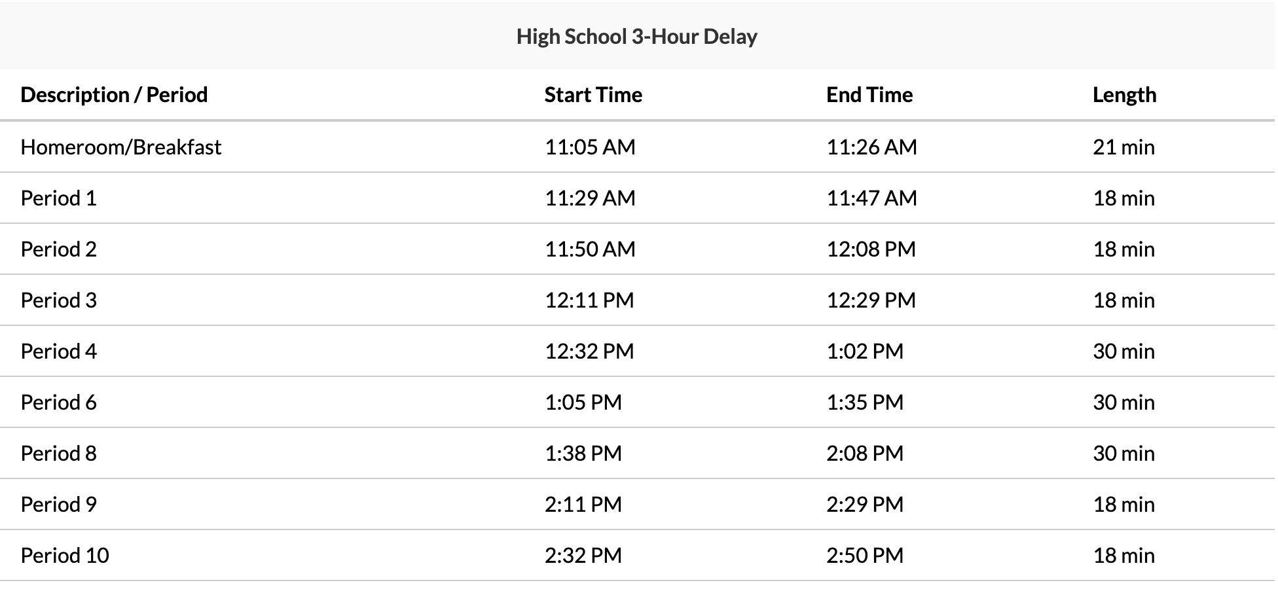

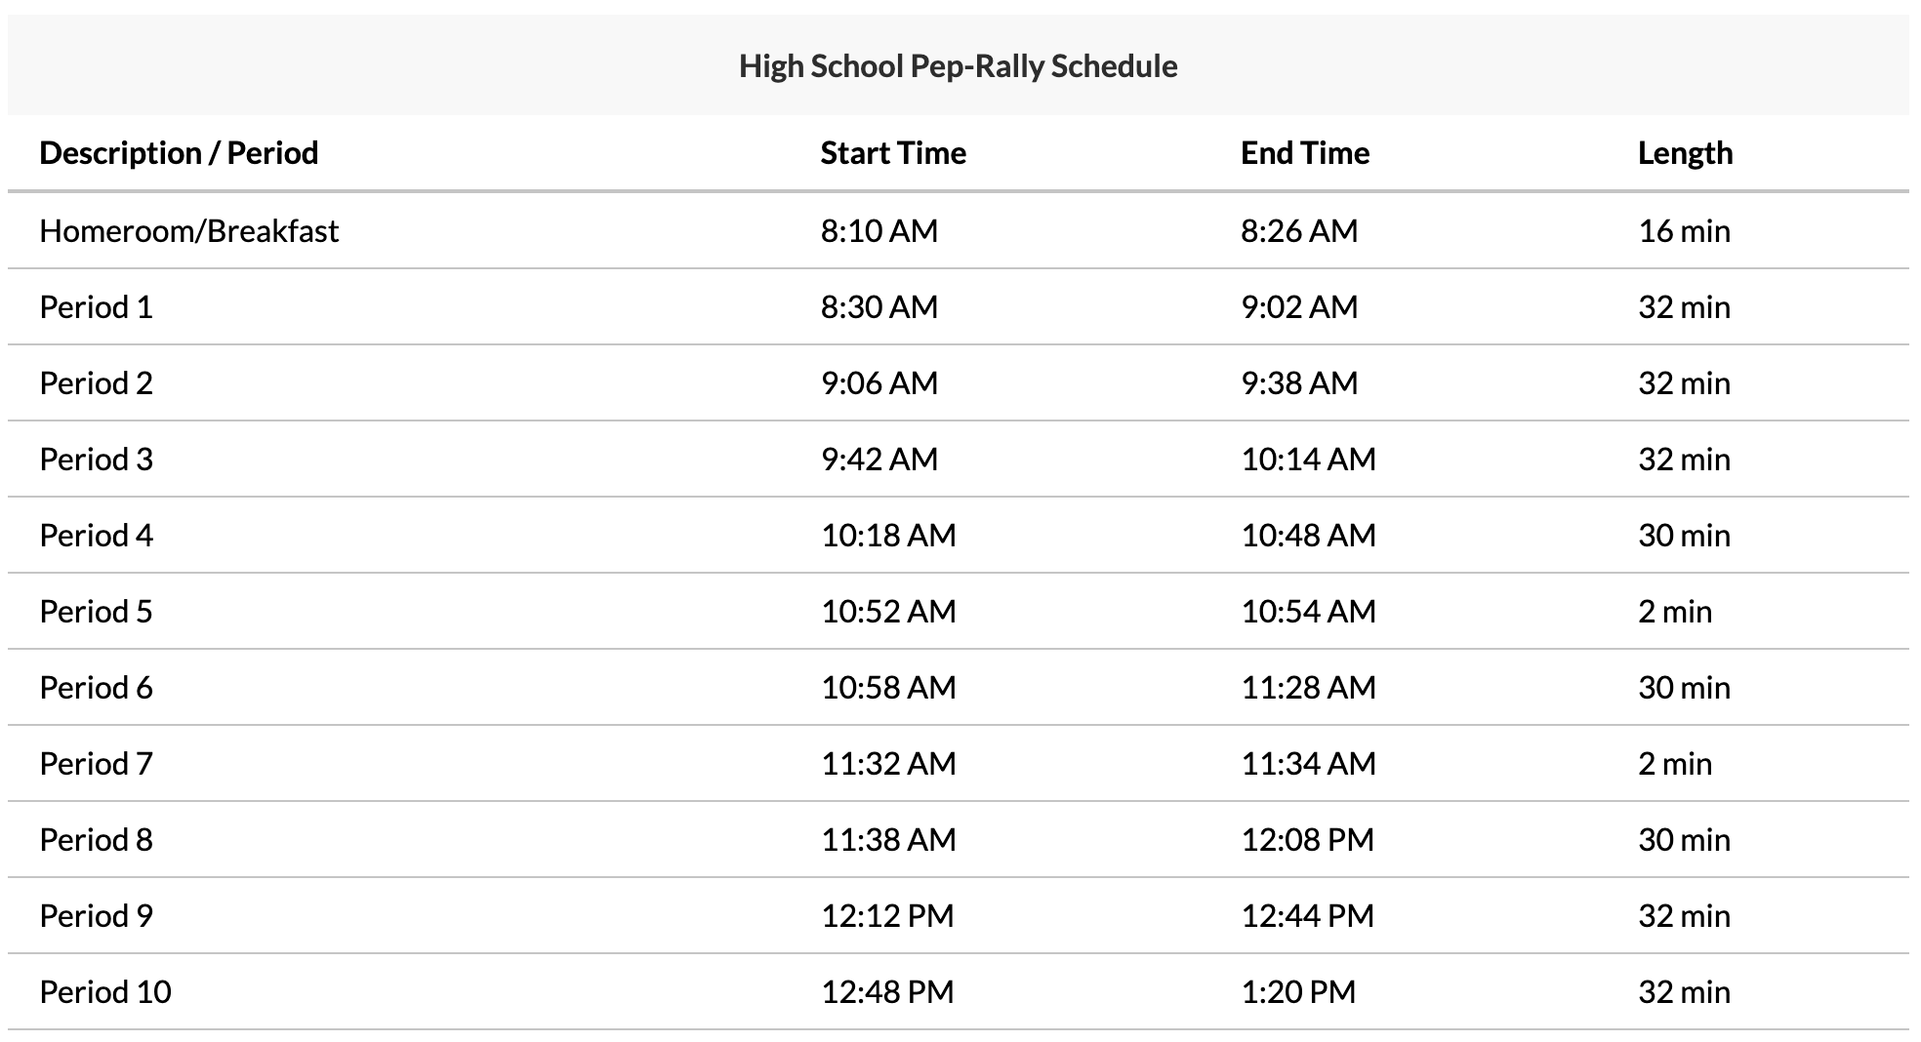

**Bussing**

Bus transportation is provided to and from the STEMM Academy at Scranton High School only for those students who meet requirements set by the Scranton School District. Intermediate school students must live one and one-half (1 ½) miles from the school to receive transportation. COLTS bus passes are provided for high school students who live more than two (2) miles from the school.

You are reminded that conduct on the bus is related to school and that the bus driver is in complete charge. Failure to behave properly may result in suspension of our privileges and other disciplinary action.

The detailed bussing policy can be found in the Scranton School District Student / Parent Handbook.

**Contact Information**

| Scranton High School | Main Office | (570) 348-3481 |
| --- | --- | --- |
| Principal | John Coyle | john.coyle@ssdedu.org |
| Assistant Principal  Last Name A-L | Michael Montoro | michael.montoro@ssdedu.org |
| Assistant Principal  Last Name M-Z | David Mitchell | david.mitchell@ssdedu.org |
| **STEM Program Supervisor** | **Katona Miller** | **katona.miller@ssdedu.org** |
| Counseling Department |  | (570) 348-3481 ext. 62030 |
| School Counselor  Last Names A - E | Morgan WIlliams | morgan.williams@ssdedu.org |
| School Counselor  Last Names F - L | Stacey Moore | stacey.moore@ssdedu.org |
| School Counselor  Last Names M - Q | Ashley Bevilacqua | ashley.bevilacqua@ssdedu.org |
| School Counselor  Last Names R - Z | Christina Nasser | christina.nasser@ssdedu.org |
| Medical Room |  | (570) 348-3481 ext. 62021 |
| Technology Support Contact | Maryann Hazzouri | maryann.hazzouri@ssdedu.org |
| 7th Grade Science | Donna Holmes | donna.holmes@ssdedu.org |
| 8th Science / 7th Comp. Science | Frank Wahl | frank.wahl@ssdedu.org |
| Math/ 8th Comp. Science | Abigail Hankee | abigail.hankee@ssdedu.org |
| English Language Arts (ELA) | Patrick Abdalla | patrick.abdalla@ssdedu.org |
| Social Studies | Michelle Bajor | michelle.bajor@ssdedu.org |
| Engineering/ Tech Education | John Ray | john.ray@ssdedu.org |
| Medical Education | Amanda O’Brien | amanda.obrien@ssdedu.org |
| 9th Grade Integrated STEM | Michael Faris | michael.faris@ssdedu.org |
| 7th Grade Phys Ed/ Health | Brooke Frable | brooke.frable@ssdedu.org |
| 8th Grade Phys Ed/ Health | Maura Kirchner | maura.kirchner@ssdedu.org |

**7th Grade Course Descriptions**

**STEMM ELA 7 (51710)**

This course will target students’ growth in the areas of reading, writing, editing, listening, speaking, discussion, and reflection. Reading strategies, critical thinking skills, and vocabulary building comprise the main elements of reading instructions. Through fiction, nonfiction, and poetry reading, students will practice reading strategies and comprehension skills. The focus of writing will be on narrative, informational, argumentative, and research writing. The overall goal of the class is to increase literacy, grade level appropriate vocabulary, and the writing ability of students. This course is aligned with the Pennsylvania Core Content Standards for English Language Arts (CC).

**STEMM Pre-Algebra 7 (51722)**

Prerequisite: Students must pass the required placement exam with a grade of 85% or higher and must meet 4 out of the 5 following criteria:

● A grade of 90% or higher in Grade 6 Mathematics

● Teacher recommendation from the 6th grade mathematics teacher

● Students must maintain at least an average of 90% by the end of 1st quarter to remain in the class

● Students must perform in the top 1/3 of the proficient/ advanced scores on the sixth grade PSSA test

● Parent’s consent Intended

Audience: This course is designed for the student who has successfully completed grade 6 with 4 out of the 5 criteria listed above, by the end of the 6th grade.

This course differs from the Common Core Math 7 course in that it contains some content from 8th grade. While coherence is retained, in that it logically builds from the 6th Grade, the additional content when compared to the non-accelerated course demands a faster pace for instruction and learning. The Mathematical Practice Standards apply throughout each course and, together with the content standards, prescribe that students experience mathematics as a coherent, useful, and logical subject that makes use of their ability to make sense of problem situations. The critical areas are as follows:

● Students develop a unified understanding of numbers, recognizing fractions, decimals, and percents as different representations of rational numbers.

● Students extend addition, subtraction, multiplication and division to all rational numbers, and view negative numbers in terms of everyday contexts. Students explain and interpret the rules for adding, subtracting, multiplying and dividing with negative numbers. They extend their mastery of the properties of operations to develop an understanding of integer exponents.

● Students use linear equations to represent, analyze, and solve a variety of problems. Students strategically choose and efficiently implement procedures to solve linear equations in one variable.

● Students learn to identify triangles by sides and angles and identify angles formed when parallel lines are cut by a transversal.

● Students will solve problems involving area and circumference of a circle and surface area of three-dimensional objects. They solve real-world and mathematical problems involving area, surface area, and volumes of two- and three- dimensional objects composed of triangles, quadrilaterals, polygons, cubes, and right prisms. Students show that the sum of the angles in a triangle is the angle formed by a straight line.

● Students calculate probability of simple and compound events. Students analyze the measures of central tendency to make predictions of a population.

● Students are introduced to the slope intercept form of an equation and use it to graph lines and interpret the equation. After successfully completing the course, students will be allowed to enroll in Algebra I Accelerated K/CC or Common Core 8P Concepts of Algebra.

**STEMM Science 7 (51740)**

Life Science establishes the study of living things and how they interact with the nonliving world. This course readies students for further, more in-depth studies in the sciences through the establishment of underlying knowledge of living things and their environments. Topics presented in this course include, but are not necessarily limited to, cells, cell parts, cell processes, classification, cell reproduction, genetics, heredity, evolution, and ecology.

**STEMM Integrated STEM 7 (51741)**

The 7th grade Integrated STEM course encourages students to use inquiry based and problem solving approaches to understand science and engineering principles. By combining traditional science concepts (life science, biology, and environmental sciences) with the application of these concepts through engineering and technology, students will gain a greater understanding of the world around them. Collaborative, student-centered lessons and cooperative learning is essential throughout this course. Students will use evidence as a basis for analysis of data and arguments. Emphasis is on the integration of knowledge from a variety of resources and effective communication of an understanding of this knowledge to meet the performance expectations. This course is aligned with the Pennsylvania Science Technology and Engineering (STEE) Standards.

**STEMM World Cultures & Geography II 7 (51730)**

Seventh Grade Social Studies is designed to introduce the geography, cultures, governments, history and economics of the East with an emphasis on Africa, Asia and Europe. The curriculum serves as a foundation that students will build upon as they progress through their academic career.

**STEMM Physical Education / Health 7 (50760)**

Provide a comprehensive, and sequential plan that motivates and assists students to develop, maintain, and improve physical health, prevent disease, and reduce health related risk behaviors.

**STEMM Sports Physiology 7 (54780)**

This physical education course is designed for students who are interested in health related fields. Students in this course will explore topics related to sports medicine, such as nutrition, anatomy, biomechanics, and exercise physiology in this interactive and hands-on course. Students will also learn about human body systems and how they work to better understand injuries that may occur as well as ways to prevent injury. This course is aligned with Pennsylvania’s Health, Safety, and Physical Education standards.

**STEMM Game Programming 7 (54790)**

This computer science course is designed for students who want to learn about computer science through the creative process of how video games are designed and developed, from the moment they are conceived to after they are published. Students will be introduced to the game design process, elements of game play, game documentation, and coding. Students will design and code their own games using block coding programs in this interactive and hands-on course. This course is aligned with the Pennsylvania Science Technology and Engineering Education standards as well as the CSTA standards for Computer Science Education.

**STEMM 3D Modeling 7 (54470)**

This course is designed for students who are interested in 3D design. Students will learn the basics of 3D modeling and the geometry of shapes. This includes how to sculpt, texture, arrange, and render 3D models in preparation for 3D printing as well as the basics of drawing and reading schematics. In this interactive and hands-on course, students will work on collaborative projects in a 3D environment following the engineering design process in programs such as TinkerCAD and OnShape. This course is aligned with the Pennsylvania Science Technology and Engineering (STEE) Standards and International Society for Technology in Education (ISTE) standards.

**8th Grade Course Descriptions**

**STEMM ELA 8 (51810)**

This course will target students’ growth in the areas of reading, writing, editing, listening, speaking, discussion, and reflection. Reading strategies, critical thinking skills, and vocabulary building comprise the main elements of reading instructions. Through fiction, nonfiction, and poetry reading, students will practice reading strategies and comprehension skills. The focus of writing will be on narrative, informational, argumentative, and research writing. The overall goal of the class is to increase literacy, grade level appropriate vocabulary, and the writing ability of students. This course is aligned with the Pennsylvania Core Content Standards for English Language Arts (CC).

**STEMM Algebra I Keystone 8 (51825)**

Prerequisites: Students must pass the required placement exam with a grade of 85% or higher and must meet 4 out of the 5 following criteria:

* A grade of 90 or higher in Common Core 7th Grade Accelerated
* Teacher recommendation from seventh grade Common Core 7th Grade Accelerated
* Students must perform in the top 1/3 of the proficient or advanced scores on the PSSA.
* Students must maintain an average of 90 or above by the end of the 1st quarter to remain in the class
* Parent’s consent

*Students entering from other schools or districts, who did not take a placement test in sixth grade, must pass the Algebra Placement Test for eighth grade with a score of 90 or better.

The 8th grade Algebra I Accelerated K/CC establishes strong algebraic thinking and problem solving skills necessary for further work in mathematics. This course involves working with abstract expressions, using mathematical models to represent real-world problems, and solving open sentences. Topics presented in this course include but are not necessarily limited to:

* structure and properties of the real number system
* algebraic notation including radicals, exponents, absolute value
* varied means for analyzing and expressing patterns, relations and functions including words, tables, graphs, sequences,
* linear equations
* quadratic equations
* systems of equations and inequalities
* polynomials and operations with polynomials including factoring
* data analysis
* probability
* problem solving strategies

At the culmination of this course, the students will sit for the Keystone Algebra I Exam, a Pennsylvania graduation requirement. Successfully completing Algebra I Accelerated K/CC in eighth grade affords the students the opportunity to study Calculus in their senior year of high school. After successfully

completing this course, students who meet the proper prerequisites will be enrolled in Honors Geometry or Geometry 9 in ninth grade.

**STEMM Concepts of Algebra 8 (51826)**

Prerequisites: Successful completion of Common Core Math 7P

In addition, the students must meet 2 out of 3 criteria:

* A grade of 80 or higher in a Common Core Math 7P
* Teacher recommendation from the 7th grade math teacher
* Students must perform proficient on the seventh grade PSSA

This course is different from Common Core 8 in that it will cover the topics in more depth and sometimes at a more aggressive rate.

Students will demonstrate an understanding of the connections between the various branches of mathematics by applying computational skills, mathematical reasoning, and introductory algebraic and geometric principles to model and solve real life problems.

* Students will understand the relationship between lines & linear equations & be able to represent such.
* Students will be able to define, recognize, and evaluate functions.
* Students will demonstrate a proficient understanding of rational and irrational numbers.
* Students will be able to use and understand the Pythagorean Theorem.
* Students will describe the dilations, translations, reflections, and rotations on two-dimensional figures.
* Use statistics and probability to investigate patterns in bivariate data.
* After successfully completing this course, students will be allowed to enroll in Algebra 1 K/CC

**STEMM Science 8 (51840)**

Physical Science is the study of matter, energy, and changes they undergo. The course includes both Chemistry and Physics topics.

**STEMM Integrated STEM 8 (51841)**

The 8th grade Integrated STEM course encourages students to use inquiry based and problem solving approaches to understand science and engineering principles. By combining traditional science concepts (physical science, chemistry, and environmental sciences) with the application of these concepts through engineering and technology, students will gain a greater understanding of the world around them. Collaborative, student-centered lessons and cooperative learning is essential throughout this course. Students will use evidence as a basis for analysis of data and arguments. Emphasis is on the integration of knowledge from a variety of resources and effective communication of an understanding of this knowledge to meet the performance expectations. This course is aligned with the Pennsylvania Science Technology and Engineering (STEE) Standards.

**STEMM US History (1607-1790)/Civics 8 (51830)**

In order to understand our country's origin and evolution, students will study the development of the American Colonies and their fight for independence from England. We will analyze the writings of philosophers such as John Locke and Thomas Hobbes, the contributions of the first representative governments in America such as Jamestown's House of Burgesses, and the impact our struggle for independence from England had on the creation of the Constitution. We will continue with an analysis of the Constitution, our rights and responsibilities as U.S. citizens, and the origins of our political parties. The year will conclude with a unit on local history from 1879 through the 1900s.

**STEMM Phys Ed / Health 8 (50860)**

Provide a comprehensive, and sequential plan that motivates and assists students to develop, maintain, and improve physical health, prevent disease, and reduce health related risk behaviors.

**STEMM PLTW Medical Detectives 8 (54880)**

In this hands-on course students play the role of real-life medical professionals as they collect and analyze medical data to diagnose diseases. Students will solve medical mysteries through hands-on projects and labs, measure and interpret vital signs, complete a dissection, investigate disease outbreaks, and explore the basics of forensic science, while also learning about various careers within these fields. This course is aligned with the Pennsylvania Science Technology and Engineering (STEE) Standards.

**STEMM App Development 8 (54890)**

Through the development of mobile applications, students will continue to explore the field of computer science and computational thinking while building on their javascript block coding skills. Students will work collaboratively to design and develop creative and innovative mobile applications, analyze real-time sensor data, and build physical prototypes for hardware based programming. This course is aligned with the CSTA standards for Computer Science Education.

**STEMM PLTW Green Architecture 8 (54870)**

Students learn how to apply green concepts to the fields of architecture and construction. They explore dimensioning, measuring, and architectural sustainability and apply what they have learned to design affordable housing units using Autodesk’s® 3D architectural design software.

**High School Pathways and Electives**

**Pathway Choices**

(Selected After 8th Grade)

**Engineering**

**Health Science (Medical)**

**Computer Science**

**Engineering**

**STEMM Introduction to Engineering Design 9**

Students dig deep into the engineering design process, applying math, science, and engineering standards to hands-on projects. They work both individually and in teams to design solutions to a variety of problems using 3-D modeling software, and use an engineering notebook to document their work.

**Principles of Engineering 10**

The PLTW Principles of Engineering course focuses on solving a wide range of engineering problems. Topics such as mechanisms, structure and material strength, and automation are explored as students research, strategize, and document the design process.

**Health Science (Medical)**

**STEMM Principles of Biomedical Science 9**

In this course, students explore concepts of biology and medicine as they take on roles of different medical professionals to solve real-world problems. Over the course of the year, students are challenged in various scenarios including investigating a crime scene to solve a mystery, diagnosing and proposing treatment to patients in a family medical practice, to tracking down and containing a medical outbreak at a local hospital, stabilizing a patient during an emergency, and collaborating with others to design solutions to local and global medical problems.

**Medical Interventions 10**

The PLTW Medical Interventions course focuses on the health of a fictitious family that students must support by providing disease prevention, diagnosis, and treatments. In this course, students study infections, human DNA code, cancer treatment, and organ failure. Course topics may also include immunology, surgery, genetics, pharmacology, medical devices, and diagnostics.

**Computer Science**

**STEMM Web Design 9**

This STEMM elective is part of the Computer Science Pathway. This course will introduce students to Web Design. It provides a hands-on introduction to designing, building, and launching websites. Students begin learning how the World Wide Web works, and examining successful websites. Then they learn the basics of HTML coding and create their own web pages. Next, students explore various web development tools, and they get practice creating websites using Adobe Dreamweaver. They learn how to make their websites more effective by applying the principles of design as well as usability and accessibility criteria. In the final unit, students explore a variety of web design careers that they might want to pursue.

**Computer Programming 10**

Computer Programming courses provide students with the knowledge and skills necessary to construct computer programs in one or more languages. Students learn to structure, create, document, and debug computer programs. An introduction to object-oriented programming will also help students develop applications for Windows, database, multimedia, games, mobile and/or Web environments. An emphasis is placed on design, style, clarity, and efficiency. In this course, students apply the skills they learn to relevant authentic applications.

**Other High School Electives**

**Integrated STEMM 9**

The 9th grade Integrated STEM Class encourages students to use inquiry based and problem solving approaches to understand science and engineering principles. By combining traditional science concepts (physical science, chemistry, and environmental sciences) with the application of these concepts through engineering and technology, students will gain a greater understanding of the world around them. Collaborative, student-centered lessons and cooperative learning is essential throughout this course. Integrated STEMM 9 will explore possible field applications of the following 3 areas; computer science, engineering, and medical. Computer science topics include: hardware vs software and cryptography. Medical includes topics such as human body investigations and surgical tools. Engineering topics include: electronics, circuits, and robotics.

**Integrated STEMM 10**

The 10th grade Integrated STEMM Class encourages students to use inquiry based and problem solving approaches to understand science and engineering principles. By combining traditional science concepts (physical science, chemistry, and environmental sciences) with the application of these concepts through engineering and technology, students will gain a greater understanding of the world around them. Collaborative, student-centered lessons and cooperative learning is essential throughout this course. Integrated STEMM 10 will explore possible field applications of the following 3 areas; computer science, engineering, and medical.

**Discipline**

This handbook provides students and parents/guardians with certain rules and expectations. It is not meant to be a comprehensive listing of every regulation. This school has broad discretionary authority for attempting to increase safety, order, and discipline. It has the right to discipline any student who distracts, disrupts, provokes, or intimidates within the school zone. This authority to discipline, includes, but is not limited to, attempts to stop bullying, hazing, harassment, verbal and physical assaults.

Referral of a student to the Principal/Assistant Principal occurs after teachers have exhausted all other appropriate, preventative, and corrective measures.

Deliberate neglect of schoolwork, insubordination, defacing school property, or any conduct that is disruptive and/or harmful to students, staff, and the reputation of the school or the good of the student body will result in disciplinary action. While not all-inclusive, this may include reprimands, detention, restricted movement, and Out-of-School Suspension. The most severe cases may result in expulsion from school. Whenever a student is suspended, a parent/guardian may be required to come in for a conference with the appropriate administrator before the student can return to school.

During any suspension the student may not attend classes, attend/participate in school activities or visit the school grounds (before, during or after school). A student suspended three or more times in a school year will not be allowed to attend or participate in co-curricular activities. This includes games, concerts, proms, semi-formal dances, plays, dances, clubs, etc.

**Electronics and Acceptable Use**

As per Scranton School District Policies, the use of an electronic device by a student is not permitted in a classroom or school building during the school day. The complete list of guidelines, allowances, exceptions, photography, video recording, and disciplinary actions can be found in Section C of the Scranton School District Parent/ Student Handbook.

Electronic devices shall include all devices that can take photographs; record audio or video data; store, transmit or receive messages or images; or provide a wireless, unfiltered connection to the Internet. Examples of these electronic devices include, but shall not be limited to, radios, walkmans, CD players, iPods, MP3 players, DVD players, handheld game consoles, Personal Digital Assistants (PDAs), cellular telephones, BlackBerries, and laptop computers, as well as any new technology developed with similar capabilities. Personal computers (desktop/ laptop computers) that are not school property are also considered electronic devices.

Where there is a question of the possession of an electronic device in obstructing or interfering with school operations or student well being, the Principal/Assistant Principal shall make the final determination that a particular item is an electronic device of the type deemed prohibited.

**Entering and Exiting the Building**

All students will enter and exit the building through the appropriate/assigned entrance. The school building opens at 7:50 am. If you walk or are driven to school, please gauge the “morning departure

time” so that you arrive at school as close to 7:50 am as possible. Upon entering the building, you should

go directly to your locker and homeroom area. If, for any reason, you arrive after 8:15 am, you will be

marked tardy. You will be required to sign in at the Main Office.

At dismissal time, go directly to your locker and leave the building promptly. Any student remaining in the building after 3:00 pm must have teacher supervision. Also, the locker areas are not accessible after

3:00 pm.

**Hallways**

Teachers will be in the hallways during the change of classes to ensure proper behavior and efficient movement of students. Students should walk to the right side of the hallway to ensure smooth traffic flow for all involved. In order to alleviate congestion, students are not to congregate in the hallways, at water fountains, or at lockers when passing to class. Students should not stop at the lavatory on their way to class, but rather should report to class and have their universal pass signed. Cameras are also used to observe students in the halls. Misbehavior of students while in the halls or stairwells will be a cause for discipline referral.

**Homeroom**

You are required to be in your homeroom, in your assigned seat, ready to begin the school day by 8:15 am. Attendance will be taken. Opening exercises via closed-circuit television or public access system will be held during this time. Students repeatedly tardy to homeroom will be assigned to detention and/or subject to suspension.

**Lavatories**

Report to class first and get the teacher’s permission to use the lavatories. You may have to wait for a student to return before it is your turn. Use the lavatory quickly and quietly; the bathrooms are not a lounge. Remember to wash your hands and please do not litter in the lavatories. Keep them clean and neat.

**Lockers**

Students will be assigned a particular locker. This is the only locker a student should use. Students are not allowed to share lockers or change locker assignments. Sharing lockers is not permitted and will result in disciplinary action.

All unauthorized locks will be removed immediately. Students who lose or damage their lock will be assessed a $5.00 replacement fee.

Gym lockers are also available in both boys and girls locker rooms. They require a combination lock. These locks can be brought in from home, if you choose to do so, they will not be provided.

Do not give your combination to anyone else. Do not share lockers. Do not leave money or valuables in your locker. Valuable items should be left at home. Lockers are not safes.

All locker difficulties should be reported to the Main Office.

Lockers are the property of the school district and are subject to search by authorized personnel if reasonable suspicion exists or a random search is conducted. The school district reserves the right to employ trained dogs to aid in the search of lockers.

Do not share your locker. Do not allow your friend to place belongings in your locker. Anything found in your locker is your property.

**Lunch/ Breakfast Program**

Scranton School District has continued its enrollment in the Community Eligibility Program (CEP). This program allows all students, regardless of income, to receive a nutritious breakfast and lunch daily at no cost. FREE BREAKFAST is available for all students every day. FREE LUNCH is available for all students every day. Students may also bring their lunch from home.

If the student would like additional items (besides the free meal) there is a computerized system that includes a computer connected to the cash register in the cafeteria. You will be able to prepay your child’s ala carte items/additional meals and eliminate the need for him/her to bring money to purchase food. With this system, your child will have an account with the cafeteria. This is a debit account where money may be deposited in advance and purchases will be deducted from the account.

Your child will be issued a Personal Identification Number or “PIN” Number. At the cashier station, your child will enter his/her PIN number on a pin pad to access his/her account. If there is money in the account, the purchase will be deducted. If there is no money in the account, the cashier will ask for money to cover the cost of food purchased. This is not a charge account. If you choose not to use the system, your child will need to bring money daily to purchase ala carte items in the cafeteria. Cashiers will let your child know when the account is getting low. The money may only be used for cafeteria purposes.

Each student will be allowed one period for lunch. Teachers will supervise lunch activities to maintain order and ensure a smooth operation. To keep the Student Commons (Cafeteria) a pleasant place to eat, there are a few rules which must be observed:

* Please keep the Student Commons (Cafeteria) clean. You are expected to see that tables and floor areas are kept clean for the next lunch group. Teachers will dismiss students after they have cleaned their table and chair areas;
* When you have finished eating, dispose of your tray and leftovers at the dish room counter.
* You must stay in your seat until the end of your lunch period;
* In the event of an evacuation, students will remain seated until instructed by the staff member in your area to exit the building.
* In order to go to the lavatory from the cafeteria, each student must have a signed pass.

Breakfast is available every morning from 8:00 – 8:15 am.

STUDENTS ARE NOT ALLOWED TO LEAVE THE BUILDING DURING LUNCH.

**Physical Education Attire**

As per Scranton School District Policies, students shall be required to change into comfortable, sports clothing for physical education. An adequate amount of time is allotted for changing. Supervision is provided in the locker rooms. It is imperative that students dress for gym classes and participate to the best of their ability. Students unprepared to dress will be given an alternate assignment. Continued failure to dress will result in possible detention and suspension.

**Removal/ Dismissal from Program**

Students enrolled in the STEMM Academy that maintain the academic and behavioral expectations expected of them will maintain a position in the Academy through 12th grade. Students already accepted do NOT need to apply each school year.

Students who wish to return to their home school may do so at any point, if they determine that the STEMM Academy is not the right fit for them. HOWEVER, once a student chooses to return to their home school, they will NOT be able to return to the STEMM Academy for the remainder of that school year. Students wishing to return will have to go through the application process. Students may enter the STEMM Academy in grades 7 through 9 ONLY.

***Students enrolled in the STEMM Academy will be expected to adhere to all policies and guidelines outlined in the Scranton School District Parent/ Student Handbook.***

**STEMM Academy Common Areas**

There are three unique Common Areas within the STEMM Academy that each serve a specific purpose.

***Inspiration Area***

A flexible learning space available to brainstorm potential prototypes for group projects, study halls, and after school activities/ clubs

***Creation Studio***

A performance computer lab that can be utilized to design prototypes for projects and after school activities/ clubs. NO food or drinks are allowed in the Creation Studio. Teacher supervision is required to use the studio.

***Tinker Zone***

A makerspace meant to test and modify prototypes for projects and after school activities/ clubs. Teacher supervision is required to use the equipment in the Tinker Zone. Each machine has specific safety requirements posted - please adhere to those safety guidelines. Repeated noncompliance may result in a loss of machine and technology privileges.

**Technology**

An Acceptable Use Policy for Network Services and Internet Access has been approved by the district. Any violation of the terms of the policy may result in the student’s access privileges being revoked. The student may also be subject to district disciplinary action and/or other legal action.

**Website**

The Scranton STEMM Academy website can be found at **stemm.scrsd.org**