Potential Reinforcer Checklist
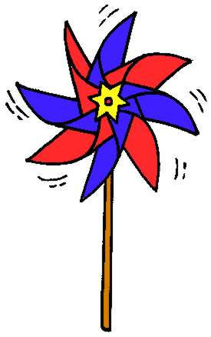
Instructions: Circle items your child enjoys most.

I. Visual Reinforcers
T.V./movies
Computer games
Video games
Wind-up toys
Tops/spinners
Flashlight
Toys that light up
Hologram stickers
Kaleidoscope
Mirrors
Picture books
Pop-up books
Toys with wheels
Car or marble ramps
Train & train track
Pop-up toys
Jack-in-the-Box
Balloons
Puppets
Glittery or shiny stickers
Crayons or markers
Party poppers (contain confetti)
Chalk & chalkboard
Markers & marker board
Etch-a-sketch or Magnadoodle
Egg timer
Waterwheels
Stamps & stamp pad
Painting
Paint with water books
Parachute men
Glow-in-the-dark objects
Viewfinder
Themed Figurines
Snow globes
Shadow play
Disc shooter
Stop
Beads
Masks
Dress-up clothes/costumes
Hats
Pouring liquids
Making photo copies
Cameras/taking photographs
Video cameras
Puzzles
Others:
____________________________________________________________________________________________________

II. Auditory (Noise) Reinforcers
Music tapes/CD’s
Books with sound effect strips
Whistles
Bells
Drum & drum sticks
Triangle
Rhythm sticks
Cymbals
Piano
Toys that talk or sing
Singing songs
Microphone
Party blowers
Canisters that make animals sounds
Clackers
Toys that beep or buzz
Nursery Rhymes
Music Box
Clapping
Kazoo
Others:
____________________________________________________________________________________________________

III. Tactile (Touch) Reinforcers
Stress balls
Lotion
Shaving cream
Play-doh
Clay
Putty
Silly-string
Sand play
Water play
Bubble wrap
Books with textured illustrations
Pipe-cleaners
Toys that bend or stretch
Toys that are rubbery
Koosh-balls
Finger painting
Bumble ball
Vibrating pen
Pom-poms
Puffy paint
3-D glue
Glitter
Magnets
Water balloons
Bean bags
Feathers/feather duster
Pillows
Soap bubbles
Tickling
Ball pit
Fan
Crumpling/tearing paper
Others:
____________________________________________________________________________________________________

IV. Kinetic (Movement) Reinforcers
Trampoline
Bouncing on therapy ball
Rolling on floor
Being held upside down
Spinning
Sock’em Boppers
Moon Shoes
Sit & Spin
Crawling on floor
Running
Jumping/hopping
Skipping
Bicycle or tricycle
Wagon rides
Piggy-back rides
Rocking chair/horse
Dancing
Climbing
Crashing into pillows
Twister
Swinging
Rolling down a hill
Being rolled up inside a blanket
Crawling through tunnel
Building a fort out of sofa cushions
Rolling on stomach over large ball
Scooter board
Skate board
Skates/roller blades
Throwing/kicking objects at targets
Sliding down sliding board/ramp
Knocking down objects
Hitting objects with bat or racquet
Batting at hanging objects
Bowling
Golf
Air hockey
Being thrown in the air
Hide & seek
Tug-o-war

Others:
____________________________________________________________________________________________________

V. Food Reinforcers
Candy
Cookies
Chips
Cracker
Pretzels
Popcorn
Marshmallows
Icing
Ice Cream
Fruit
Soda
Juice
Milk
Others:
____________________________________________________________________________________________________

