**10 Best Indoor At Home Exercises & Workouts without Equipment**



Some days, it’s just really difficult to go outside, especially in the winter months. It can be rainy or cold, and the sun may already set by the time you get off work.

So what are you going to do to get some exercise, especially if you don’t have a [gym membership](https://www.moneycrashers.com/negotiating-a-gym-membership-contract/) to rely on or want to [stay healthy and exercise at home on a budget](https://www.moneycrashers.com/create-free-workout-plan-routines/)?

Are you struggling to stay motivated while working out at home? **[Aaptiv](https://www.moneycrashers.to/aaptiv?sid=r:search.tb.ask-p:18642-z:content-d:1-l:3of10-e:a" \t "_blank)**is an audio-based fitness app with thousands of available workouts. Join over 200,000 members and [**start your free 7-day trial of Aaptiv**](https://www.moneycrashers.to/aaptiv?sid=r:search.tb.ask-p:18642-z:content-d:2-l:4of10-e:a).

Here are 10 ideas for ways you can exercise indoors at home for free or on the cheap.

**1. Jump Rope**  
My husband recently bought a [jump rope](https://amzn.to/2Z1vM2w), and I couldn’t help but laugh because it reminded me of elementary school. I always thought jump ropes were for little girls, but boy, was I wrong!

About a minute into jumping rope, I was literally out of breath. I only made it a few minutes, and my calves were killing me the next day.

If you want a good cardio workout in a matter of minutes, try a jump rope.

**2. Stair Stepping**  
Stair stepping is a great exercise to do in your home, even if you don’t have a set of stairs available. Find the biggest book you own (or a sturdy chair), put it in front of the TV, and step up and down while watching your favorite show. You may not work up a sweat like you would with a jump rope, but you will be keeping your body active and healthy.

**3. The Plank**  
If you don’t have a lot of time, but you want to build up your core muscles, this is the exercise for you. Get into a push-up position, but instead of bending your arms and moving down towards the floor, hold the position with your arms extended. Start off holding the position for 30 seconds, and add an additional 10 seconds every day. See how long you can go for – it’s definitely not easy! This is one of the most challenging exercises, but it’s also one of the best for your core.

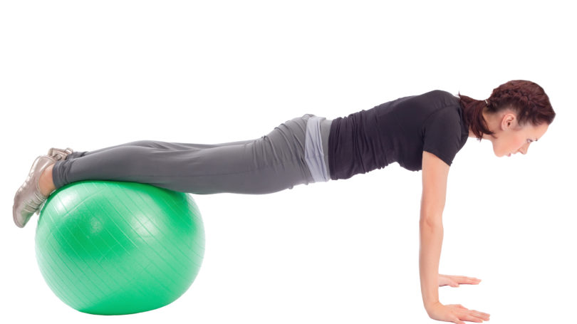

**4. Dancing**  
In college, I lived in an apartment with a bunch of girls. We would get bored with normal workouts, so we started to have dance parties. Once a week, we picked out different music and just danced to our hearts’ content.

Dancing is an excellent way to burn calories, and get your heart rate going while having fun. If you are in the privacy of your own home, there is no need to look like a pro or impress anyone.

**5. Lunges**  
I was in a workout class a few years ago, and one of the exercises was to do lunges down the hallway. Instead of stepping back into place, we would step forward, and we would continue until we made it all the way down the hallway and back. I could always feel the intense burn in my legs with this workout.

You can do the same thing in your home. Try it whenever you go down the hall, or from room to room. If that gets too easy for you, hold weights in your hands to make the lunges more challenging.

**6. Cleaning**  
Cleaning can be very physical, especially vacuuming and mopping. If you are unable to go out one day to ride your bike or go for a run, set up a [house cleaning schedule](https://www.moneycrashers.com/weekly-house-cleaning-schedule-template-checklist-chart-printable/) and clean your house instead. You might as well kill two birds with one stone!

**7. Water Bottle Weights**  
If you are looking to do some arm, shoulder, and back strength training, you can make your own weights by filling up [water bottles](https://amzn.to/2WjLwRN). If using water bottles becomes too easy, use milk jugs. You can tailor the exercise to your level by filling the jugs to the exact weight that you need. For a greater challenge, increase the water amount just a little bit each time you workout.

**8. High Knees**  
I really love running, so I tried to run in place in my home one day when the weather was bad. While it was great that I was able to keep my body active, running in place was very awkward. My heart rate did not get very high either.

Instead of running in place, I’ve found that high knees can really get your heart pumping, especially if you go double time. To do this exercise, march in place or down a hall, and bring your knees as high as they can go.

**9. Jumping Jacks**  
This is another elementary school throwback, but it offers a great cardio workout. If you are watching a TV show, get up during the commercials and do a round of jumping jacks.

**10. YouTube Workouts**  
There are a lot of workout routines on YouTube. You can search “workout,” or you can search by the specific type of workout that you would like. This eliminates the need to use workout DVDs, and it allows you to mix up what you are doing to avoid boredom and [lose weight fast](https://www.moneycrashers.com/tips-how-to-lose-weight-fast-safe-cheap-easy/). YouTube is also great if you want to do a traditional workout with push-ups, squats, and crunches, but are unsure on how to properly do these types of exercises. There are tons of videos that instruct you on how to use correct form as you exercise.

**Pro tip**: If you don’t find anything on YouTube, look into **[Aaptiv](https://www.moneycrashers.to/aaptiv?sid=r:search.tb.ask-p:18642-z:content-d:3-l:9of10-e:a" \t "_blank).** There are over 2,500 workouts and it starts at less than $10 per month.

**Final Word**

I love working out at home because it takes very little preparation and zero driving. You can utilize these exercise tips when you’re stuck inside on a cold winter day.

If you don’t want to workout at home, but the weather is not nice, head to your local mall and do some power walking. Or try to [sneak a workout into your day](https://www.moneycrashers.com/tips-how-to-sneak-workout-routine/) by being cognizant of your activity level.

<https://www.moneycrashers.com/indoor-at-home-exercises-without-equipment/>

Author: Casey Slide