Minute | Exercise | Image | Check-off
1 | 1 minutes of mountain climbers | 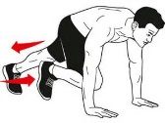
2 | 20-30 sit-ups (1 min)
3 | 1 minutes of jumping jacks
4 | 10-30 pushups (1 min) – DO NOT do knee push-ups (do elevated if you need to, this makes it easier, but still addresses the core) | 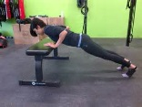
5 | 1 minutes of stairs (or step-ups if no stairs)
6 | 1 minute shoulder raises forward (hold arms out like a mummy for one min or use weights and repeat) | 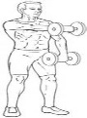
7 | 10 burpees (1 min) | 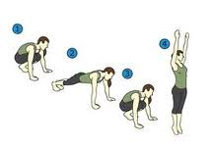
8 | 1 minute shoulder side raises (hold arms out half way snow angel) | 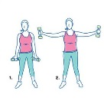
9 | 10 squat jumps (1 min)
10 | WATER BREAK
11 | 1 minute of step ups
12 | 1 minute wall sits
13 | 1 minute Push-up position tucks (alternate knees in & out or both feet to each side) | 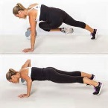
14 | 1 minute of planks
15 | 30 seconds of high knees and 30 seconds of butt kicks
16 | 10 bent over back rows on each side (1 min) use anything weights pulling like starting a lawnmower or lay on ground and pull yourself up using a table, etc. | 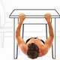
17 | 1 minute of bicycle crunches
18 | WATER BREAK
19 | 15 bicep curls (1 min) – use a backpack or gallon milk to curl
20 | 1 min line jumps - side to side and up and backs
21 | 10-25 bench dips (1 min) | 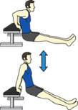
22 | 1 min step ups
23 | 20-30 sit-ups (1 min)
24 | 1 min - Jog around or in place
25 | 10-30 pushups (1 min)
26 | 1 min of stairs or high knees
27 | 1 min of jumping jacks or line jumps
28 | 1 min of mountain climbers or knee tucks
29 | 1 min of stairs, step ups, or butt kicks
30 | 1 min of squats

