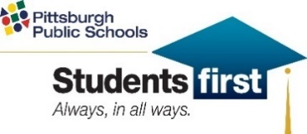
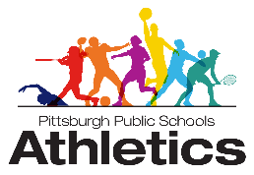
Pittsburgh Public Schools
Interscholastic Athletics
2024 Middle School Wrestling Schedule
as of 12-12-23

Tuesday, March 20, 2024
South Hills @ Obama
Allegheny @ Arsenal
Langley @ PCA
SouthBrook @ Colfax

Wednesday, April 3, 2024
Allegheny@ Westinghouse
Langley @ Obama
South Brook @ Arsenal
Colfax @ PCA

Monday, April 8, 2024
PCA @ South Brook
Arsenal @ Langley
Obama @ Allegheny
Westinghouse @ South Hills

Thursday, April 11, 2024
Langley @ South Hills
South Brook @ Westinghouse
Colfax @ Obama
PCA @ Arsenal

Thursday April 18, 2024
Arsenal @ Colfax
Obama @ South Brook
Westinghouse @ Langley
South Hills @ Allegheny

Monday April 15, 2024
South Brook @ Allegheny
Colfax @ South Hills
PCA @ Westinghouse
Arsenal @ Obama

Monday April 22, 2024
Westinghouse @ Arsenal
South Hills @ PCA
Allegheny @ Colfax
Langley @ South Brook

Thursday, April 24, 2024
Obama @ PCA
Westinghouse @ Colfax
South Hills @ South Brook
Allegheny @ Langley

Monday, April 29, 2024
Colfax @ Langley
PCA @ Allegheny
Arrsenal @ South Hills
Obama @ Westinghouse

Friday, May 3, 2024
City Championship @ Carrick
3:30 pm
2:30pm Weigh Ins

