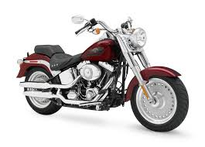

14th Annual MTHS DECA Car Show

Sunday - October 22, 2017

Open to ALL Cars, Trucks & Motorcycles

(*Rain Date-October 29)*

Help Us Honor and Respect our Veterans as we support

WREATHS ACROSS AMERICA

 

Location-Monroe Township High School

200 Schoolhouse Rd

Monroe Twp, NJ 08831

*Registration Begins at 9AM--$15 at Door*

*Every $15 buys 1 Wreath*

*Wreaths will be placed on graves Nationwide on December 16*

*Early Bird Registration-$10 by October 7*

*Registration Form Attached*

*All Proceeds Benefit Wreaths Across America*

*2017 Theme “I am American, Yes I am”*

*Trophies, Door Prizes, Goody Bags, DJ, Food, Silent Auction*

Contact—Debbie Stapenski

Email--dstapens@monroe.k12.nj.us

Phone—908-601-6124

**EARLY BIRD REGISTRATION FORM**

Name________________________________________________________________

Address______________________________________________________________

_____________________________________________________________

Phone #______________________________________________________________

Car_________ Truck_________ Motorcycle________

*Please return registration form with your $10 registration fee (checks please make payable to MTHS DECA) to:*

Debbie Stapenski-MTHS DECA

Monroe Township High School

200 Schoolhouse Road

Monroe Township, NJ 08831