

**ETRIEVE USER’S MANUAL**

**Introduction**

Etrieve is the District’s system for process automation and document management. Etrieve enables the District to manage daily processes in a way that is efficient and safe. Etrieve is a system that will eliminate the need for many of the manual documents that are used in the District. The purpose of this manual is to provide an overview of the Etrieve System and the procedures for entering information to the system. Initially, the District is implementing In-District Travel, Out-of-District Travel and Professional Leave Request. Additional forms will be added to the system in the future.

**Accessing Etrieve**

If you have logged into your computer, then you can access etrieve on the district website (elbert.k12.ga.us) by clicking on the E-forms link under Staff page or Financial Services page. When the next screen opens, click on Etrieve and this will take you directly into your Etrieve Central Box (as shown on page 3) where you have the options to view your inbox, activity, create forms or view drafts. If prompted to sign-on, then use your google sign-on username and password.

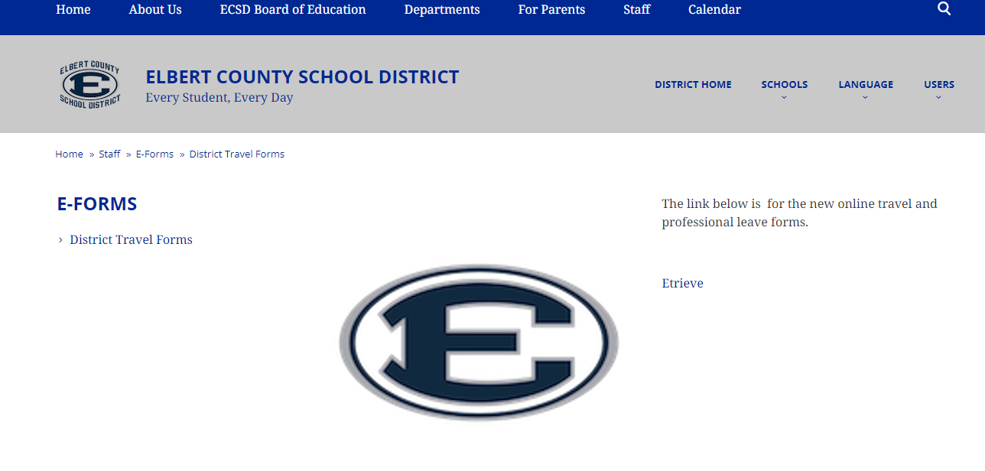

**Accessing Forms in Etrieve**

After logging into Etrieve, the following menu will appear:

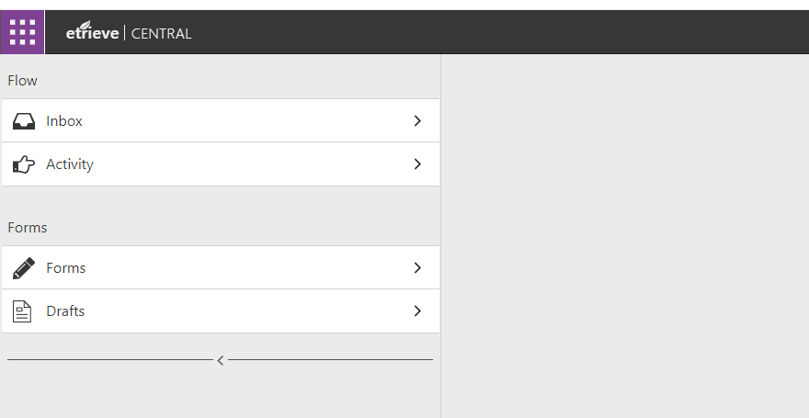

The forms link contains the in-district travel form, the out-of-district travel form and the professional leave request form, as follows:

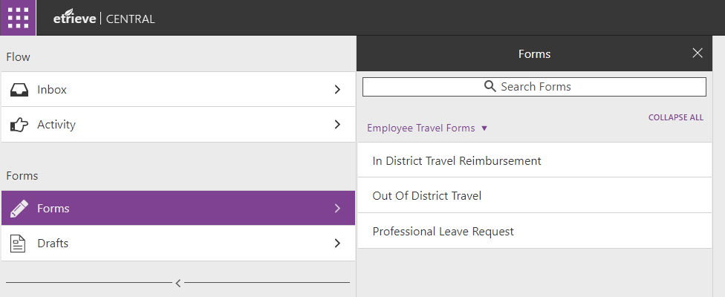

**Inbox**-will display all documents that you have originated.

**Activity**-will display all documents you have taken action on.

**Forms**-to find the blank forms to complete in district travel reimbursement, out of district reimbursement and professional leave request.

**Drafts**-contains documents that you have started but did not completed.

**In District Travel Form:**

This form is used to request reimbursement for in-district travel for official business. To complete the in district travel form, click on the In District Travel Reimbursement link, the following page will appear:

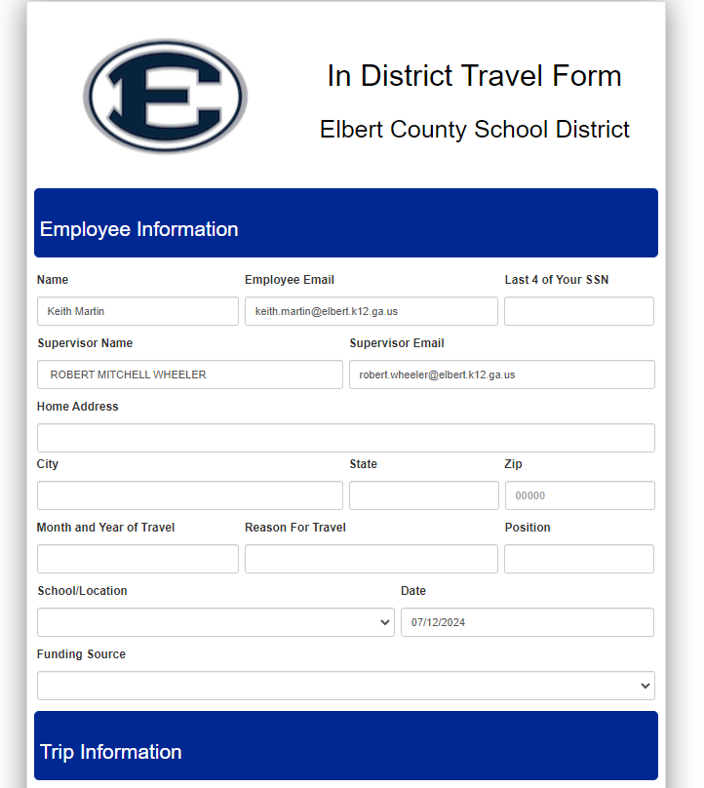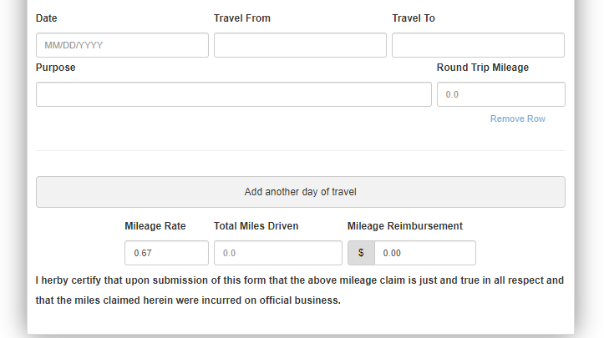

**Instructions for In District Travel Form**:

1. Name, email address, supervisor’s and email will automatically default.
2. The total miles driven and mileage reimbursement will automatically calculate.
3. All other field must be completed.
4. The funding source field must be selected. If there are questions regarding funding source, please call the Finance Department. This field can be adjusted by the immediate supervisor.
5. If you need to add another day click on the “Add another day of travel” link. Up to 31 days can be added to one form.
6. If any supporting documentation is required, it must be attached using the link at the bottom-left of the page.
7. Once all fields are completed, hit submit (bottom left corner). The form will go to your immediate supervisor for approval and further processing.
8. Once the form has been fully processed, it will go to the Finance Department for payment.

**Out of District Travel Form:**

This form is used to request reimbursement for out of district travel for official business. To complete the Out of District travel form, click on the Out of District Travel Reimbursement link, the following page will appear:

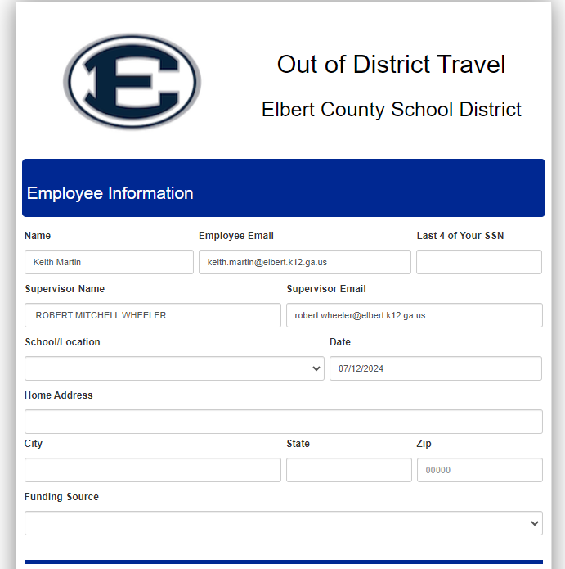

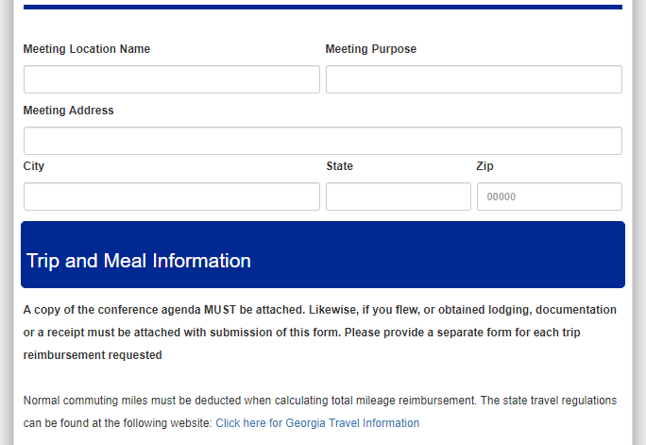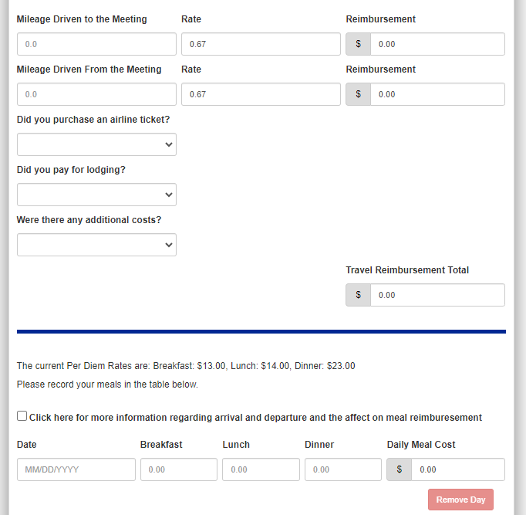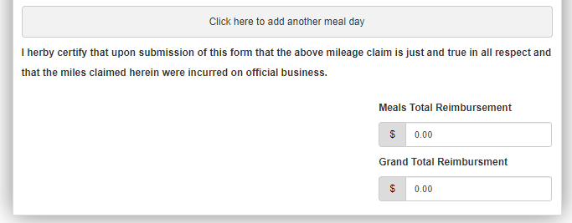

**Instructions for Out of District Travel Form**:

1. Name, email address, supervisor’s and email will automatically default.
2. The total miles driven and mileage reimbursement will automatically calculate.
3. All other field must be completed.
4. The funding source field must be selected. If there are questions regarding funding source, please dicuss with your immediate supervisor. This field can be adjusted by the immediate supervisor.
5. If you need to add another day click on the “Add another day of travel” link. Up to 31 days can be added to one form.
6. **If any supporting documentation is required, it must be attached using the link at the bottom-left of the page. A conference agenda is required to be attached.**
7. When travel from home normal commuting miles must be deducted from the miles claimed.
8. Meals claimed must be in compliance with State regulations as follows:

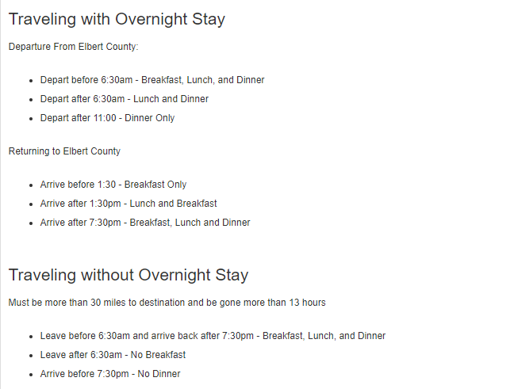

1. Once all fields are completed, hit submit (bottom left corner). The form will go to your immediate supervisor for approval and further processing.
2. Once the form has been fully processed, it will go to the Finance Department for payment.

**Professional Leave Request Form**

This form is used to request leave for professional development activities. Professional Leave must be approved 3 days prior to leave. To complete the Professional Leave Request form, click on the Professional Leave Request Form link, the following page will appear: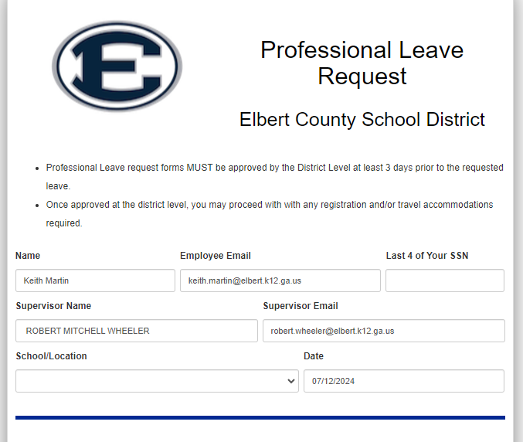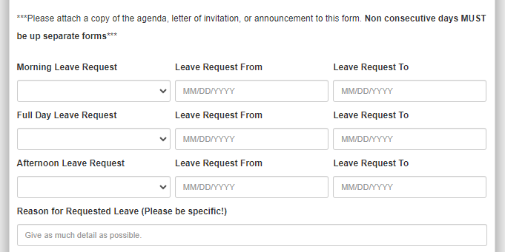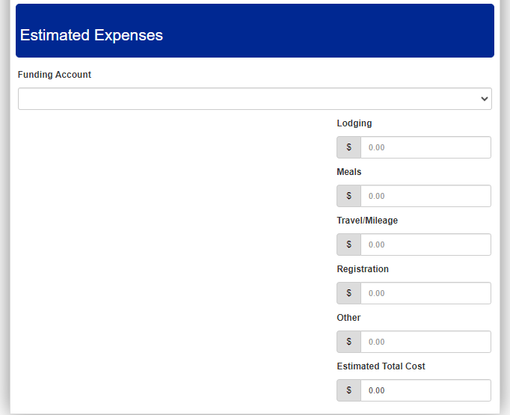

**Instructions for Professional Leave Form**:

1. Name, email address, supervisor’s and email will automatically default.
2. The estimated total costs will automatically calculate.
3. All other field must be completed.
4. In the reason for requested leave, please be as specific as possible (i.e. name of conference, purpose of conference, etc). DO NOT JUST LIST CONFERENCE OR SOMETHING GENERIC.
5. The funding source field must be selected. If there are questions regarding funding source, please discuss with your immediate supervisor. This field can be adjusted by the immediate supervisor.
6. If you travel is on non- consecutive days a separate form must be completed.
7. If any supporting documentation is required, it must be attached using the link at the bottom-left of the page. A conference agenda is required to be attached.
8. When estimating travel miles remember normal commuting miles must be deducted from the miles claimed.
9. When estimating meals claimed remember it must be in compliance with State regulations as follows:

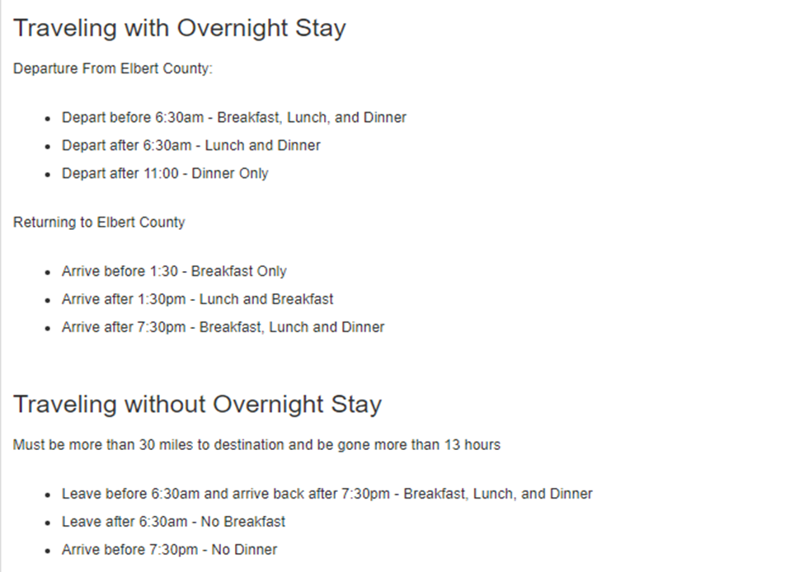

***Remember meals provided by the conference cannot be reimbursed.***

1. Once all fields are completed, hit submit (bottom left corner). The form will go to your immediate supervisor for approval and further processing.
2. Once the form has been fully processed, it will go to the Finance Department for payment.

**General Information:**

-If you have questions about the status of your submitted form, you contact Keith Martin (4052) or Suann Baker (4016) in the Finance Office.

-If your immediate supervisor or someone at the district level has a question about your request, it might be returned or denied for more information. If this happens, you will receive an email with a link to the Etrieve form to address any issues. Once the form is edited, it can be re-submitted through Etrieve. Thanks.



**IF YOU HAVE ANY QUESTIONS ABOUT ETRIEVE, PLEASE CALL THE FINANCE DEPARTMENT**