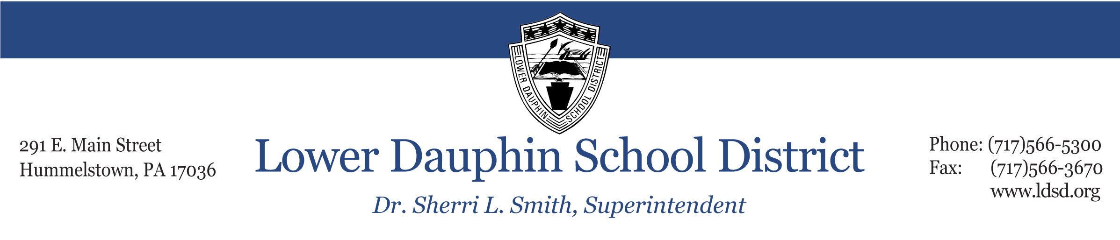

Re: Special Transportation Guidelines for Parents

Dear Parent or Guardian,
This letter is sent to you to inform you of the Lower Dauphin School District’s procedures and guidelines in regard to special transportation for your child. Your child is receiving special transportation due to his/her individual needs for a specific academic program and placement. Our purpose for sending this letter is to make every effort to communicate and work with parents while working to ensure the safety of our students.
As a general practice, students receiving special transportation will be transported with peers of the same schooling level. For instance, elementary students will be transported on vans or buses with other elementary students, and secondary students with other secondary students. Should student, placement, and/or programmatic needs require a different arrangement where your child is transported with students outside of his/her schooling level, you will be contacted directly to discuss the arrangement prior to implementation. If a parent disagrees with the proposed busing arrangement or a change in transportation affecting their student, the parent has the right to appeal the proposed arrangement or change through an appeals process, using the form enclosed with this letter. Parents may file a Request Form to Appeal Transportation Assignment, which shall be considered by the Transportation Coordinator and may be appealed to the Director of Pupil Services.
Lower Dauphin’s transportation staff and special education staff meet annually prior to the start of each school year to review transportation routes and bus/van assignments. Any significant changes to special transportation during the school year will be reviewed prior to implementing these changes. Additional considerations to be discussed at these meetings are the particular behavioral and emotional needs of the students on special transportation. The following procedures will be used based on the make-up of each bus/van involved in special transportation.
- If student behaviors present an identified safety risk, the district will determine the need for and assign additional assistance to the bus driver in the form of an aide or adult support staff. The ratio of transportation support staff to students shall be evaluated to ensure the safety of all students and adults.
- No less than annually, the District will provide training to drivers and transportation support staff in regard to maintaining a safe environment in transport vehicles, such as deescalating student behaviors, appropriate use of safety vests, responding to student behavior emergencies, and appropriately reporting any incidents occurring during transportation within 24 hours of any incident.
- All district staff and/or those contracted by the district to provide services will adhere to the requirements of each student’s IEP. Any desired change from the transportation restraints (e.g. safety vests) that are written into the IEP will first be discussed and approved by the IEP team, inclusive of the District's Director of Pupil Services, prior to implementation.
- Parents will be made aware of any long-term changes of the vehicle by which their child is transported in a timely manner. In situations where an identified student’s disability manifests in behaviors of concern during transportation, the transportation staff and special education staff will meet to review and consider any safety concerns. The transportation and special education staff will meet annually prior to the start of each school year to review transportation routes and bus/van assignments.

- In the event that a student is injured on District transportation because of another student's behavior, the bus driver and/or support staff will provide written documentation to the transportation coordinator within 24 hours, and the transportation coordinator or other district staff will contact the parents of students involved as soon as is practical and will provide a written summary, with appropriate redactions of confidential information.

It is the intention of the district to communicate effectively and in a timely manner with parents of students with special transportation needs. Parents of these students with safety concerns related to changes in transportation shall contact district administration in the following order: (a) Transportation Coordinator and (b) Director of Pupil Services. If a parent has contacted the transportation department concerning a safety issue and does not receive a return response within 24 hours, the parent should contact the Director of Pupil Services, Mr. Andrew McCrea, at 566-5318.
Sincerely,
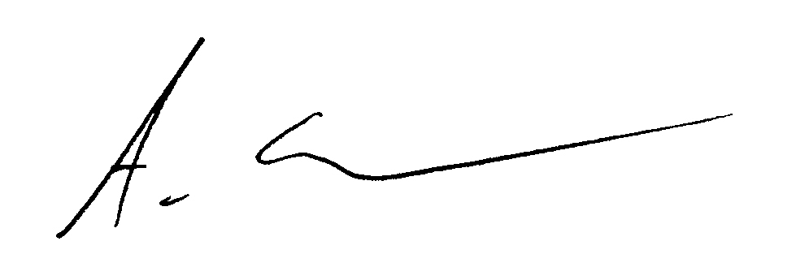
Andrew McCrea
Director of Pupil Services

