**Lesson 6 Study Guide**

**Big Ideas:**

1. **How do I divide larger numbers by two-digit divisors?**
2. **Use the “DMSB” steps for long division (Divide, Multiply, Subtract, Bring Down)**
3. **VOCAB: What are the different parts of a division problem?**

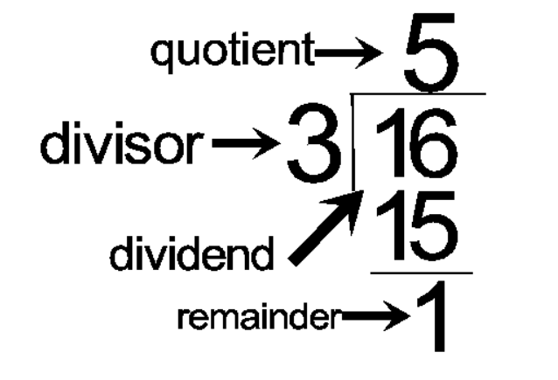

Practice:

1. Divide larger numbers by two-digit divisors, with and without remainders

ex. 4,673 ÷ 32

1. Divide numbers with zeros in the dividend

ex. 7,048 ÷ 21